Four Seasons Resort and Residences Jackson Hole Partners with Local Ski Company to Create a Customised Ski Experience

Local artist to design exclusive custom ski cover beginning in 2019
August 20, 2018, Jackson Hole, U.S.A.

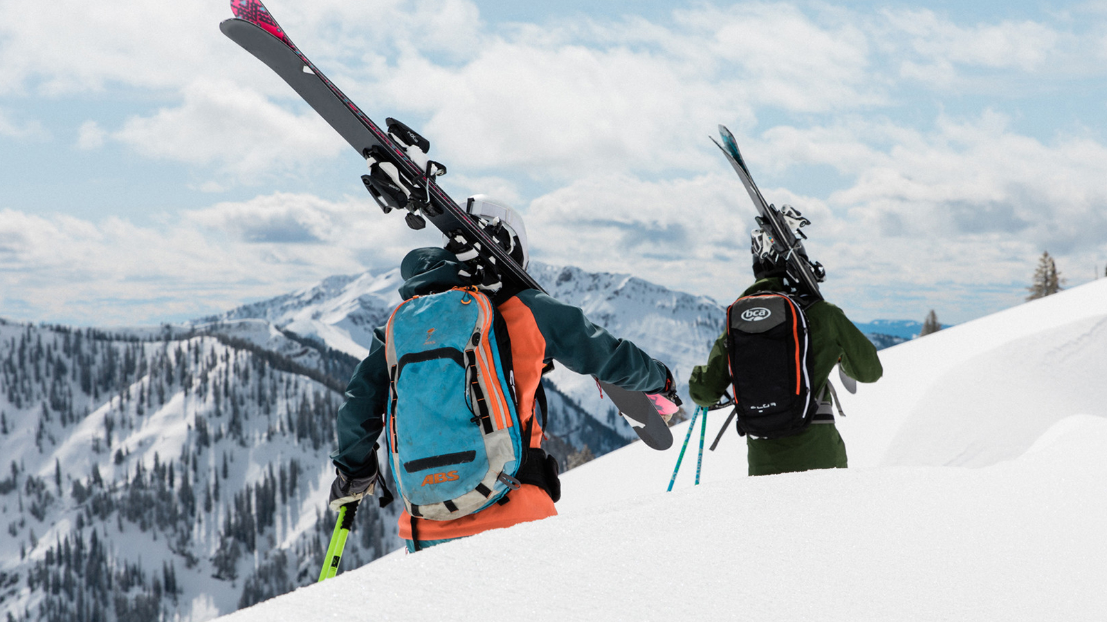
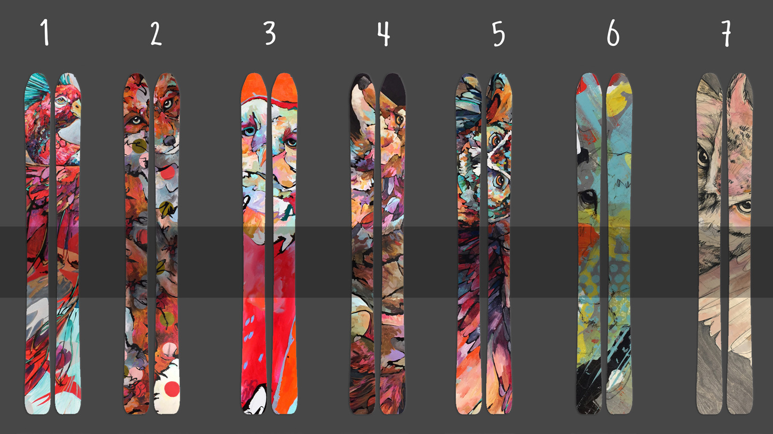
Update, October 12, 2018: Four Seasons Resorts and Residences Jackson Hole announced that local artist Amy Ringholz will be designing the 2019 cover to the custom ski. Originally from Ohio, Amy has built her name as a contemporary wildlife artist over the past thirteen years in Jackson Hole. Her work is best known for distinctive style, portraying wildlife with a combination of bold, gestural lines and vivid colour. The new design will be available in the beginning of the New Year and exclusively available to Four Seasons guests to rent during their winter visit. For more on the design and artist follow @FSJacksonHole on Instagram.

A new selection of all-star skis will be joining the line-up of equipment available to guests of Four Seasons Resort and Residences Jackson Hole this winter. Conceived and crafted in the Tetons by local company Sego Ski, these customised skis are top of the line big mountain, all terrain skis, with an exclusive design for Four Seasons Resort Jackson Hole.
Passion for skiing inspired the Resort’s Director of Marketing Cory Carlson to look towards creating a customised ski. Carlson is no stranger when it comes to the ski industry, having been a member of the US Ski Team for 10 years and representative of the US in World Cup competitions. He joined his love for skiing together with the Resort’s commitment to service to bring these locally produced skis to our guests.
“We delight in surpassing the expectations of our guests at every turn and it was in that spirit we reached out to Sego to partner on a customied ski that excels on the mountain it was built for. Guests are going to love the ease in which both models perform in deep snow and off the groomed runs, ” says Carlson.
Jackson Hole’s premier ski in/ski out destination offers exceptional service with its dedicated Ski Concierge, which caters to creating a seamless ski experience from gear rental to slope access, mountain tips, ski tuning, boot warming and even assisting guests with putting on their boots. The custom Sego skis will be the newest offering, creating an elevated ski experience this winter.
“We don’t compromise when it comes to our materials. Like a chef, when you start with the best ingredients you will get a great product. We are continually innovating our product and testing in our backyard with world class athletes to ensure that when we roll out our products, they are dialled in,” says Tim Wells, Sego Ski CEO.
Segos Ski was the obvious choice for Carlson as he felt it was important to create something in the Tetons for the Tetons. The company was started four years ago by brothers Tim and Peter Wells. The materials used to make the skis are sourced as close to home as possible and the entire process is made in-house.
The skis consist of the Clever 102 , Sego’s bestselling men’s ski recent recipient of Powder Magazine’s Skier’s Choice award and Freeskier Magazine’s Editors' Pick award; and the UP 92, Sego’s bestselling women’s ski and Freeskier Magazine’s Editor Pick . The inspiration for the Clever 102 came from the Tetons, where solid landings, stability at high speed and large powerful turns are at a premium. The UP92 provides lots of pop in a highly durable, light weight package that is also ready to stay afloat when hitting secret powder stashes. From groomers to powder days these all mountain skis are built to keep the legs fresh all day.
“The UP 92 hits the sweet spot for skiers in general. It’s playful, it’s fun and it floats nicely,” says Wells.
Guests can expect to rent these skis this winter at the property’s Ski Concierge, located on the 2nd floor of the Resort. Four Seasons custom designed skis are not available for purchase and will be exclusively available to Resort guests for rent during their stay.

RELATED

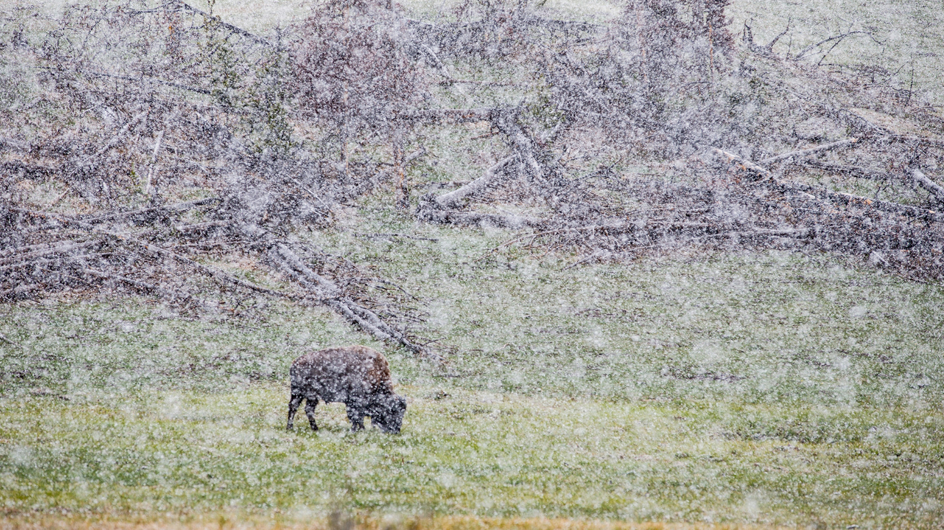 | October 19, 2018, Jackson Hole, U.S.A.  Four Seasons Resort and Residences Jackson Hole Invites Guests for Unforgettable Experiences This Winter Season  https://publish.url/jacksonhole/hotel-news/2018/winter-experiences.html
October 19, 2018, Toronto, Canada
Experience North America’s Premier Ski Destinations with the Four Seasons Mountain Collection
https://publish.url/news-releases/2018/skiing-at-four-seasons-mountain-resorts.html

PRESS CONTACTS

Nina Braga
Public Relations Director
7680 Granite Loop Road, P.O. Box 544
Teton Village
U.S.A.
nina.braga@fourseasons.com

+1 (307) 732-5062

