Four Seasons Hotel Toronto Celebrates a Decade of Luxury

Four Seasons Hotel Toronto celebrates its 10-year anniversary with special offers, activations and festivities throughout the flagship property, Café Boulud, d|bar by Chef Daniel Boulud and the Spa at Four Seasons Toronto
September 28, 2022, Toronto, Canada

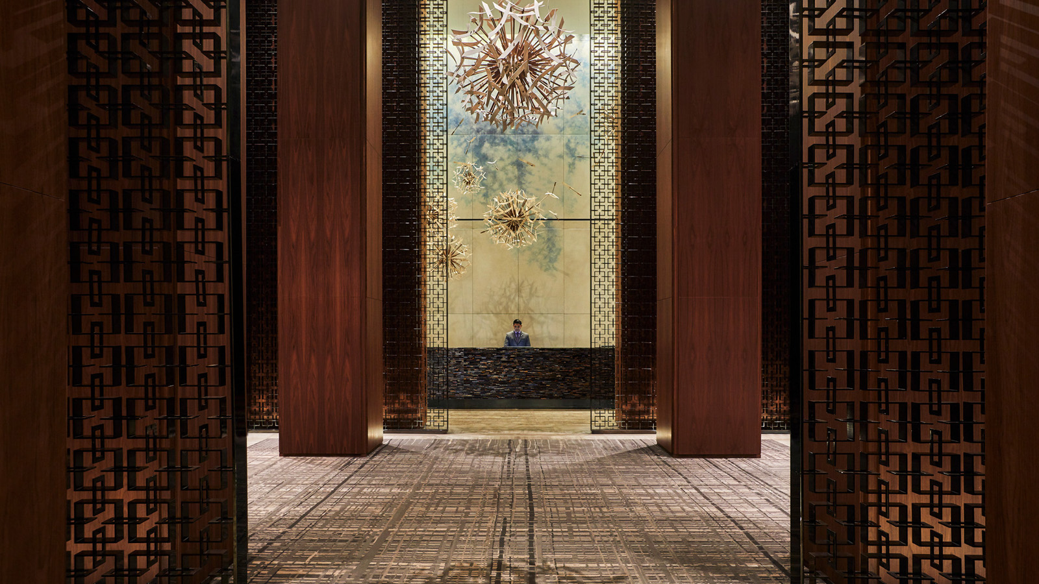
A decade of award-winning service, unparalleled accommodations, authentic French cuisine and wellness marks the tenth anniversary of Four Seasons Hotel Toronto. Since opening the doors to its Yorkville location in 2012, the global flagship property remains an innovative leader and trendsetter in the luxury hospitality space. To celebrate the milestone, Four Seasons Hotel Toronto will honour its history by unveiling month-long programming consisting of special offers, dining experiences, a commemorative black-tie affair and its largest sweepstakes yet.
The 2012 opening introduced the city of Toronto to renowned Chef Daniel Boulud’s modern French brasserie Café Boulud and the lively street-level bar and lounge d|bar by Chef Daniel Boulud. Toasting to ten years of gastronomy, on Tuesday, October 11, 2022 Café Boulud will host a one-night-only collaboration dinner helmed by Chef Daniel and three global culinary masters. Accompanying Chef Daniel is Yoric Tièche, Executive Chef of Michelin-starred fine-dining restaurant Le Cap inside of Grand-Hôtel du Cap-Ferrat, A Four Seasons Hotel; Massimo Mantarro, award-winning Executive Chef of Sicilian fine-dining restaurant Principe Cerami at San Domenico Palace, Taormina, A Four Seasons Hotel; as well as Yudith Bustos, the talented Executive Pastry Chef of LAW at Four Seasons Resort and Club Dallas at Las Colinas. These renowned talents will come together to present a feast for the senses with flavours and aromas dreamed up for this coveted collaboration. Downstairs in d|bar, Sous Chef Maru Cacho has created a limited-edition menu, A Decade of d|bar, highlighting ten beloved menu items. From Tuesday, October 11, to Saturday, October 15, 2022, guests can indulge in signature dishes from past and present while savouring every sip of Head of Mixology Mike Birdsey’s anniversary cocktails.
Come Wednesday, October 12, 2022, Four Seasons Hotel Toronto will host THE FOUR SEASONS, an invitation-only black-tie celebration. Cleverly playing on the city’s four seasons, the extravagant event will nod to spring, summer, autumn and winter through breath-taking decor, floral installations, entertainment and seasonally-inspired culinary masterpieces. Chef Daniel and the visiting masters will each create a show-stopping station where they will present guests with an immersive and engaging feature dish. The city’s most notable business leaders, public figures, media moguls and creators will embark on an experiential journey in true Four Seasons fashion.
“Toronto is where Four Seasons was born, and this Hotel, as we see it, is at the heart of the brand’s continued innovation and success,” says Isadore Sharp, Founder and Chairman of Four Seasons Hotels and Resorts. “I am proud to call this property home and it’s an honour to both witness and be part of the unique magic the team here continues to create, that I know will carry on into the next decade and beyond.”
Throughout the month, guests can enjoy Four Seasons in true grandeur with two all-encompassing packages, A Decade of Luxury and A Decade of Tranquility. Guests will experience all facets of the property with A Decade of Luxury, inclusive of a two-night stay in a perfectly appointed suite, champagne, a three-course dining experience with accompanying wine pairings at Café Boulud, a trip to the Spa at Four Seasons Toronto, monogrammed bathrobes and more. Those looking to unwind can book A Decade of Tranquility, a dedicated Spa package designed with serenity in mind. Guests will enjoy a range of services including a Rose Gold facial, Gold Body Scrub, Reviving Foot Therapy treatment, and a Yorkville Manicure, in addition to a special Spa luncheon. The pampering continues as guests will receive additional take-home amenities and products to ensure the relaxation continues all month long.
As the festivities draw to a close, the flagship will host its 10 Days of Giveaways via Instagram. Beginning Saturday, October 22, and ending Monday, October 31, 2022, Four Seasons Hotel Toronto will give back to the surrounding community and those who aid in the success of the property by giving away the pinnacle of luxury prizes. With a combined approximate retail value of CAD 40,000, prizes range from private dining experiences and trips to the spa to overnight stays in Dubai, London, New York, Orlando, Maui, Paris, Montreal and Whistler. Concluding the giveaway is the ultimate grand prize, a Four Seasons Signature Sleep Set with a mattress and mattress topper, a sheet set, duvet, duvet cover set and down feather pillows.
“Milestones as significant as this are best celebrated with the people dedicated to our growth and achievements from day one, and we organized these month-long festivities to do just that,” says Patrick Pollak, General Manager, Four Seasons Hotel Toronto. “This property is special to many, not just our employees but Torontonians and guests from around the world. It was our goal to ensure everyone, no matter how near or far, feels they are a part of the ten-year anniversary celebrations.”
To stay up to date with Four Seasons Hotel Toronto and learn more about the 10 Days of Giveaways, click here to follow the property’s official Instagram.
Click here to secure a reservation at Café Boulud and here to secure a reservation at d|bar. Those looking to book A Decade of Luxury or, A Decade of Tranquility can call Four Seasons Hotel Toronto directly at 416 964 0411.

RELATED

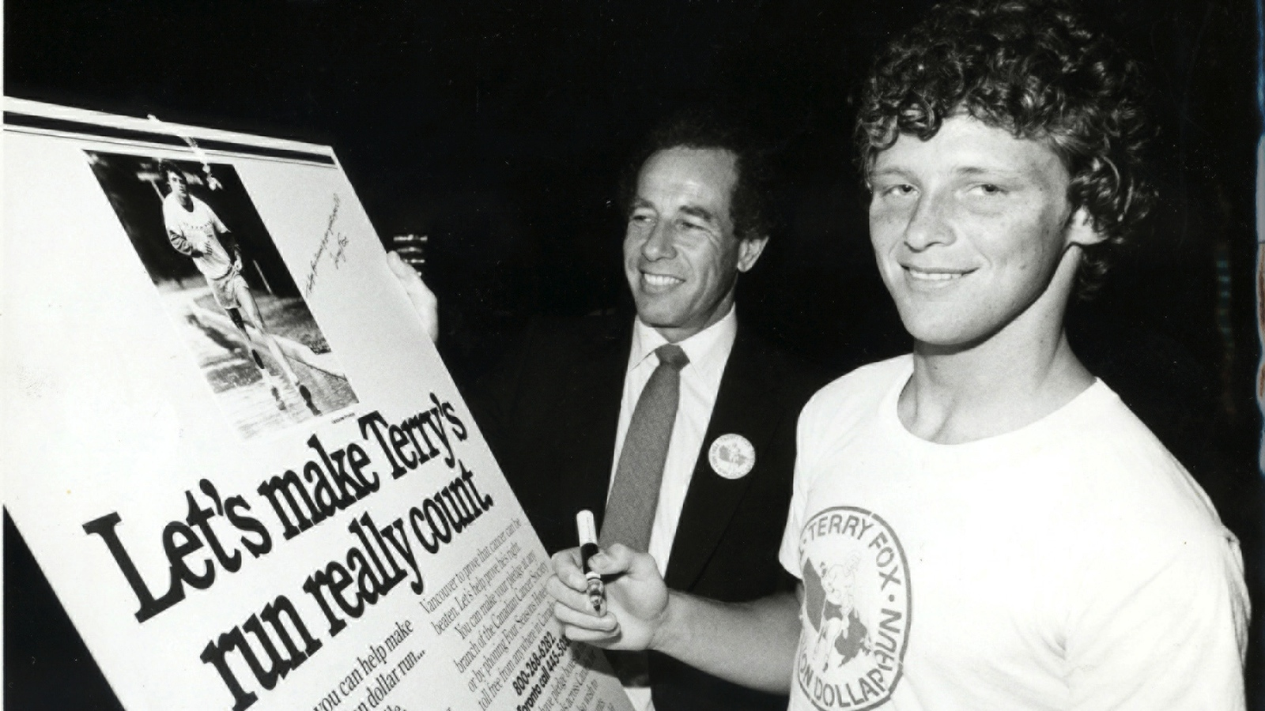 | September 12, 2022, Toronto, Canada  Join Four Seasons Global Head Office and Hotel Employees for the 42nd Annual Terry Fox Run, Returning to Wilket Creek Park for the First Time Since 2019 on Sunday, September 18, 2022  https://publish.url/news-releases/2022/toronto-terry-fox-run.html
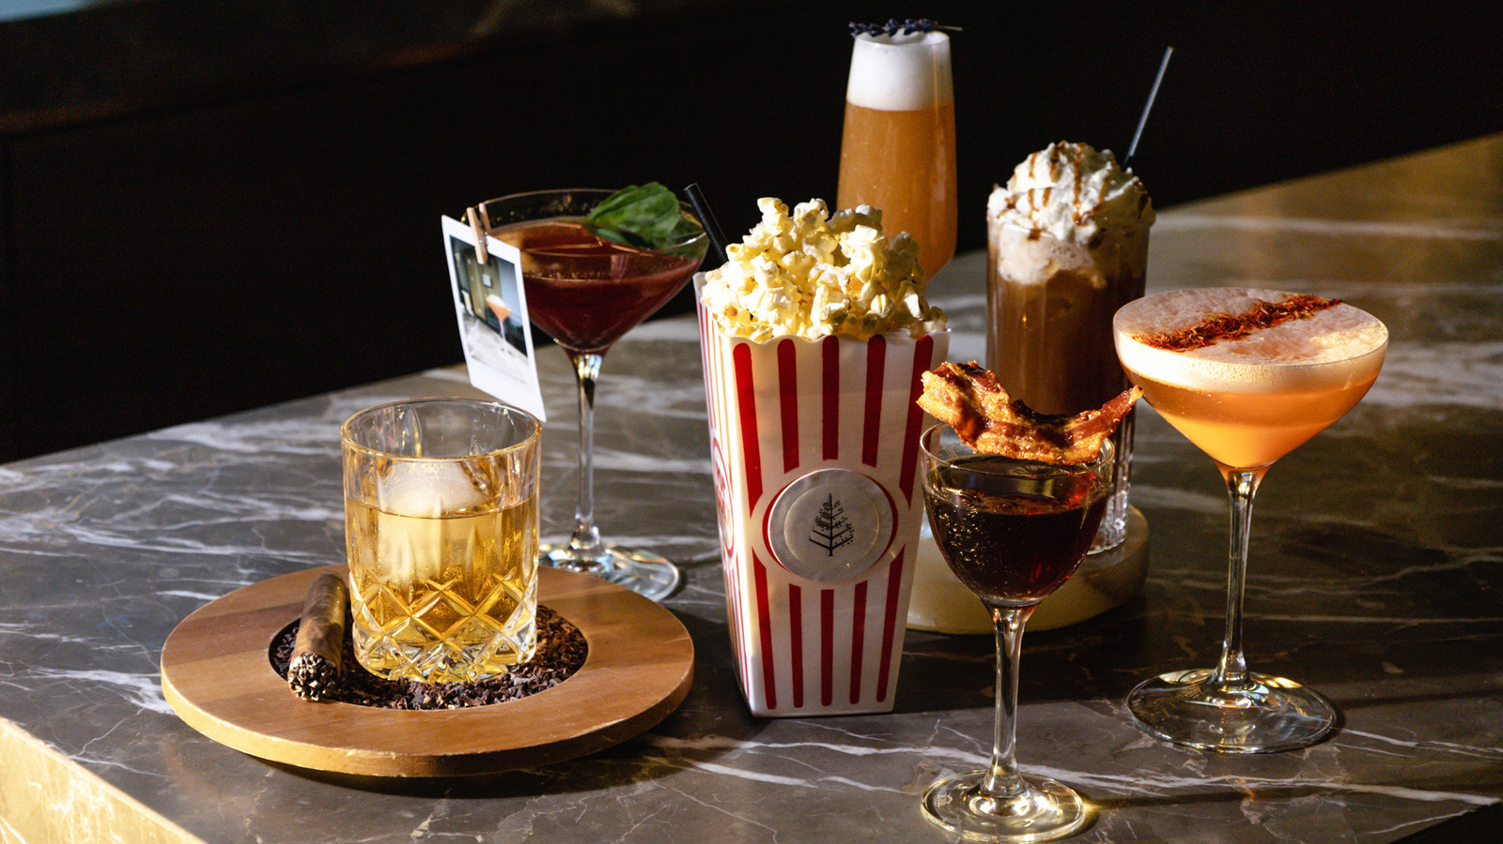 | September 6, 2022, Toronto, Canada  Film Festival Season Returns to Yorkville at Four Seasons Hotel Toronto  https://publish.url/toronto/hotel-news/2022/film-festival-events.html

PRESS CONTACTS

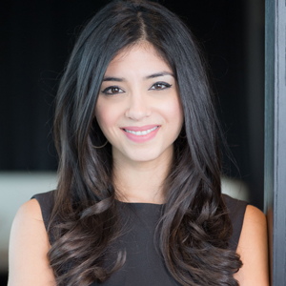 | Halla Rafati  Public Relations Director  60 Yorkville Avenue  Toronto  Canada  halla@haloandco.co  +1 416 364 0404

