Experience Winter at Four Seasons Resort and Residences Whistler

October 15, 2020, Whistler, Canada

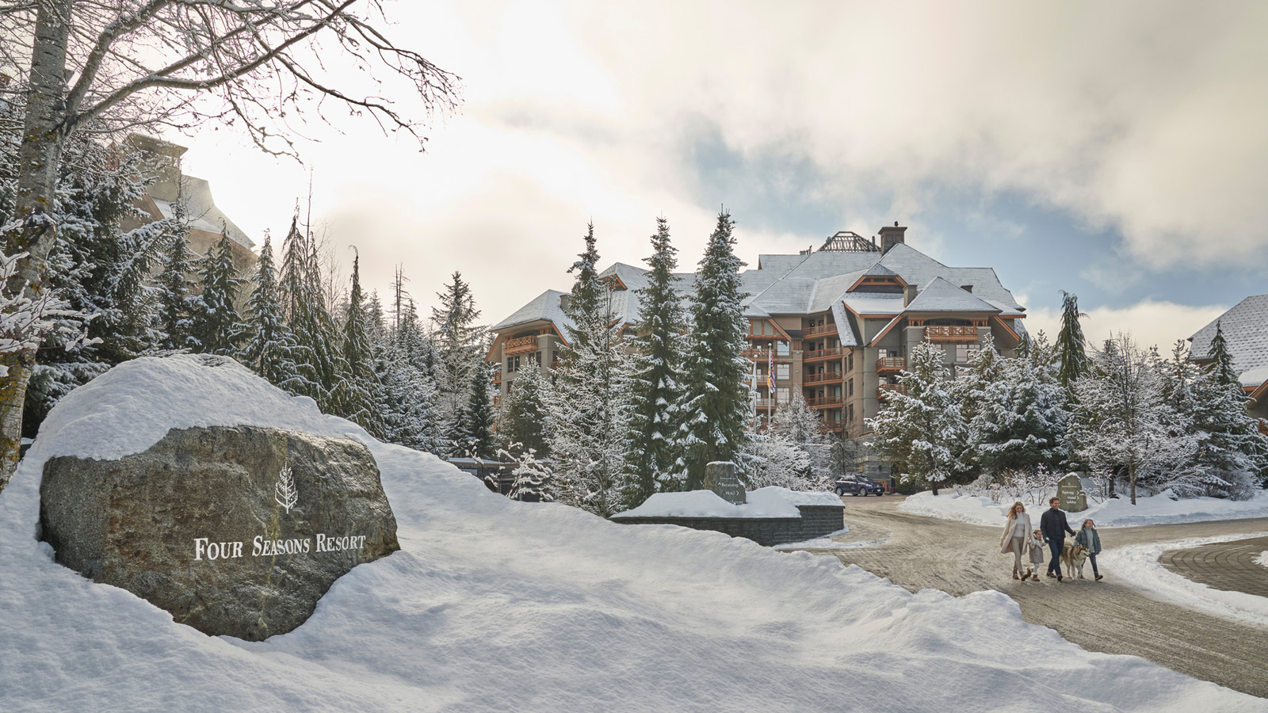
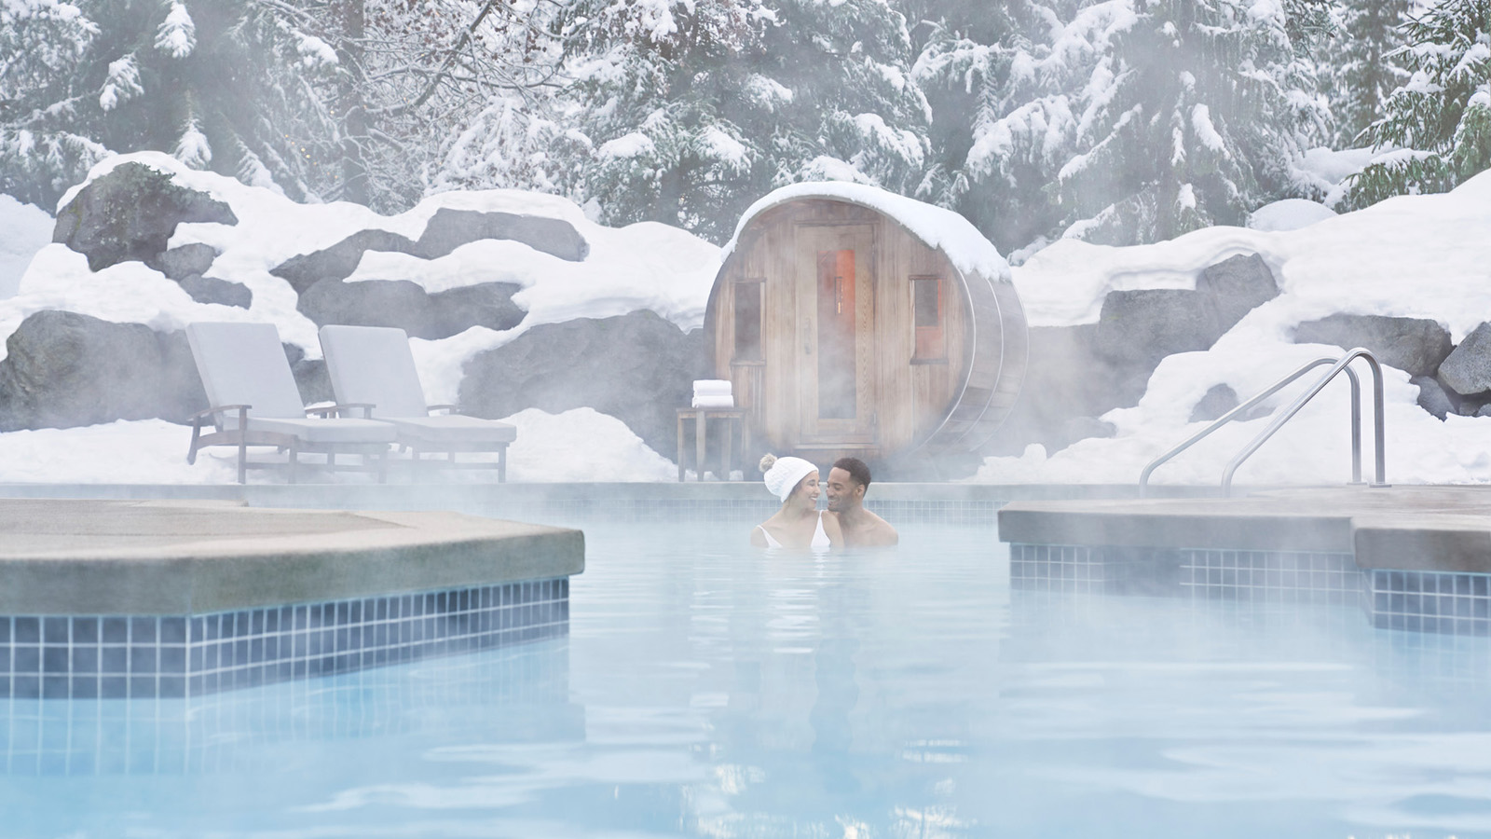 |  | 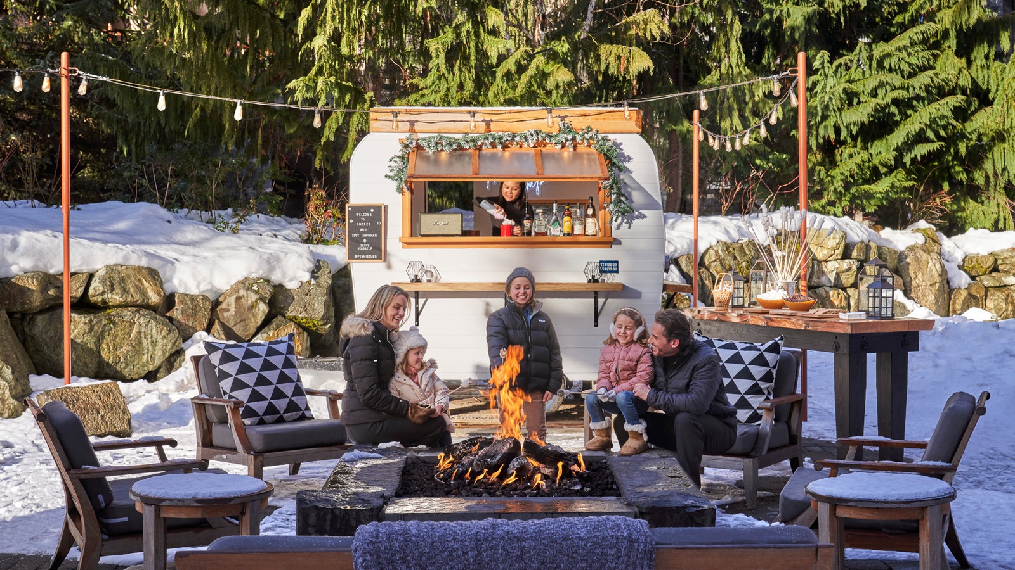
Following a sweeping renovation, Four Seasons Resort and Residences Whistler invites guests to discover an unforgettable winter season at the iconic mountain lodge. Inspired by the snow-capped peaks and pristine evergreen forests that surround the property, the revitalisation combines sleek, contemporary design with the warmth of a classic chalet. Embracing time-honoured traditions and one-of-a-kind experiences, Four Seasons Resort Whistler is posed to celebrate the coastal mountain region’s most bountiful season. Private luxury retreats, bespoke in-room dining options, elevated restaurants and bars, and exclusive wintertime activities found only at Four Seasons Resort Whistler together make for an exceptional winter season. Each offering is a fresh opportunity to reconnect with nature, welcome new adventures, and build upon a mountain on memories.
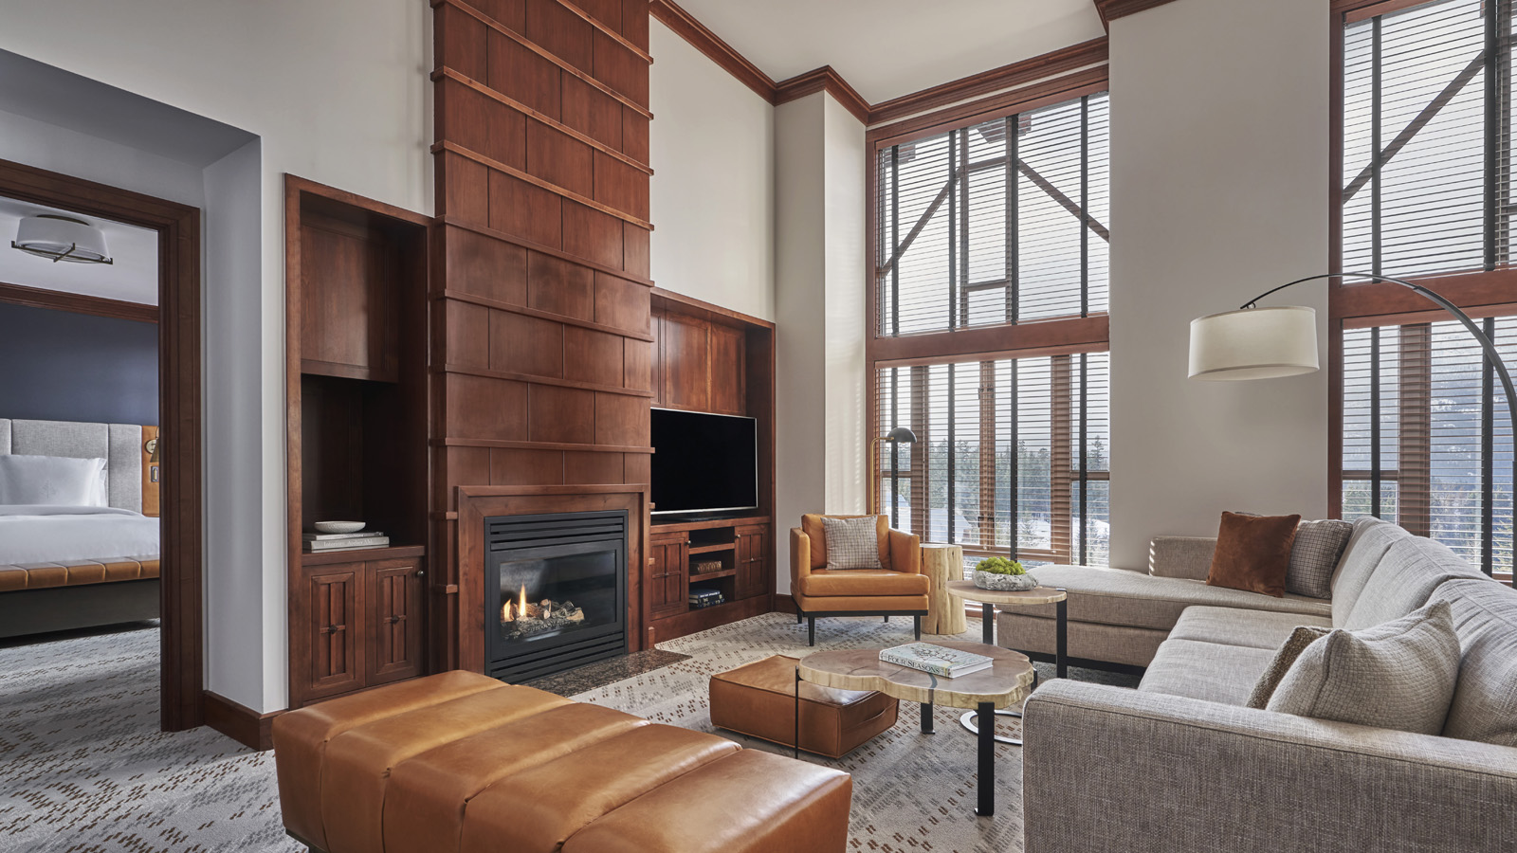
Signature Suites
Following last year’s redesign, Four Seasons Resort Whistler presents a full renovation of all 273 rooms and suites. Lead by Vancouver’s award-winning DIALOG architecture studio, the refurbishment is a luxurious update, synthesising alpine elegance with the warmth and ease.
Of special prominence this winter season is the debut of ten new Signature Suites. Inspired by the picturesque homes of Whistler, each suite is its own private mountain retreat, with every design element selected to highlight the stunning snowy vistas. Cosy accents such as plush throws, soft upholstery, and rich ashwood detailing, are combined with urban-minded mid-century furnishings, reimagining sophisticated après ski style.
Each suite features expansive balconies, fireplaces, and a separate living room area, as well as individual charm and character. The expansive two-storey Townhouse, designed for those looking for a home away from home, features a private hot tub - ideal after a day out on the slopes, taking in the restorative mountain air. The Blackcomb Suite is perfectly suited for at-home entertaining while keeping mind of physical distancing. The suite features a separate dining area, kitchenette, and three balconies to take in unrivalled mountain views while indulging in a homecooked meal.
Debut Dining Out
Dining out at Four Seasons is essential for any visit to Whistler. This winter season, Four Seasons Resort Whistler premieres two newly realised culinary visions: the all-new Braidwood Tavern and the re-imagined SIDECUT.
Braidwood Tavern is a contemporary take on the classic mountainside tavern, embracing the warmth and lively charm of Whistler. Bringing this vision to life is Chef Richard Sandoval, creating a menu of mountainside tavern classics, playful cocktails, and craft beer offerings selected from outstanding breweries in the Sea-to-Sky region. Inspired by classic cabin architecture, the space is wrapped in rich braided wood-panelling, made from woven reclaimed pine, cedar, and spruce. With expansive tables, keeping in mind of physical distance, it’s an ideal setting to kick back with friends with a frosty pint.
The Resort's beloved SIDECUT debuts a stunning renovation lead by Vancouver-based studio Box Interior Designs. Serving its famed classics–prime hand-cut steaks seasoned with Chef’s Classic Rubs, the space has been finished in a luxurious palette of buttery leathers, black walnut, and brass accents.
In-Room Dining Experiences
For those looking to luxuriate in an intimate setting, Four Seasons Resort Whistler presents two in-room dining experiences designed to make the most of the season. To indulge before a long day on the slopes (or at the Spa) the Resort has one-upped breakfast in bed with the signature Balcony Breakfast. A multi-tiered tower stacked with all the savoury and sweet breakfast treats - pastries, avocado toast, sausage, bacon, pancakes with warm maple syrup - all enjoyed from the balcony. Wrapped in soft robes, it’s a comforting and cosy way to get a day of exploration started.
Looking to keep the cosy mood going après ski? Ordered conveniently through the Four Seasons App, guests can return to a homey, comforting crockpot meal waiting for them in-room. Guests may choose from a menu of craveable favourites, and tuckered out families and friends can be greeted by a warm dish to enjoy together, recapping the laughs and adventures of the day.
Wintertide Celebrations
In celebration of the arrival of Whistler’s most joyous season, the Resort team has dreamed up a variety of wintertide activities to delight all. The Resort’s charming vintage patio camper is back for winter, serving up hot chocolate and cook-your-own s’mores. Guest can gather around the fire pit to warm up after a long day out adventuring, and enjoy the playful signature hot chocolate, The Tipsy Snowman, or wind down with the sommelier’s selection of British Columbia wine, with tastings offered each evening. Keep watch for Maola, the Resort’s resident Alaskan malamute. Her name is from the First Nations Lil'wat language meaning “raccoon,” a nod to the pup’s distinct facial markings.
Guests are invited to embrace the spirit of discovery at Four Seasons Resort Whistler that uplifts, connects, and create indelible moments with those they love.
To be among the first to experience this Winter season at Four Seasons Resort Whistler, the Stay Longer-Fourth Night Free offer is available for online booking today.

RELATED

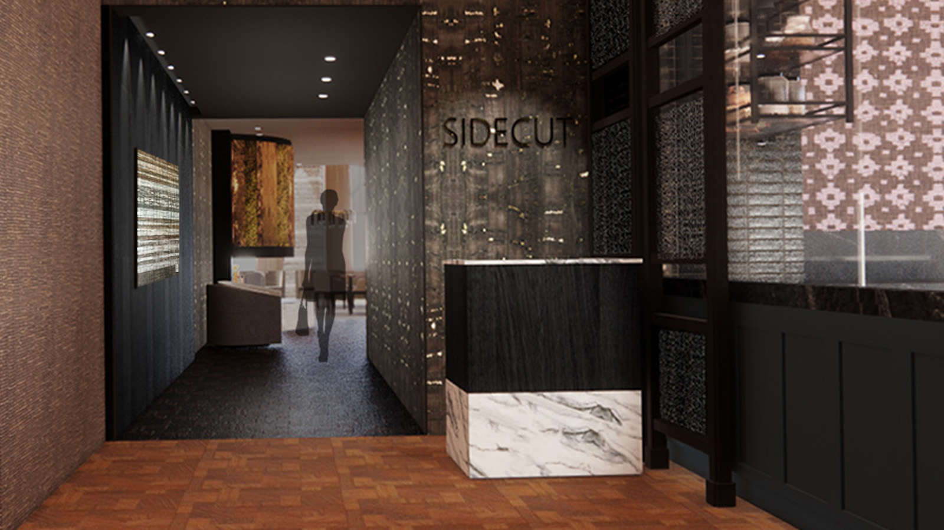 | November 16, 2020, Whistler, Canada  Four Seasons Resort and Residences Whistler Debuts the Revitalised SIDECUT Steakhouse  https://publish.url/whistler/hotel-news/2020/sidecut-reopening.html
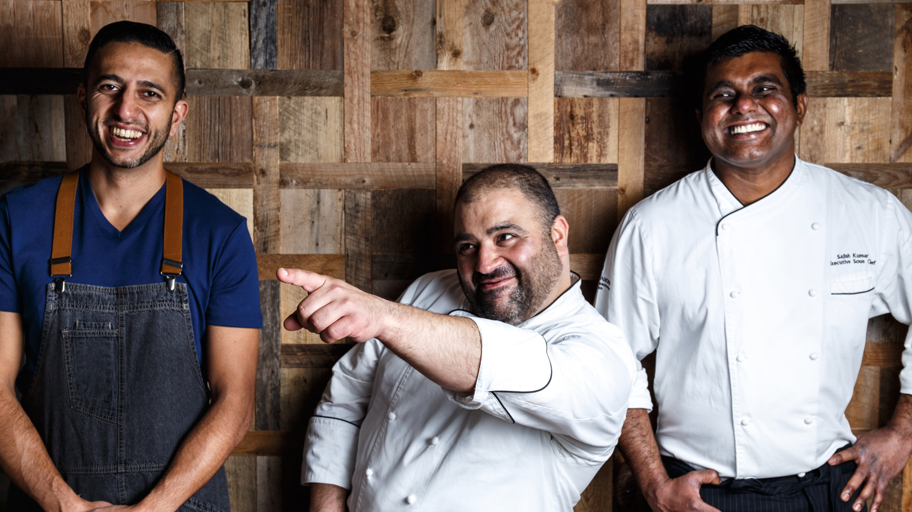 | October 26, 2020, Whistler, Canada  Four Seasons Resort and Residences Whistler Announces the Highly-Anticipated Braidwood Tavern  https://publish.url/whistler/hotel-news/2020/new-braidwood-tavern.html

PRESS CONTACTS

Carolina Pires
Marketing Coordinator
4591 Blackcomb Way
Whistler
Canada
carolina.pires@fourseasons.com

+1 604 967 1869

