Make Eid Al-Adha Memorable at Four Seasons Hotel Bahrain Bay

Delectable dining experiences, family-friendly fun and outstanding accommodation packages promise a joyous celebration for guests at the luxury hotel in the heart of the Kingdom’s capital
August 10, 2018, Bahrain Bay, Bahrain

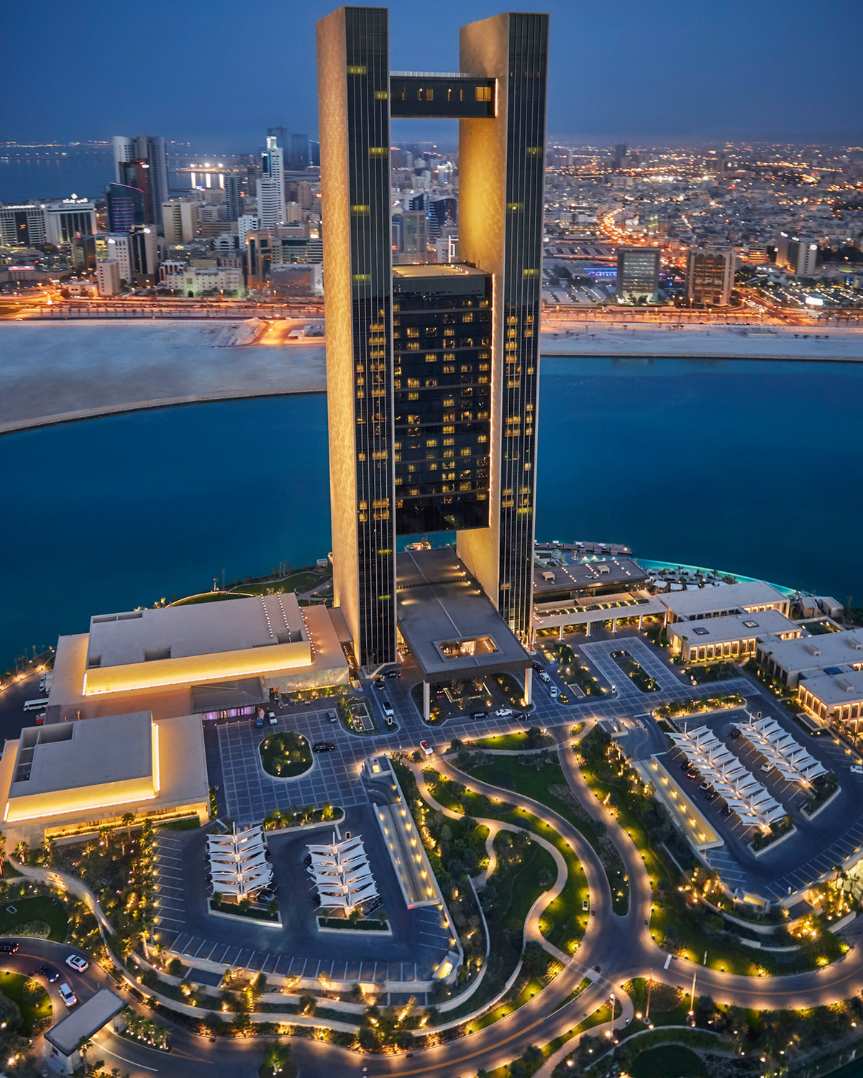
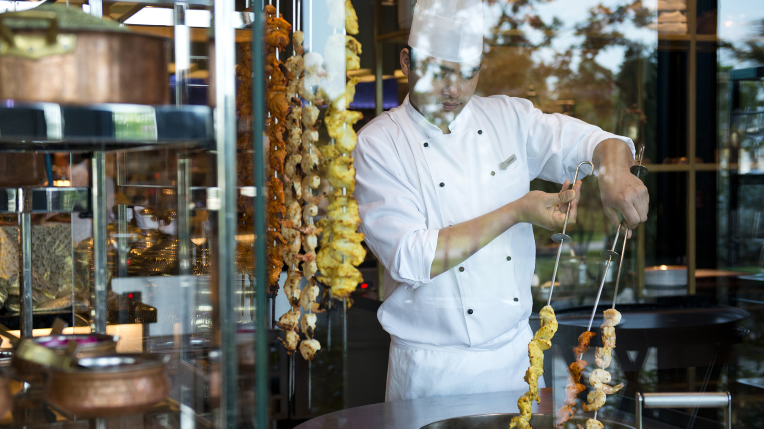 | 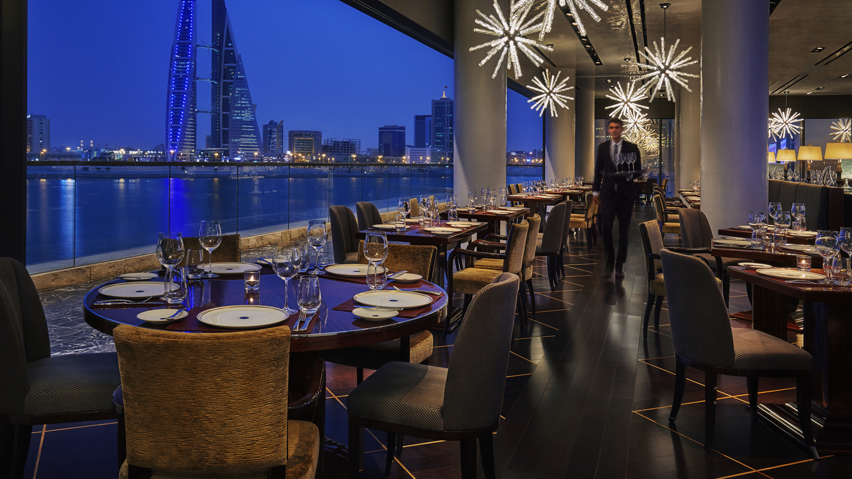 | 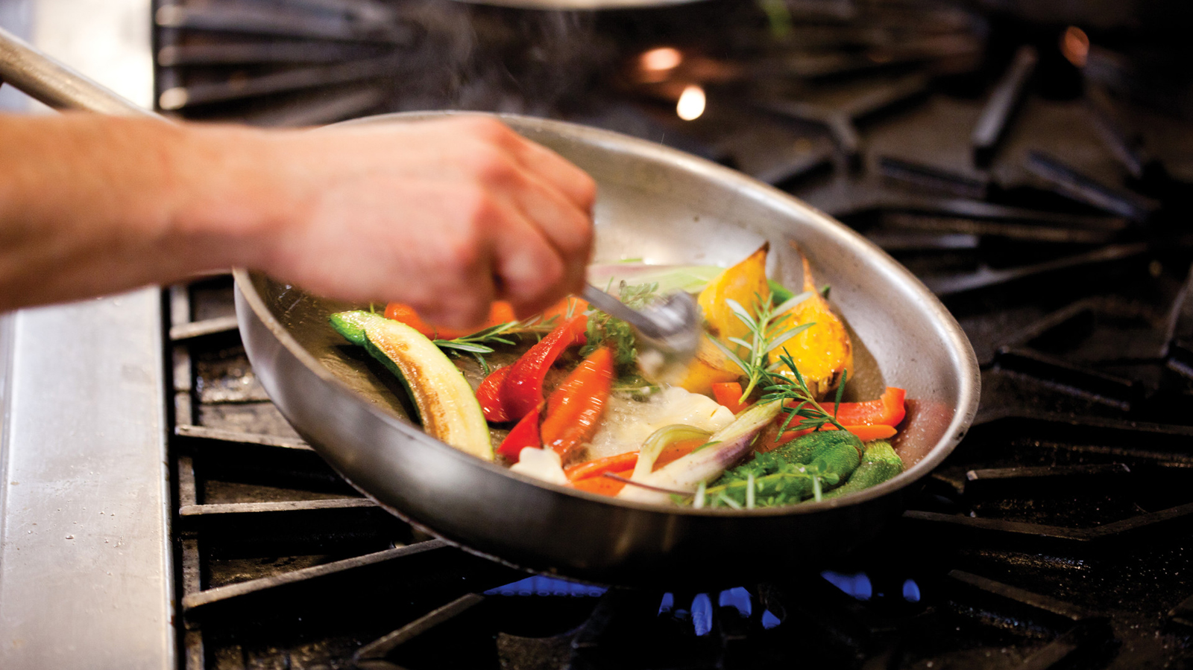
As the joyous festival of Eid Al-Adha approaches, Four Seasons Hotel Bahrain Bay has unveiled an array of exceptional offerings for guests to spend precious moments together and create cherished memories during this special time of year. The stylish five-star property will be serving up enticing culinary fare at its Eid Brunch Extravaganza, a delightful day for kids with a traditional Heya Beya celebration and outstanding accommodation packages that allow guests to make the most of the festivities.
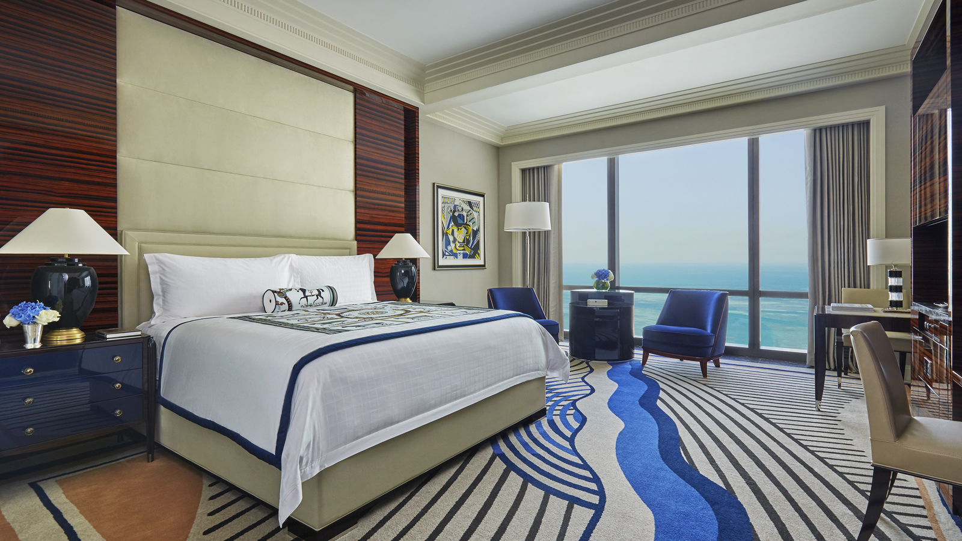
Celebrate the Arrival of Eid with a Feast to Remember
The Hotel extends a warm invitation for guests to welcome Eid Al-Adha together with family and friends at a special 4-day Eid Brunch Extravaganza at Bahrain Bay Kitchen. Executive Chef Hyung Gyu Kim is preparing an extensive gourmet buffet to mark this holiest of occasions, which will feature a traditional goat carving station as its centrepiece. Diners can also enjoy a diverse feast of regional and global specialities, including hot and cold mezze items, a sushi station and salad bar, generous buffet setups with dedicated live cooking stations, a Moroccan tagine island, homemade pasta station and an Asian section.
Guests with a sweet tooth will appreciate the rich dessert buffet, which offers a selection of family favourites including specialities from Pastry Chef Imad Boukli, all rounded off with a free-flowing chocolate fountain. In keeping with the spirit of giving associated with Eid, a delicious box of traditional Bahraini sweets will also be presented to each table for guests to take home and enjoy with their family. The authentic festive ambience will be completed with live entertainment from talented musicians.
The Eid Brunch Extravaganza will take place each day at Bahrain Bay Kitchen from Tuesday, August 21 to Friday, August 24, 2018 between 1:00 and 4:00 pm. The event costs BHD 25 per adult. Children below five years eat free, while kids between six and 12 years will receive 50 percent savings.
Enjoy Seasonal Treats at CUT by Wolfgang Puck
Guests can celebrate the arrival of Eid with a delicious meal at the Hotel’s exquisite fine dining restaurant CUT by Wolfgang Puck. Helmed by Executive Chef Brian Becher, this stylish steakhouse concept is the perfect spot to gather with family and friends. To mark the occasion, Chef Pierre Chambon has created a unique seasonal dessert – summer berry kunafa with herbed ricotta ice cream – which promises an unmissable treat.
CUT by Wolfgang Puck is open for dinner from 7:00 pm daily.
Traditional Fun for All the Family
Young guests will love the Hotel’s Heya Beya event on the second day of Eid. Arranged by the Kids For All Seasons club, this traditional Bahraini ritual will see the shores of the city crowded with children wearing colourful traditional clothes. This delightful part of the Eid Al-Adha celebrations takes place on the second day of Eid in Bahrain Bay Kitchen restaurant, together with a kids fashion show. Entertainment will include traditional Heya Beya songs with a live band, Heya Beya baskets, a trip to the garden for the basket-throwing ceremony, and the sharing of sweets to commemorate this special occasion.
Throughout the Eid weekend, kids can enjoy a range of fun activities including a bouncy castle, the waterslide in the family pool, football, water volleyball and table tennis tournaments.
For further details on the Heya Beya event, visit the Hotel's Facebook event page.
Bahrain Getaway – 20 Percent Off
Guests booking a two-night minimum stay can enjoy a 20 percent savings on the Hotel’s standard room rate with the Bahrain Getaway package. Visitors can discover ancient souqs and the world-renowned National Theatre as they explore the city, or simply unwind in the Spa or in the Hotel’s luxurious suites and guest rooms.
To book a memorable Eid experience, call Four Seasons Hotel Bahrain Bay today on (973) 1711 5000.

RELATED

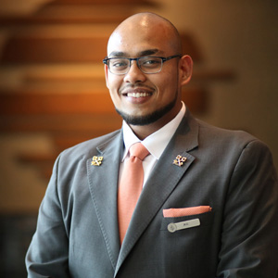 | August 1, 2018, Bahrain Bay, Bahrain  Four Seasons Hotel Bahrain Bay Now Has Three Certified Les Clefs d'Or Members, Making It the Most Qualified Hotel Concierge Team in the Region  https://publish.url/bahrain/hotel-news/2018/three-les-clefs-dor-members.html
August 1, 2018, Bahrain Bay, Bahrain
الكونسييرج في فندق فورسيزونز خليج البحرين يتألق على مستوى الشرق الأوسط مع حصول ثلاثة من الفريق على التقدير الدولي المرموق لعضوية "Les Clef d’Or" – المفتاح الذهبي
https://publish.url/ar/bahrain/hotel-news/2018/three-les-clefs-dor-members-2.html

PRESS CONTACTS

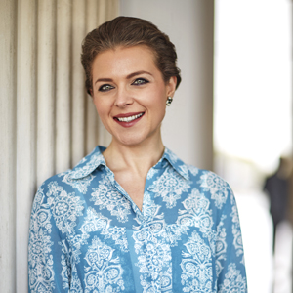 | Veronika Szabo  Director of Public Relations and Communications  Bahrain Bay, PO Box 1669  Manama  Kingdom of Bahrain  veronika.szabo@fourseasons.com  (973) 1711 5000

