Open Up to Deeper Love This Valentine’s Day with The Love Awakening Event at the Spa at Four Seasons Hotel Los Angeles at Beverly Hills

The Love Awakening Event, a multi-sensory evening of meditation, breath work and sound with wellness experts Deganit Nuur and Nish Fox, will awaken the senses to deep connection, trust, self worth, sensuality and self-love
February 2, 2019, Los Angeles at Beverly Hills, U.S.A.

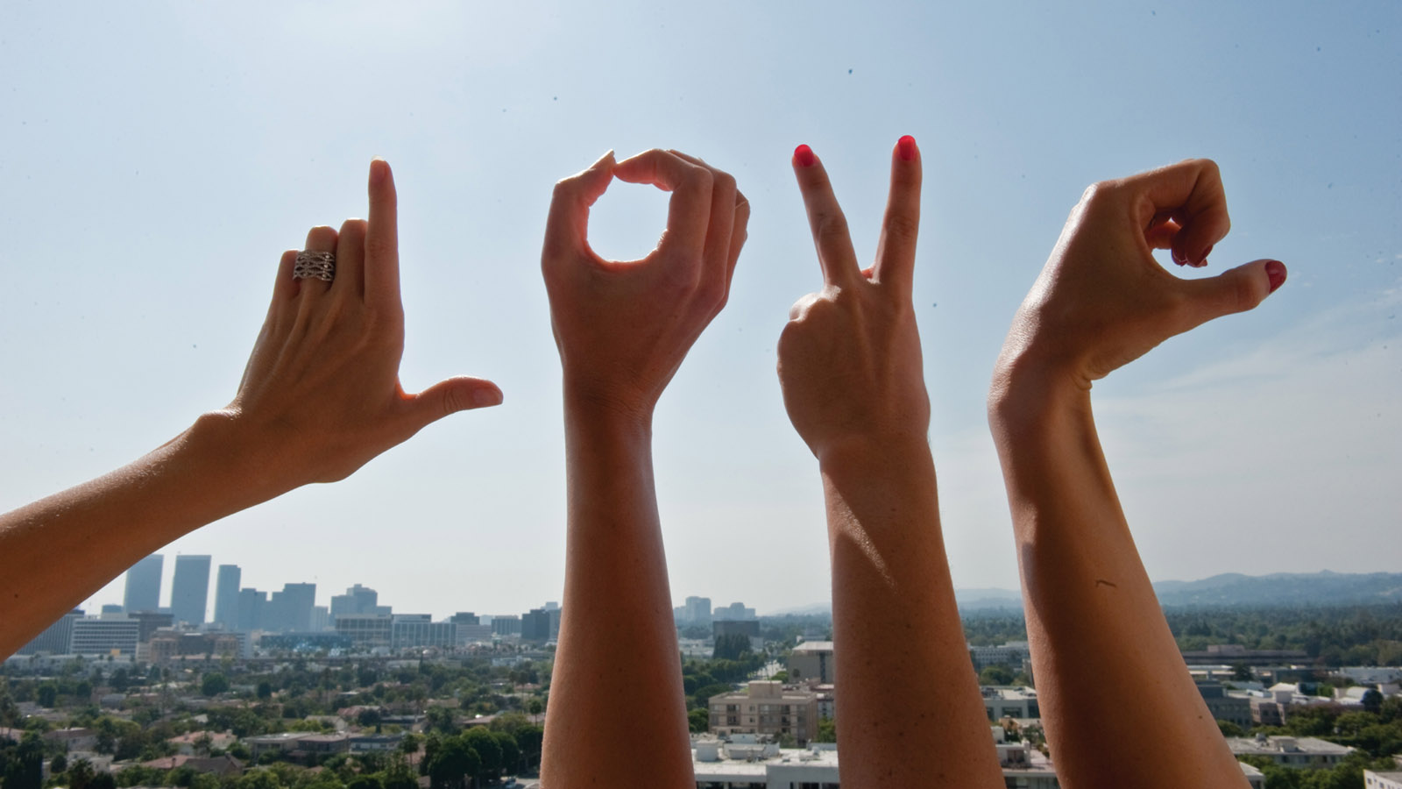
The Spa at Four Seasons Hotel Los Angeles at Beverly Hills introduces The Love Awakening Event as a deeply healing and transformative evening. After opening up to love, participants will be able to energetically invite in and attract their ideal romantic partner, remove the obstacles and negative patterns that hold them back from high levels of love vibrations, and deepen the intimate connection with their partner. The event is priced at USD 55 per person and will take place at 5:30 pm on February 14, 2019.
The Love Awakening Event begins with Deganit Nuur, a clairvoyant intuitive and meditation instructor, guiding participants in retraining the brain to accept and receive the intimacy, support and passion that they deserve. Nish Fox, a sound and energy healer, will then offer a deeply relaxing, hypnotic and healing breathwork sound bath. After the heart has been opened through the 90-minute session, participants will have the opportunity to enjoy a conscious cocktail and bottle their euphoria up in the creation of a custom love potion made of therapeutic essential oils.
The evening’s activities have been designed to shift energy that can be felt at different levels. Benefits include stress and anxiety relief, quieting of mental chatter, deeper connection to oneself and intuition, strengthening emotional balance, and improved sleep quality. Participants can also expect to achieve a greater ability to focus, improved memory and medical benefits including reduction of chronic pain, reduced blood pressure, lower cholesterol and decreased risk for heart disease and stroke.
“This event will be inspiring and uplifting, whether you are single or partnered,” says Magdaleena Nikolov, Director of Spa at Four Seasons Hotel Los Angeles at Beverly Hills.
Reservations may be booked by calling 310 273 2222.

RELATED

January 28, 2019, Los Angeles at Beverly Hills, U.S.A.
Immerse in Roses This Valentine's Day with the New 1,000 Roses Facial at the Spa at Four Seasons Hotel Los Angeles at Beverly Hills
https://publish.url/losangeles/hotel-news/2019/valentines-day.html

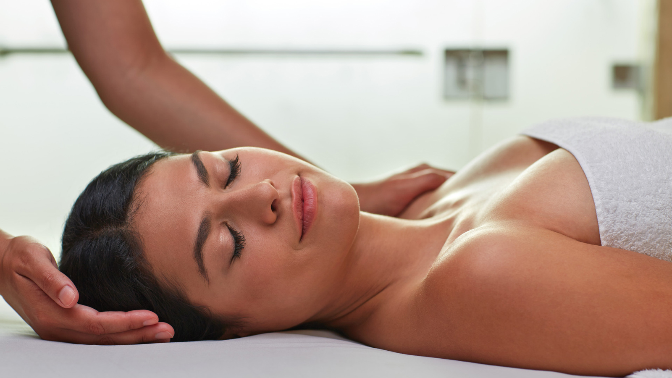 | January 22, 2019, Los Angeles at Beverly Hills, U.S.A.  Turn Back Time for Ageless Beauty with the New Liquid Surgery Facial at the Spa at Four Seasons Hotel Los Angeles at Beverly Hills  https://publish.url/losangeles/hotel-news/2019/liquid-surgery-facial.html

PRESS CONTACTS

Melanee Shale
Digital Marketing Manager
300 South Doheny Drive
Los Angeles
U.S.A.
melanee.shale@fourseasons.com

+1 (310) 786-2217

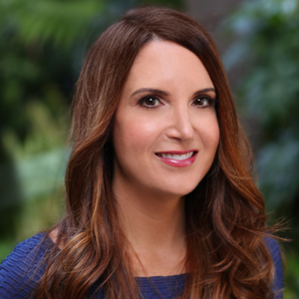 | Kim Kessler  Director of Public Relations  300 South Doheny Drive  Los Angeles  U.S.A  kim.kessler@fourseasons.com  1 (310) 786 2212

