FOUR SEASONS Mexico City
Tel: 52 (55) 5230-1818 Email: press@fourseasons.com

OPENING DATE: March 1994
GENERAL MANAGER: Tulio Hochkoeppler

Physical Features
Total Number of Rooms: 240
- Guest Rooms: 200
- Suites: 40
Number of Stories: 8
Design Aesthetic:
- Hacienda style, built around a quiet garden courtyard
- Renovated in 2015 with contemporary touches
Architect: Wimberly, Allyson, Tong and Goo

Spa and Wellness
Spa Services
- Treatment rooms: 2
- Spa treatments also available in guest rooms
Pools:
- Number of Pools: 1
Fitness Facilities:
- Size: 180 sq m / 1,938 sq ft
- Special Features: Overlook sun deck and outdoor pool

Dining
Executive Chef: Gerardo Maniscalco
Executive Pastry Chef: Laura Rodríguez
Restaurant: Zanaya

Recreation
Local Experiences - click here for details:

Meeting Rooms
Total Size: 1,122 sq m / 12,084 sq ft
Largest Ballroom: 393 sq m / 4,230 sq ft
Meet and Feed Capacity: 500
Banquet Capacity: 320
Breakout Spaces: 12
Private Dining Room Capacity: 20
- Unique Meeting and Event Facilities: Most meeting rooms open onto the peaceful interior courtyard

Special Features
Courtyard: The formal garden in the interior courtyard features fruit trees, tropical plants, and Mexican folk art
Childcare Services: Babysitting and childcare services for families traveling with children.
Pet-Friendly Accommodations: Pet-friendly rooms and services for guests traveling with their pets.

PRESS CONTACTS
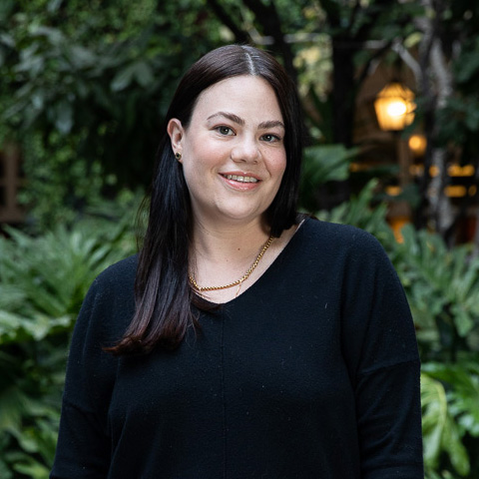 | Daniela Dibildox  Public Relations Manager  Paseo de la Reforma Ave. 500,  Mexico City  Mexico  daniela.dibildox@fourseasons.com  +52 (55) 5230-1818
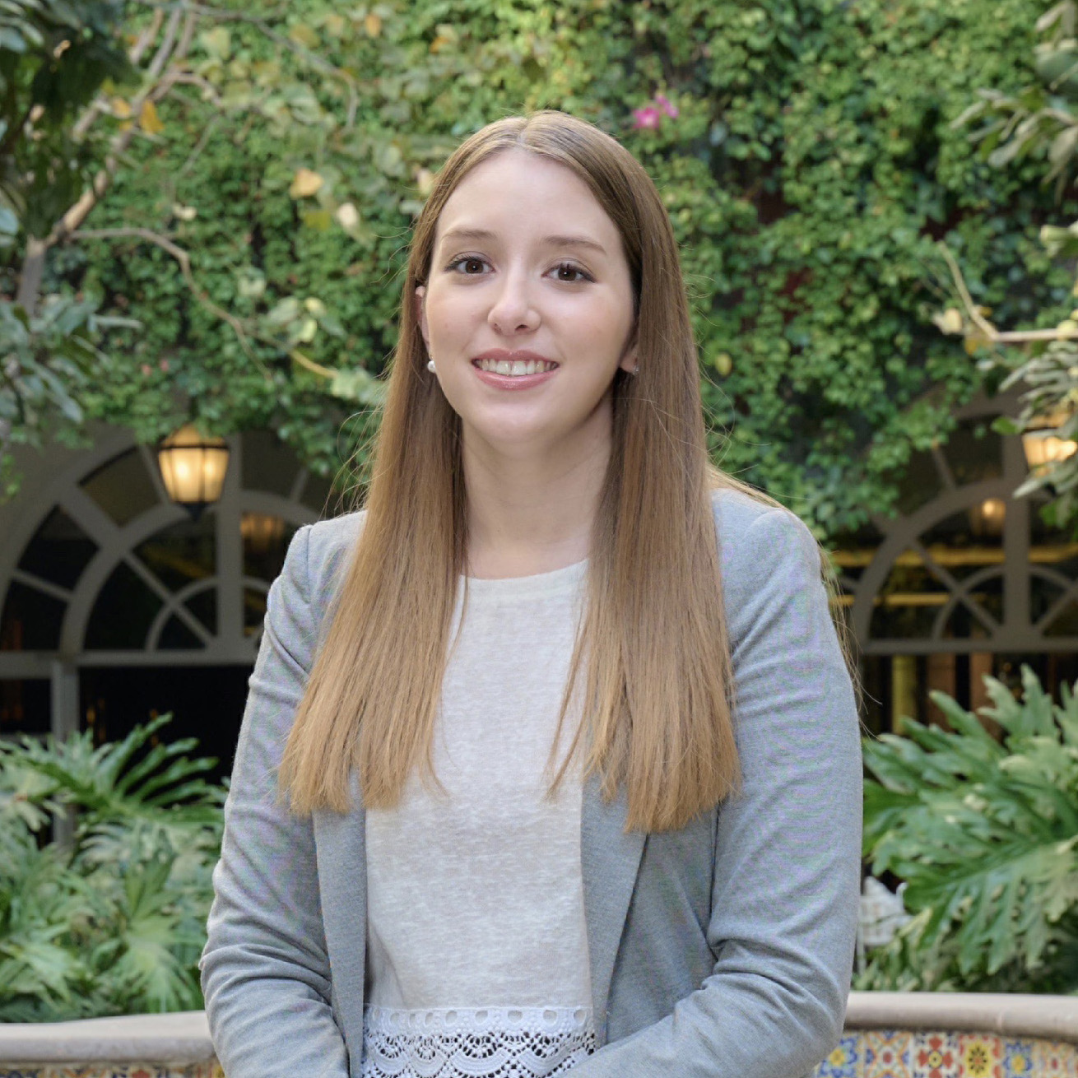 | Renata Garrido  Marketing Coordinator  Paseo de la Reforma Ave. 500,  Mexico City  Mexico  renata.garrido@fourseasons.com  +52 (55) 5230-1818

