An Epicenter of Culinary Excellence: Jean-Georges Vongerichten and Greg Vernick to Open at Four Seasons Hotel Philadelphia at Comcast Center

Two acclaimed chefs bring four new dining experiences to Philadelphia’s acclaimed culinary reputation
July 22, 2019, Philadelphia, U.S.A.

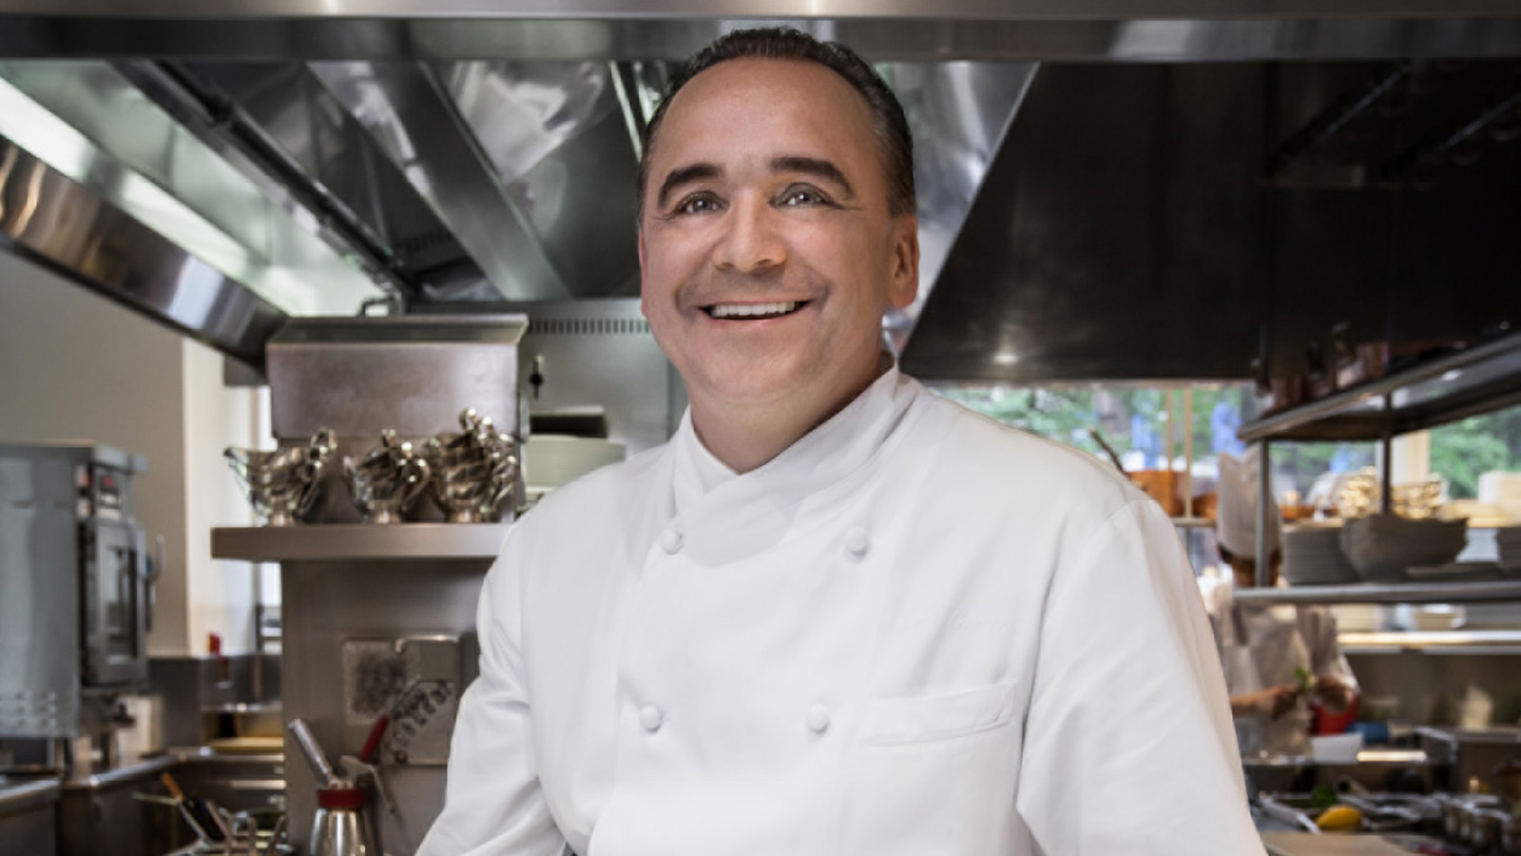
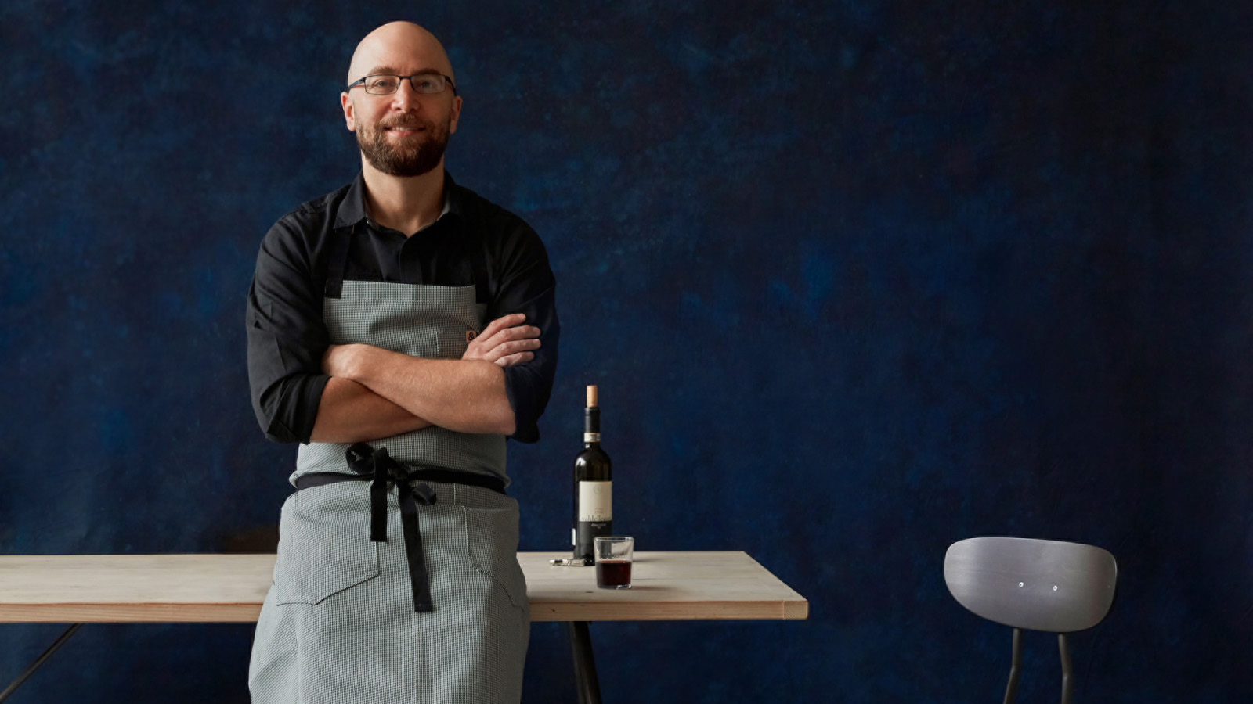 | 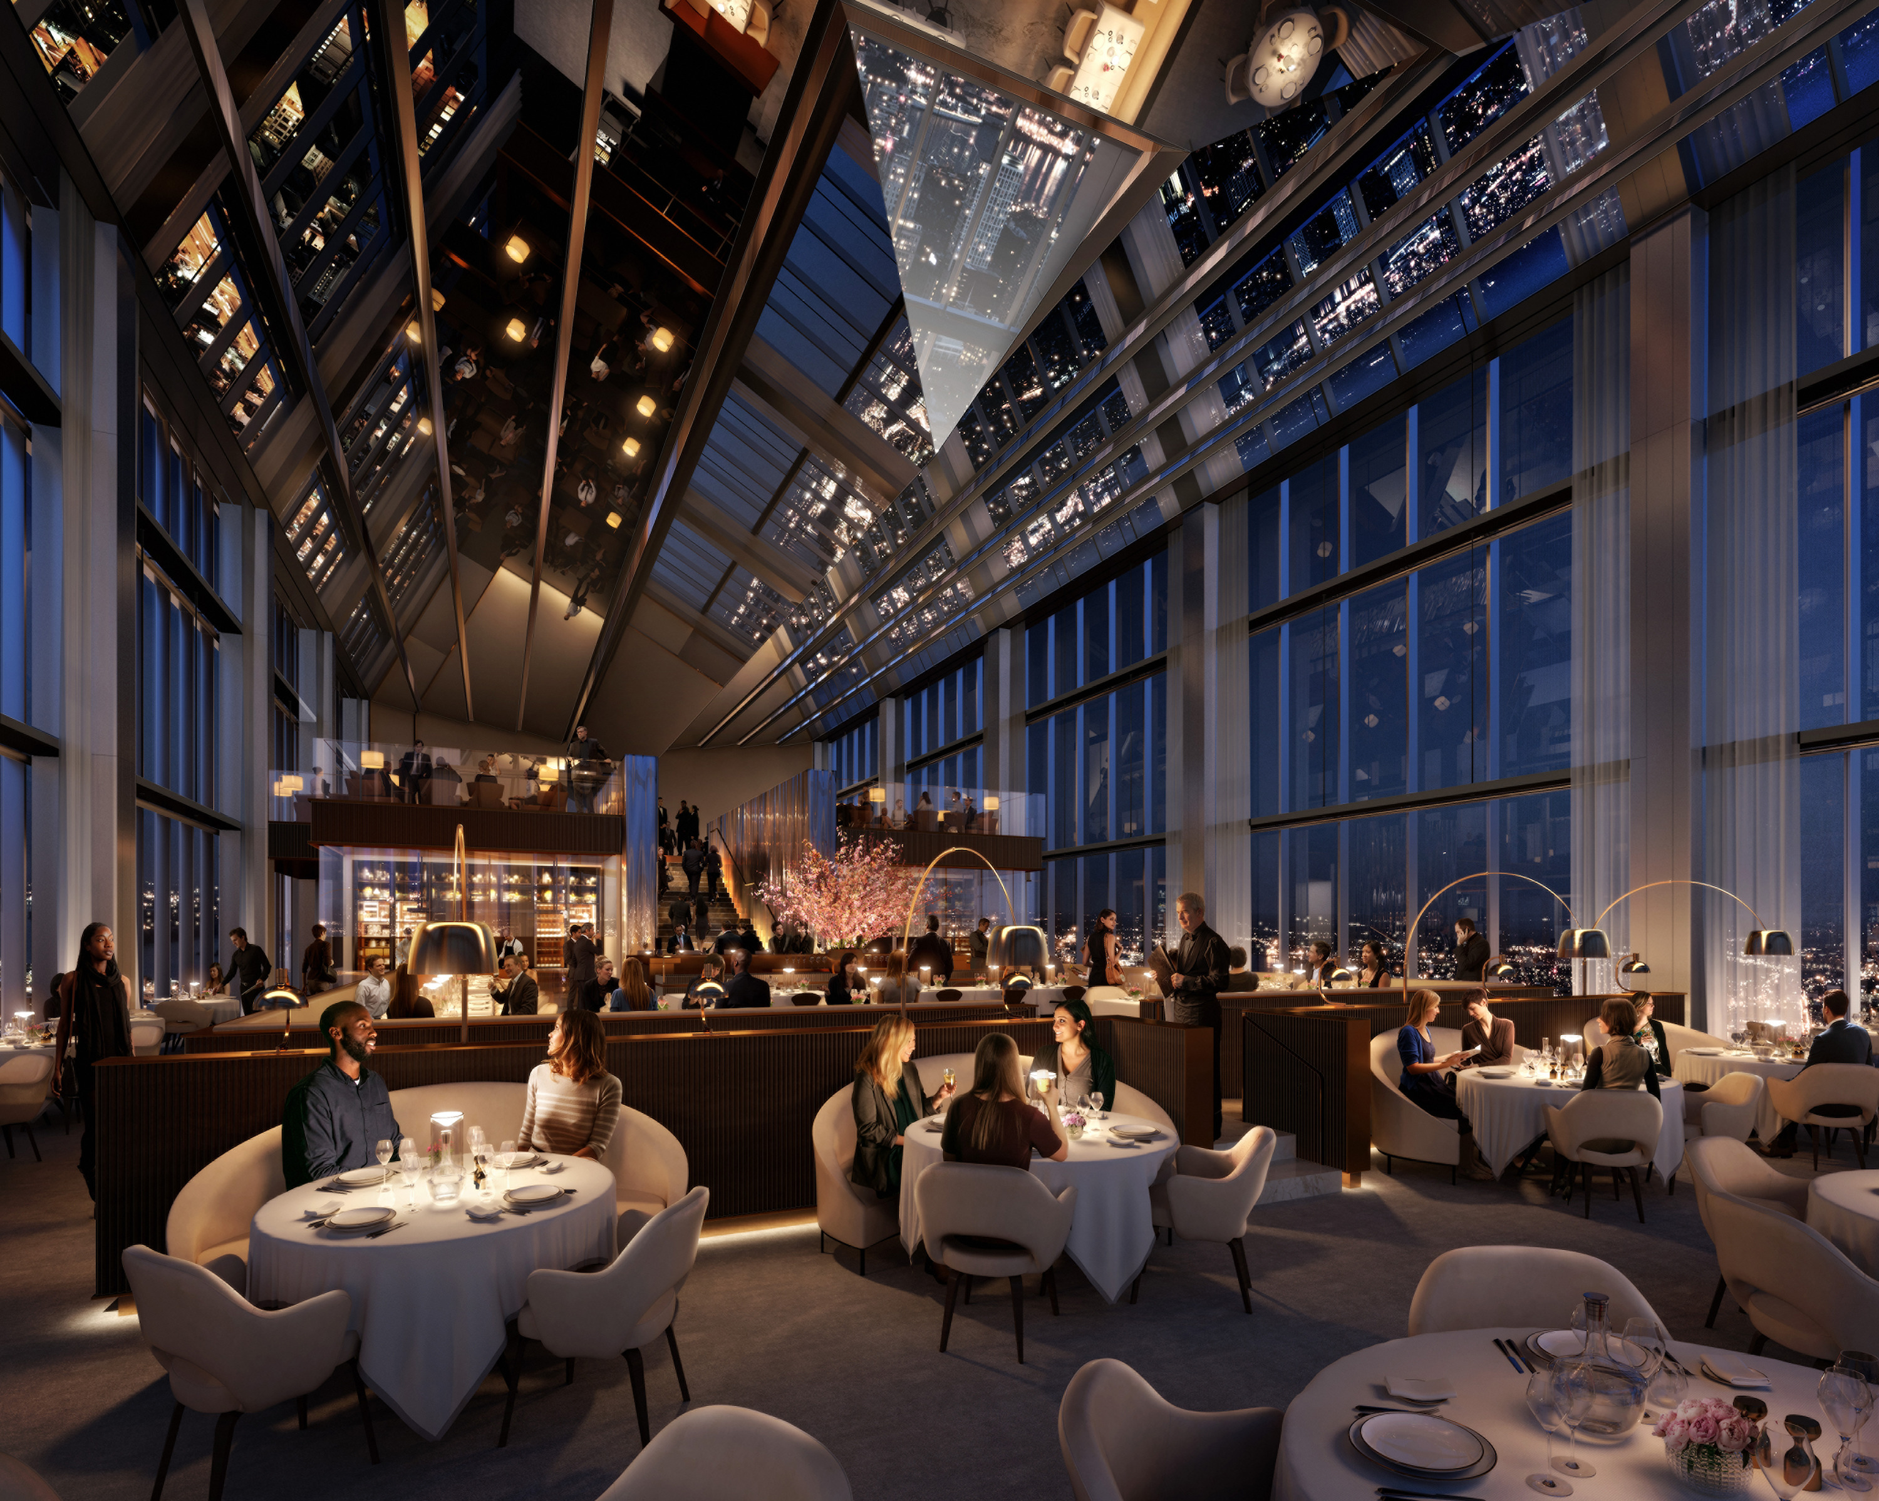 | 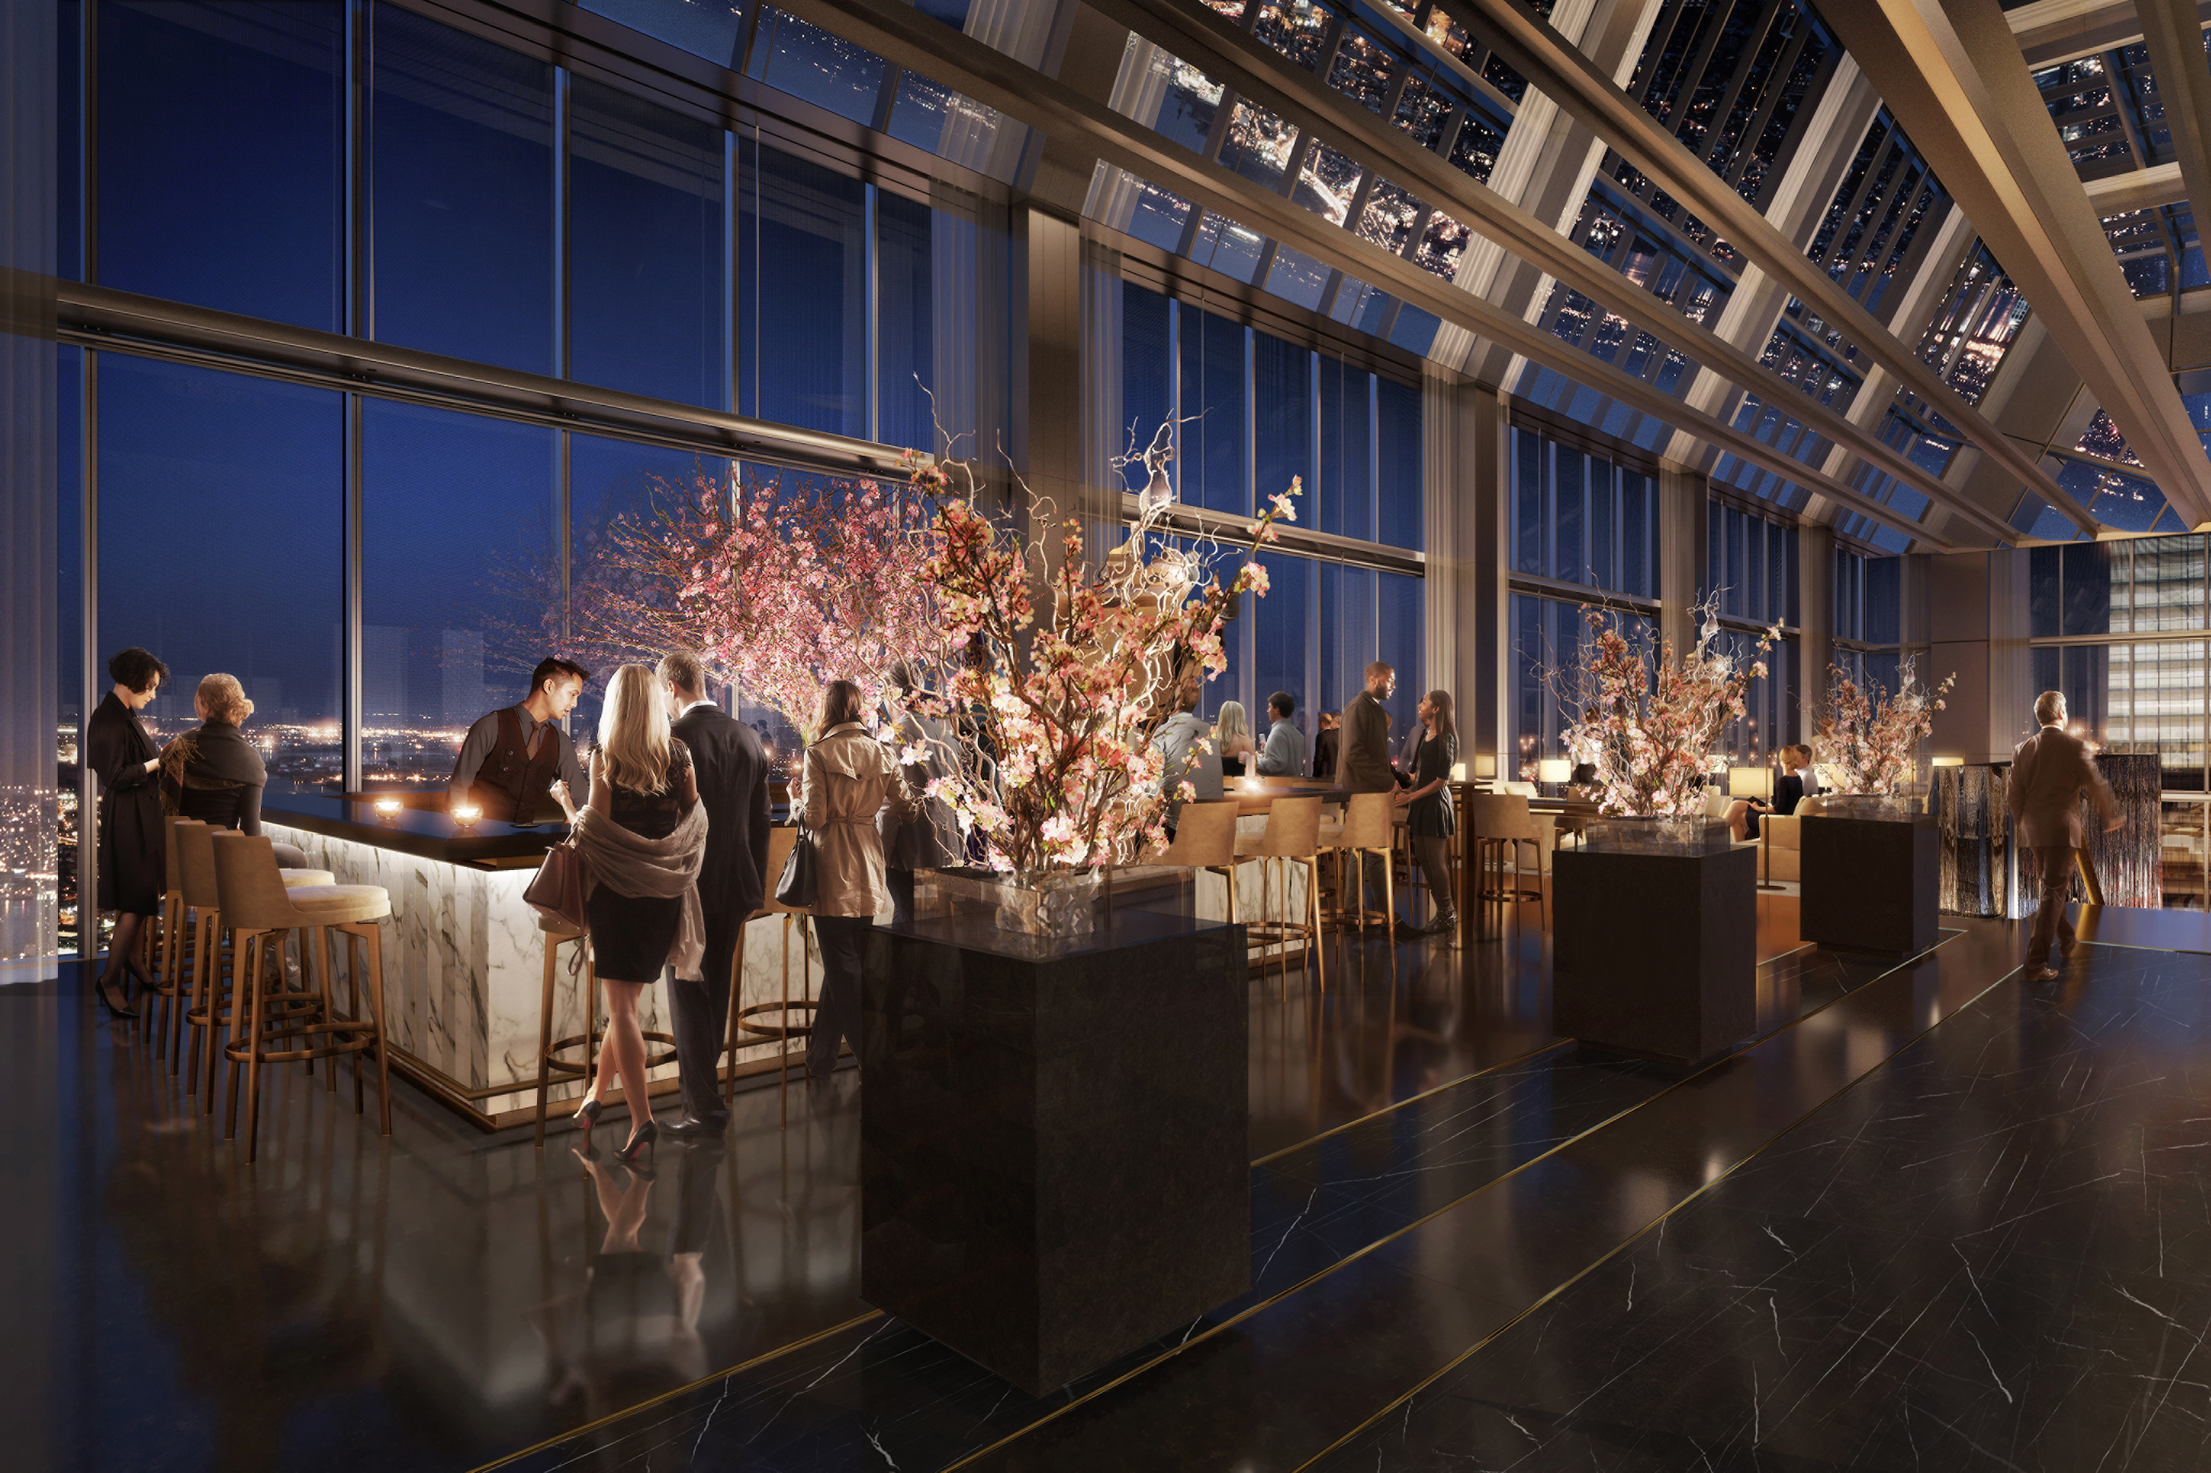
Four Seasons Hotel Philadelphia at Comcast Center has partnered with two renowned chefs to offer four distinct dining experiences in vibrant Center City, all scheduled to open on August 12, 2019: Jean-Georges Philadelphia and JG SkyHigh from Michelin starred Chef Jean-Georges Vongerichten; and Vernick Fish and Vernick Coffee Bar from James Beard Award winner Chef Greg Vernick.
“With Jean-Georges and Greg Vernick, Four Seasons Hotel Philadelphia will offer one of the most distinguished hotel offerings in the nation, and I’m looking forward to adding to Philadelphia’s amazing culinary scene,” adds Ben Shank, the Hotel’s General Manager, whose Four Seasons career began in the city 20 years ago.
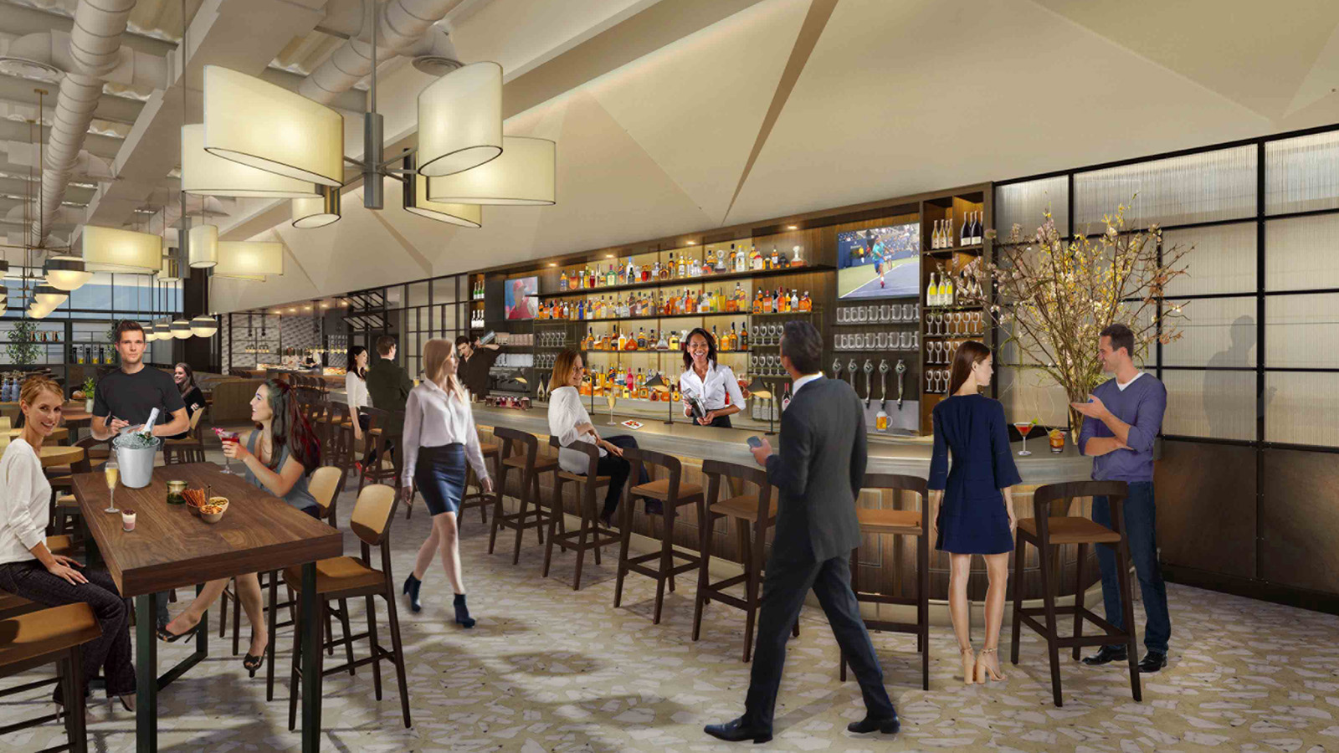 | 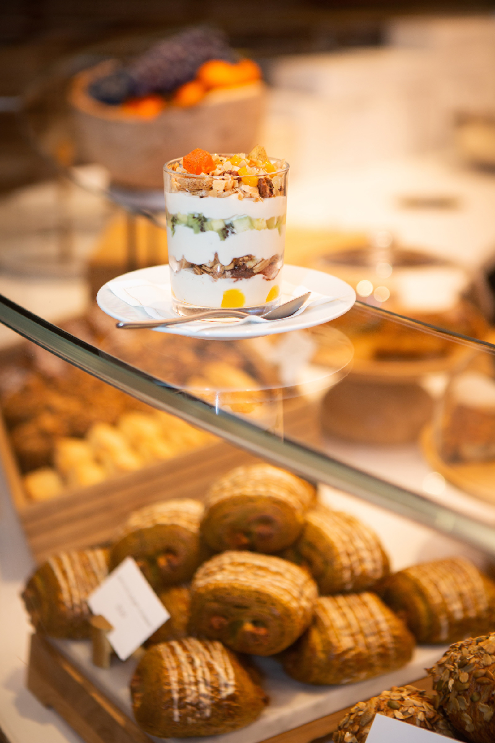
Redefining “Elevated”: Jean-Georges Philadelphia
Designed by Norman Foster of Foster + Partners, star Chef Jean-Georges Vongerichten presents a new culinary destination. On the 59th floor, Jean-Georges Philadelphia will offer exciting new dishes uniquely developed for Philadelphia, along with some must-have classics from his flagship New York restaurant. With 40-foot-high (12 metre) floor-to-ceiling windows, the panoramic city views set a dramatic backdrop to a dynamic menu. The restaurant will offer power breakfast, and à la carte and prix-fixe menus for lunch. Dinner options will include à la carte, prix-fixe and tasting menus.
“This is a menu that I am very excited to bring to Philadelphians. I am thrilled to be joining this culinary community, and am delighted to make Four Seasons my home in Philadelphia,” says Vongerichten.
A grand staircase flanked by waterfall features leads to Philadelphia’s new premier cocktail destination, JG SkyHigh. Here the menu features a selection of small plates meant to compliment the bar offerings. In this modern, comfortable space, enjoy Jean-Georges’ greatest hits as the mirrored ceilings flood the space with sunset colours followed by sparkling skies. In addition to wines by the glass and craft beers on tap, the cocktail menu features an exciting selection of JG classics and new creations.
Chef de Cuisine Nicholas Ugliarolo helms the kitchen at Jean-Georges Philadelphia. A native New Englander, Ugliarolo has been a part of the Jean-Georges team since 2012.
From the Ground Up: Vernick Fish
Bookending the dining experience is Vernick Fish on the ground floor. The 3,400 square foot (315 square metre) space created by Tihany Design will seat 200 guests across a main dining area, private dining room, an extensive bar, chef’s counter, and seasonal outdoor patio. Guests will be transformed as they step past a cool zinc bar towards the Mediterranean blue tiles and plush banquette seating.
Vernick Fish, helmed by Philadelphia’s own Chef Greg Vernick working alongside Chef de Cuisine Drew Parassio, will highlight a seasonally inspired and seafood-focused menu. Similar to his flagship restaurant, Vernick Food & Drink, Vernick Fish will also feature global ingredients and flavours with ample vegetable options and well-selected meat entrees. Greg refers to Vernick Fish as his take on an American oyster bar, where diners enjoy pristinely raw offerings and whole-fish preparations.
“To be a part of Four Seasons Philadelphia with Jean-Georges, who I spent the early part of my culinary career with, is exactly where I belong for my next endeavour,” explains Greg Vernick. “It feels full-circle, and I look forward to welcoming Four Seasons guests in my hometown.”
Vernick Coffee Bar, also a partnership between Chef Vernick and Four Seasons, has been welcoming guests on the second floor lobby of the Comcast Technology Center since opening in October 2018. This coffee bar and restaurant has already distinguished itself among Philadelphia’s vast breakfast and lunch options with its elevated offerings.
Four Seasons Welcomes Vongerichten and Vernick to Its Global Culinary Team
Jean-Georges Vongerichten and Greg Vernick worked together over a five-year span and they are the latest in a group of acclaimed chefs who are partnering with Four Seasons to present extraordinary dining experiences around the world.
Four Seasons is committed to operating some of the best restaurants and bars in the world. Hotels and resorts work with restaurant and chef partners who share the same dedication to the highest levels of crafstmanship, quality and service, which has resulted in working with some of the world’s best chefs, and creating incredible dining experiences at Four Seasons.
Reservations for Jean-Georges Philadelphia, Vernick Fish, and Vernick Coffee Bar are available with OpenTable.

RELATED

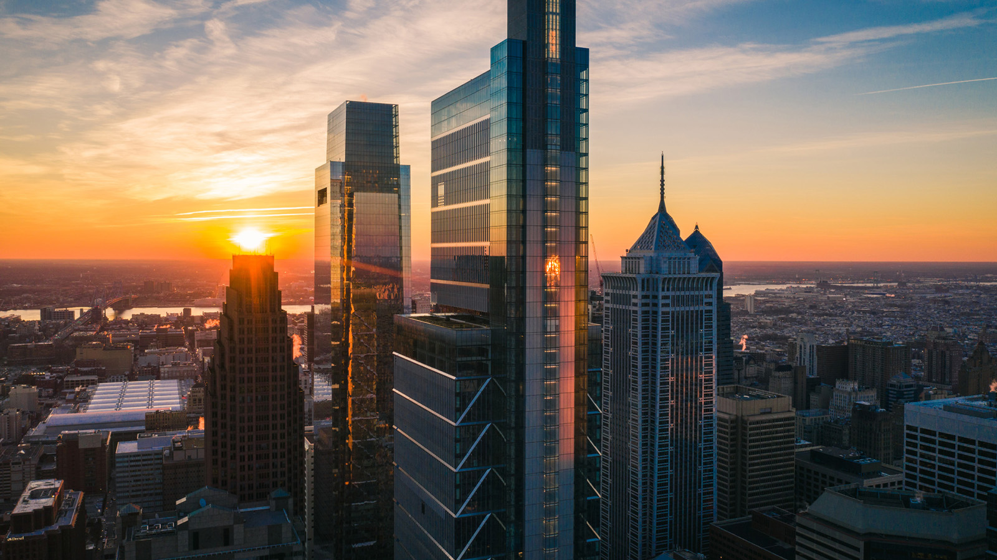 | June 5, 2019, Philadelphia, U.S.A.  Redefiniendo el paisaje urbano: Four Seasons Hotel Philadelphia at Comcast Center abre reservaciones y estará en la cima del rascacielos más alto de la ciudad  https://publish.url/es/philadelphia/hotel-news/2019/reservations-live-3.html
June 5, 2019, Philadelphia, U.S.A.
Au sommet du plus haut gratte-ciel de la ville, le Four Seasons Hotel Philadelphia at Comcast Center redéfinit la skyline de Philadelphie
https://publish.url/fr/philadelphia/hotel-news/2019/reservations-live-4.html

PRESS CONTACTS

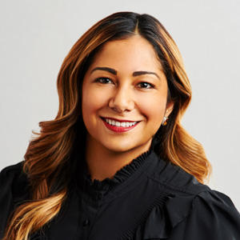 | Melissa Quinones  Director of Public Relations  One North 19 Street  Philadelphia  U.S.A.  melissa.quinones@fourseasons.com  +1 (215) 419-5033

