Four Seasons Hotel Megève Announces Its Reopening on October 20, 2022

September 6, 2022, Megeve, France

 | 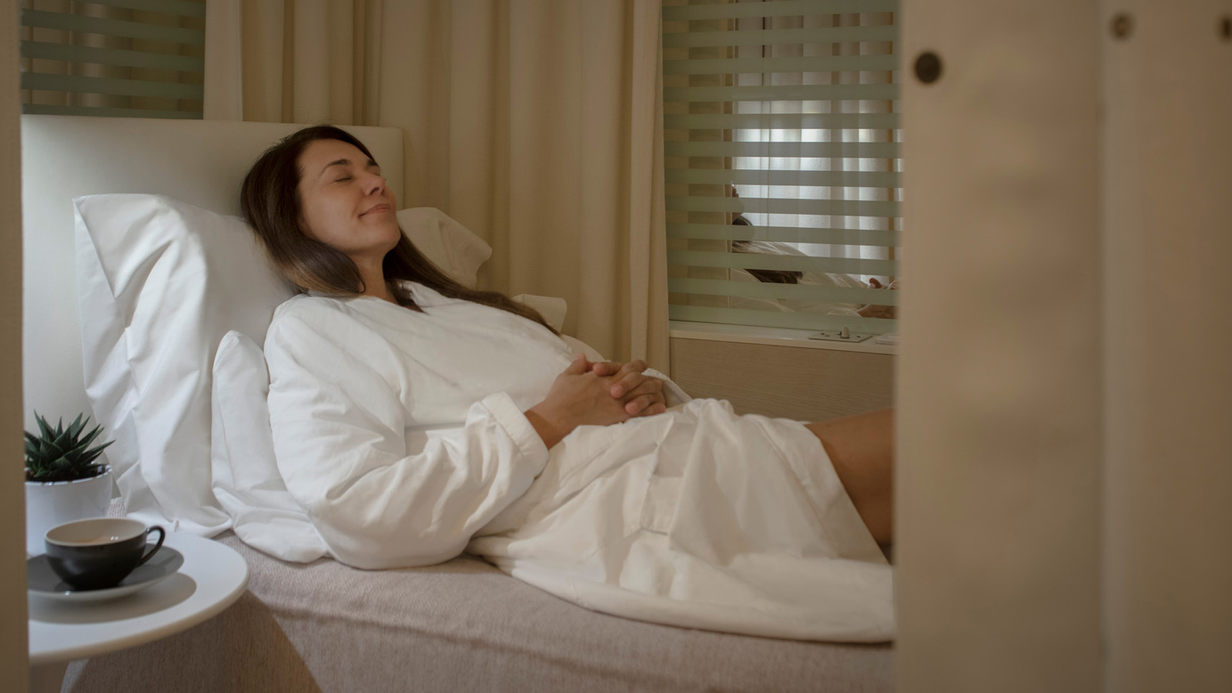 | 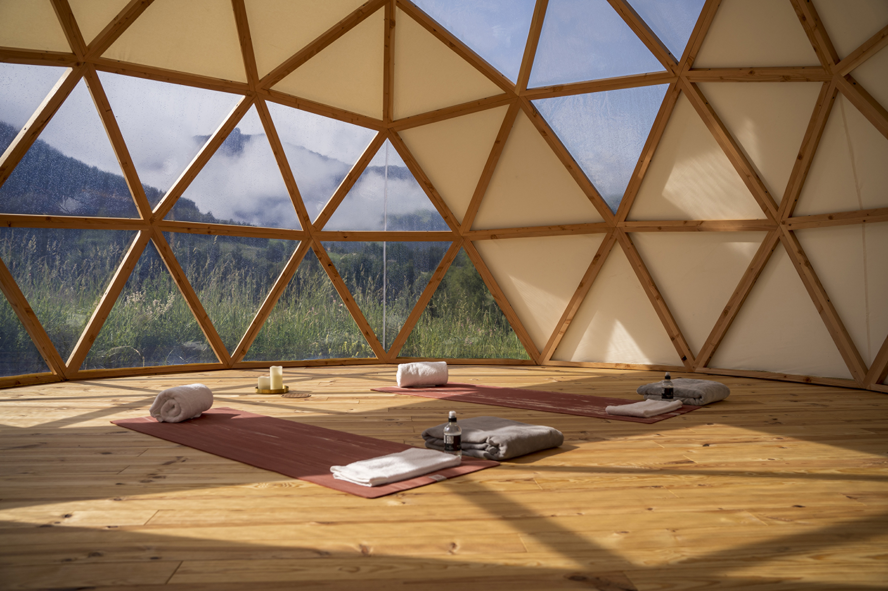
This year, All Saints holidays will be dedicated to reconnecting with nature and to escaping for a beautiful autumn break at Four Seasons Hotel Megève in the Mont Blanc region.
Reconnect the body and mind in the heart of the great outdoors
The Alps offer the perfect setting for recharging one’s batteries after a hectic back-to-school season, between autumn colours and Indian summer. On a charming hillside opposite Four Seasons Megève, the new open-air geodesic dome welcomes guests for meditation, yoga and Pilates sessions, or for treatments in an intimate setting with a breath-taking view of the mountains. As for the spa, Charlotte Ginolin, the Spa Director, and her teams have created treatments based on local plants to reconnect with the surrounding nature.
"As a native of Savoie, I have always paid particular attention to the benefits of the plants that surround me. I naturally thought of including them in our signature treatments - A Stroll Through Megève, and Alpine Glow - to offer our guests a unique sensory walk across our mountains. White fir buds, hand-picked blueberry flowers and precious edelweiss wildflowers are the basis of these invigorating treatments," says Charlotte Ginolin.
Little guests will also be able to relax with the TOO FRUIT treatments range, offering an interlude of well-being while having fun, and those in search of relaxation at the waterside will enjoy the indoor-outdoor pool heated to 28&deg;C.
An undeniable meeting place for golf lovers
Located on the heights of Megève, the 18-hole golf course of the Domaine du Mont d’Arbois is the oldest mountain golf course in the region and offers an exceptional view of Mont Joly and the Aravis mountain range. Guests can access the course on foot or by cart from Four Seasons Hotel Megève. During October and under the initiative of Matthieu Azzolin, Director of Golf, the Hotel welcomes the most competitive players for various tournaments such as the R'Shot Cup (October 2), the Parents-Children Scramble (October 8) or the Ringer Score 2022 Final (October 9) in a friendly and sporting atmosphere.
A gastronomic escape at the summit
It is in the warm setting of Kaito that guests can savour a pan-Asian Japanese fusion cuisine where the classics of the Japanese culinary art blend with other flavours from Asia, Latin America and Savoy. This includes rolls, sashimi, nigiri, not to mention the famous Reblochon tempura with blueberry-yuzu jam, a perfect illustration of the mix of flavours. A cocktail of tastes to be savoured on the sumptuous heated terrace offering a breath-taking view of the surrounding mountains, or in the interior room with its chic oriental decor imagined by interior designer Pierre-Yves Rochon.
At the end of the afternoon, Pastry Chef Jonathan Chapuy will propose his low-sugar sweets featuring seasonal fruits for a gourmet Tea Time, while talented Head Bartender Marie Picard will compose refreshing and creative cocktails based on local spirits such as Mont Blanc Gin or Chartreuse for a gustatory journey.
Happy Halloween in the mountains
Four Seasons Hotel Megève has come up with a whole program to thrill young and old alike. Redecorated for the occasion, the lobby will welcome guests for a total immersion in the world of Halloween. In the Kids Club, little guests will enjoy pumpkin carving, a costume workshop, a treasure hunt or a snuggle with the rabbits from the farm located at the entrance of the Hotel, and many more activities. Meanwhile, older children will find themselves in the intimate setting of the Teen Zone for movie screenings. The chilling atmosphere continues at the Bar Edmond with a cocktail specially designed for the occasion to be enjoyed on the sumptuous terrace with family or friends.
Experience the mountain in a different way
Underneath the freshly fallen leaves lie mushrooms ready to be cooked. Accompanied by an expert, guests can go mushroom picking in the heart of the Alps to discover all the secrets of this ancestral practice. Back at the Hotel, chefs will share personalized recipes according to each picking basket. Chanterelle, cepe or horn of plenty will season dishes and delight the palates of young and old alike.
For the more energetic, the concierges will devise a personalized itinerary starting from the Hotel on an electric mountain bike, or on foot to fill up on energy and explore the natural gems around the Hotel.

RELATED

September 6, 2022, Megeve, France
Une parenthèse automnale au cœur des Alpes avec Four Seasons Hotel Megève
https://publish.url/fr/megeve/hotel-news/2022/fall-activities-2.html

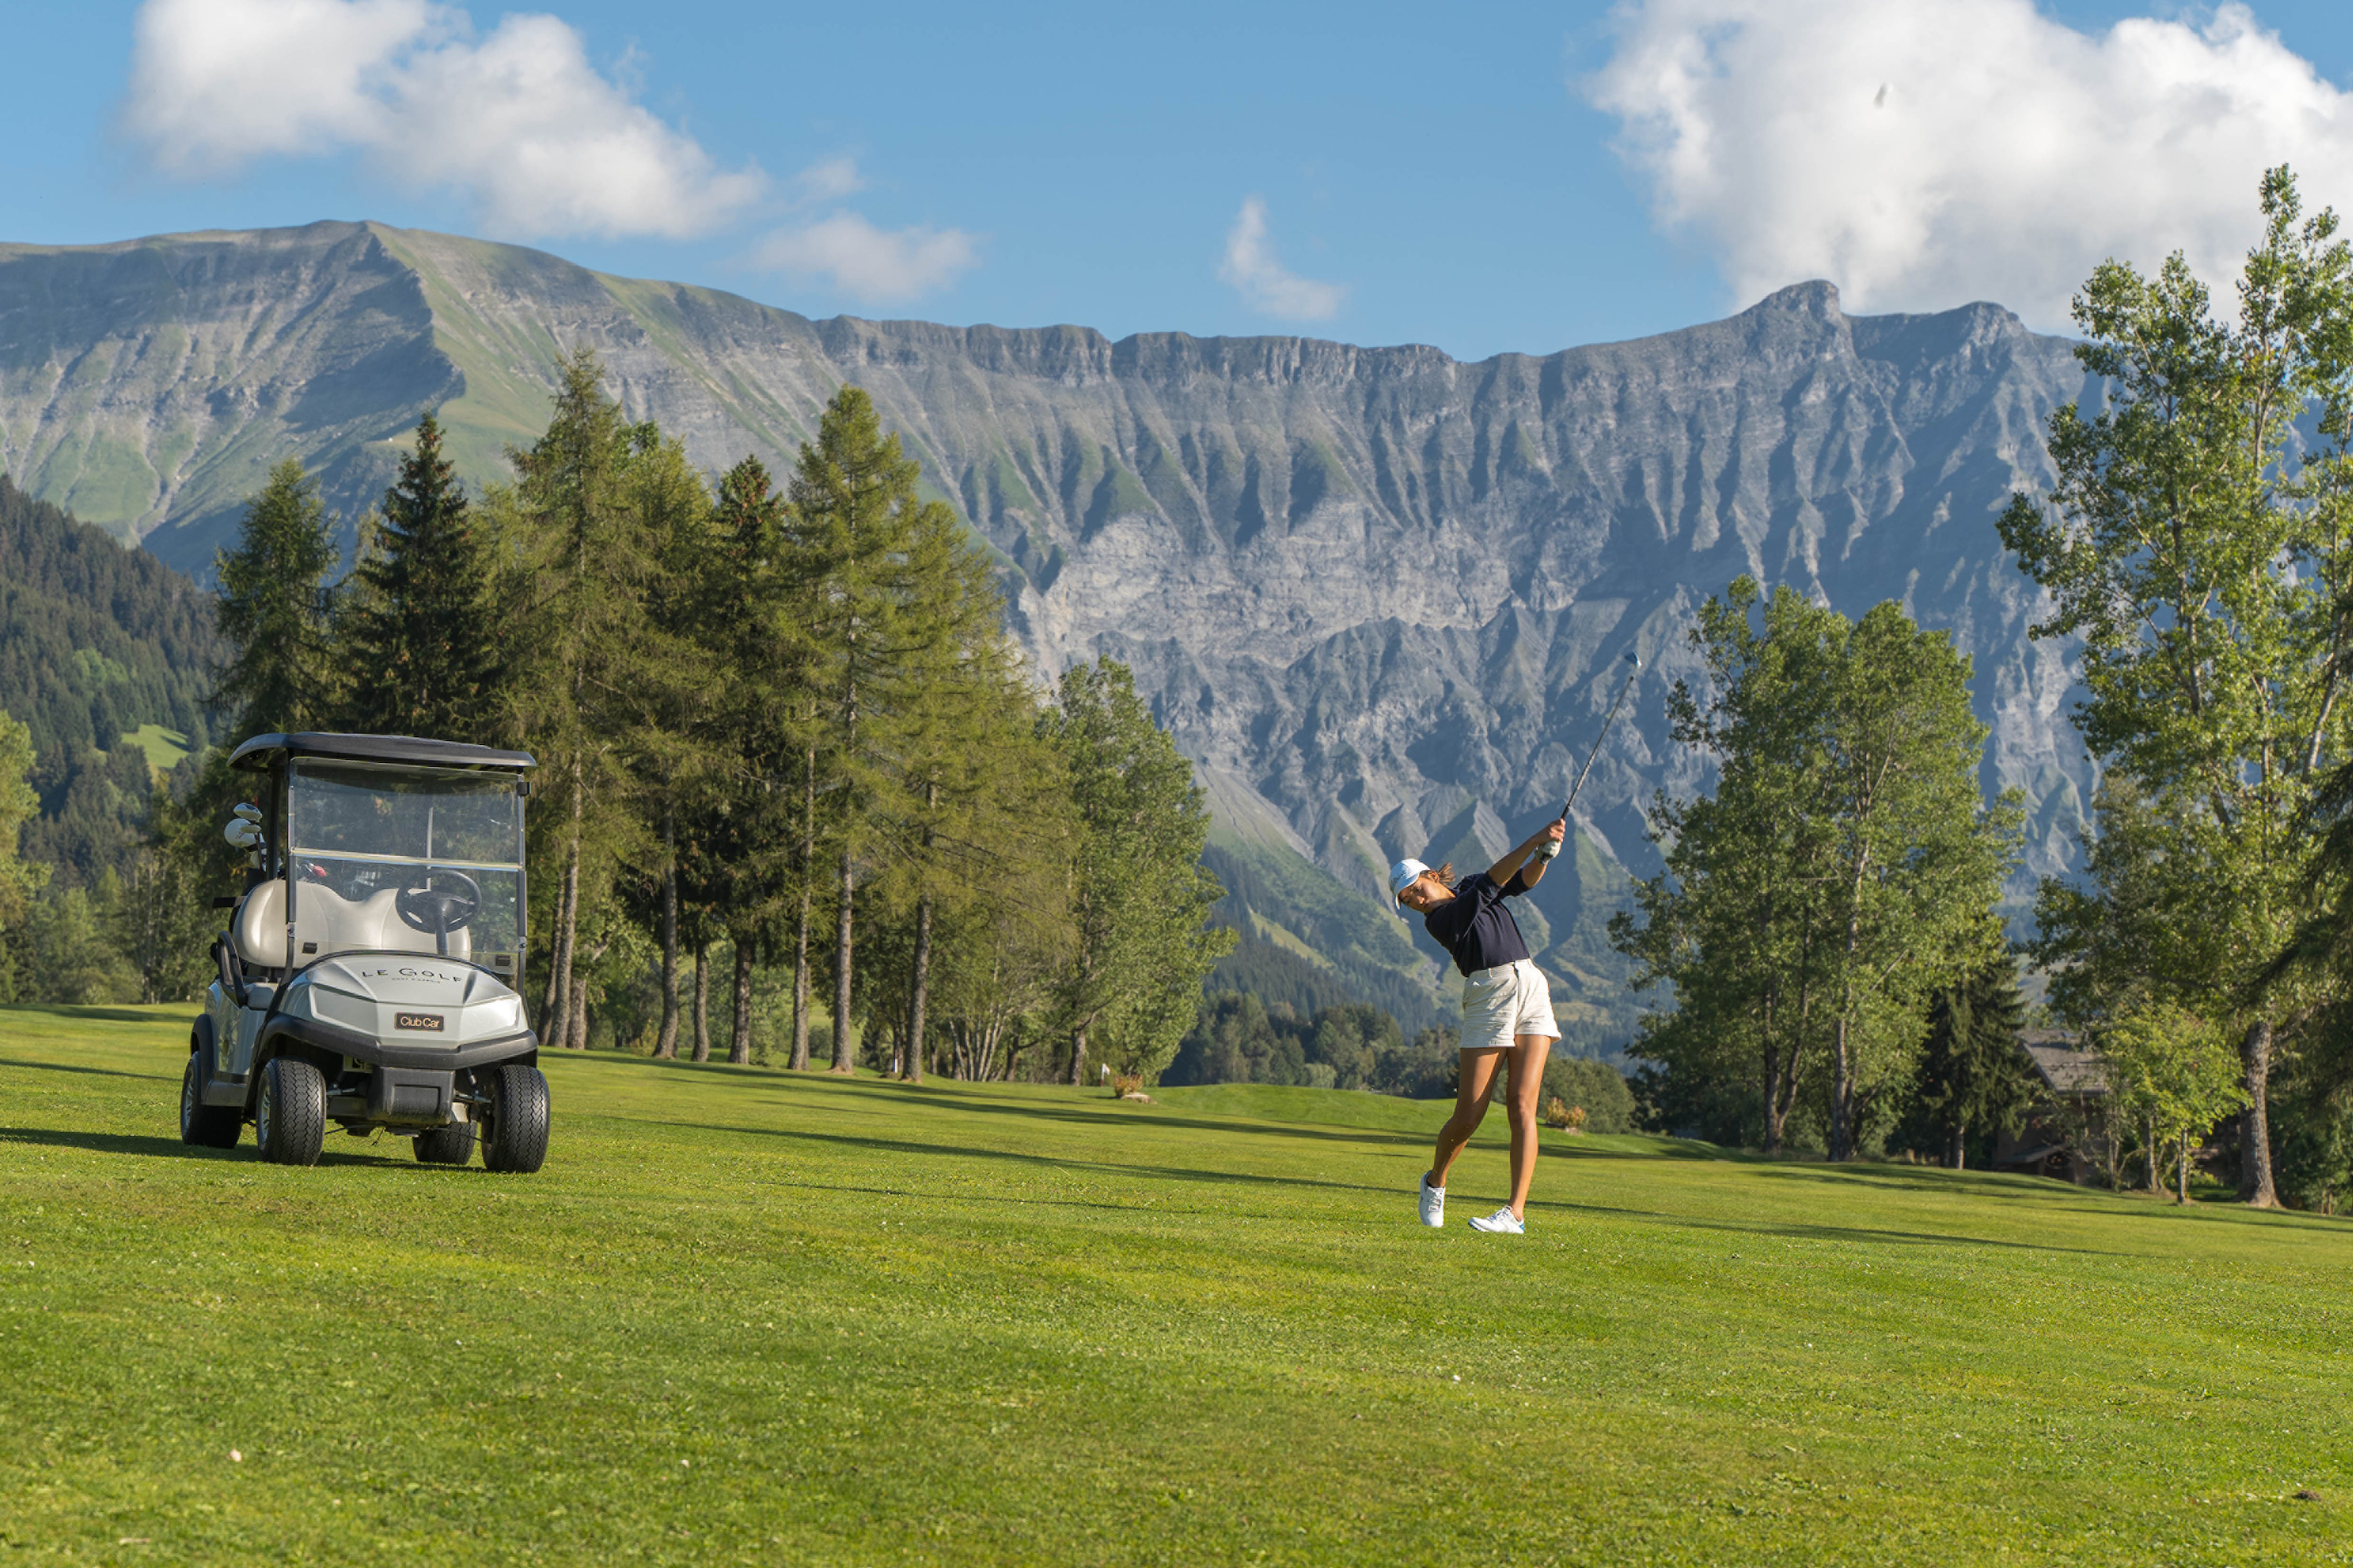 | June 9, 2022, Megeve, France  Four Seasons Megève Collection organise sa première compétition Pro-Am au Golf du Mont d’Arbois  https://publish.url/fr/megeve/hotel-news/2022/pro-am-four-seasons-megeve-collection.html

PRESS CONTACTS

Emilie Pignol
Marketing and Sales Director
3001, Route Edmond de Rothschild
Megève
France
emilie.pignol@fourseasons.com

+33 7 68 61 90 53

