Four Seasons Resort and Residences Napa Valley Debuts Private Retreats

Nestled amid scenic vineyards, wine country’s most luxurious new residences are now available
April 18, 2022, Napa Valley, U.S.A.

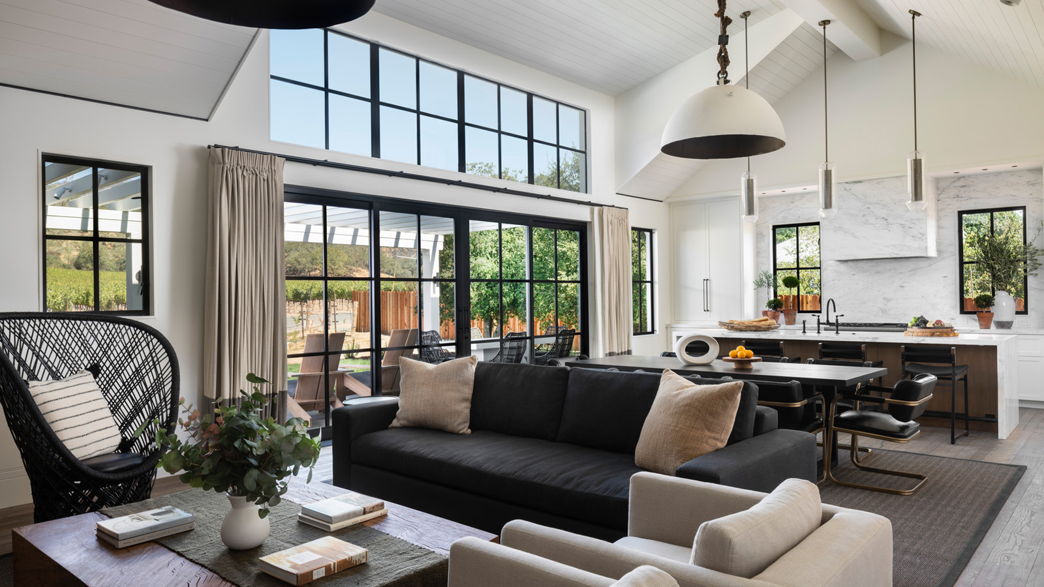
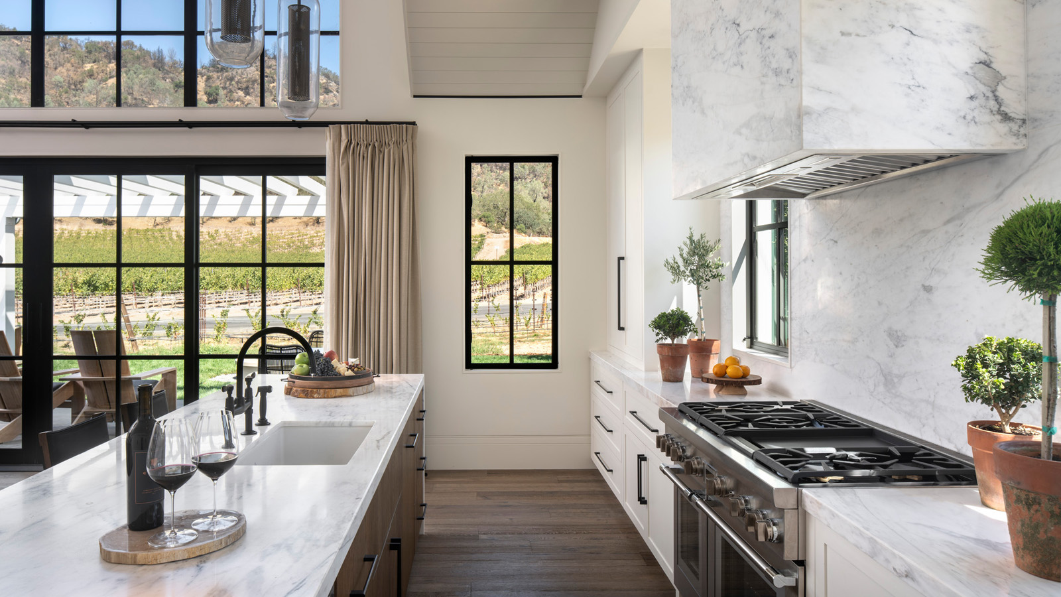 | 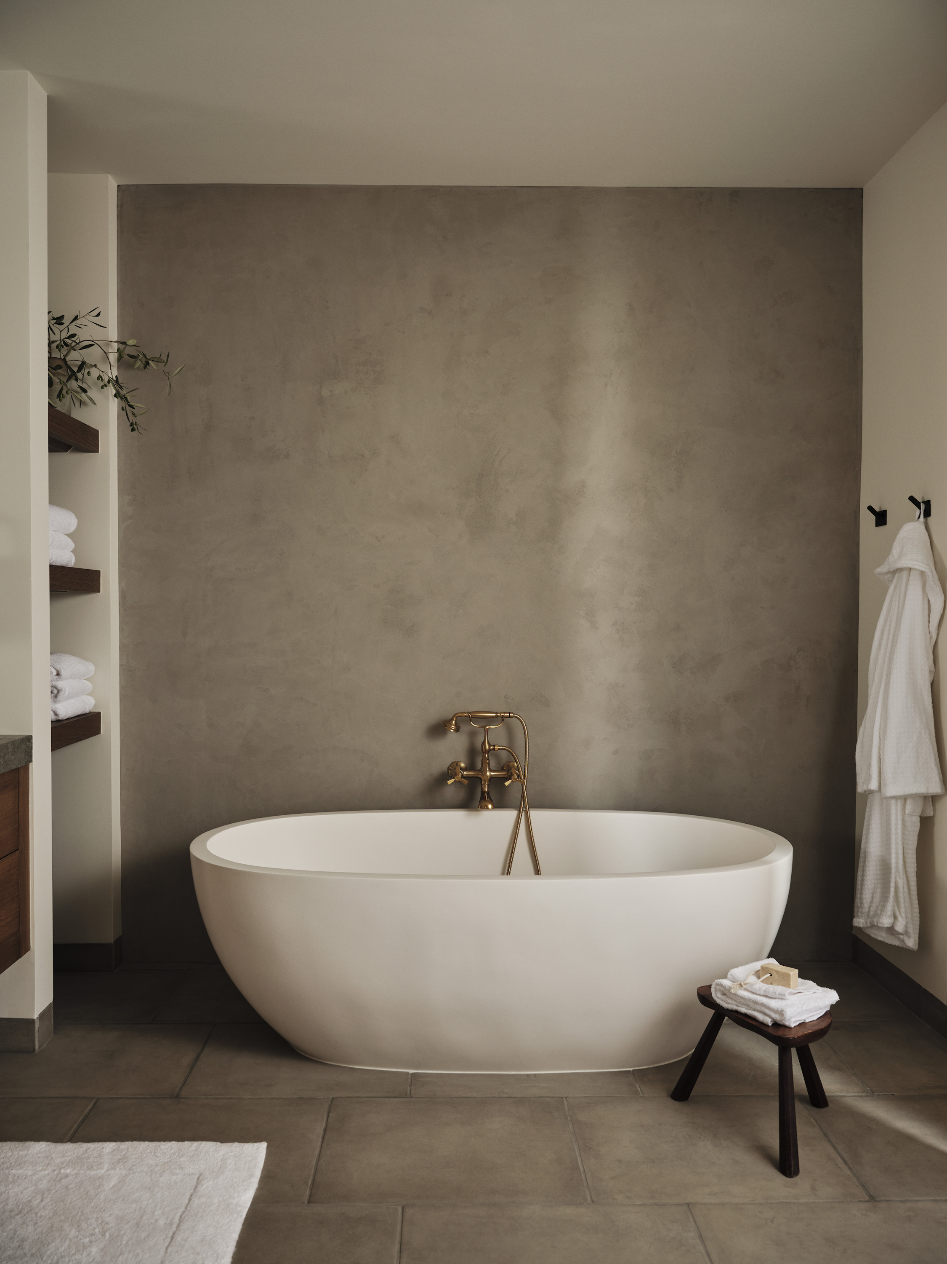 | 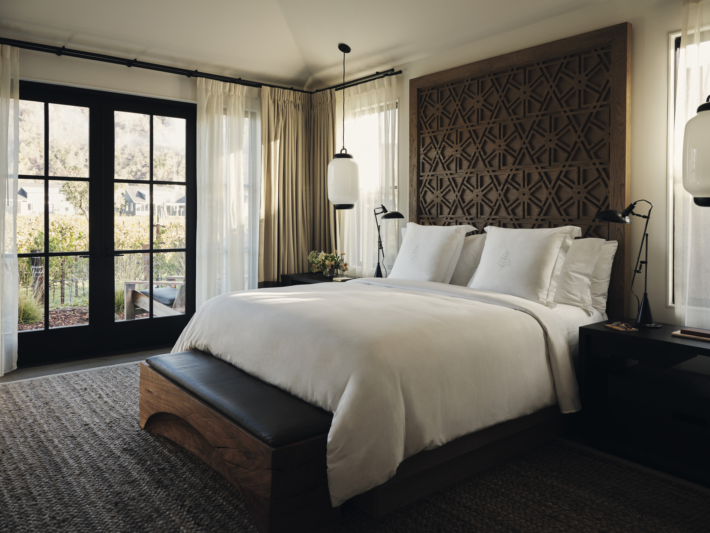
Four Seasons Resort and Residences Napa Valley, wine country’s leading luxury resort, sets a new standard for inspired vacations with the launch of its Private Retreats. The exquisite collection of one- and two-storey luxury residences blends seamlessly with the lush natural surroundings of charming Calistoga, offering guests an idyllic, private home-away-from-home nestled amid the property’s vineyards to reconnect and reunite in wine country.
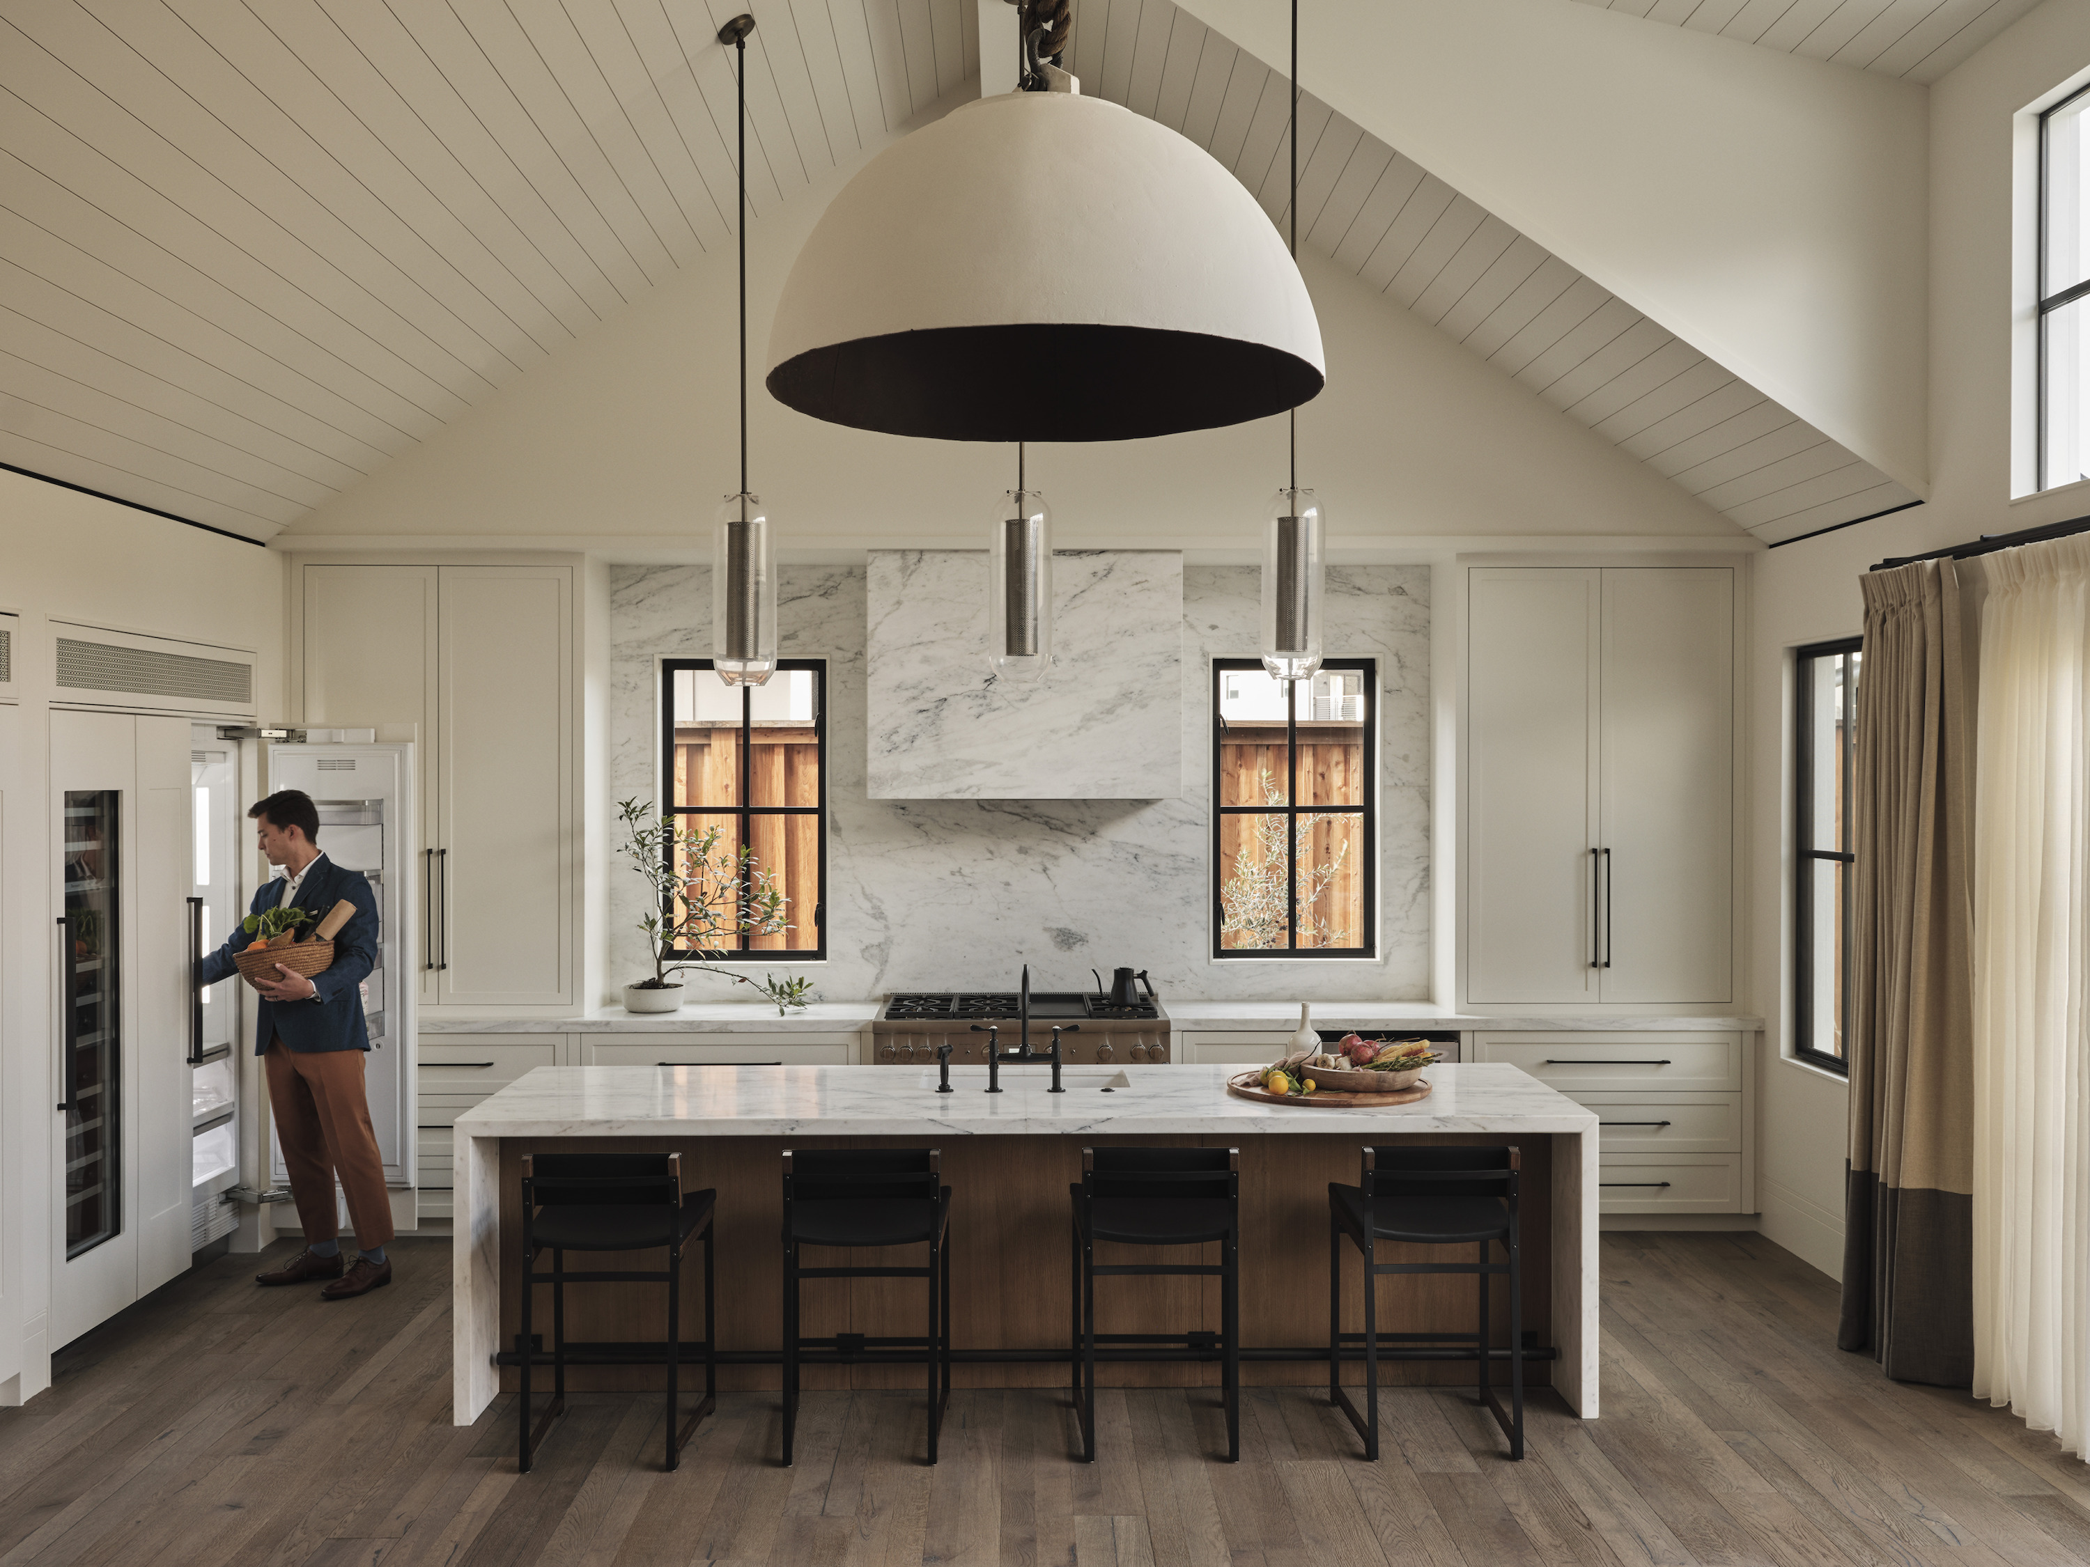 | 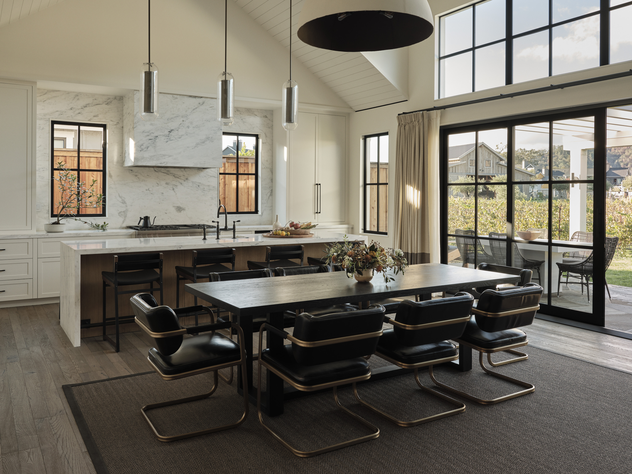 | 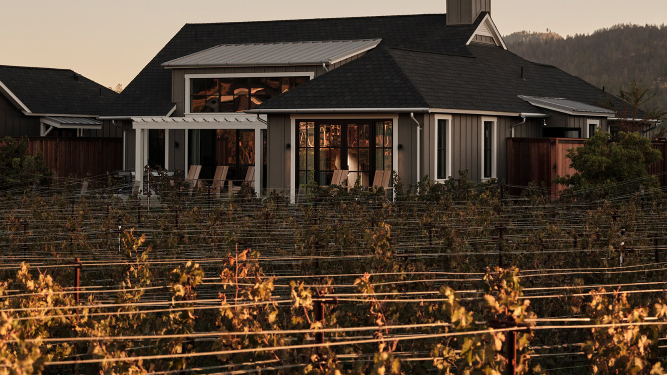
Four Seasons Resort and Residences Napa Valley, which recently opened as the region’s first and only resort located on a working winery, is delighted to add these eight extraordinary vacation homes to its boutique offering of accommodations. General Manager Mehdi Eftekari comments, “For discerning travellers looking to escape with their significant others, spend time with family in an intimate setting, or celebrate special occasions with friends, the luxury residences at Four Seasons Resort and Residences Napa Valley present a truly memorable vacation experience where the best of wine, wellness, culinary, and design come together like nowhere else. We look forward to hosting friends and families here to savour precious moments together.”
The residences in the Private Retreats collection are masterfully designed by renowned architects and designers to make the very best of living, hosting, and vacationing possible. The homes’ interiors range from 2,500 to 3,460 square feet (232-320 square metres), featuring one premier four-bedroom residence with a private pool along Napa Valley’s famed Silverado Trail.
Each spacious sanctuary draws inspiration from the California countryside, pairing modern farmhouse architecture with sophisticated yet understated interiors featuring earth-tone colours, board and batten siding, meticulous stone detailing, and pitched metal roofs. The residences feature well-appointed bedrooms, private open-concept kitchens – ideal for entertaining and gatherings large and small – plus five-fixture bathrooms evoking spa-like serenity, walk-in closets, and spacious private outdoor terraces with fire pits to unwind and admire striking views of the vineyards and Palisades Mountains.
For ultimate relaxation and enjoyment – wine country style – a variety of services and amenities are available to book, including pre-arrival grocery shopping, on-site massages, intimate private yoga sessions, and more.
Just outside each residence’s front door, a 4.7-acre (1.9 hectare) vineyard and winery, helmed by winemaker Jonathan Walden and consulting winemaker Thomas Rivers Brown, beckons with an authentic grape-to-glass experience. Wine aficionados and novices alike are invited to explore the world of wine and winemaking at Elusa Winery, including harvest activities and guided tasting sessions with expertly crafted cheese pairings. Guests also have the opportunity to enjoy the many other amenities on the grounds of Four Seasons Resort and Residences Napa Valley, including TRUSS Restaurant + Bar – a spirited dining destination with farm-fresh cuisine and sweeping views, plus two outdoor swimming pools dedicated for families and adults, CAMPO Poolside restaurant, the fully supervised Kids for All Seasons program, a bocce ball court, state-of-the-art fitness facilities, vineyard barn, meeting and event facilities, and Spa Talisa, a haven for relaxation and indulgence that is inspired by Calistoga’s 150+ years of wellness traditions.
At Four Seasons Resort and Residences Napa Valley, guests are treated to an incomparable hospitality experience centred on exceptional food, wine and spirits, wellness-inspired amenities, authentic service, and a distinct approachable luxury environment akin to its locale in the quaint town of Calistoga.
Select Private Retreats are now available to rent. To speak with a member of the Four Seasons team to learn more or book, contact +1 707 709 2100 or click here.

RELATED

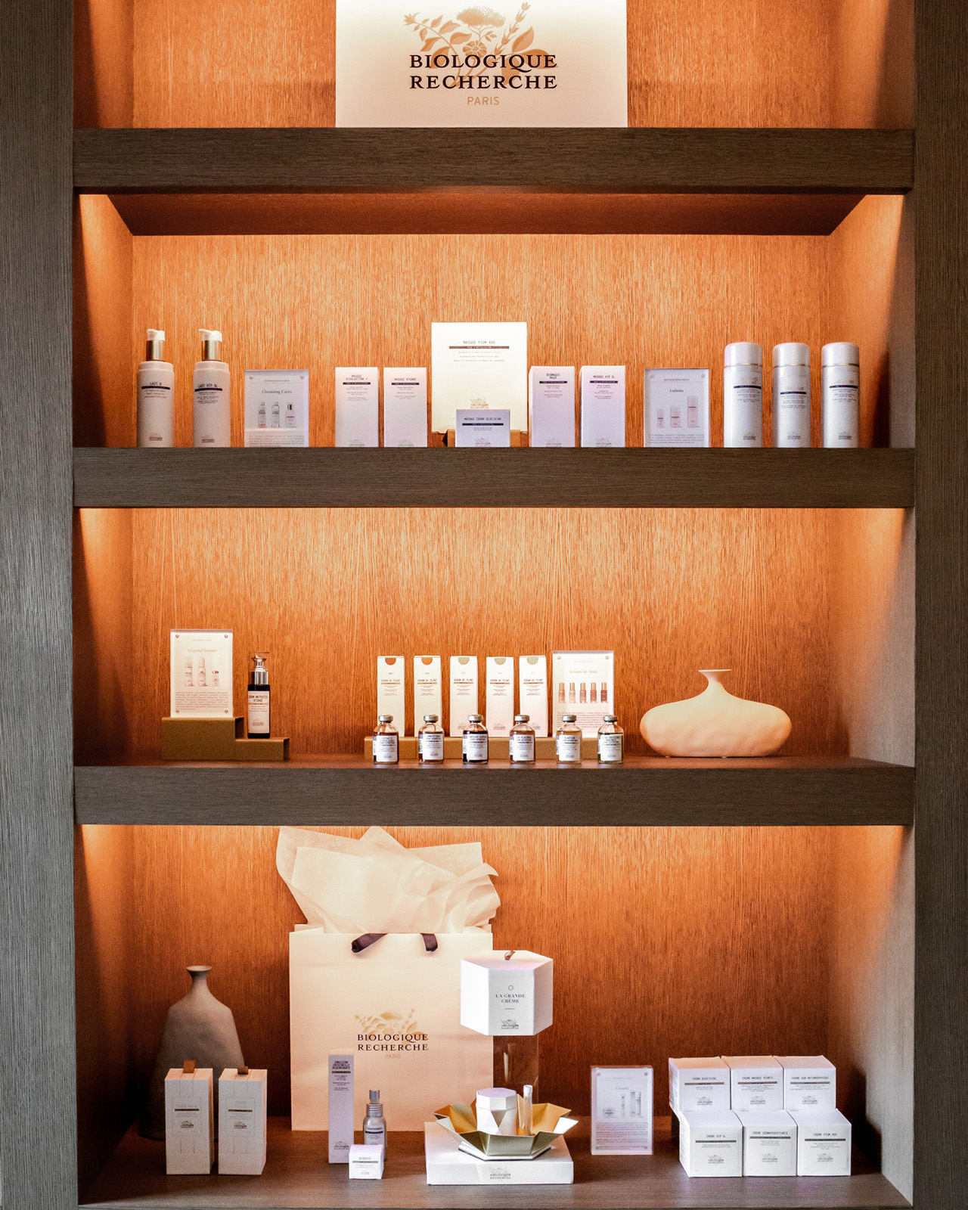 | February 24, 2022, Napa Valley, U.S.A.  Spa Talisa at Four Seasons Resort and Residences Napa Valley Introduces Biologique Recherche Bespoke Treatments and Retail Line  https://publish.url/napavalley/hotel-news/2022/new-biologique-recherche-treatments-at-spa-talisa.html
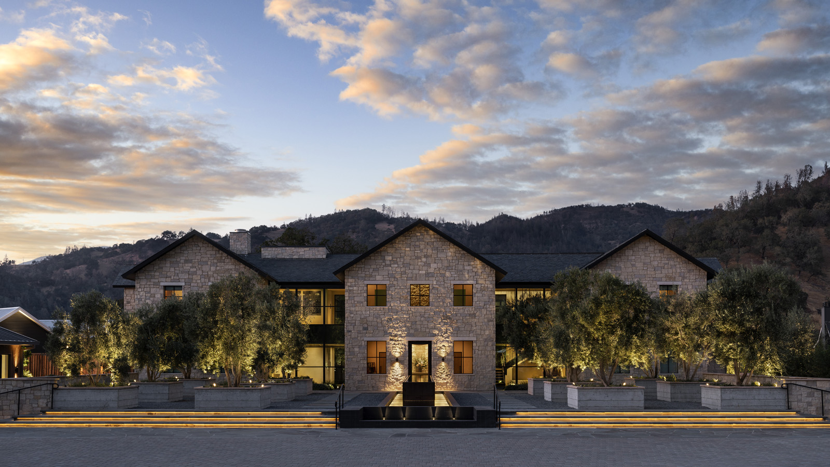 | November 1, 2021, Napa Valley, U.S.A.  NOW OPEN: Raise a Glass to the All-New Four Seasons Resort and Residences Napa Valley, the First Ever Four Seasons Set within a Working Winery  https://publish.url/napavalley/hotel-news/2021/now-open.html

PRESS CONTACTS

Nicole Lax
Vice President, Account Lead, J Wade Public Relations
550 15th St Suite 25
San Francisco
USA
fourseasonsnapapr@jwadepr.com

+1 248 763 6588

