Four Seasons Resort Punta Mita Introduces New Wedding Offerings to Say “I Do” by the Mexican Pacific

Couples will never forget this milestone celebration carefully designed to their unique taste, by the property´s wedding specialists
November 22, 2021, Punta Mita, México

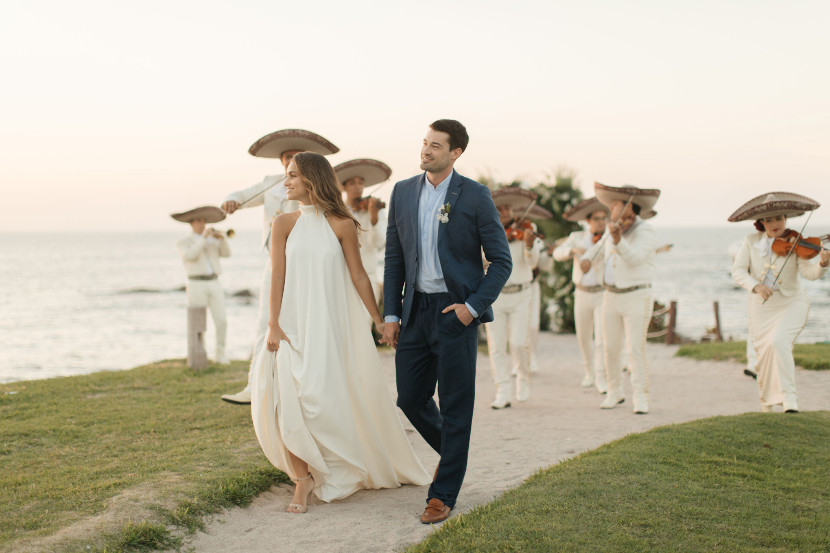
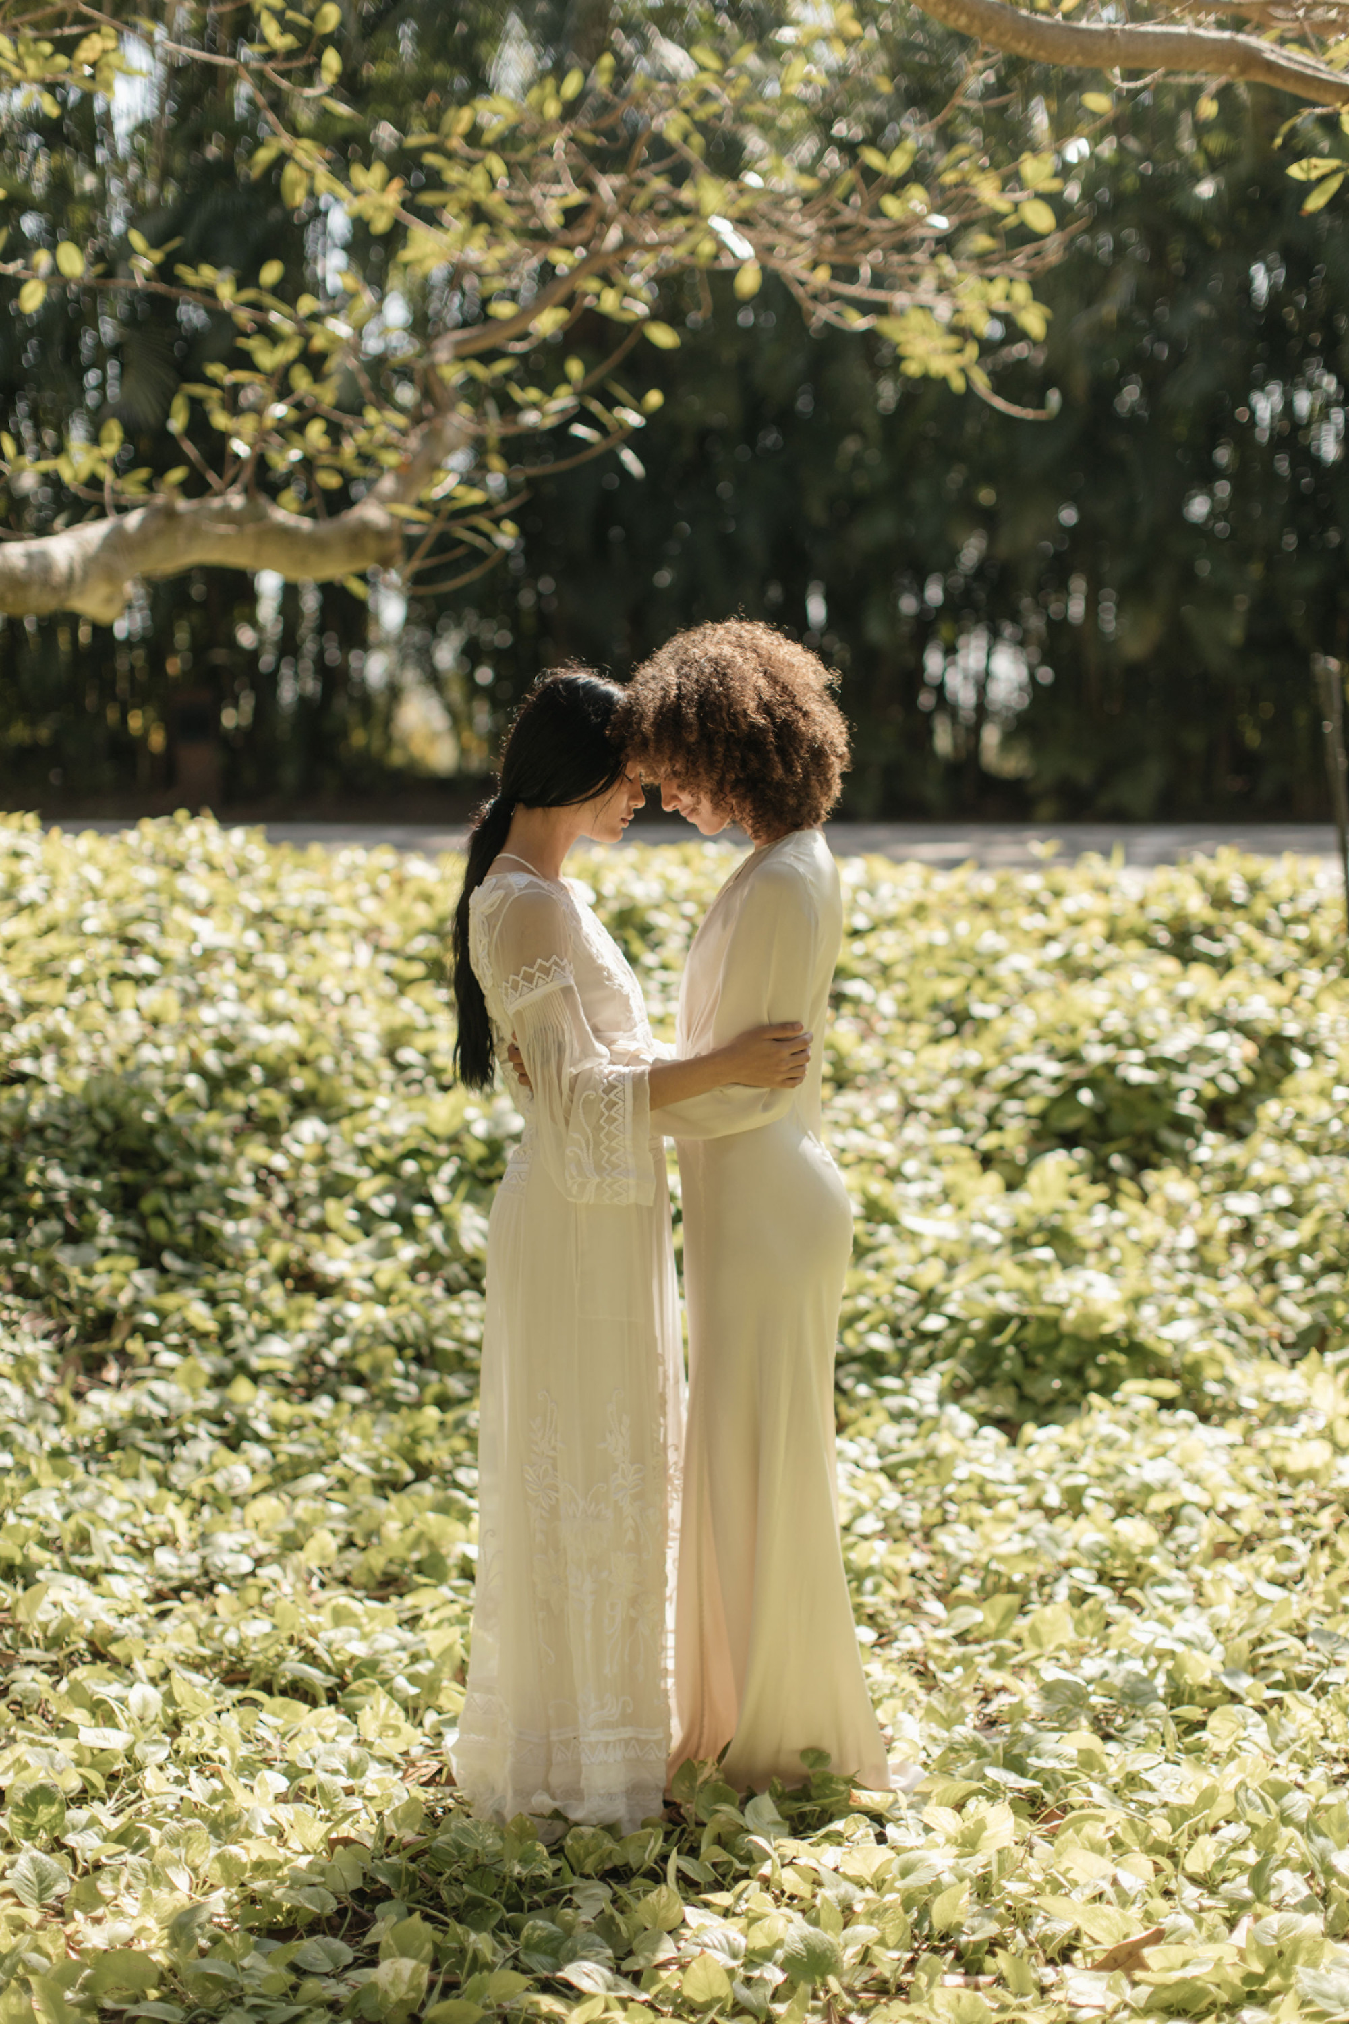 |  | 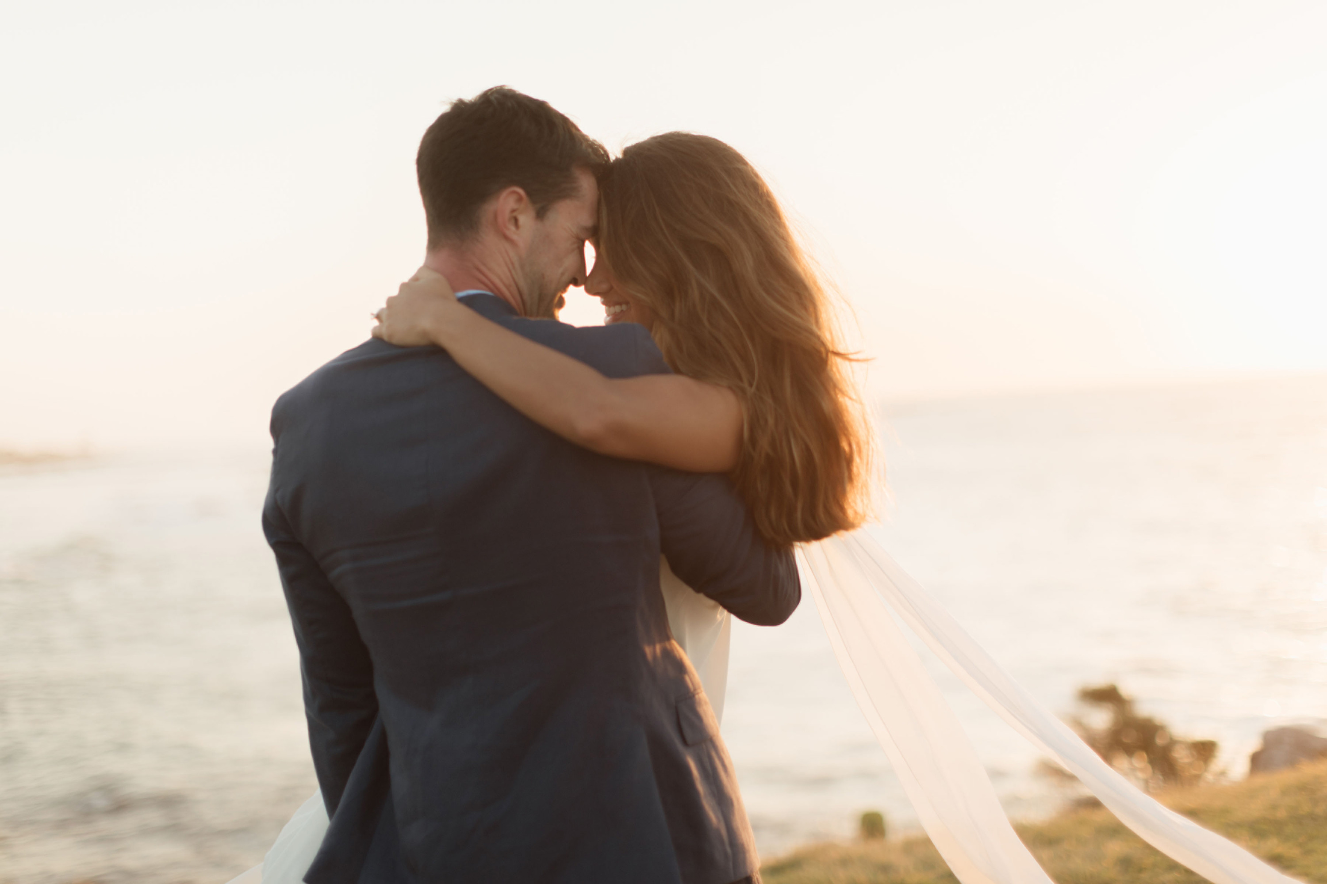
With a prime location on the Pacific coast, Four Seasons Resort Punta Mita is perfect to make the most important day unforgettable for any couple. From intimate celebrations to a grand wedding, evert details are expertly planned and carried out. With an array of stunning venues, innovative Mexican cuisine and tasteful, stylish décor, every wedding will be completely unique and touchingly authentic.
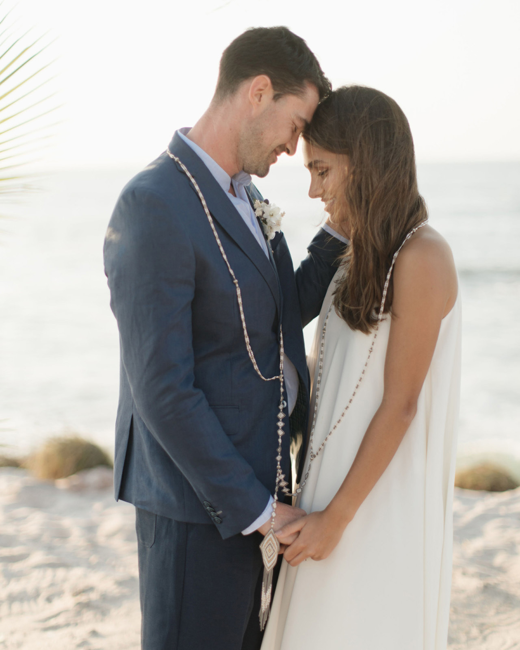
Four Seasons Resort Punta Mita has created four new wedding packages, carefully designed to tailor celebrations to the couple’s unique taste. These packages have been designed for parties from 2 to 40 people, all with choice of wedding site, a Four Seasons designated Wedding Planner, a décor credit, a wedding cake, and other special details.
“These wedding packages were designed to ensure each couple has the destination wedding of their dreams,” says Paula Méndez, Weddings and Social Events Manager for the property. “Whether they are looking to elope and celebrate their ceremony on top of The Rock overlooking the Pacific Ocean, to have an intimate celebration with their loved ones at the romantic Manzanillas Beach, or an unforgettable traditional Mexican wedding with all their friends and family gathered to witness the most important day in the couple's life, each option will exceed everyone's expectations.”
Just the Two of Us
Celebrate this special commitment focusing entirely on each other. Perfect for those wanting an intimate romantic ceremony, this package is designed to make this special day only for them. Starts at USD 4,500. Special feature: The most romantic dinner under the stars.
Soulful Ceremony
Escape together to the idyllic shores of Punta Mita for an intimate wedding experience. Whether it's just the couple or with their closest friends and family, this package is the perfect way to exchange vows in a deeply personal way. Starts at USD 5,350. Special feature: A three-course dinner personally crafted by a private chef.
A Wedding to Remember
Carefully created to deliver the whole ultimate destination wedding experience, this package takes care of all the particular details in the wedding day, ensuring that the happily ever after starts in the most memorable of ways - by experiencing the best of Punta Mita. Starts at USD 11,750. Special feature: Choose between the turtle release, a spa treatment, a private dinner, or a tequila blending experience.
Once Upon a Time in Punta Mita
Weave the beauty of the Mexican culture into this special day to create truly unique memories that will last a lifetime. Choosing this package will guarantee the perfect Punta Mita wedding, including a traditional lasso ceremony, all managed by the Resort's dedicated wedding planners. Starts at USD 10,000. Special feature: Punta Mita lasso traditional ceremony.
For more information about wedding packages at Four Seasons Resort Punta Mita, click here.

RELATED

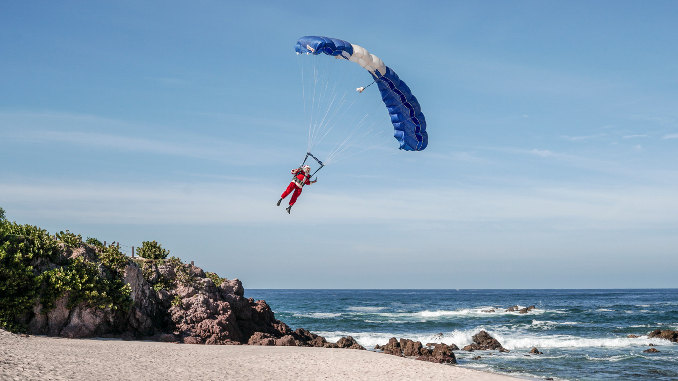 | November 19, 2021, Punta Mita, México  Celebrate the Holidays This December at Four Seasons Resort Punta Mita  https://publish.url/puntamita/hotel-news/2021/festive-season.html
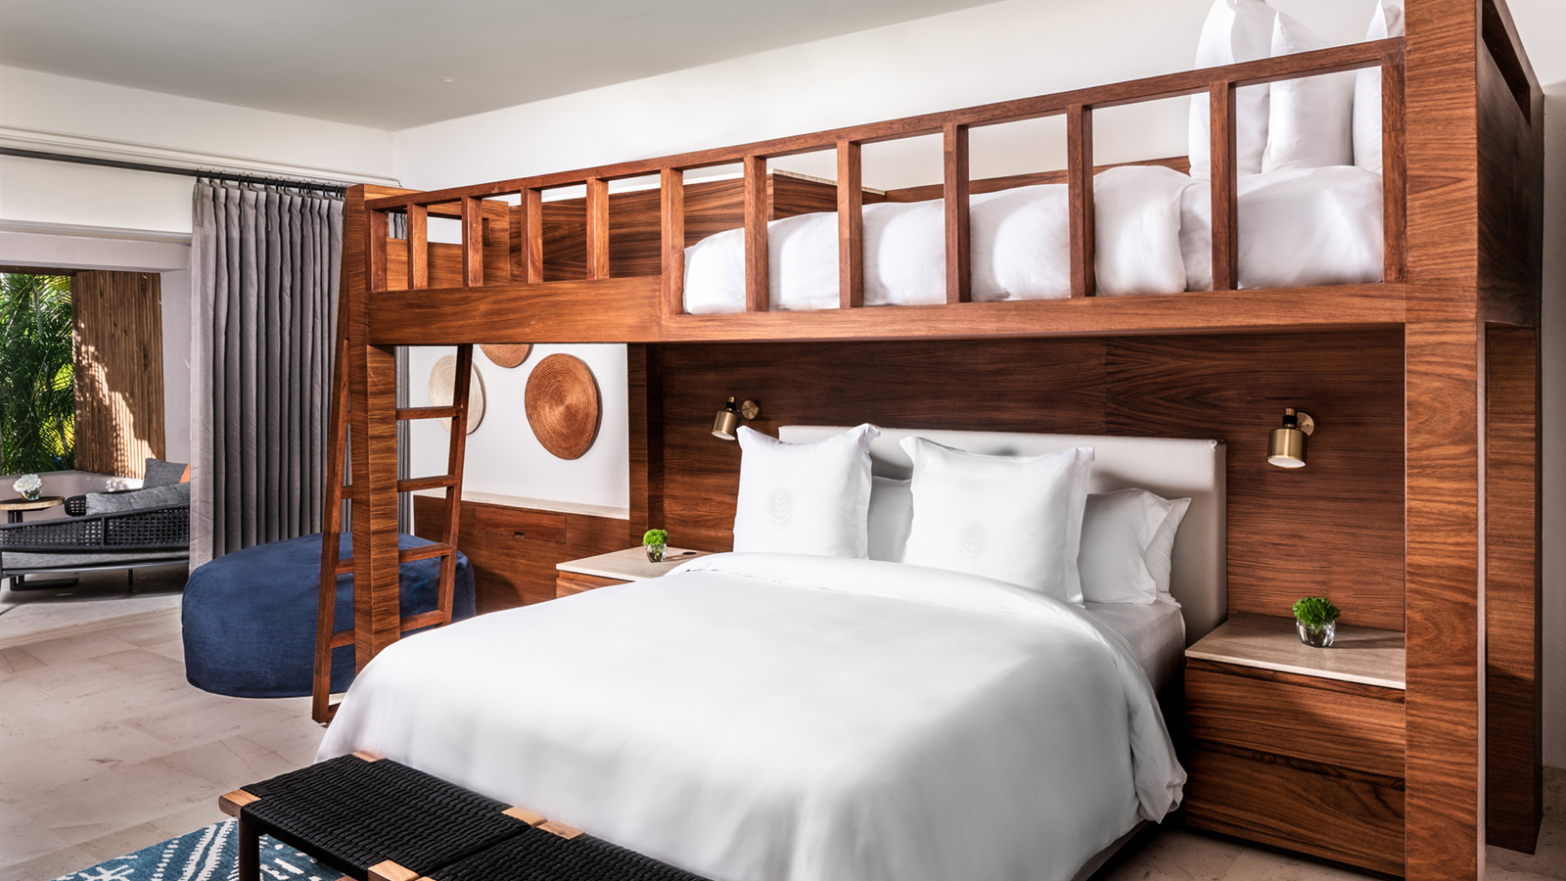 | May 17, 2021, Punta Mita, México  Four Seasons Resort Punta Mita Presenta sus Nuevas Casitas Familiares de dos Habitaciones con Literas  https://publish.url/es/puntamita/hotel-news/2021/new-family-suites-with-bunk-beds-2.html

PRESS CONTACTS

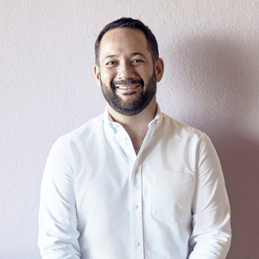 | Miguel Peregrina  Director of Public Relations  Punta Mita, Bahia de Banderas  Nayarit  Mexico  miguel.peregrina@fourseasons.com  +52 329 29160000

