Strawberry Tarts Forever – Four Seasons Dubai Invites Foodies to a Masterclass by World-Renowned Pastry Chef Nicolas Lambert

April 19, 2023, Dubai, U.A.E.

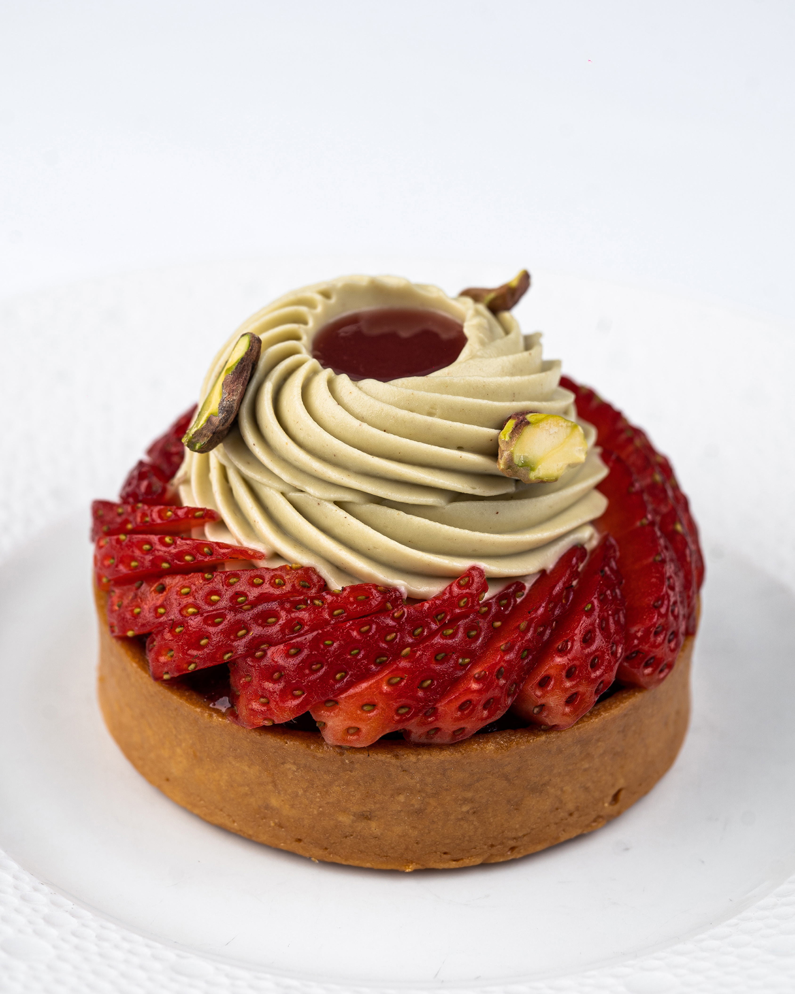
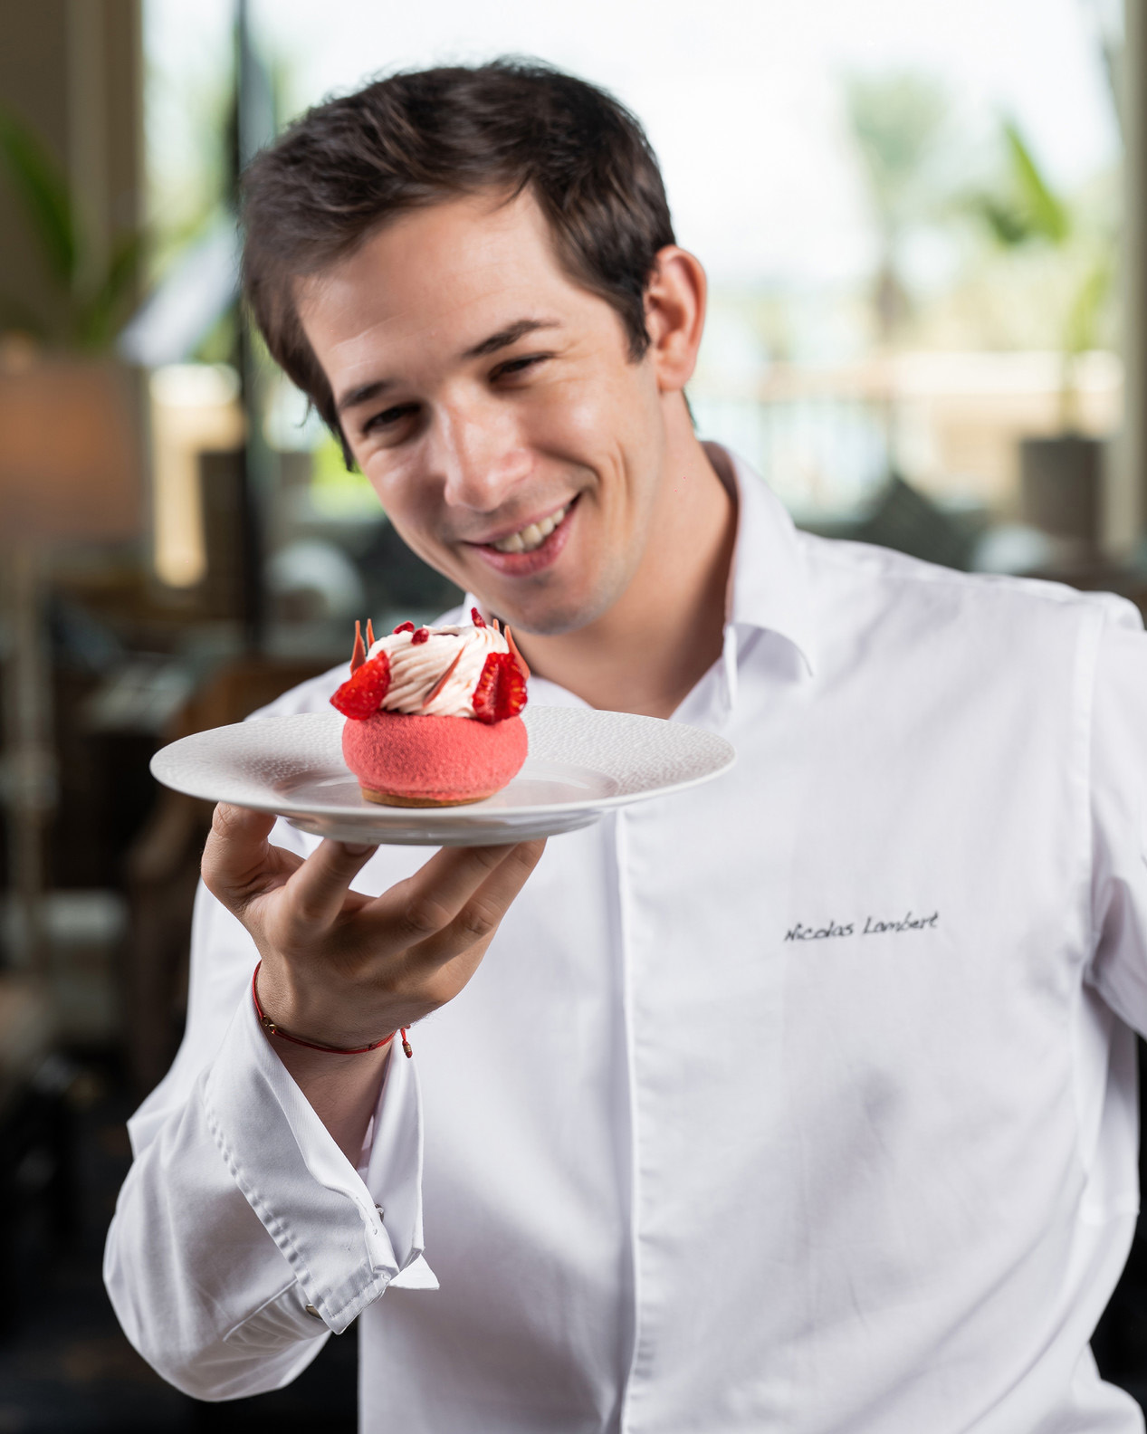 | 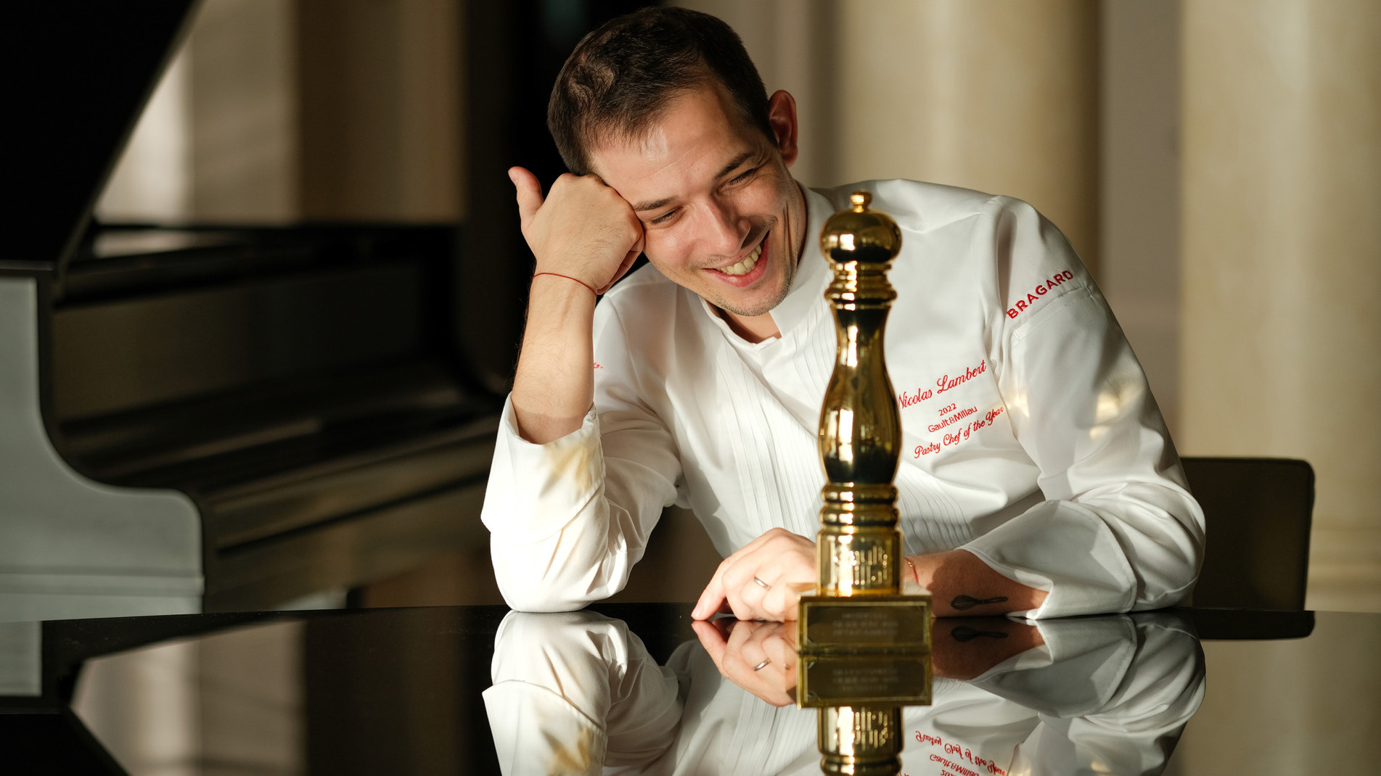
Four Seasons Dubai announces a very special exclusive masterclass led by award-winning Pastry Chef Nicolas Lambert, where pastry enthusiasts can learn the art of making the perfect Tarte de Fraises, as part of the Dubai Food Festival Foodie Experiences. The event will take place on May 6, 2023, from 10:00 am to 12:00 noon, at The Monogram Room at Four Seasons Hotel DIFC, providing a unique opportunity to refine pastry-making skills under the guidance of a world-renowned expert.
Chef Nicolas Lambert, who is the Senior Executive Pastry Chef at Four Seasons Dubai, is renowned for his creativity and expertly balancing flavours. In this masterclass, he will teach participants how to create the perfect Tarte de Fraises, a classic French pastry that is sure to impress. The class is suitable for all levels of expertise, and guests will have the opportunity to learn from one of the world's top pastry chefs in the state-of-the-art facilities at Four Seasons Hotel DIFC.
The Dubai Food Festival 2023 is a celebration of Dubai's rich culinary culture, with a range of food events, masterclasses, and foodie experiences. This year's festival promises to be the biggest and best yet, with more than 150 food-related events taking place throughout the city.
The masterclass will be priced at AED 300 per person, and interested participants can book their spots by contacting restaurants.dubaijb@fourseasons.com or calling +971 4 270 7777. As places are limited, early booking is recommended to avoid disappointment.
For more information, follow Four Seasons Dubai on Instagram.

RELATED

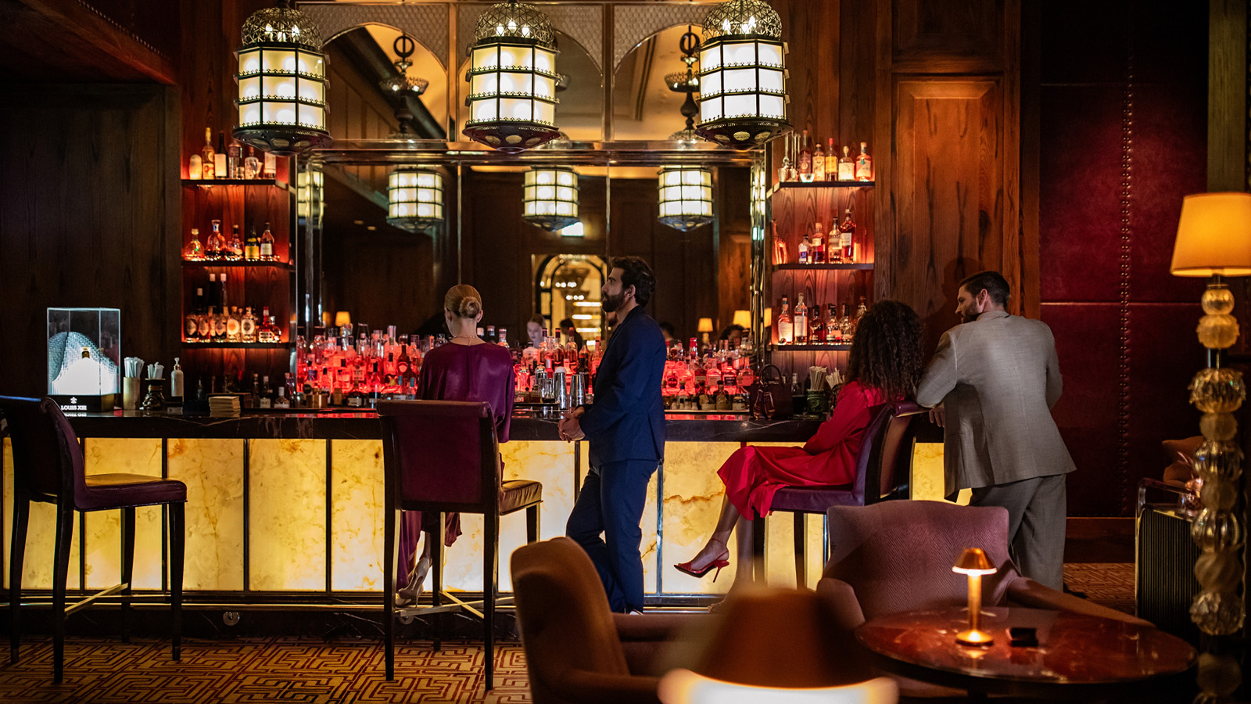 | April 11, 2023, Dubai, U.A.E.  Four Seasons Resort Dubai at Jumeirah Beach Hosts VIRTÙ at Hendricks Bar, Evoking the Spirit of Tokyo  https://publish.url/dubai/hotel-news/2023/guest-bartender-keith-motsi-at-hendricks.html
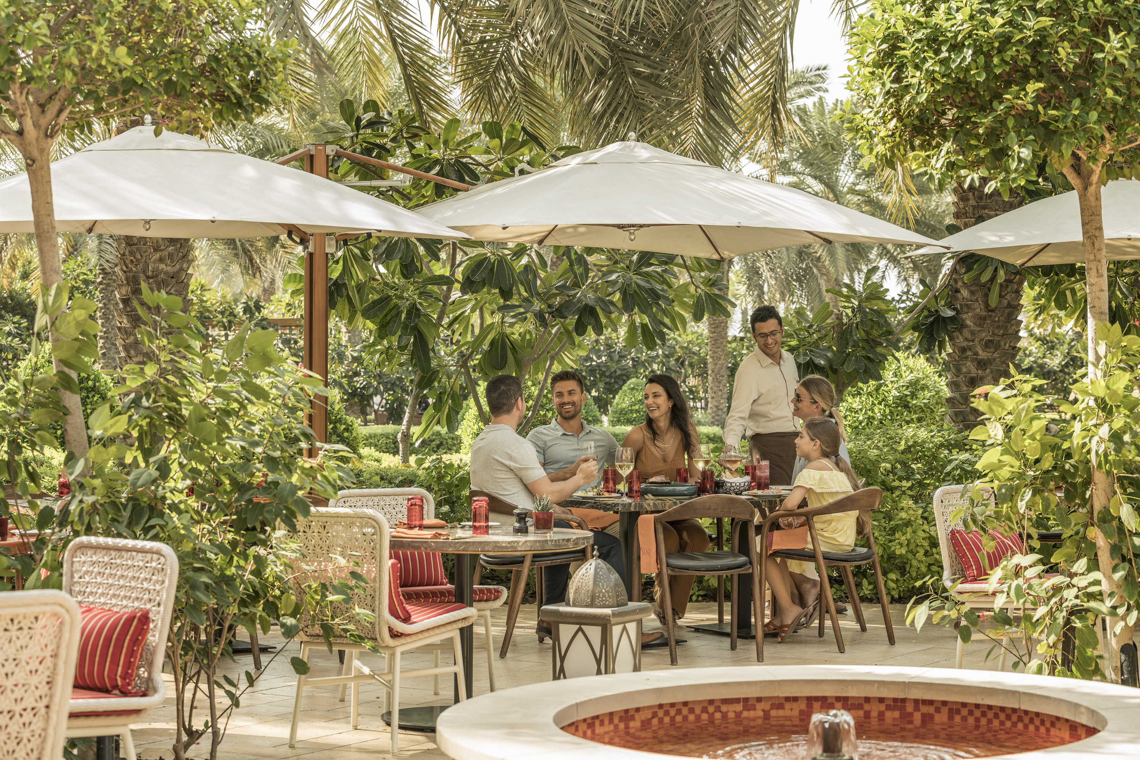 | March 30, 2023, Dubai, U.A.E.  Four Seasons Resort Dubai Introduces the Easter Edition of the Sensational Brunch  https://publish.url/dubai/hotel-news/2023/easter.html

PRESS CONTACTS

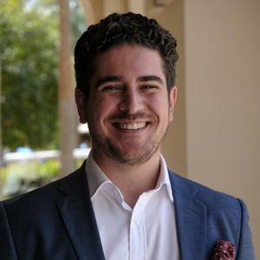 | Ghaith Adnan  Assistant Director of PR and Communications  Jumeirah Road  Dubai  United Arab Emirates  ghaith.adnan@fourseasons.com  + 971 4 270 7884

