Mind and Body Bliss at Four Seasons Hotel The Westcliff Johannesburg

Four Seasons welcomes guests to its revitalised Spa and Après-Spa offerings, including the opportunity for exclusive experiences of its expansive facilities
August 16, 2021, Johannesburg, South Africa

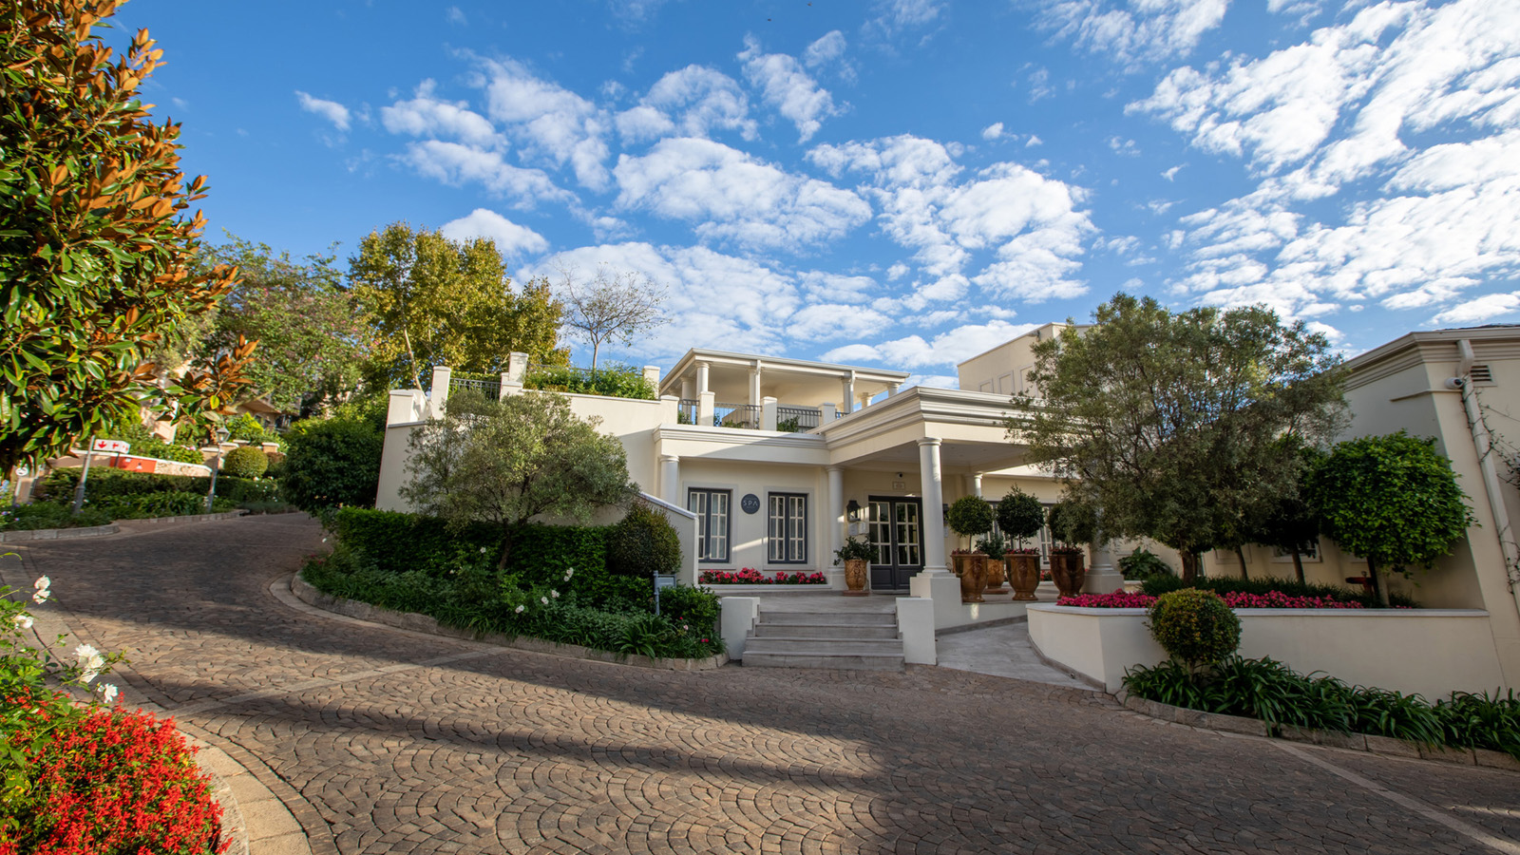
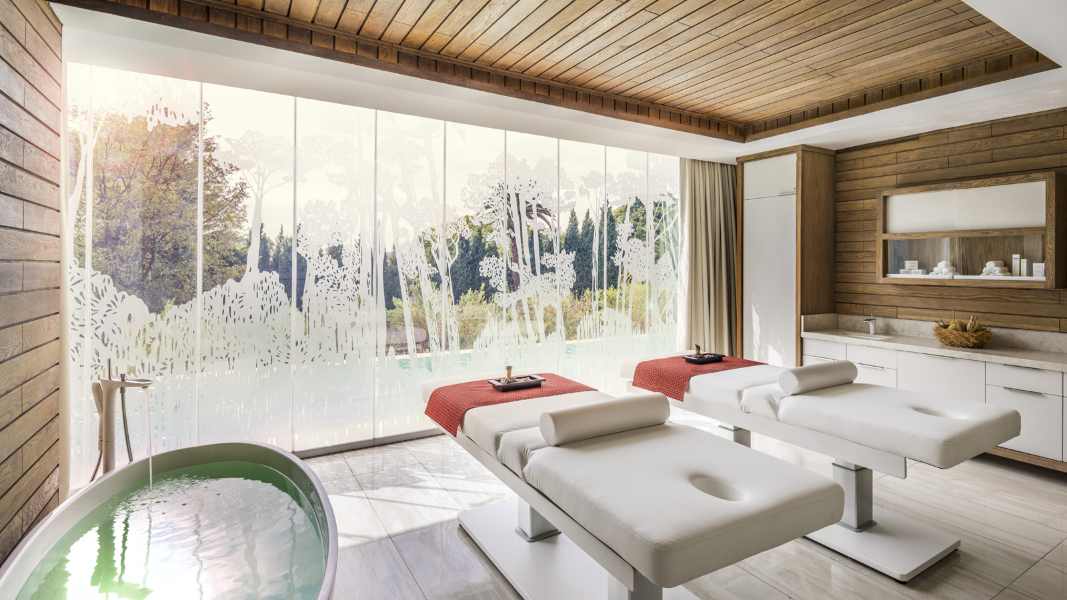 | 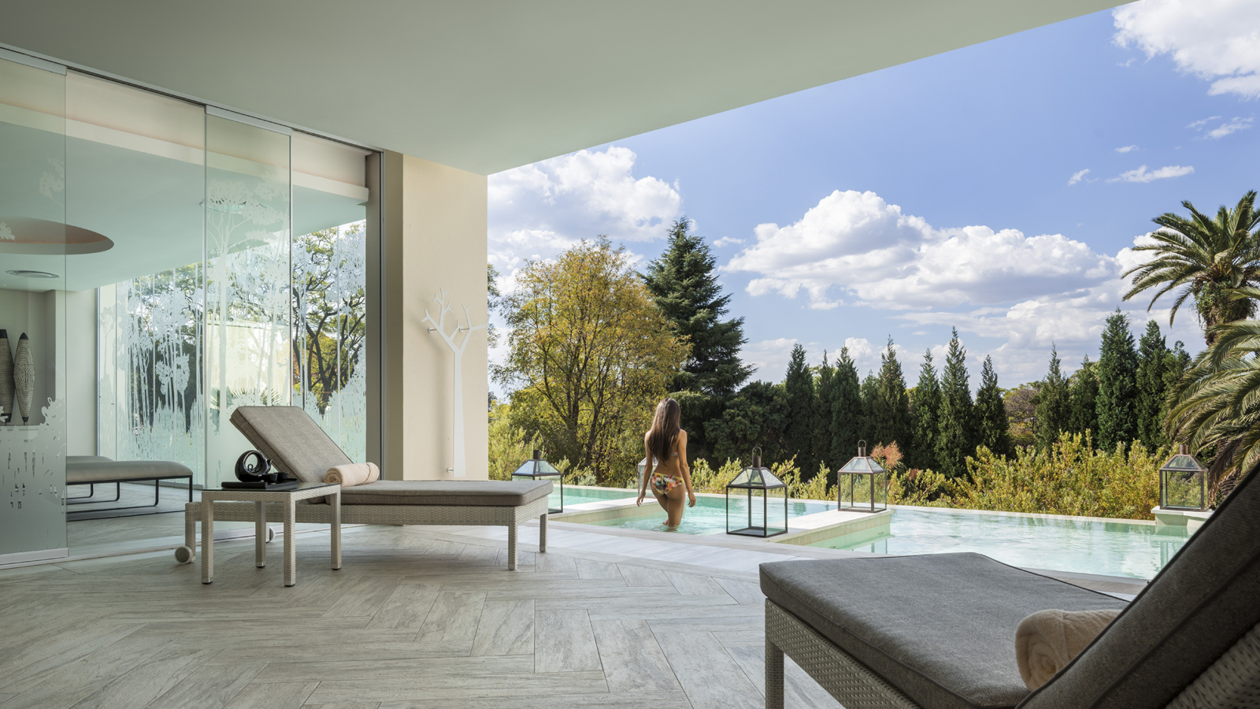 | 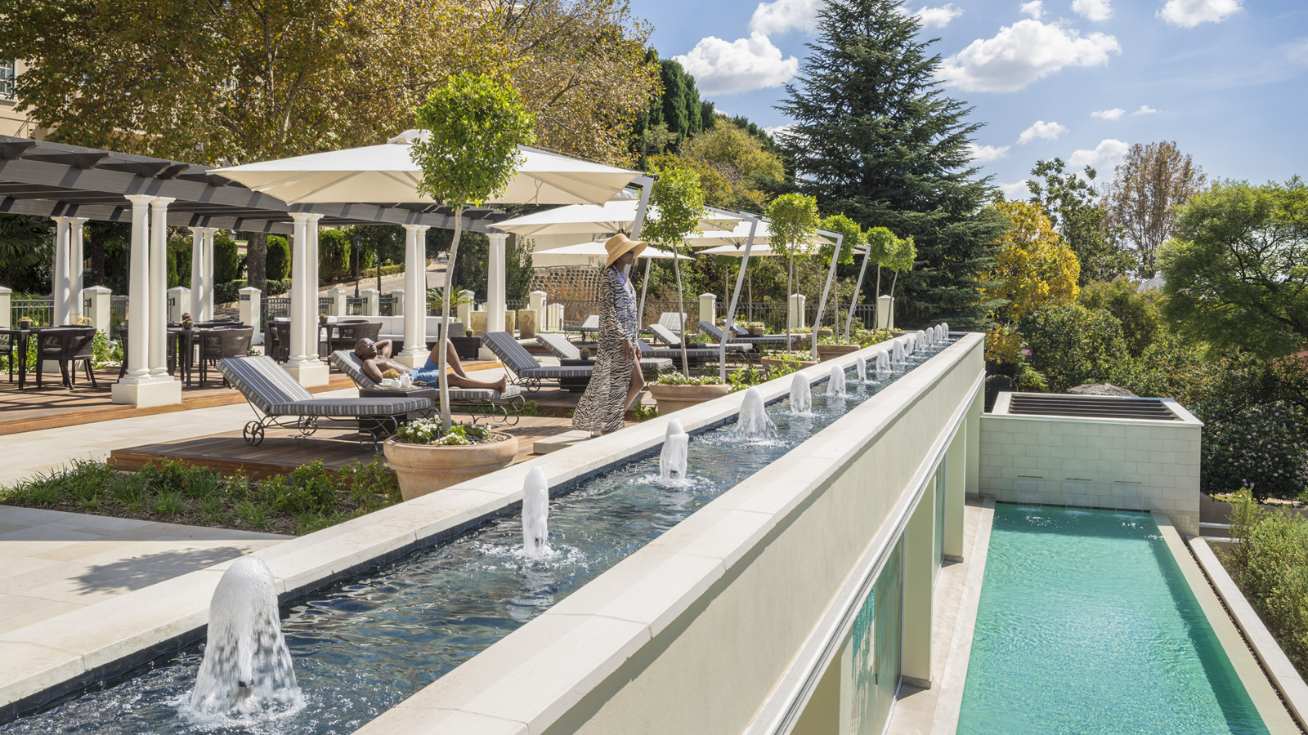
Encased in the hill-top villas of Westcliff, discover a haven of tranquillity at the Spa at Four Seasons Hotel The Westcliff Johannesburg. With panoramic city views, this urban oasis provides a generous 1,200 square metres (12,900 square feet) of light-infused space with multiple spa amenities and offerings.
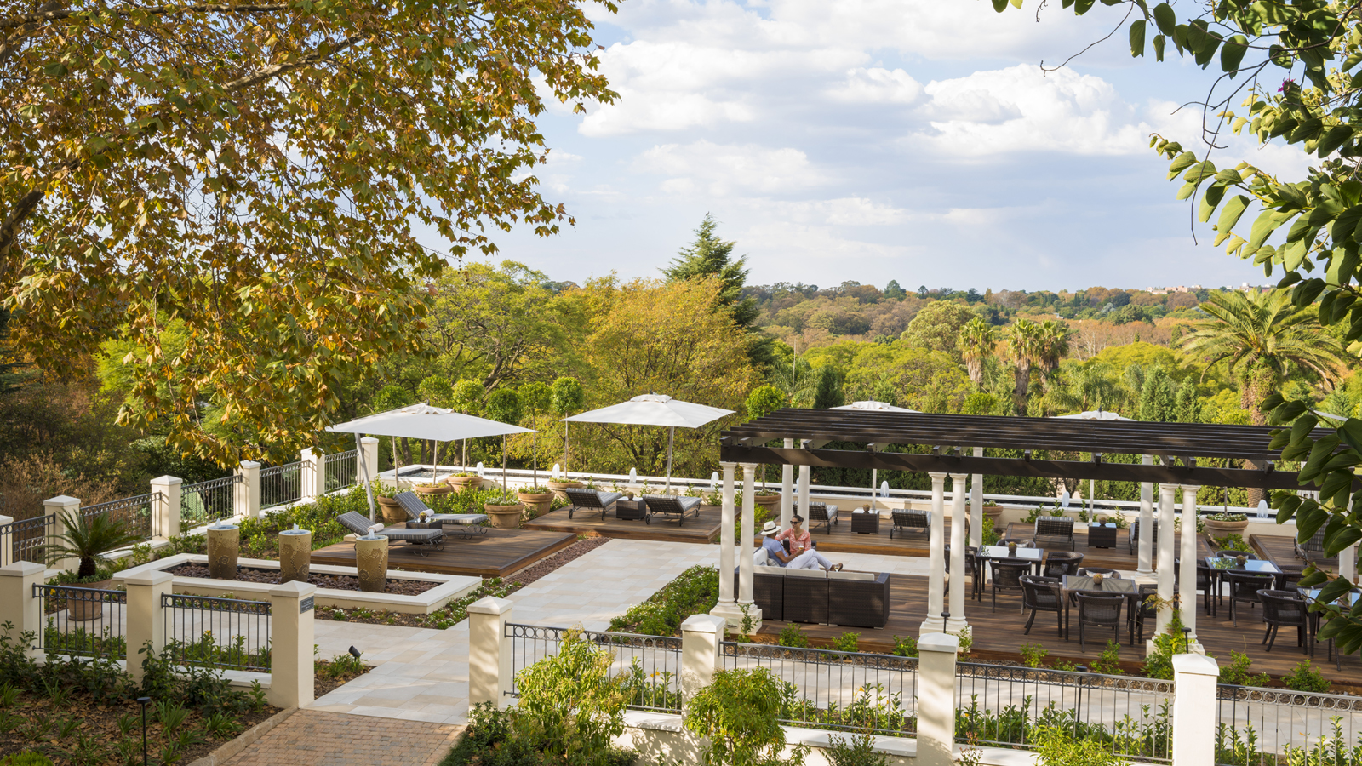
Share the experience with a loved one in the fully private couple suites and choose from a plethora of sumptuous wellness and beauty treatments. Or allow the Spa’s skilled therapists to provide a specially curated spa experience for two in a room for exclusive use.
Make an occasion out of it in the secluded Garden Spa Suites with a group of close friends. Ideal for celebrations and intimate gatherings, the Garden Spa Suites provide a discreet venue for up to eight guests – perfect for baby showers or any private occasion for good friends to come together and enjoy a day of relaxation and indulgence.
With a focus on techniques and products that promote rejuvenation and relaxation, the Spa provides organic, signature rituals that engage every sense, blissfully transporting body and soul to experience the harmony of African nature. Combining a results-driven approach to beauty, through the use of pure, raw ingredients as well as innovative and meticulous procedures, Four Seasons Hotel The Westcliff Spa is dedicated to treating every guest to the best version of themselves.
Experience two new signature treatments exclusively created by TheraNaka for Four Seasons Safari and Islands collection, Africa including The Westcliff. TheraNaka’s unique body treatments and rituals were inspired, designed and based on Africa’s rich heritage, cultural traditions, rituals and beliefs; created to celebrate Mother Earth and her connections with life.
Revel in a new-found glow at the glorious Après-Spa, enjoying a menu reflecting this sanctuary of calm. Sun loungers, al fresco dining and a crystalline lap pool are at guests’ disposal as they take in the view from this hill-top paradise.
Become a complimentary member of the Spa and be rewarded with generous savings on treatments. In addition, members are first to know of the enticing spa events held in the gardens. Take time out for ballet-inspired barre workouts, guided meditation, and yoga in the in the unparalleled setting of a Jozi landmark.
Four Seasons The Westcliff Spa and Après-Spa can be booked for private events on weekdays and outside of opening hours. Contact the Spa on 011 481 6450 or spa.johannesburg@fourseasons.com for more information or to personalise a package.
In keeping with the Hotel’s commitment to guests and staff safety, Four Season Hotel The Westcliff remains committed to global COVID policies through the Lead With Care initiative. Enhanced cleanliness and safety measures remain the priority and are practised in every on-property experience.

RELATED

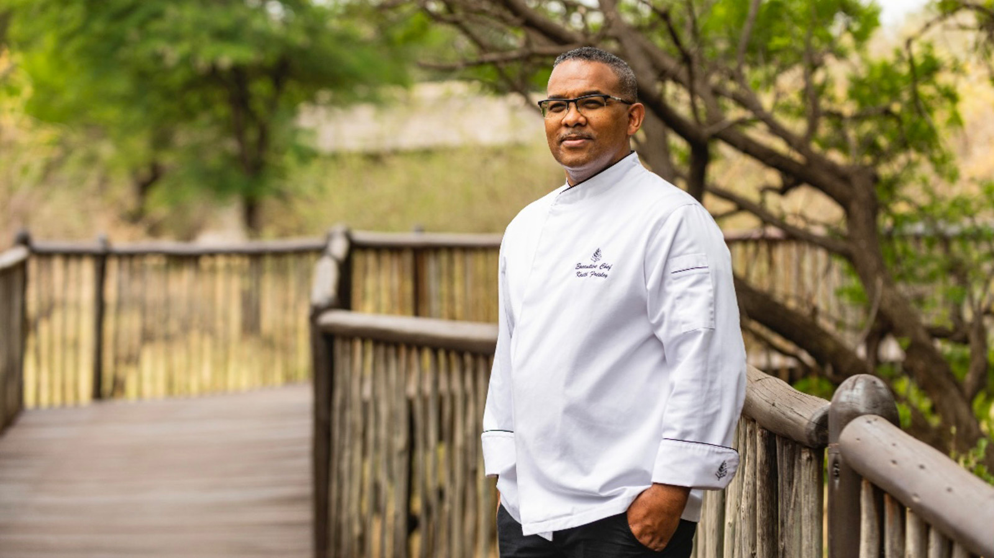 | August 13, 2021, Serengeti, Tanzania  Keith Frisley Appointed Executive Chef at Four Seasons Safari Lodge Serengeti  https://publish.url/serengeti/hotel-news/2021/new-executive-chef-keith-frisley.html
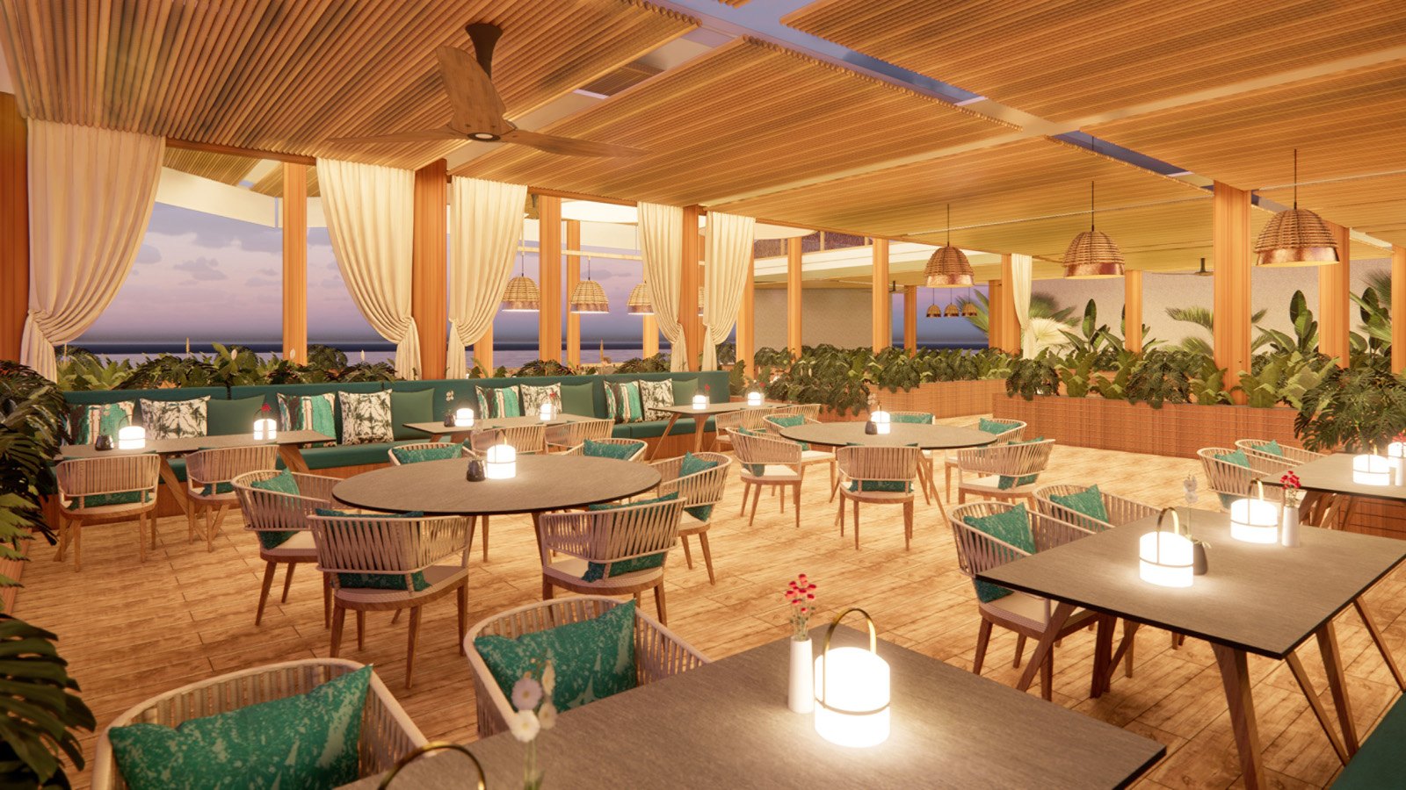 | July 8, 2021, Mauritius  Four Seasons Resort Mauritius at Anahita Announces a Resort Culinary Transformation Through Multi-Million Dollar Restaurant and Bar Renovations  https://publish.url/mauritius/hotel-news/2021/restaurant-and-bar-renovation.html

PRESS CONTACTS

Natalie Harrison
Public Relations and Communications Manager
67 Jan Smuts Avenue P.O. Box 2700
Johannesburg
South Africa
natalie.harrison@fourseasons.com

+27 (0)11 481 6000

