SÉZANNE at Four Seasons Hotel Tokyo at Marunouchi Named “The Best Restaurant in Japan 2023” and #2 Among Asia’s 50 Best Restaurants

March 28, 2023, Tokyo, Japan

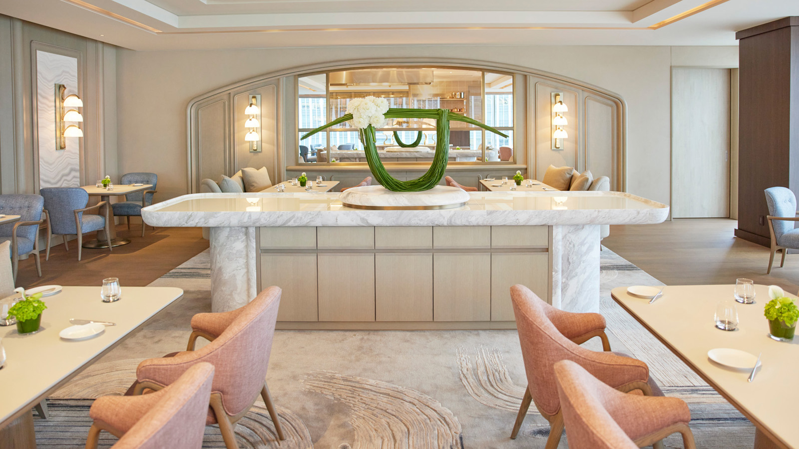
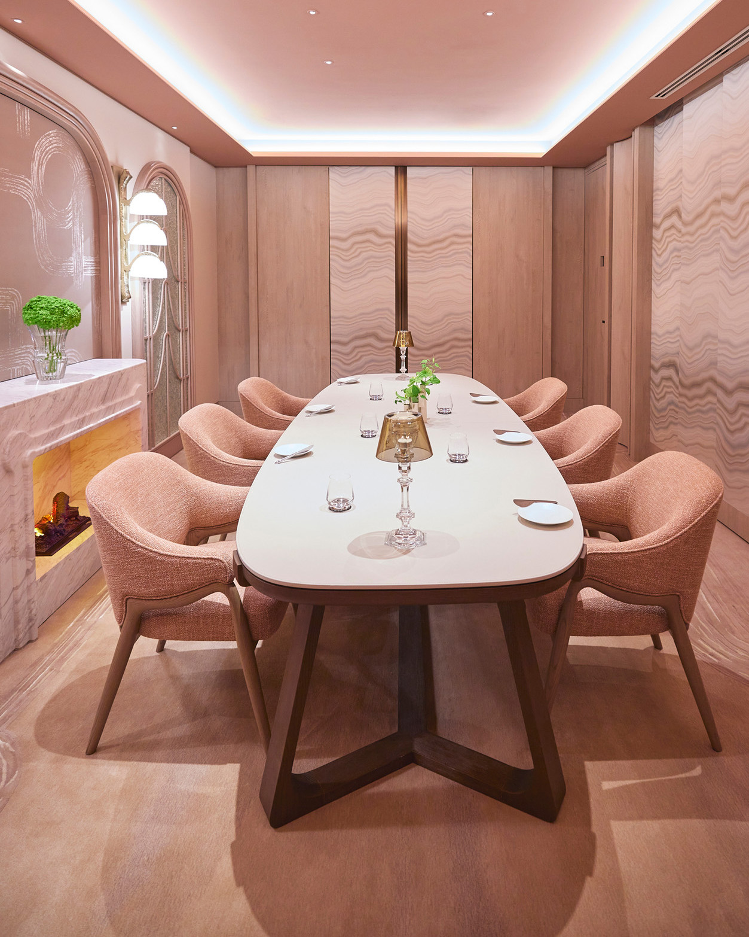 | 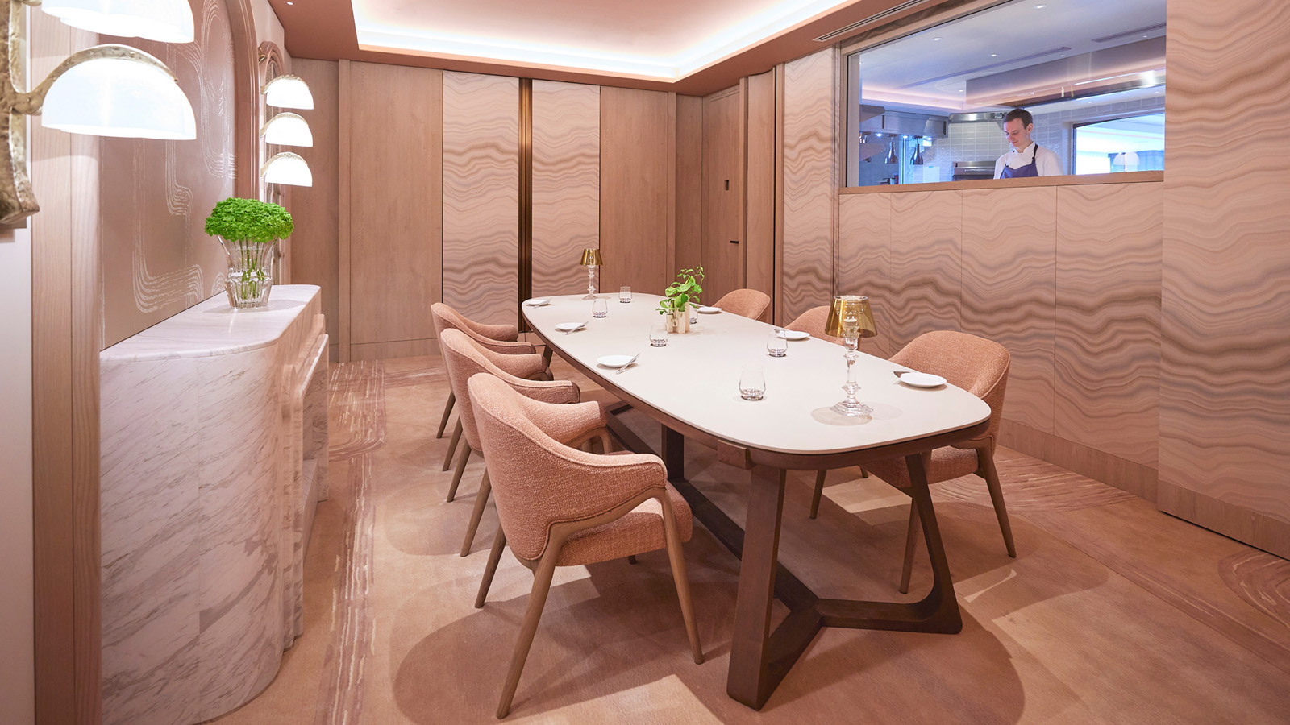 | 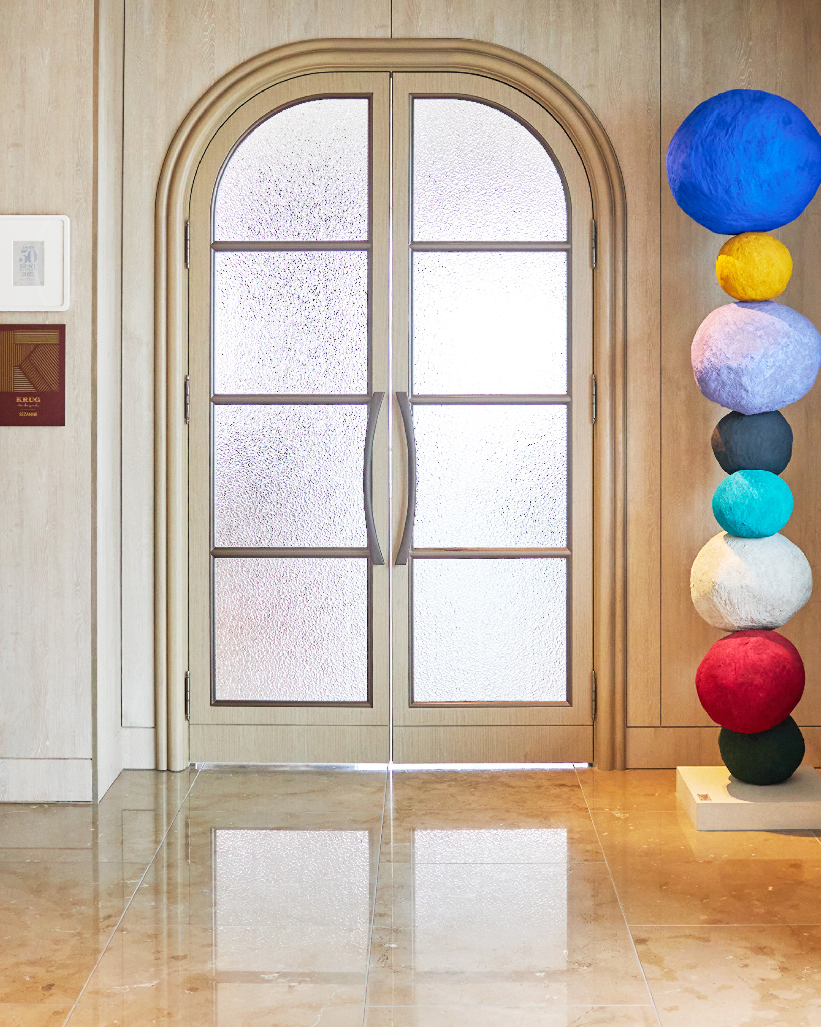
This year’s edition of Asia’s 50 Best Restaurants has once again awarded a coveted spot to SÉZANNE, the signature French restaurant at Four Seasons Hotel Tokyo at Marunouchi. Ranked at #2 in 2023, the restaurant moved up the prestigious list from a #17 ranking in 2022.
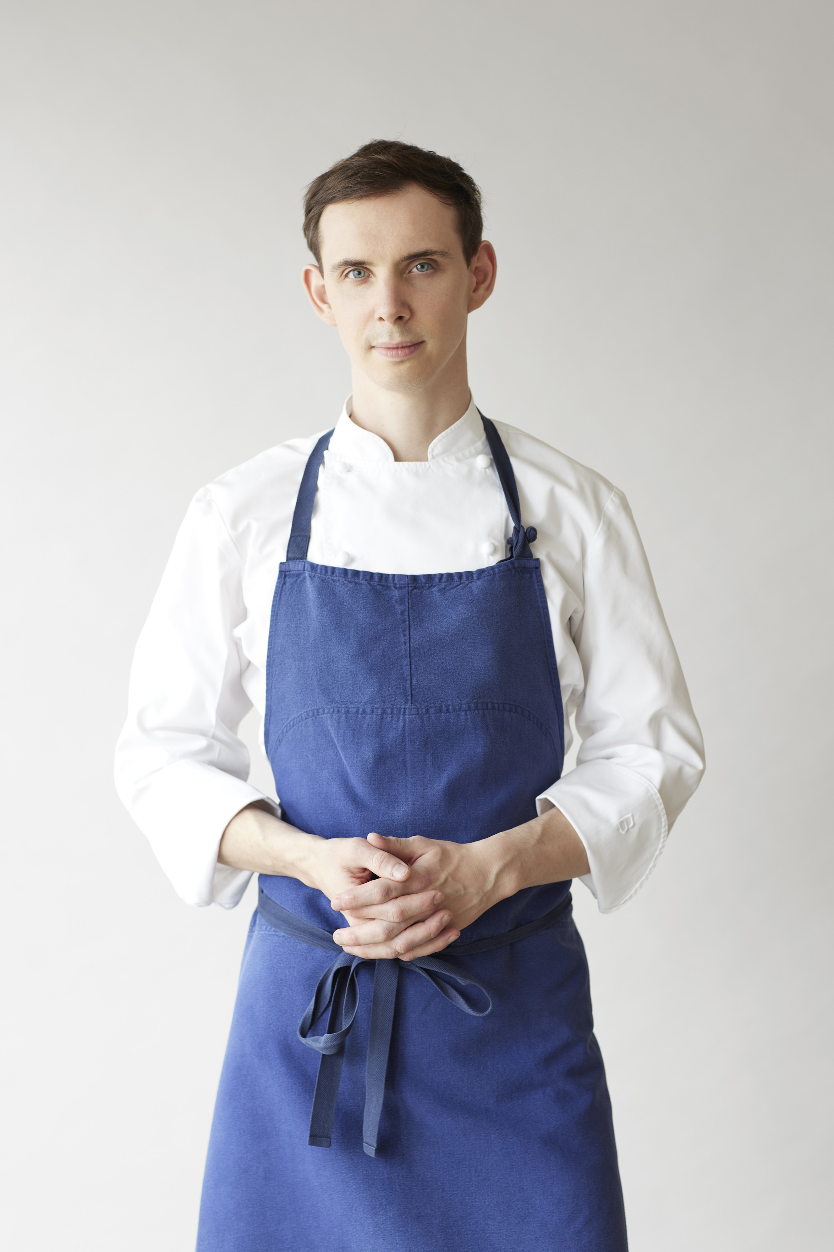
Announced in Singapore on March 28, 2023, the award re-confirmed SÉZANNE’s place among Asia’s top culinary trailblazers. The ceremony was attended by Executive Chef Daniel Calvert and Executive Sous Chef Ashley Caley.
“It’s an honour for us to be chosen as one of Asia’s 50 Best Restaurants. This award is a reflection of our team’s dedication to every step of the food journey, from procuring the best of local ingredients to completing the final touches on each plate,” says Chef Daniel. “We truly appreciate the continued support of our guests, both from Japan and overseas.”
Helmed by Chef Daniel’s singular vision, SÉZANNE has made its mark on Tokyo’s glittering gastronomic scene, quickly becoming a must-visit for epicures in the city. The restaurant currently holds a two Michelin star rating.
“It means a lot to us that diners come back again and again to SÉZANNE,” says Charles Fisher, General Manager of Four Seasons Hotel Tokyo at Marunouchi. “This is a tribute to the standard of excellence that has been created and consistently upheld by Daniel’s team.”
Dynamic French Dining 2023
Gently rising above the heart of downtown Tokyo, SÉZANNE serves classically rooted modern French cuisine, crafted with a light touch and plated with precision. There is always something new for diners to discover, with seasonally refreshed menus, an eclectic curation of Champagne, and a classical dessert experience.
Envisioned by acclaimed designed Andre Fu, the ambience speaks a language of relaxed luxury, allowing Chef Daniel’s cuisine to shine through. The contemporary interiors reflect a blend of subtle French craftsmanship and fine Japanese detailing.
The show kitchen invites diners to engage with the cooking journey, while the Chef’s Table offers an opportunity to experience SÉZANNE’s intricate culinary performance first hand. Hosted personally by Chef Daniel, this gourmet feast resonates with the visual energy of the kitchen.
Sommelier Nobuhide Otsuka curates a fine selection of Champagne, wine and sake. With SÉZANNE being a Krug Ambassador, guests can also experience the rare pleasure of Maison Krug Champagnes.
About Chef Daniel Calvert
From a low-key commuter town in southeast England to star-studded kitchens in London, Paris, New York and Hong Kong, Daniel Calvert’s self-propelled rise to stardom is the stuff of dreams. He crossed the Atlantic to hone his skills as sous chef at Per Se in New York City, followed by a placement at Epicure at Le Bristol in Paris – both reputed establishments with three Michelin stars. Living and working across several of the world’s culinary capitals has made Daniel an open-minded chef, with a willingness to embrace versatile cultural influences and ingredients.
About Asia’s 50 Best Restaurants
The Asia’s 50 Best Restaurants list was created by the Asia’s 50 Best Restaurants Academy, an influential group of over 300 leaders in the restaurant industry across Asia. Spanning six voting regions across the continent, the list is published by William Reed Business Media and known for showcasing exceptional chefs, rising culinary trends and ground-breaking dining experiences.

RELATED

March 28, 2023, Tokyo, Japan
【フォーシーズンズホテル丸の内 東京】フレンチレストラン「SÉZANNE(セザン)」が 「アジアのベストレストラン50」で2位にランクイン
https://publish.url/jp/tokyo/hotel-news/2023/sezanne-asias-50-best-restaurants-2.html

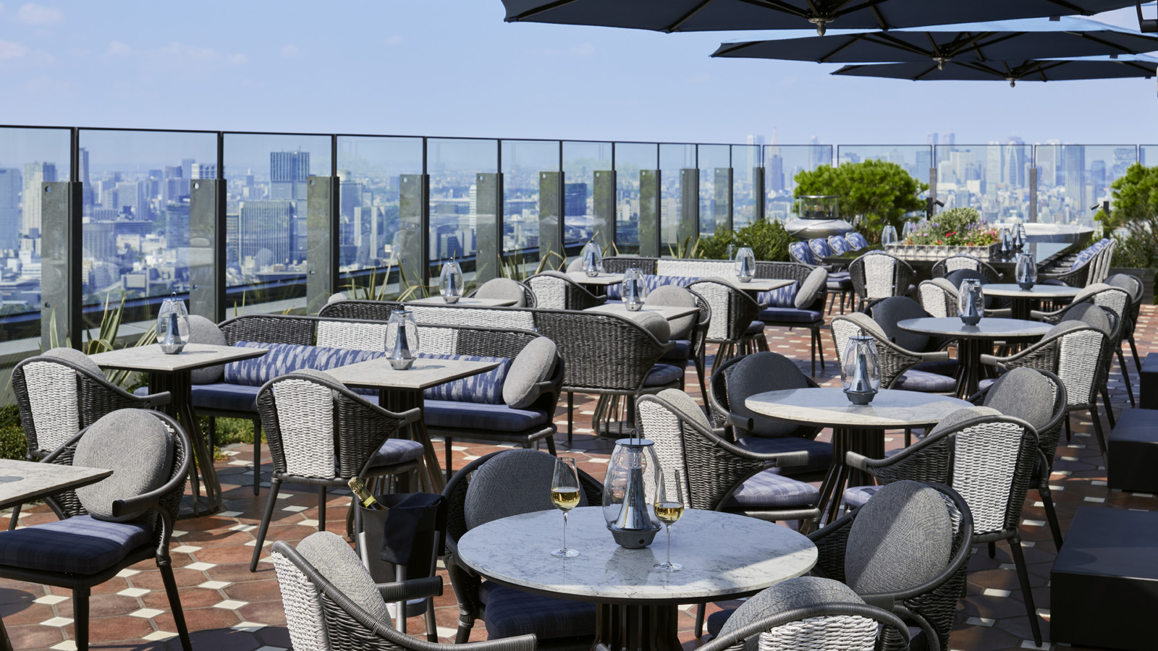 | March 27, 2023, Tokyo, Japan  上空200メートルに位置する、天空のテラスが4月10日（月）に再オープン  https://publish.url/jp/otemachi/hotel-news/2023/pigneto-terrace-reopens-2.html

PRESS CONTACTS

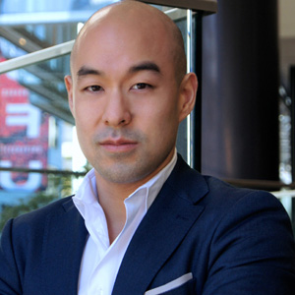 | Shingo Kido  Director of Public Relations and Communications  1-2-1 Otemachi  Chiyoda-ku, Tokyo  Japan  shingo.kido@fourseasons.com

