Cinder House at Four Seasons Hotel St. Louis Adds Spice to Valentine’s Day Celebrations with Special Menu

Plus Hotel’s Vegas-style pop up chapel brings award-winning Elvis tribute artist for weddings and vow renewals; Hotel package includes “overnight honeymoon”
January 9, 2023, St. Louis, U.S.A.

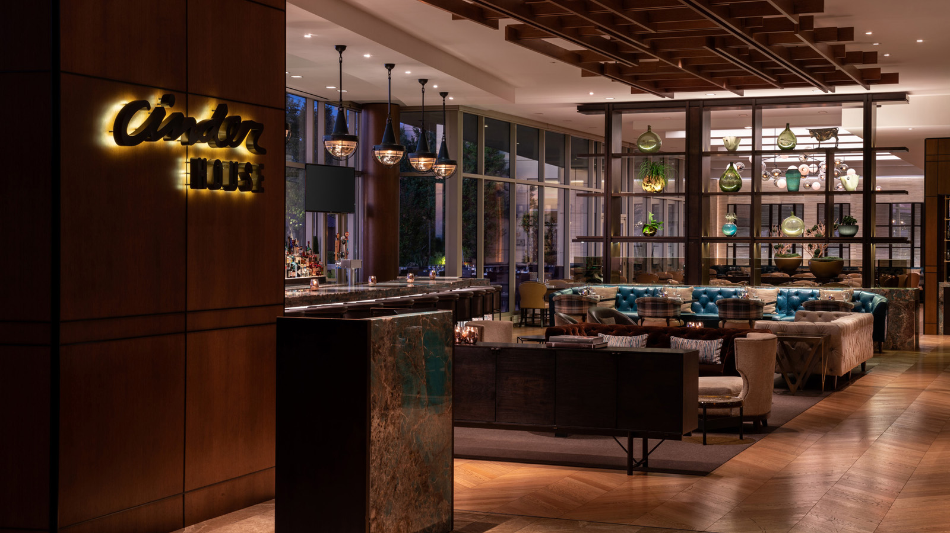
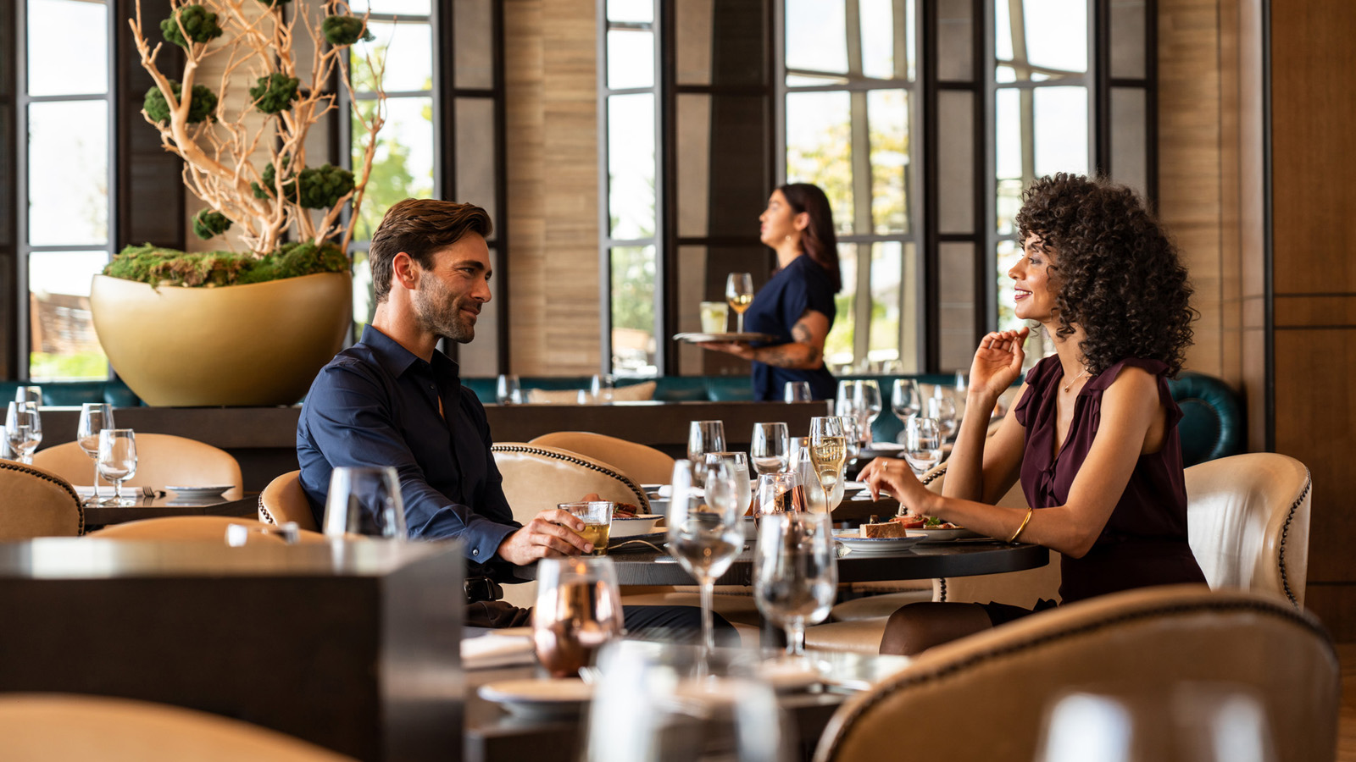
This Valentine’s Day, Four Seasons Hotel St. Louis invites couples to celebrate with one-of-a-kind experiences that will spark romance and create memories of a lifetime. Choose from a delectable three-course dinner in Cinder House or get hitched in the Hotel's very own Little White Chapel” done in the iconic style of the Las Vegas original. With a special hotel package, guests can indulge in overnight honeymoon in a sumptuous guest room.
Cinder House Valentine’s Day Menu
With breath-taking views of the iconic Gateway Arch, majestic Mississippi, and twinkling city lights, Cinder House is the perfect spot for a cosy Valentine’s Day celebration. In addition to the restaurant’s flavourful menu, Chef de Cuisine Peter Slay has created a special Valentine’s Day Prix Fixe Three-Course Dinner with touches of heat and spice along with luxurious indulgences. Guests can choose from three options for the appetizer and main course from the following menu:
Amuse Course
- Grilled Beach Cheese - Tamarind Honey, Crunchy Quinoa
First Course
- Black Truffle Tapioca Cheese Tots - XO Hot Sauce
- Winter Citrus Salad - Hearts of Palm, Fresno Chili, Avocado, Lobster Knuckle, Crab Spiced Puffed Rice
- Celery Root Veloute - Chestnut, Truffle, Black Trumpet Mushroom
Second Course
- Wood Fired Rohan Duck Duo - Confit Empanada, Vatapa, Bok Choy, Spicy Peanuts
- Parihuela - Peruvian Seafood Stew, Saffron Bomba Rice, Sofrito
- Red Wine Braised Oxtail - Yucca Gnocchi, Miropoix, Sweet Pepper, Aji Panka
Dessert
- Spicy Chocolate Mousse
The cost of the prix fixe dinner is USD 90 per person. Reservations are required and can be made on Open Table. A deposit of USD 50 will be taken at the time of booking, and will be applied to the total check at the end of the meal.
Pop-Up Vegas-Style “Little White Chapel”
What happens in St. Louis, stays in St. Louis. And, this Valentine’s Day what’s happening is a pop up Vegas-style chapel on eighth floor of Four Seasons Hotel St. Louis across from Cinder House. Created in the iconic style of the original Las Vegas “Little White Chapel,” Elvis tribute artist Terry Phillips of Close To Elvis will take centre stage to wed couples, renew vows, or hold commitment ceremonies on the evenings of February 10, 11, and 14, 2023. Clad in a classic Vegas-era Elvis jumpsuit, Terry will serenade couples who book one of the 30-minute appointments with a live processional and recessional Elvis song of their choice. Each ceremony package also includes up to ten digital photos taken by Lawrence Bryant of LB Photography to capture the moment and seating for up to ten guests. The price for each ceremony is USD 500.
For those who want to include a romantic mini break or overnight honeymoon, a package is available that features a one-night stay in one of the Hotel’s newly renovated guest rooms. The Hotel package includes accommodations for one night, an early check-in so guests can dress for the chapel, a welcome amenity, and the full ceremony program. The price of the room package starts at USD 850 plus tax. For more details and booking, send an email to elvis.stlouis@fourseasons.com

RELATED

January 4, 2023, St. Louis, U.S.A.
Can’t Help Falling in Love with the Vegas-Style Pop Up Chapel at Four Seasons Hotel St. Louis This Valentine’s Day
https://publish.url/stlouis/hotel-news/2023/valentines-day-elvis-wedding-chapel.html

December 7, 2022, St. Louis, U.S.A.
Ring in the New Year in Style at Four Seasons Hotel St. Louis
https://publish.url/stlouis/hotel-news/2022/new-years.html

PRESS CONTACTS

Teresa Delaney
Director of Public Relations
999 North 2nd Street
St Louis
USA
teresa.delaney@fourseasons.com

+1 314 881 2025

