Sky’s the Limit for Couples at Four Seasons Hotel Toronto

For the chic couple in search of unique experiences and stunning accommodations, Four Seasons Hotel Toronto unveils Sky’s the Limit
August 9, 2021, Toronto, Canada

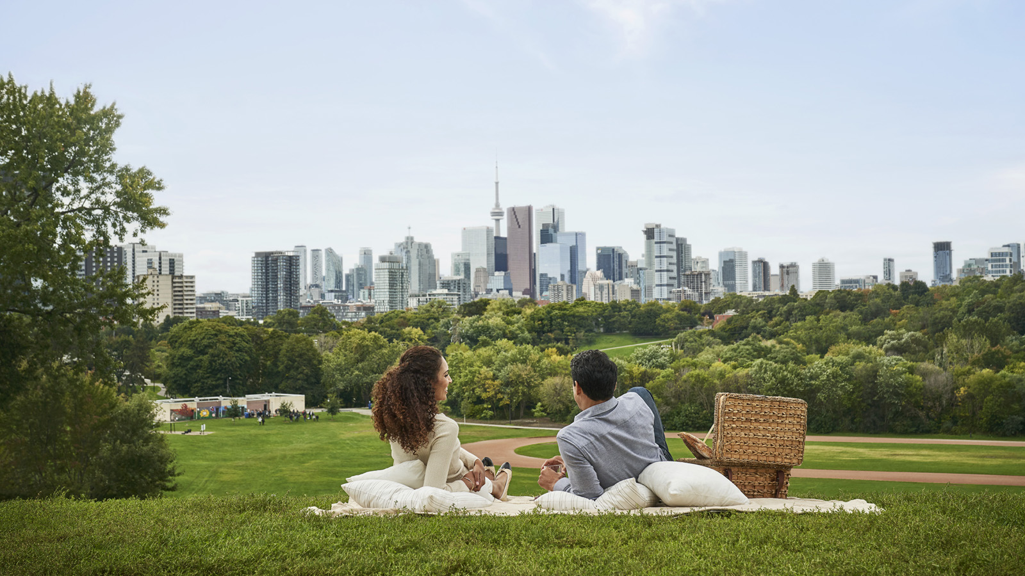
Four Seasons Hotel Toronto introduces Sky’s the Limit, where couples are invited to immerse themselves in the world of Four Seasons and enjoy the most romantic experiences in the city and within the luxe setting of the brand’s global flagship Hotel.
Sky’s the Limit has been thoughtfully created for the chic and adventurous pair in search of memorable moments. Upon arrival, guests are welcomed to the Hotel with a chilled bottle of Dom Pérignon Vintage 2010 Champagne and delicate caviar. To follow, an itinerary of breath-taking experiences includes a private helicopter tour through the iconic Toronto skyline. Back on the ground, guests will be escorted in style courtesy of the Hotel’s Maserati Quattroporte house car for a perfect night out in Yorkville or another bustling area of the city the couple wishes to explore with an itinerary carefully curated by Chef Concierge Carolina Aviara. At the Hotel’s Forbes Five-Star Spa, a private evening atop Cloud 9 awaits. Sip Champagne while indulging in a poolside couple’s treatment before plunging into a night swim surrounded by rose petals and the warm glow of candles.
“Offering guests access to exclusive experiences that can only be found here characterises our signature hospitality,” says Chad Merced, Hotel Manager. “As our city comes to life once again, we are excited to show our guests the vibrant city of Toronto through the lens of true luxury.”
In true Four Seasons fashion, Sky’s the Limit takes couples on a culinary journey featuring a six-course Chef’s table in Café Boulud and an expertly-chosen wine pairing. To begin each leisurely morning, guests can also look forward to unique brunch experiences including Champagne, caviar and gourmet Caesars. Delectable menu items include lobster avocado toast, rosti benedict skillet with Montreal smoked meat and truffle hollandaise, and mouth-watering mascarpone and orange French toast. The evenings will end with a Signature Nightcap, macaron ispahan and seasonal fruit amenity in the comfort of their perfectly appointed accommodations, the Hotel’s most sought-after Royal or Presidential Suites.
For more information, click here or call 416 964 0411 to book this package.

RELATED

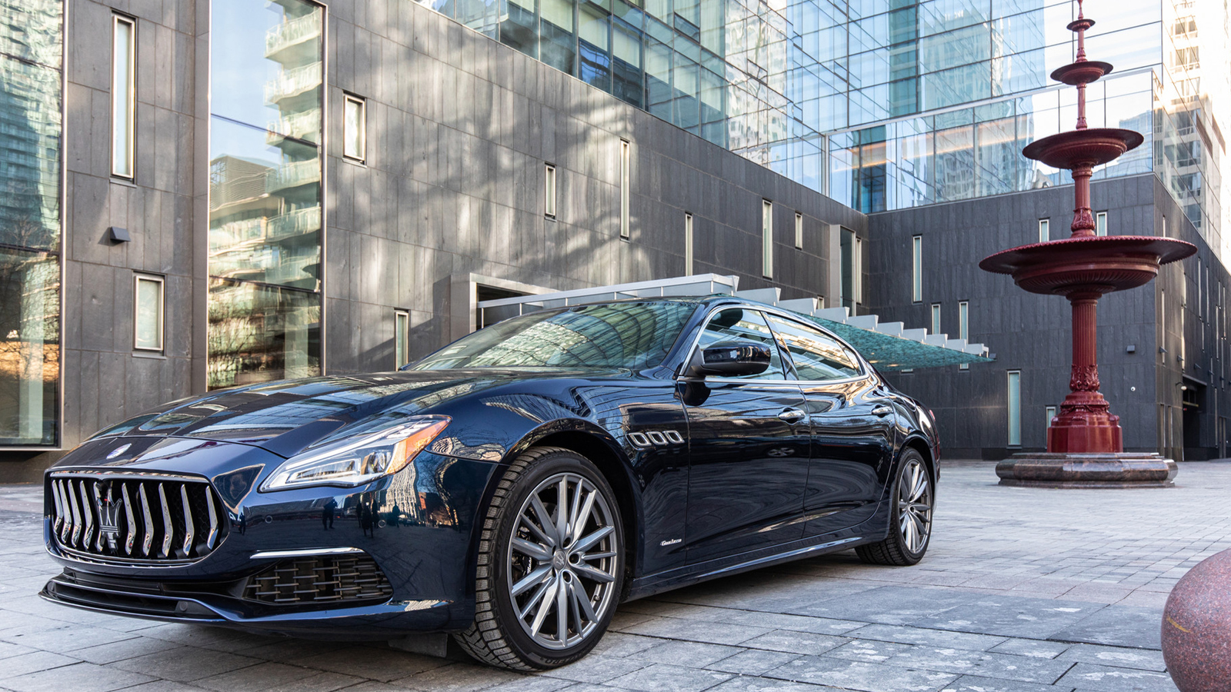 | July 20, 2021, Toronto, Canada  Maserati Quattroporte Named as the Official House Car of Four Seasons Hotel Toronto  https://publish.url/toronto/hotel-news/2021/new-maserati-house-car.html
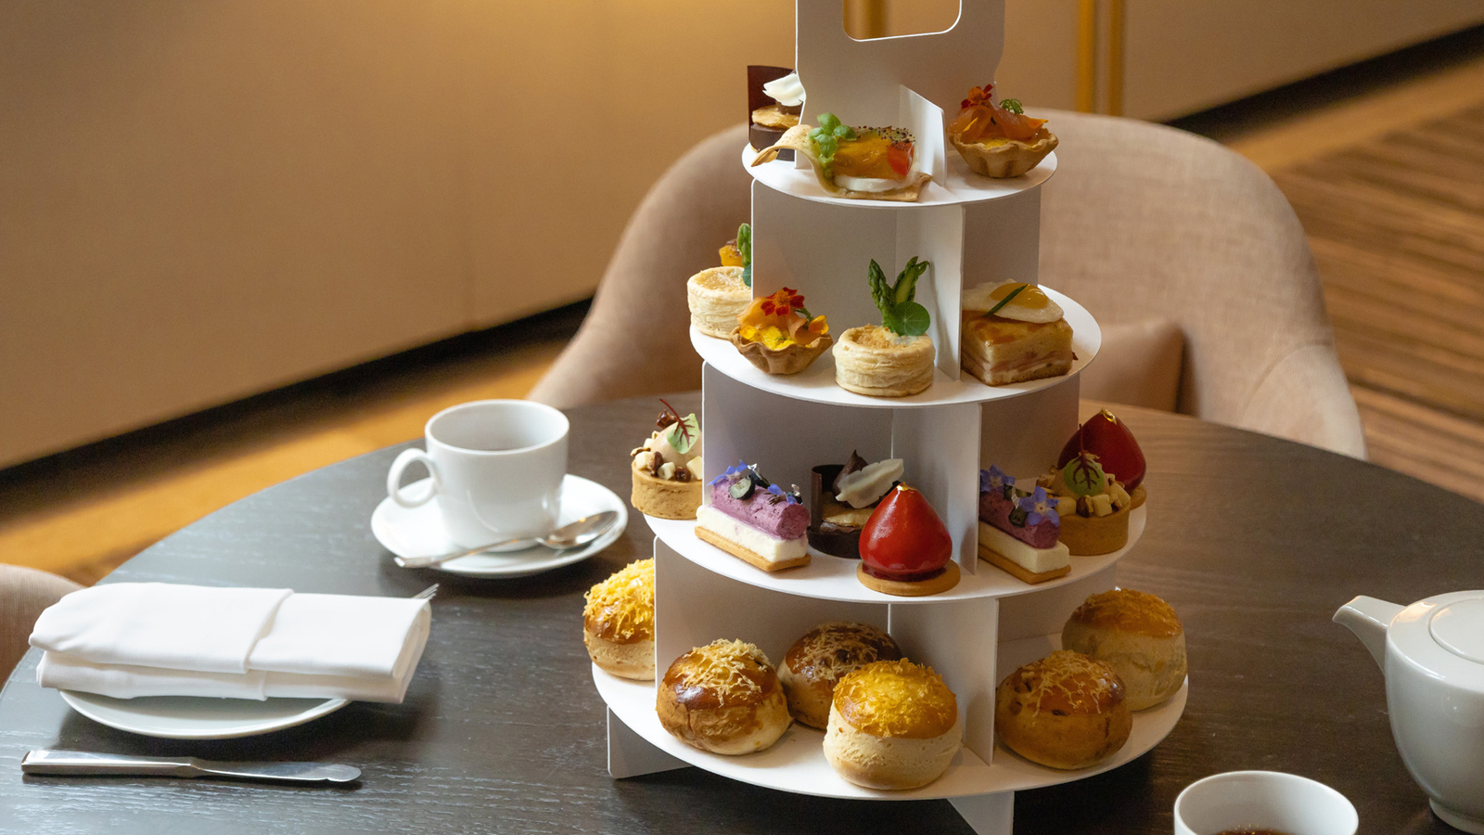 | July 8, 2021, Toronto, Canada  Four Seasons Hotel Toronto and Cheese Boutique Announce an Exclusive Afternoon Tea Collaboration  https://publish.url/toronto/hotel-news/2021/cheese-boutique-afternoon-tea.html

PRESS CONTACTS

Halla Rafati
Public Relations Director
60 Yorkville Avenue
Toronto
Canada
halla@haloandco.co

+1 416 364 0404

