Celebrate an Eggceptional Easter at Four Seasons Resort Scottsdale at Troon North

Enjoy a bountiful brunch and egg hunt at Four Seasons
March 21, 2019, Scottsdale, U.S.A.

Indulge in a lavish gourmet brunch at Talavera or hop over to Proof, An American Canteen for a more casual celebration this Easter Sunday, April 21, 2019 and be sure to stay for the annual Easter Egg Hunt at Four Seasons Resort Scottsdale at Troon North.
Talavera
Continuing its tradition of treating guests to a bountiful brunch, Talavera restaurant will present an indulgent Easter buffet. The menu will include a seafood and raw bar, a tapas and spring salads selection, a carving station with roasted leg of lamb, beef rib roast and salmon, omelets made to order, a charcuterie and cheese station, baked lemon ricotta pancakes and much more. Dessert lovers will enjoy a host of sweet choices including a dessert action station featuring fairy floss chocolate-centred lollipops and assorted cotton candy with chocolate centres. A children’s buffet will offer baby carrot crudité with hummus, pigs in a blanket, mini deep dish cheese pizzas, grilled chicken breast, fruit cups and vegetables and steamed rice plus Nutella and marshmallow crème pizzas for dessert. Talavera’s Easter brunch buffet will be served from 10:00 am to 2:00 pm and is priced at USD 118 per adult and USD 48 per child for ages 5 to 12. Prices are exclusive of tax and gratuity. Reservations are required.
Proof
Proof, an American Canteen, will offer an enhanced breakfast and brunch buffet as well as Easter Sunday Dinner specials. Specialty brunch items will include carrot cake muffins, slow roasted pork belly and honey-orange waffles with cardamom syrup. The Proof brunch buffet, available from 7:00 am to 1:00 pm, is USD 42 per person for adults, and USD 20 for children ages 5 to 12. An a la carte menu also will be available from 1:00 to 3:00 pm. The dinner specials, served a la carte, include melon salad with goat’s milk feta cheese, house-made sheep’s milk ricotta ravioli, smoked lamb roulade and chocolate cherry cake as the specialty dessert. Regular Proof dinner menu items also will be available. Dinner will be served from 4:00 to 9:30 pm. Prices are exclusive of tax and gratuity. Reservations are highly recommended.
Easter Egg Hunt
Families who dine at Talavera or Proof on Easter Sunday will be invited to get hoppin’ to the picturesque Ironwood Terrace where the Resort will host additional activities with Pinnacle Peak as the backdrop. Egg hunts will be held at 10:00 am and again at 1:00 pm. Plus, the Easter Bunny will make special appearances throughout the day. Activities such as face painting, balloon animal making, crafts and games will be open to Talavera and Proof brunch guests as well as Resort guests.
For reservations or additional information regarding Easter activities and rates, call Four Seasons Resort Scottsdale at 480 513 5085.

RELATED

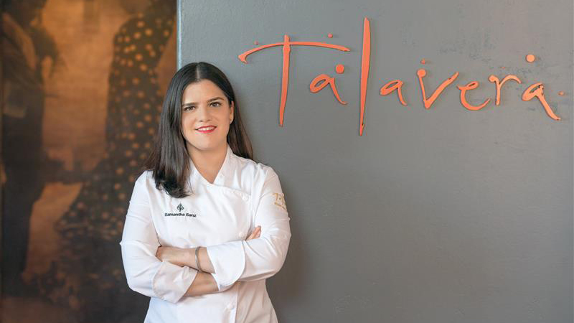 | March 19, 2019, Scottsdale, U.S.A.  Four Seasons Resort Scottsdale Chef Earns Top Culinary Kudos  https://publish.url/scottsdale/hotel-news/2019/james-beard-award-nominated-chef-samantha-sanz.html
February 25, 2019, Scottsdale, U.S.A.
Plan Ahead for Spring at Four Seasons Resort Scottsdale at Troon North
https://publish.url/scottsdale/hotel-news/2019/spring-break.html

PRESS CONTACTS

Jennifer Franklin
Director of Public Relations and Communications
10600 East Crescent Moon Drive
Scottsdale
U.S.A.
jennifer.franklin@fourseasons.com

+1 (480) 513-5049

