A Wonderful Winter: Four Seasons Hotel Beijing Introduces Winter Program for Kids

December 21, 2018, Beijing, China

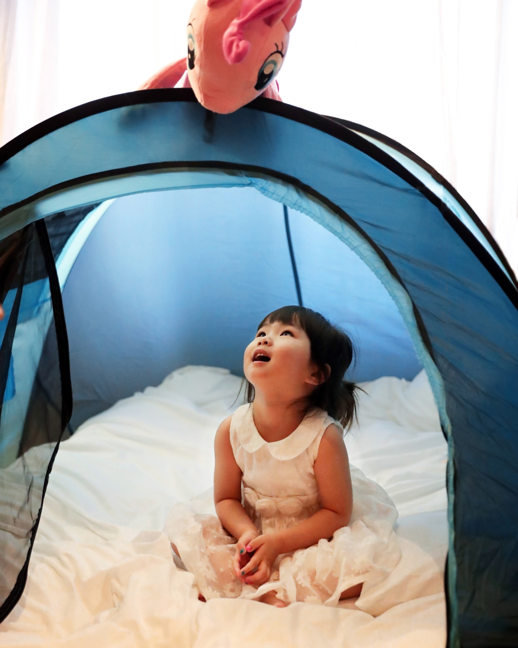
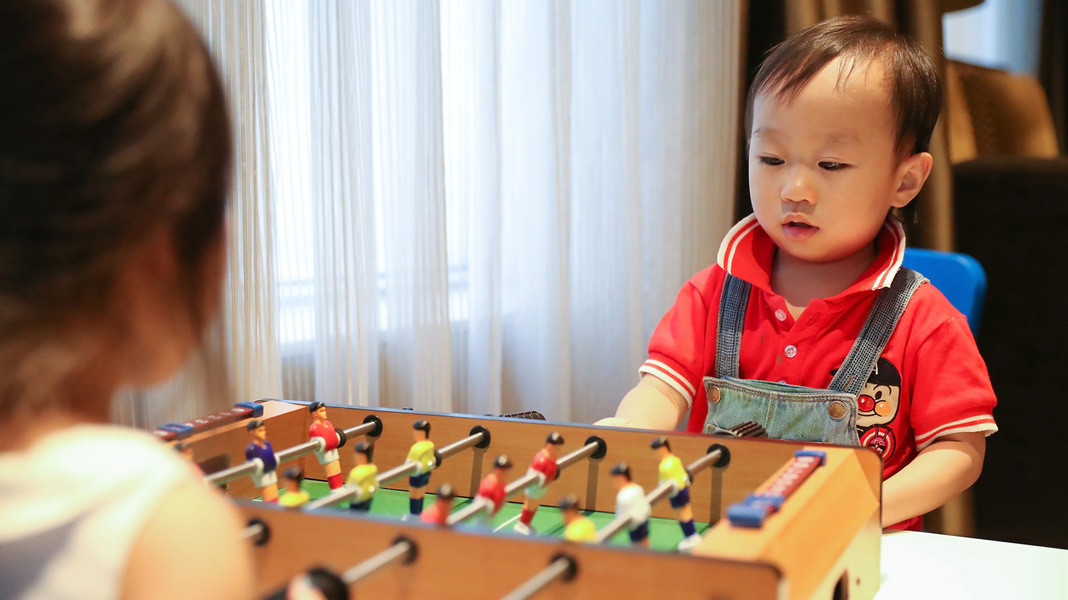 |  | 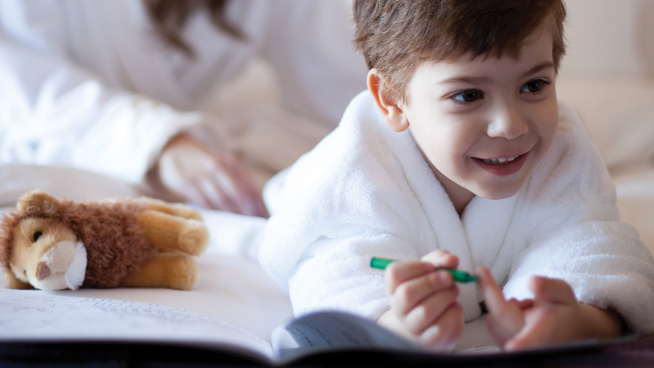
Winter may be a time to cosy up indoors, but that doesn’t mean it has to be boring. At Four Seasons Hotel Beijing, winter is a time for exploration and festive holiday fun, with an array of activities for kids in a unique Winter Program that ensures a vacation during the cooler months will be anything but forgettable.
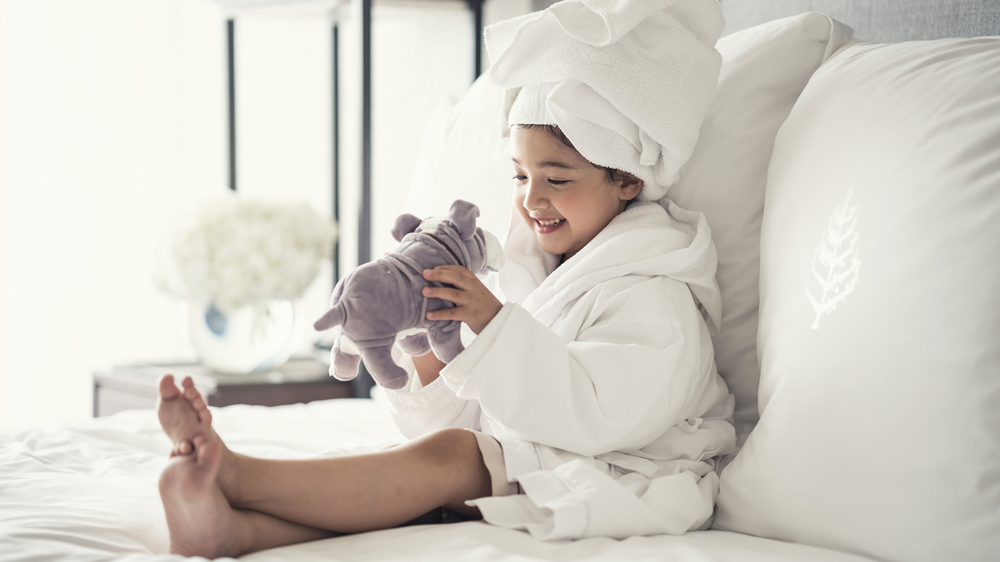
From baking cookies and building a gingerbread house with an executive chef to joining an exclusive yoga class by the pool with Mom and Dad, the Winter Program offers stimulating experiences that engage kids both mentally and physically while they have the time of their lives.
Kids will get a true taste of the holiday season with a special baking class with Executive Pastry Chef Wendy Bai, who will teach them to make delicious gingerbread cookies, and an even tastier gingerbread house. Or, kids can team up with the in-house florist to create panes of gorgeous dried, pressed flowers while sipping afternoon tea.
Mom and Dad can relax with the kids in a yoga session by the pool, before the little ones slip away to unleash their creativity in a special art class with the Four Seasons Hotel Beijing Artist in Residence. And winter wouldn’t be winter without a spectacular Christmas tree decorating session with the talented Four Seasons Hotel Beijing florist.
The fun doesn’t stop there. Kids will discover even more excitement when checking in, as the Four Seasons Hotel Beijing Guest Experience team will whip up customised in-room welcome amenities for little guests, transforming guest rooms into wonderlands of delight.
Make this winter a time of discovery and joy for the whole family at Four Seasons Hotel Beijing.
Chat with the Guest Experience team via Four Seasons Mobile App or Facebook Messenger to learn more or to make special requests.

RELATED

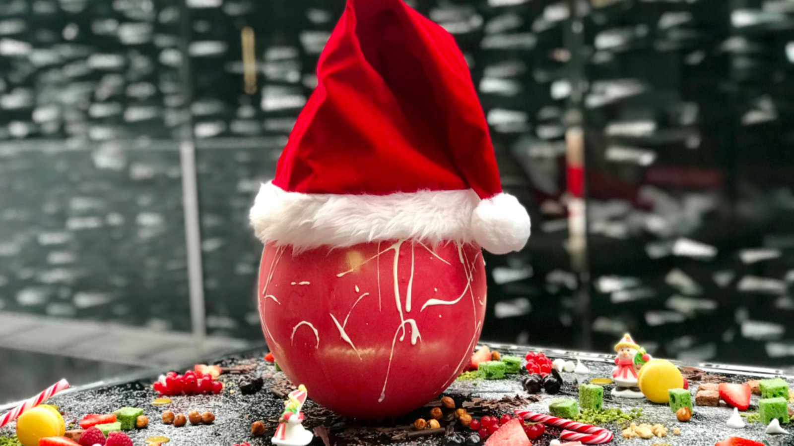 | December 13, 2018, Pudong, Shanghai, China  精彩年末·节日庆典  https://publish.url/zh/pudong/hotel-news/2018/festive-season-2.html
December 13, 2018, Pudong, Shanghai, China
Seasonal Celebrations with Festive Luxury at Four Seasons Hotel Pudong, Shanghai
https://publish.url/pudong/hotel-news/2018/festive-season.html

PRESS CONTACTS

Emilie Zhang
Assistant Director of Public Relations
48 Liang Ma Qiao Road Chaoyang District
Beijing
China
emilie.zhang@fourseasons.com

+86 10 5695 8706

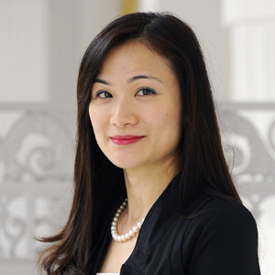 | Vivian Koh  Director, Public Relations and Content, Asia-Pacific  Tourism Court, 1 Orchard Spring Lane #04-01  Singapore  Singapore  vivian.koh@fourseasons.com  +65 6739 5806

