Cinder House at Four Seasons Hotel St. Louis Welcomes Miami’s Executive Chef Aaron Brooks for “A Chef For All Seasons” Dinner in July

June 16, 2022, St. Louis, U.S.A.

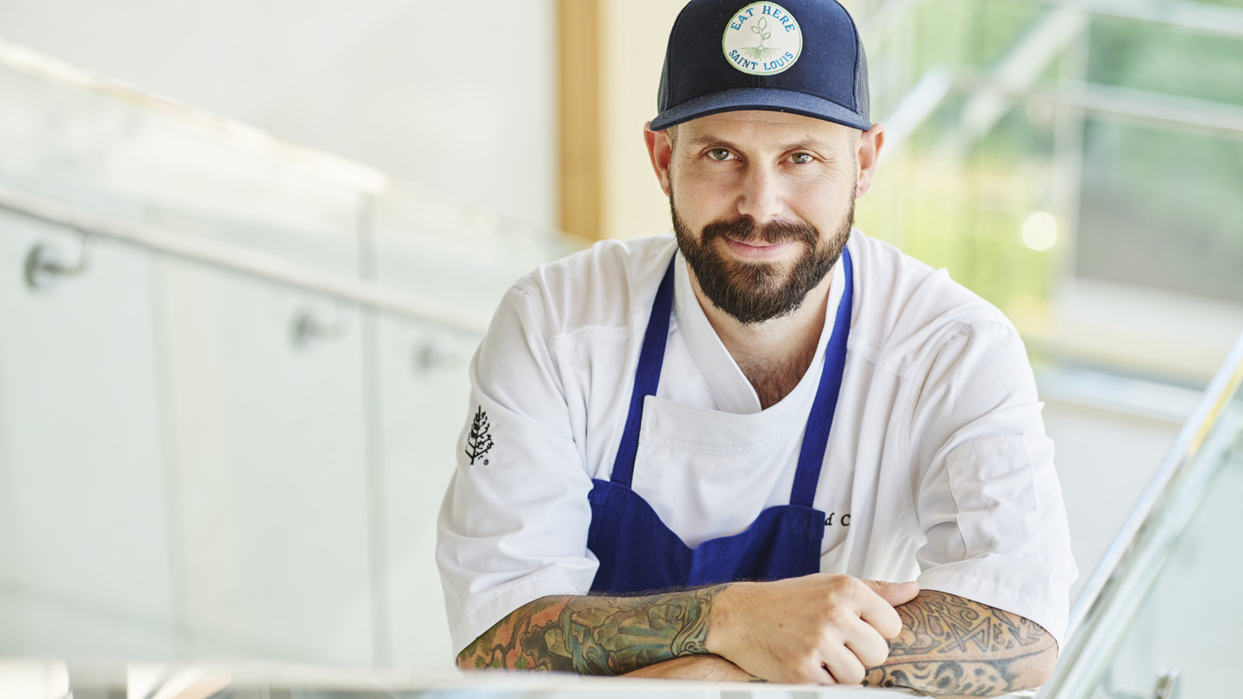
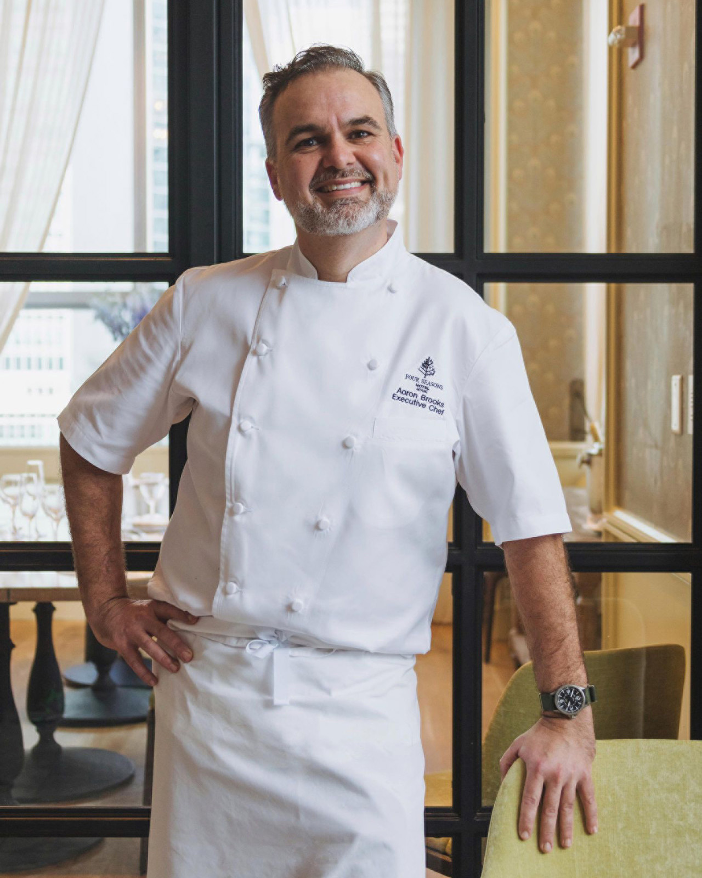 | 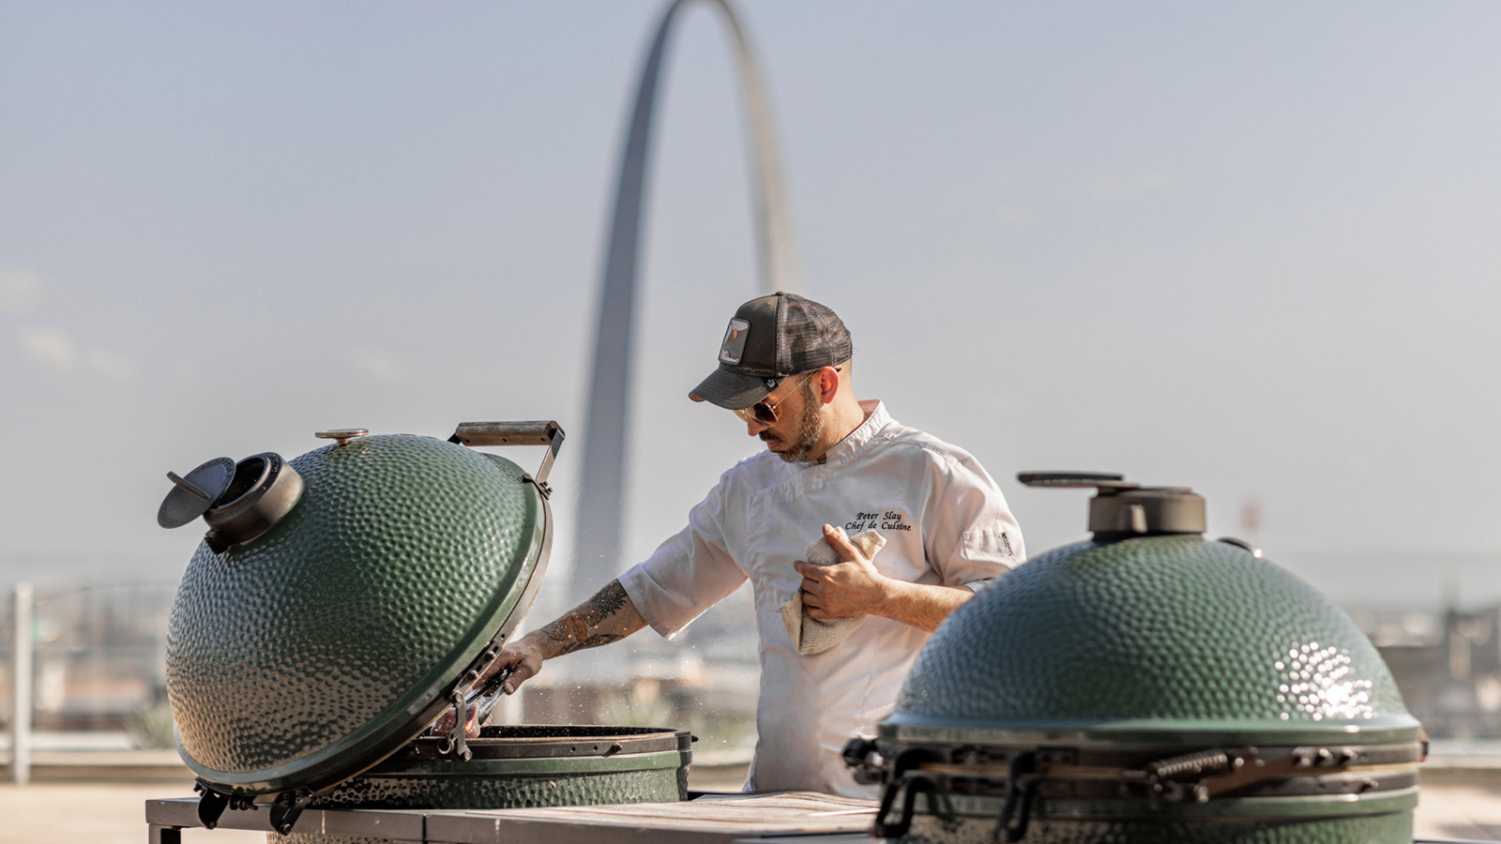
Four Seasons Hotel St. Louis announces the program and menu for the next A Chef For All Seasons dinner featuring Executive Chef Aaron Brooks of EDGE, Steak & Bar at Four Seasons Hotel Miami to be held at its Cinder House on Thursday, July 28 and Friday, July 29, 2022. This is the second dinner in the series of three that celebrates the culinary craftsmanship of the Four Seasons brand, which is globally recognized for its exceptional dining options.
Dubbed an Aussie Barbecue With Latin Flavours, the star of the evening will be Chef Brooks’ tomahawk steaks, cooked as they are suspended above two Big Green Eggs on the Cinder House terrace. First seasoned with his EDGE Steak signature rub, Chef Brooks then slow roasts the steaks hanging above the grill to bring out a rich and intense flavour. Lastly, he sears the steaks on the hot grill and then serves them with Peruvian Anticucho sauces.
The evening will begin with passed canapés accompanied by the Cinder House Maracuya cocktail, while guests can opt to head al fresco or a first-hand look at the chefs’ innovative grilling techniques. Dinner will be seated inside the Cinder House dining room with a multi-course menu served family style. Highlights in addition to the Tomahawk Steaks include: local heirloom tomato consommé - confit cherry tomato, compressed cucumber, chia seed, bush basil, coriander oil; BBQ yellow fin tuna loin with black garlic, oyster sauce, aji panca, dried lime, tomari; and, quinoa and roasted corn salad with a meyer lemon vinaigrette.
There will be one seating with cocktails starting 6:00 pm and followed by dinner. This dinner experience is USD 125 per person (plus tax and gratuities) and includes a signature cocktail, canapés and the multi-course dinner. An optional wine pairing is available on request. Seating is limited, reservations are required, and can be made on OpenTable.
The concept of Chef Brooks’ EDGE, Steak & Bar at Four Seasons Hotel Miami is to offer the integrity of a modern steakhouse but focus on a “savour-more” concept, inviting diners to enjoy great flavours in an enhanced social dining experience. He earned himself and the restaurant recognitions, such as one of Miami's "Hot Shot Chefs," a "Man of Meat," one of the "Hottest Places to Eat and Drink in Miami," listed on The Miami Herald's 2016 Food 50 list, and most recently "Best Chef in Miami" and "Best Restaurant in Miami," by Miami New Times.
The final A Chef For All Seasons Dinner will take place October 6 and 7, 2022 with Chef Greg Vernick of Vernick Fish at Four Seasons Hotel Philadelphia. Chef Vernick serves a personal take on his favourite hallmarks of American oyster bar fare and is committed to sourcing the best seafood and preparing it using the best techniques. His accolades include recognition from Food & Wine, Bon Appetit, StarChefs, Philadelphia magazine, The Washington Post, The New York Times, and more. Greg was also named the Best Chef: Mid-Atlantic by the James Beard Foundation and “Chef of the Year” by the Philadelphia Inquirer. Greg’s other restaurants include: Vernick Coffee Bar, also in partnership with Four Seasons Hotel Philadelphia, his debut restaurant Food & Drink and a tasting menu experience at Vernick Wine shop. Menu highlights and booking details will be available closer to the date.

RELATED

June 3, 2022, St. Louis, U.S.A.
Cinder Bar Launches “Tasting Thursdays” on the Rooftop at Four Seasons Hotel St. Louis This Summer
https://publish.url/stlouis/hotel-news/2022/tasting-thursdays-at-cinder-bar.html

May 24, 2022, St. Louis, U.S.A.
Celebrate Dad in a Big Way at Cinder House at Four Seasons Hotel St. Louis with Craft Beer and Whiskey Flights Served with Grilled Tomahawk Steaks
https://publish.url/stlouis/hotel-news/2022/fathers-day.html

PRESS CONTACTS

Teresa Delaney
Director of Public Relations
999 North 2nd Street
St Louis
USA
teresa.delaney@fourseasons.com

+1 314 881 2025

