Experience the Flavours of Italy with “A Night in Tuscany and Piedmont” at Culina Restaurant at Four Seasons Hotel Los Angeles at Beverly Hills

Executive Chef Fabrizio Schenardi from Four Seasons Resort Orlando to cook alongside Culina’s Chef de Cuisine Luca Moriconi
September 23, 2019, Los Angeles at Beverly Hills, U.S.A.

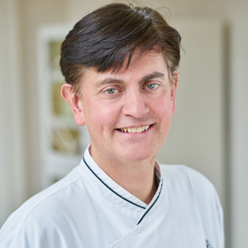
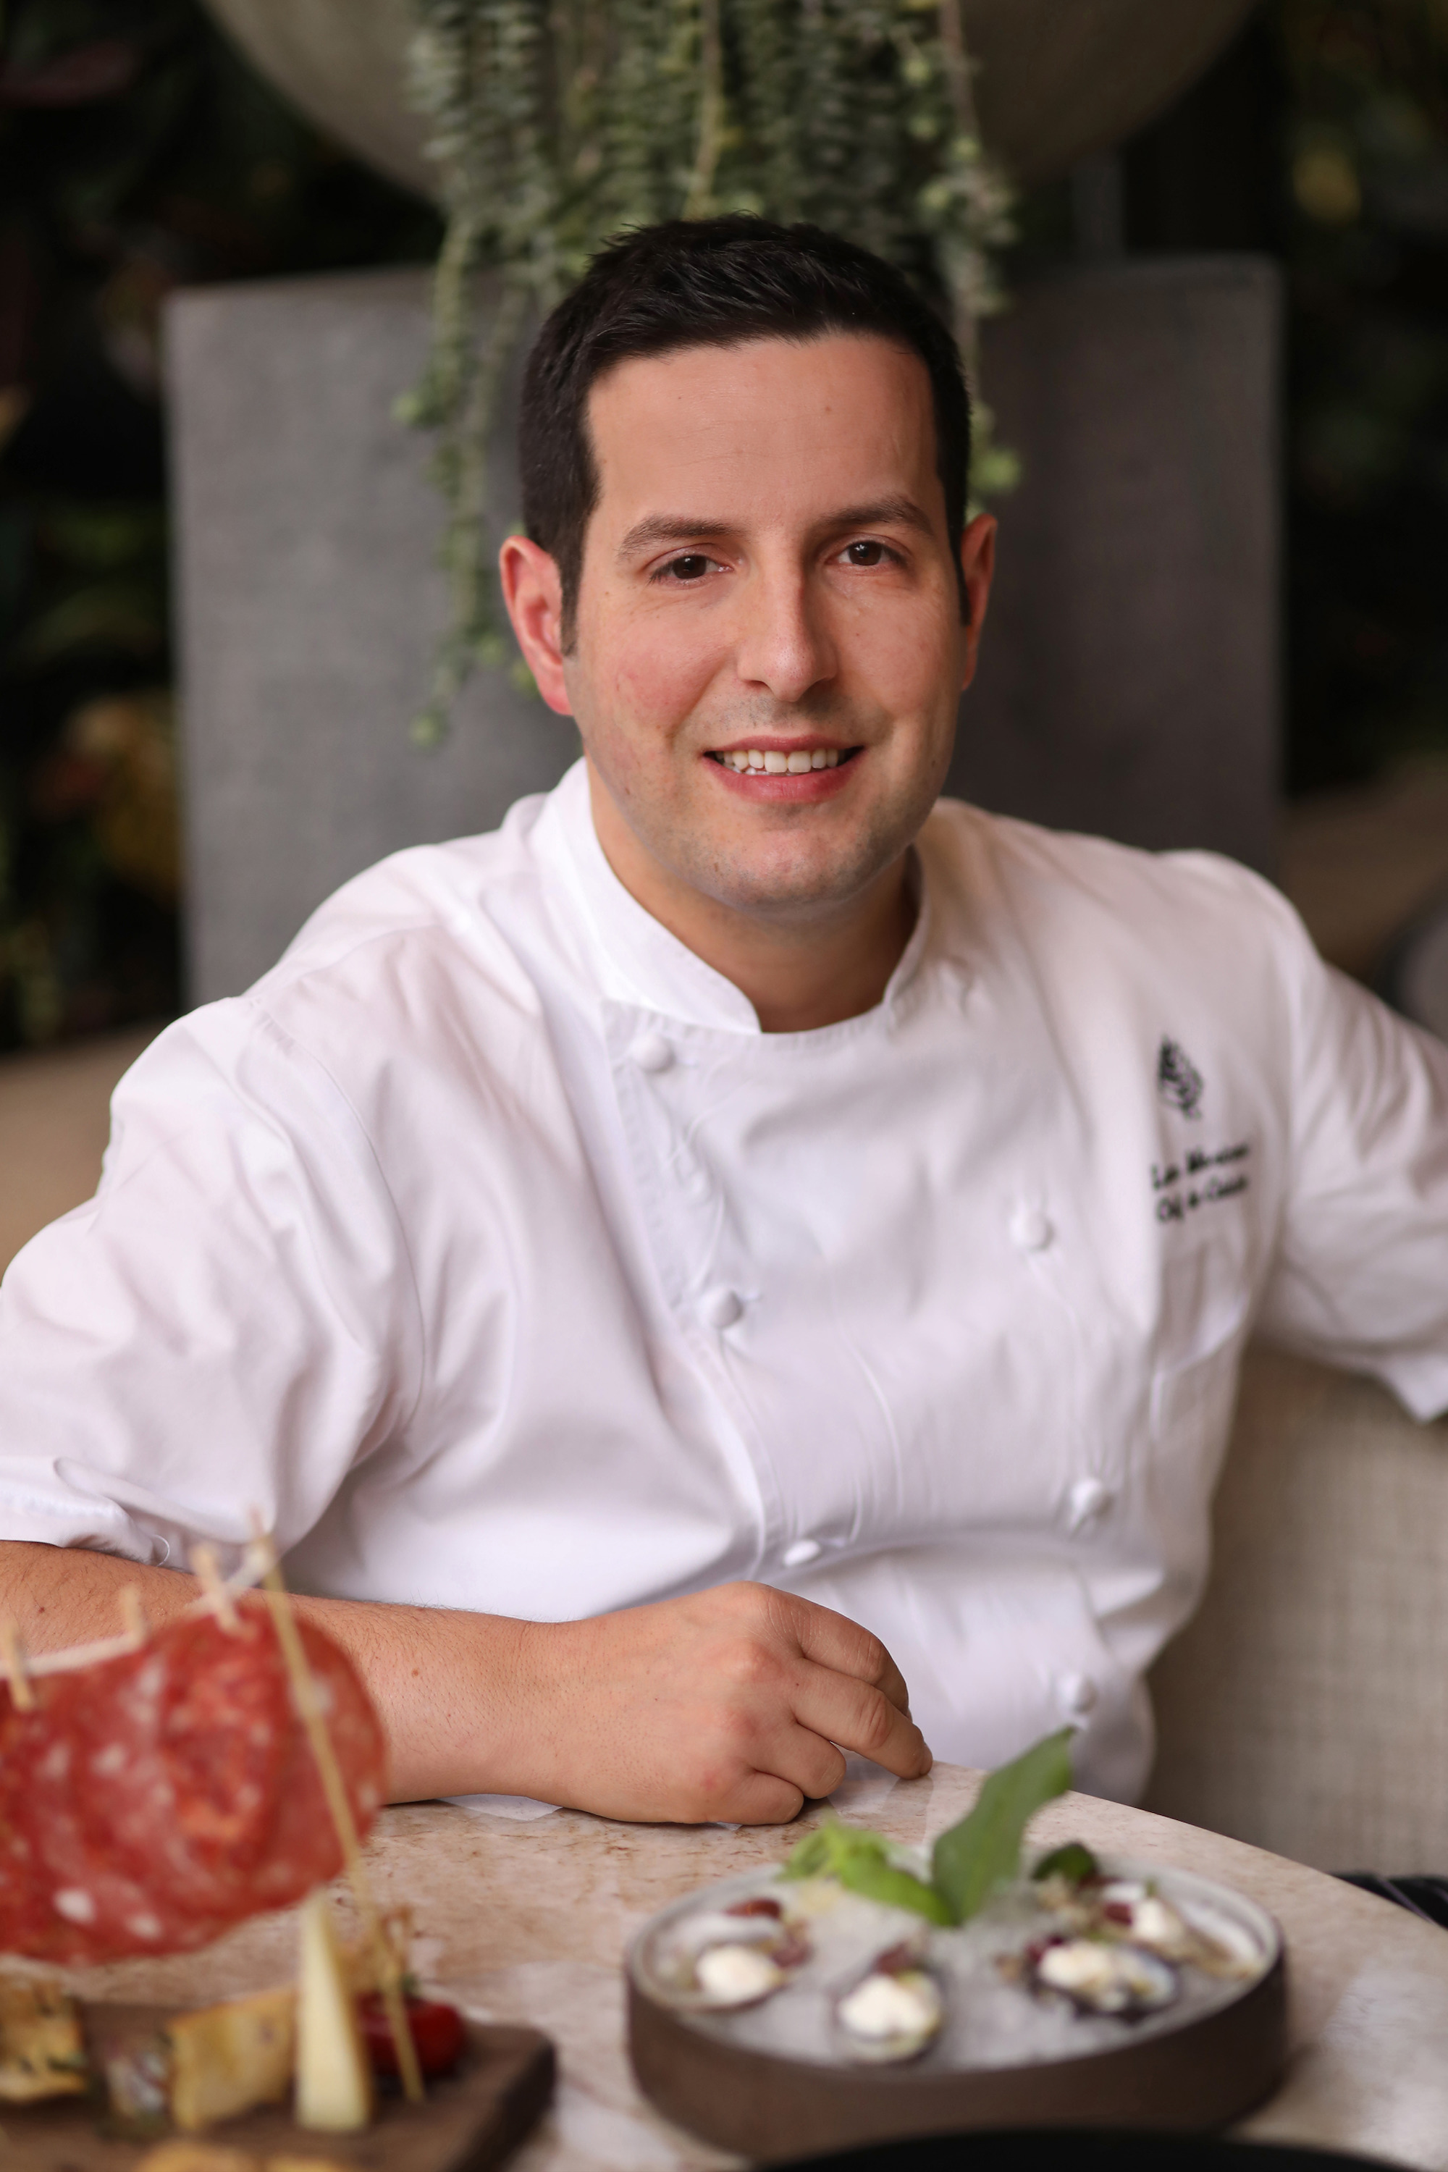 | 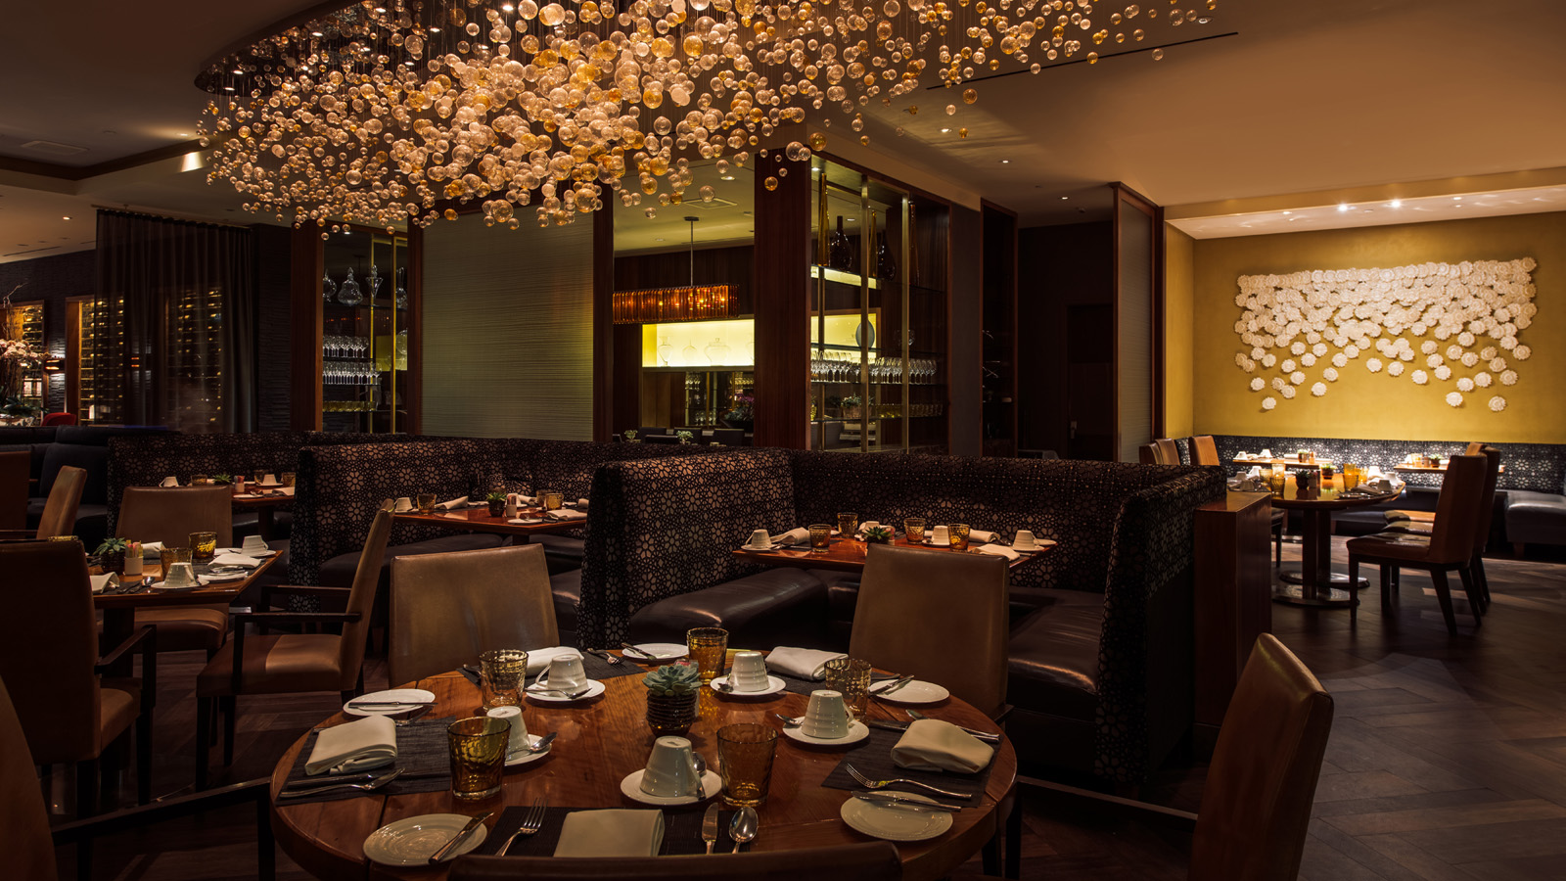
Two talented chefs who hail from two different regions in Italy are combining their culinary talent to present a delicious Italian dinner at Culina restaurant at Four Seasons Hotel Los Angeles at Beverly Hills. The menu will be a celebration of the flavours of fall, including the seasonal truffle. In addition to Chef de Cuisine Luca Moriconi from the Tuscany region, Four Seasons Resort Orlando at Walt Disney World Resort Executive Chef Fabrizio Schenardi, who is from the Piedmont region of Italy, will be welcomed as a special guest chef for the evening. Each chef will prepare dishes respective of their region.
“I am honoured to cook alongside Chef Luca, and I look forward to cooking for Angelenos and guests of Four Seasons Hotel Los Angeles, highlighting cuisine from my homeland,” says Schenardi, who was born and raised in Torino and in 2015 received the prestigious Paolo Bertani Award for promoting Italian culinary culture. Schenardi oversees all of the culinary operations at Four Seasons Resort Orlando, including the Italian restaurant Ravello, and signature rooftop steakhouse Capa. Raised above his grandparents’ bakery, Schenardi literally grew up in a kitchen. His passion for his Italian cuisine is evident in his cooking, as Ravello has raised the bar for Italian cuisine in the Orlando area. Schenardi and team make all of the pasta, pizza dough, and breads fresh in house. Many of the recipes Schenardi uses are passed down from his grandmother; some updated with a “Fabrizio twist” to give them a modern flair. He was an invited guest chef at the James Beard House in New York in 2016, and annually, he hosts a James Beard guest chef dinner at the Resort.
Moriconi has been part of the Four Seasons family since 2008, beginning as a Junior Sous Chef at the Michelin-starred Il Palagio Restaurant at Four Seasons Hotel Firenze before serving as the resident Italian Restaurant Chef at Four Seasons hotels in Damascus, Amman and Palm Beach. Moriconi’s love for sharing exceptional ingredients and exquisite dining experiences has been long encouraged throughout his time with Four Seasons, and he brings his authentic and inventive culinary point of view to the Hotel’s Italian dining destinations, Culina and Vinoteca. His greatest intention at Culina and Vinoteca is to transcend guest expectations by offering an elevated culinary journey through personalised touches and thoughtful presentation.
Chefs Moriconi and Schenardi will present the following prix-fixe menu on October 24, 2019 at USD 95 per person or available with a wine pairing for USD 155 per person:
First Course by Chef Moriconi
- Zuppetta di Farro - spelt and borlotti bean soup, rosemary-infused EVOO, lardo tartare, ciabatta bread chips
Second course by Chef Schenardi
- Agnolotti del Plin e Tartufo - Piedmont-style ravioli, butter and sage sauce, seasonal truffle, Parmigiano reggiano
Third course by Chef Moriconi
- Baccala e Porri - stewed salted cod fish, leeks, cipollini onions, Vernaccia wine xauce
Fourth course by Chef Schenardi
- Guancia di Vitello Brasata - braised veal cheek, chick pea puree, lemon, raisin and saffron sauce
Fifth Course - Dolce Finale by Chef Moriconi and Chef Schenardi
- Crostata di Fragole – Harry’s Berries strawberries, pinenut gelato, cinnamon sugar crust, strawberry jam, and semifreddo al torroncino e gianduja
- Wild berries and limoncello sauce
This is an intimate special dinner, and seating is limited. For reservations, call 310 860 4000.

RELATED

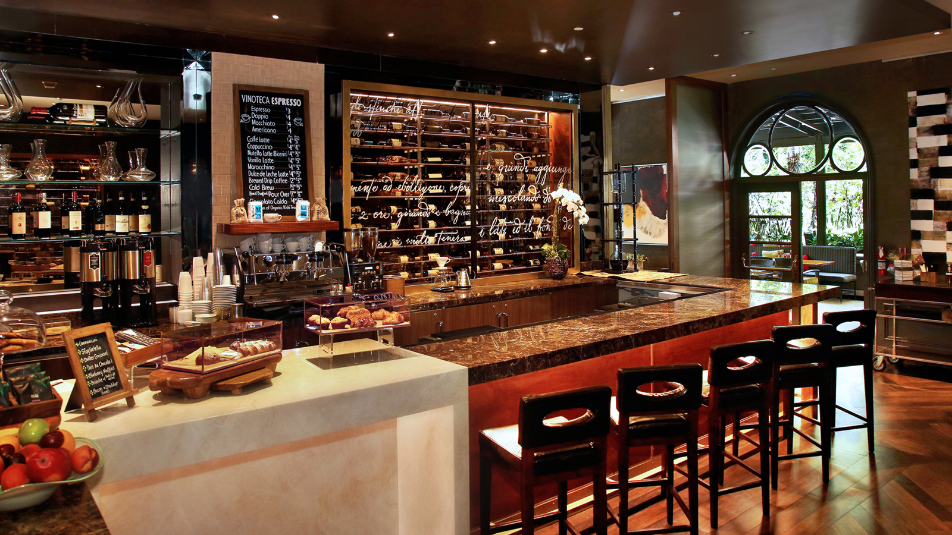 | September 5, 2019, Los Angeles at Beverly Hills, U.S.A.  Celebrate Fall at Four Seasons Hotel Los Angeles at Beverly Hills with a Culina Cab Fest and End of Summer Barbecue  https://publish.url/losangeles/hotel-news/2019/culina-cab-fest-and-end-of-summer-barbecue.html
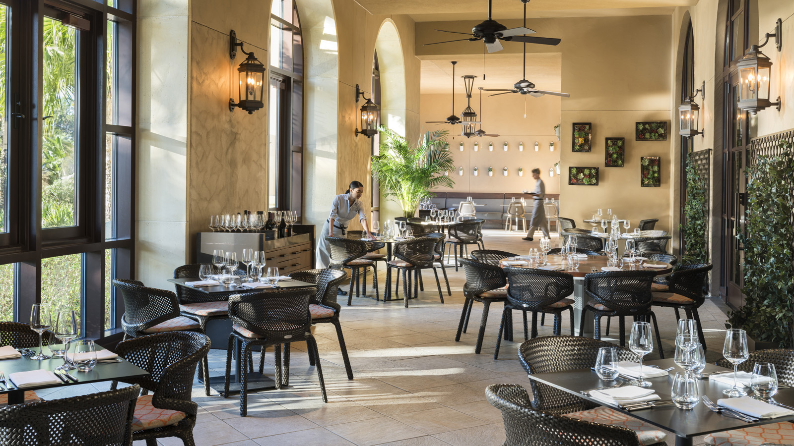 | August 15, 2019, Orlando at Walt Disney World Resort, U.S.A.  Four Seasons Resort Orlando Announces Magical Dining Menu at Ravello  https://publish.url/orlando/hotel-news/2019/magical-dining-menu-at-ravello.html

PRESS CONTACTS

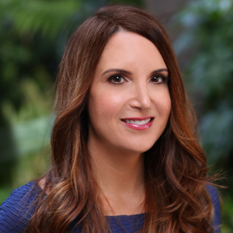 | Kim Kessler  Director of Public Relations  300 South Doheny Drive  Los Angeles  U.S.A  kim.kessler@fourseasons.com  1 (310) 786 2212
Melanee Shale
Digital Marketing Manager
300 South Doheny Drive
Los Angeles
U.S.A.
melanee.shale@fourseasons.com

+1 (310) 786-2217

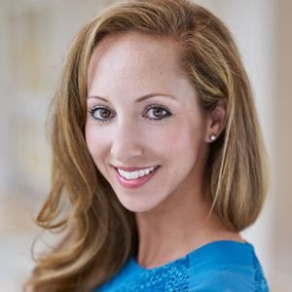 | Dana Berry  Director of Public Relations  10100 Dream Tree Boulevard  Orlando  U.S.A.  dana.berry@fourseasons.com  1 (407) 313-7777

