Celebrate the Spirit of Malaysia at Four Seasons Hotel Kuala Lumpur

Sample beguiling flavours from across the country at two incredible gastronomic events
August 13, 2019, Kuala Lumpur, Malaysia

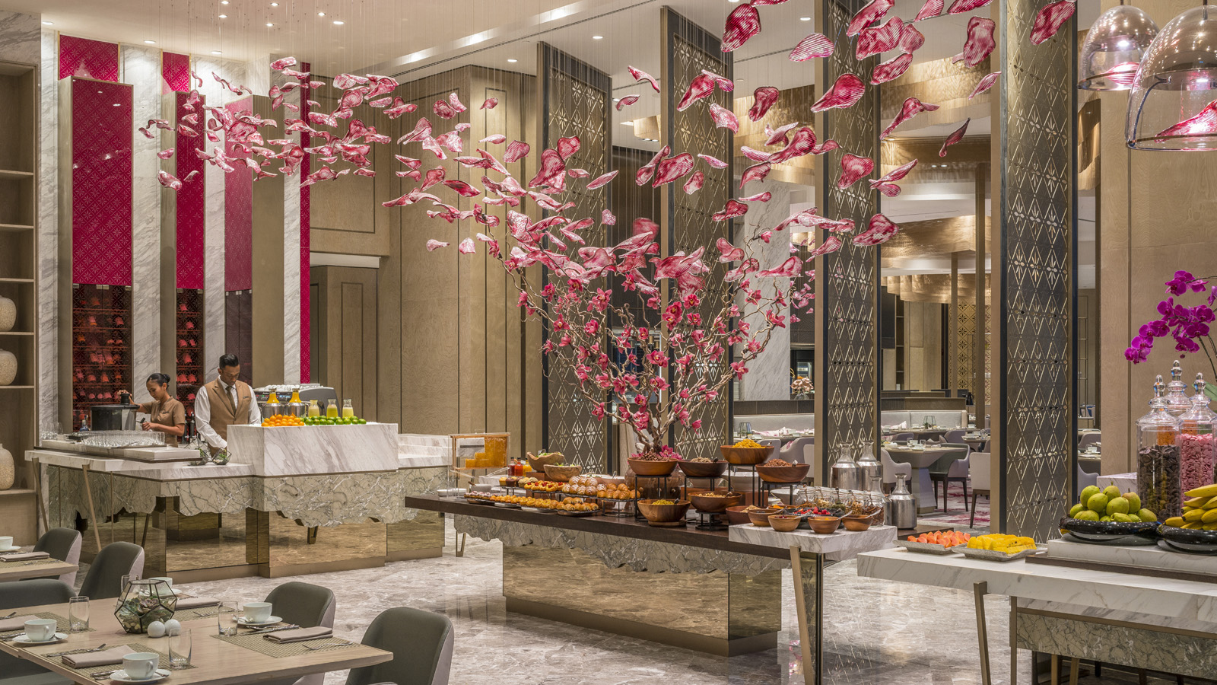
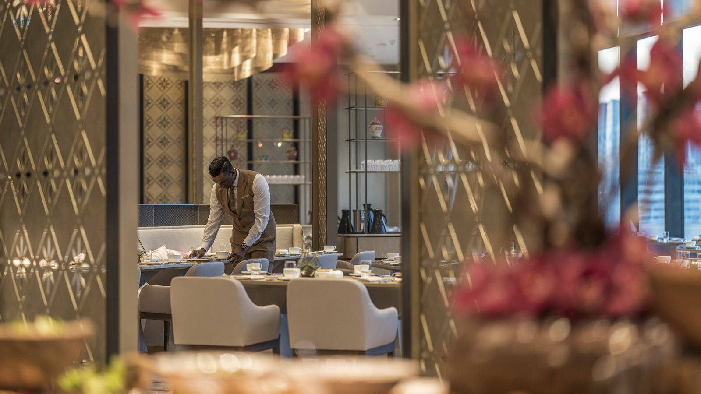 | 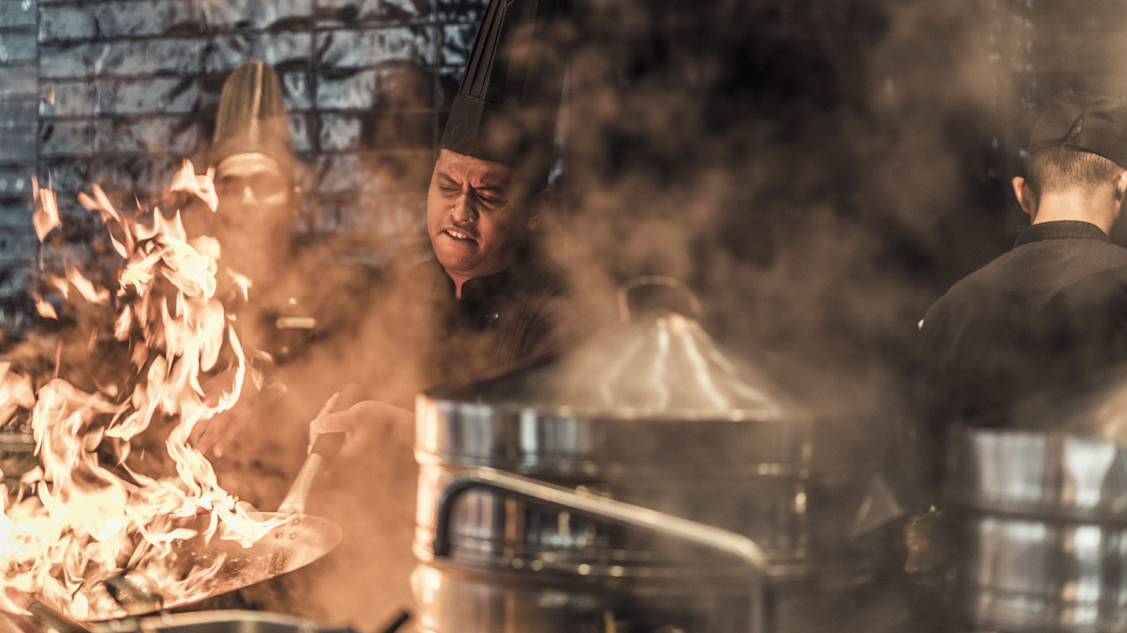 | 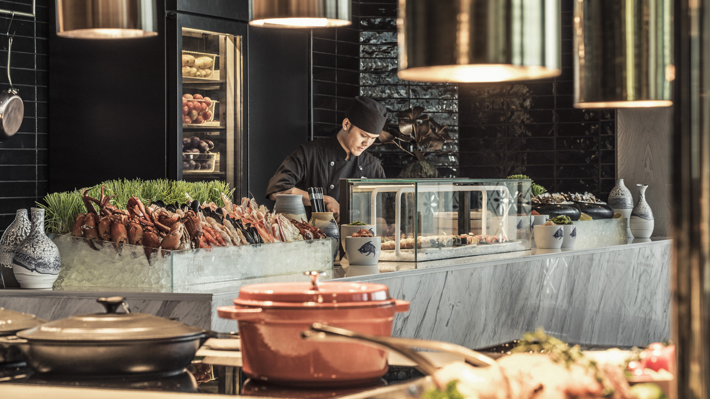
It’s that special time of year again, when every Malaysian heart beats with pride and the nation’s fascinating culture takes centre stage. Celebrate the vibrant spirit of Malaysia with two exclusive dining events at Four Seasons Hotel Kuala Lumpur. Festooned with hibiscus-petal artwork, the airy interiors of Curate offer the perfect venue to gather, eat and drink with family and friends this festive season.
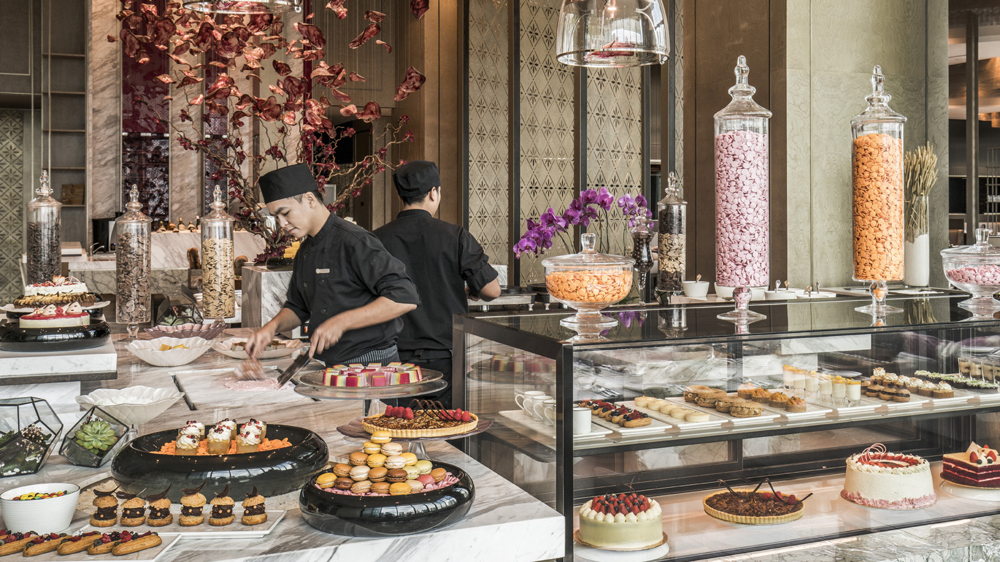 | 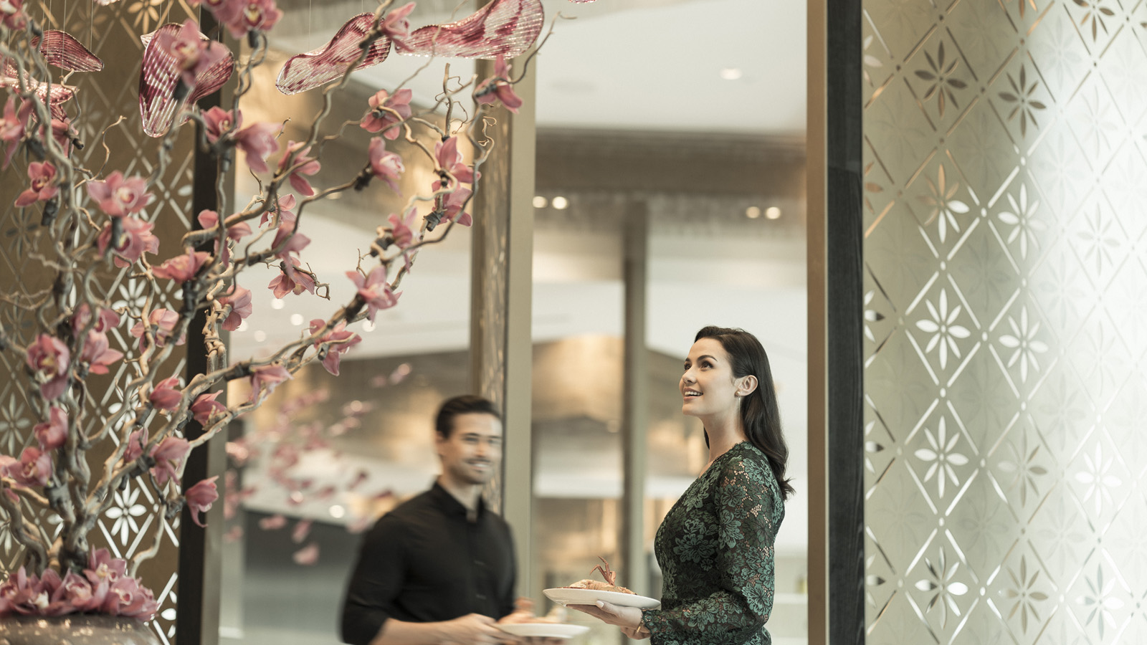
Merdeka Day
Bring in Independence Day, the greatest milestone in Malaysia’s modern history, with an exhilarating immersion into the nation’s culture and cuisine. Curate’s culinary brigade brings guests an astonishing array of authentic local dishes, from street food delights to treasured state specialties such as gulai telur itik dengan kulit rambai, rendang pucuk ubi and ekor asam pedas. While feasting on these delectable flavours, enjoy live tunes by Malay musicians.
Guests are invited to get into the Malaysia Boleh spirit by dressing up to theme of “Proud to be Malaysian.” At the Merdeka Eve Dinner, the best-dressed adults and kids win exciting prizes. The countdown dinner offers a front-row seat to the spectacular city fireworks at midnight. Watch the sky light up with glittering showers and sparkling cascades, surrounded by the best of Malaysian food, music and hospitality – a splendid way to usher in Merdeka Day.
Curate will host Merdeka Eve Countdown Dinner on August 30, 2019 (MYR 228 per adult, inclusive of all taxes) and Merdeka Day Brunch on August 31, 2019 (MYR 210 per adult, inclusive of all taxes). Children up to 12 enjoy 50 percent savings.
Malaysia Day
As every Malaysian knows, the country’s rich culinary heritage is symbolic of its unique identity. This year, embark on a delicious cross-country journey to celebrate the union of Malaysia with its Borneo brothers. An authentic menu awaits at Curate, with signature specialties from all over Malaysia complementing a range of famed local favourites. Sample faraway flavours such as gulai lemak ayam dan nangka and carved crispy aromatic duck, and savour beloved recipes such as tauhu bakar sumbat with vegetables and peanut sauce, and panggang chicken salad with desiccated coconut. Guests can also enjoy a variety of intriguing local desserts, from sarawak layer cakes to sago gula with palm sugar and coconut milk.
Curate will host Malaysia Day Eve Dinner on September 15, 2019 at MYR 198 per adult and Malaysia Day Brunch on September 16, 2019 at MYR 210 per adult. Prices are inclusive of all taxes. Children up to 12 enjoy a 50 percent savings.
Explore Celebrate Malaysia Package
Celebrate Malaysia’s 62nd year of independence. Enjoy a sumptuous spread of favourite Malaysian and international cuisine for breakfast and dinner and take in Kuala Lumpur’s vibrant cityscape on a four-hour day tour.
Experience this beautiful Malaysian destination in unforgettable Four Seasons style by booking online.
Reservations
For reservations, chat via the Four Seasons App or through WhatsApp at +60-323828888.

RELATED

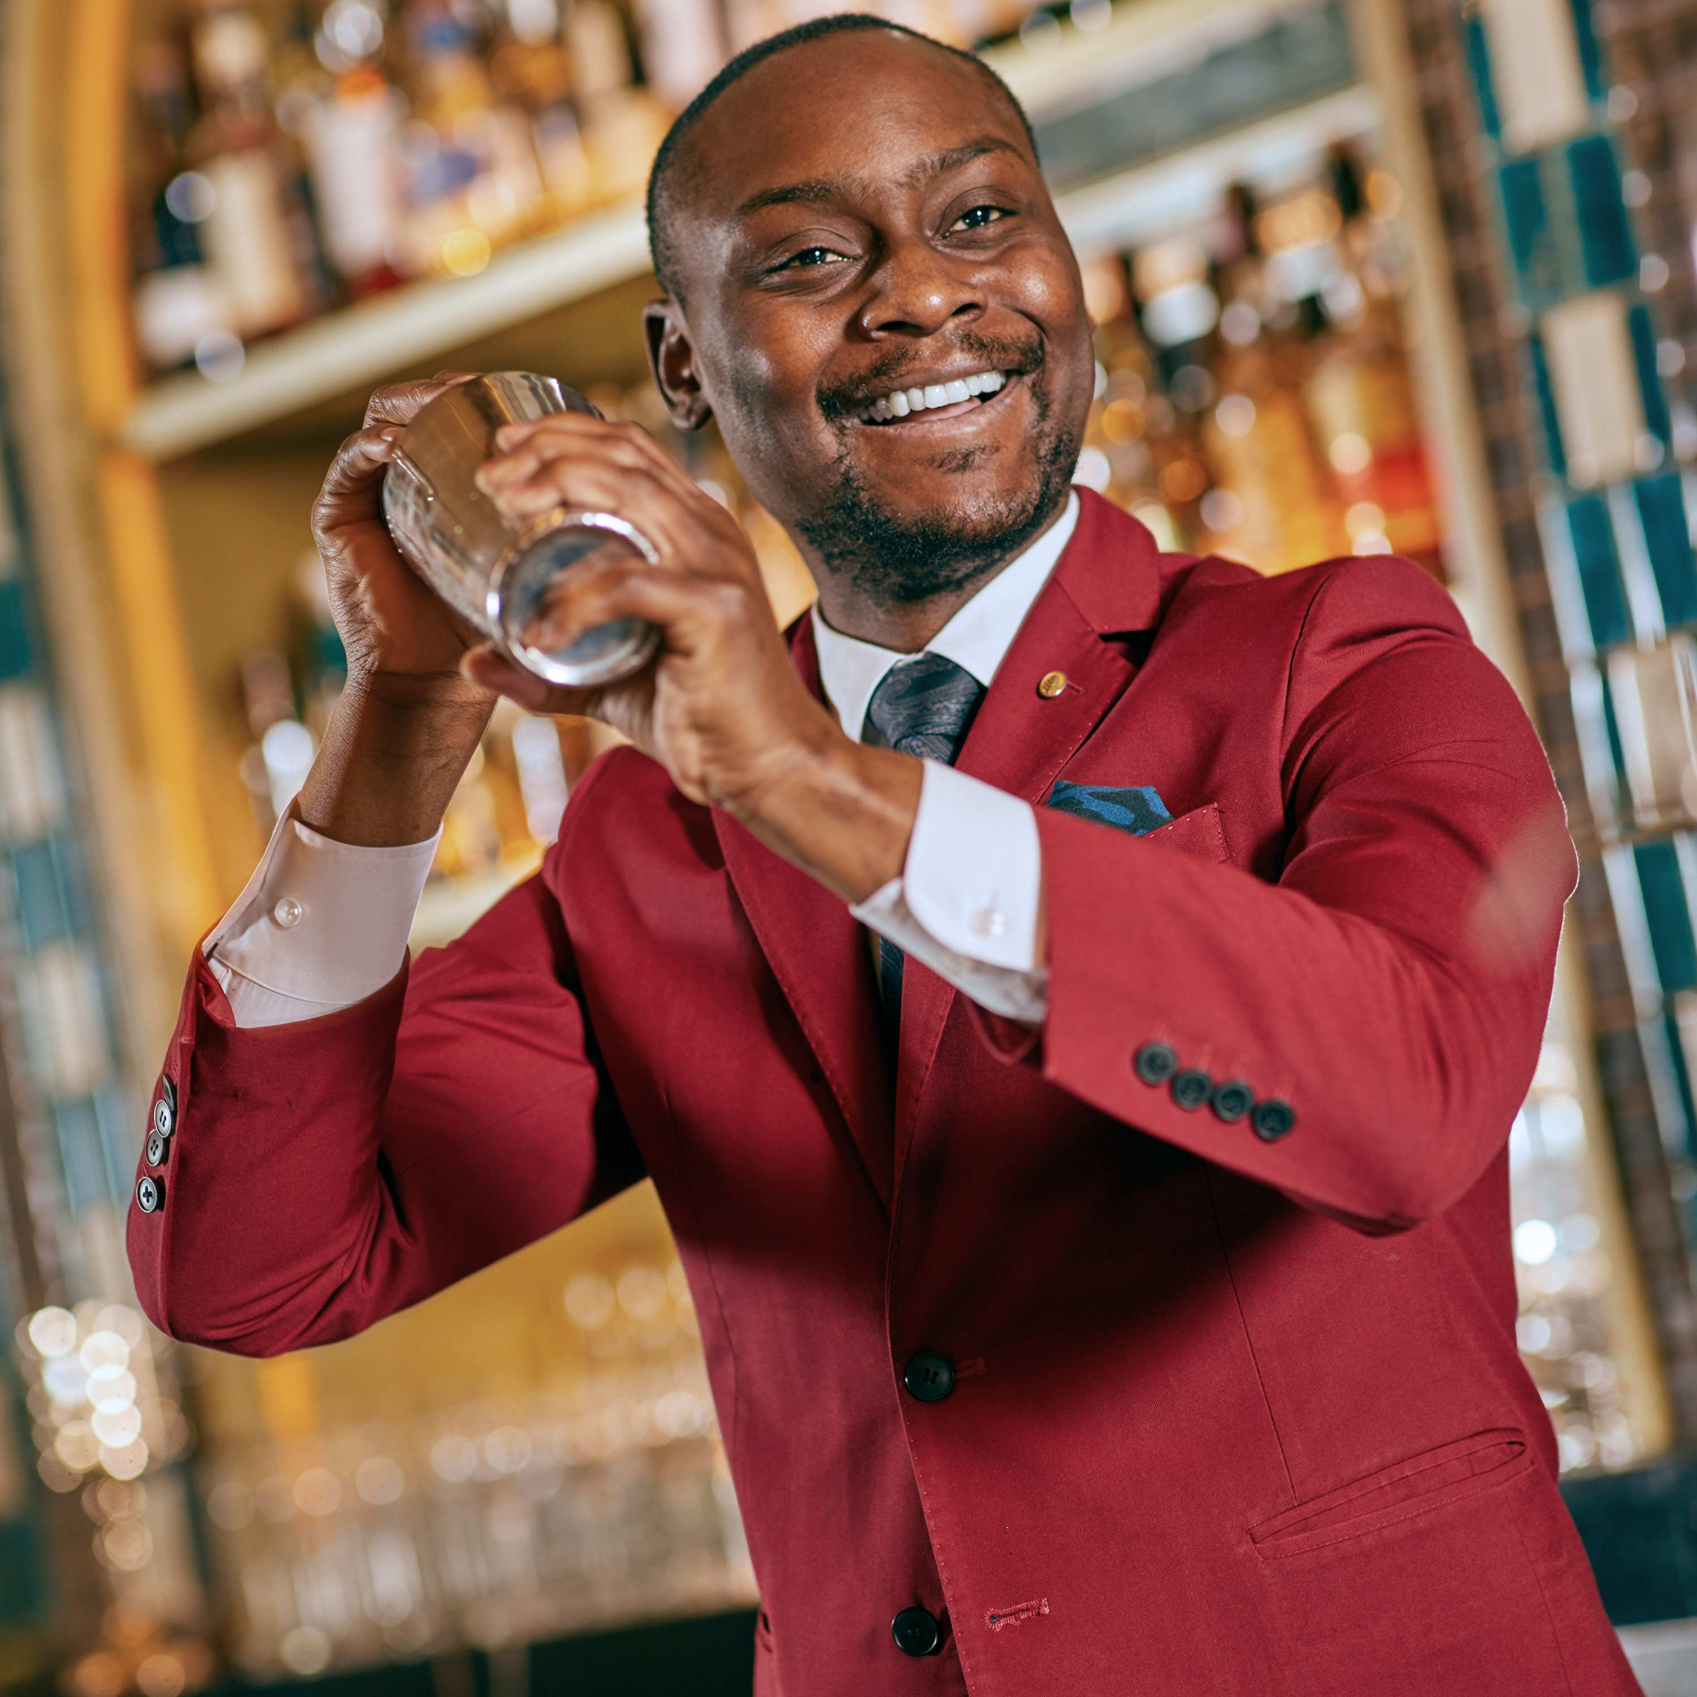 | August 21, 2019, Kuala Lumpur, Malaysia  Sojourn to Seoul at Four Seasons Hotel Kuala Lumpur  https://publish.url/kualalumpur/hotel-news/2019/korean-food-and-beverage-promotion.html
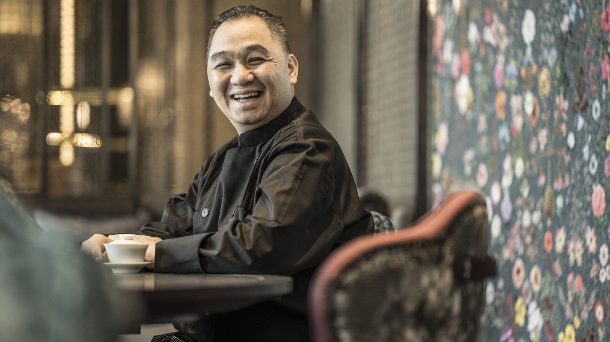 | August 13, 2019, Kuala Lumpur, Malaysia  Savour “Michelin Star Week” at Four Seasons Hotel Kuala Lumpur  https://publish.url/kualalumpur/hotel-news/2019/guest-chef-at-yun-house.html

PRESS CONTACTS

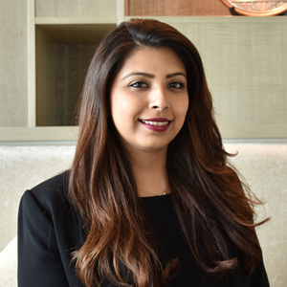 | Kanchana Ganglani  Director of Public Relations  145 Jalan Ampang  Kuala Lumpur  Malaysia  kanchana.ganglani@fourseasons.com  +6(03) 2382 8740

