Love Grows Beautiful Things at Four Seasons Resort Seychelles

Marine conservation specialist WiseOceans and Four Seasons introduce new interactive coral rescue and sponsorship experience for couples
January 16, 2017, Seychelles

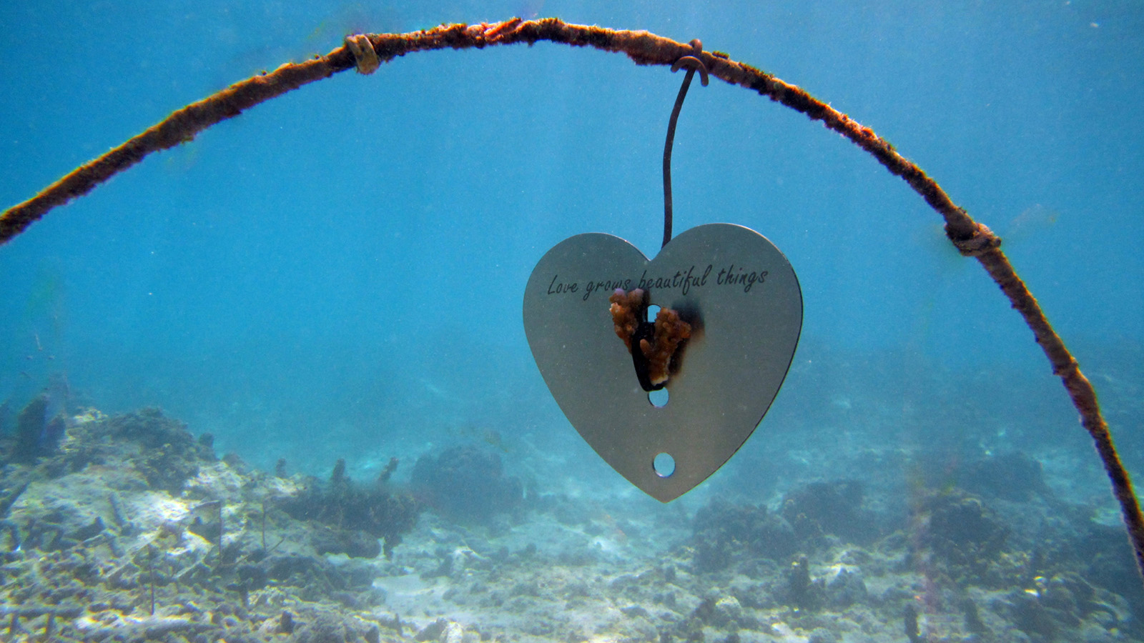
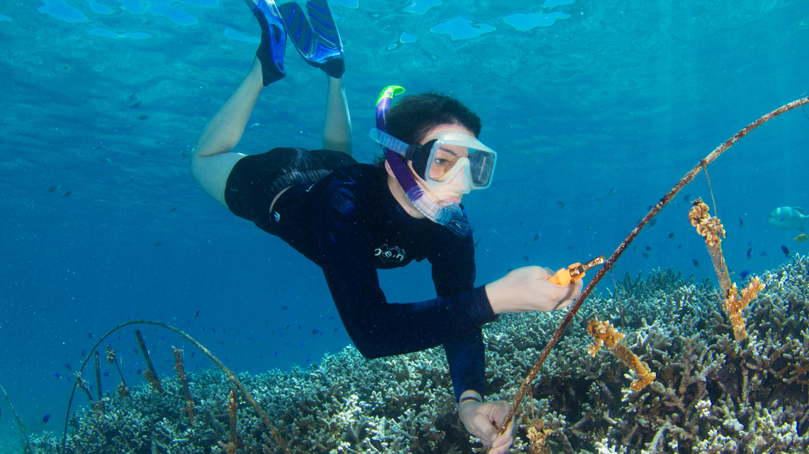
Arriving to the forest-lined hillsides and open ocean views of Seychelles, vacationing couples are instantly immersed into the nature of the islands, yet to offer a bond that lasts for a lifetime,
Four Seasons
Resort Seychelles is introducing a new interactive marine experience to save and sponsor a coral fragment, as part of the Petite Anse Reef Restoration Project.
Whether newlyweds, couples celebrating an anniversary, or simply those on a romantic escape together, the luxurious Seychelles resort, along with marine education and conservation partner WiseOceans, is providing every couple the opportunity to contribute to the ongoing reef restoration project. As part of the new Love Grows Beautiful Things experience, guests will help prepare a rescued coral fragment for attachment to a heart-shaped metal frame (that will help sustain the growth of their coral), before it is planted into the coral nursery for a full recovery, and eventual transplantation back to the reef.
Under the expert guidance of Sam Barnett, a WiseOceans Marine Educator based at the Resort, couples may also take to the water with WiseOceans to watch the planting of their fragment in the coral nursery, before a guided snorkel of the bay, where numerous fish, and on occasion sea turtles, may be seen living among the coral. After a number of months in the coral nursery, the strengthened coral will be transplanted back onto the reef - during this time, couples will receive email updates on their fragment to allow them to keep up to date on its progress.
Commenting on the new experience, Sam says: “I'm thrilled to be able to share the work of the Petite Anse Reef Restoration Project with guests of the Resort, and this new experience is a great way for couples to share their love with the marine life that calls Petite Anse home. The Love Grows Beautiful Things experience is not just an enjoyable way to spend a day at the beach, but most importantly, it is a worthwhile act that helps to support the coral reef and connects couples with the nature of Seychelles."
Every heart-shaped metal frame is engraved with "Love Grows Beautiful Things" and each couple will receive a special handmade gift after the experience, as a thank you from the reef and from the WiseOceans team for their valuable contribution to the project.
The Petite Anse Reef Restoration Project is a partnership between
Four Seasons
Resort Seychelles and WiseOceans that was launched in March 2015, with the aim of restoring 10,000 square metres (100,000 square feet) of coral reef in Petite Anse bay. The method of restoration is unique to Petite Anse, attaching coral fragments to metal bars and growing them in an underwater nursery until they are ready to be transplanted back onto the reef.
The Love Grows Beautiful Things experience is priced at EUR 120 per couple and can be arranged by contacting the Resort directly on +248 4393000 or e-mailing sam@wiseoceans.com.

RELATED

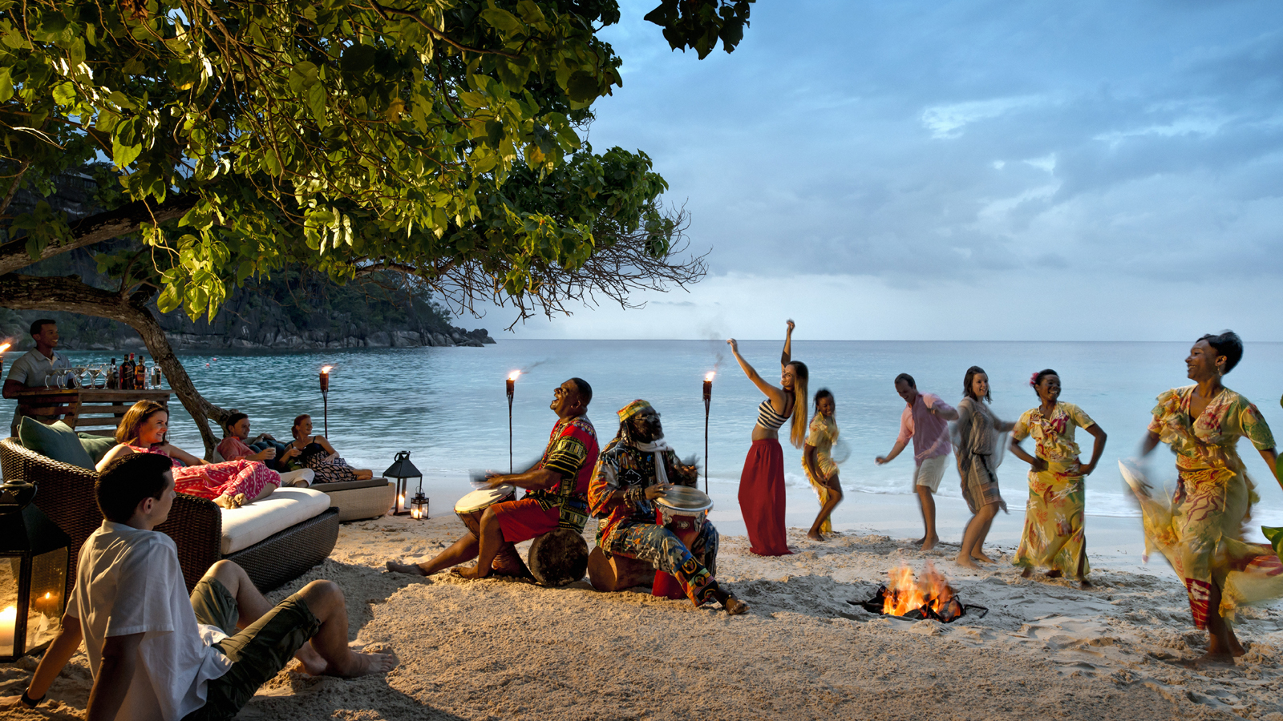 | September 21, 2017, Seychelles  Celebrate A Season of Sapphire at Four Seasons Resort Seychelles this Christmas and New Year  http://publish.url/seychelles/hotel-news/2017/festive-season.html
August 3, 2017, Seychelles
From A "Cravings Hotline" to Personalised Welcome Amenities: Parents-to-Be are Pampered in Paradise with a New Babymoon Experience from Four Seasons Resort Seychelles
http://publish.url/seychelles/hotel-news/2017/babymoon-experience.html

PRESS CONTACTS

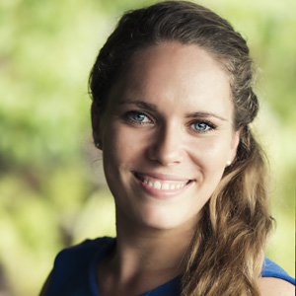 | Amy Sefton  Public Relations Coordinator  Petite Anse, Baie Lazare, P.O. Box 1397  Victoria, Mahe  Seychelles  amy.sefton@fourseasons.com  +248 439 3016
Debbie Duval
Director of Public Relations and Communications

Beau Champ
Mauritius
debbie.duval@fourseasons.com

(230) 402 3100

