Four Seasons Hotel Kuwait is Ready to Spread the Spring Mood

February 20, 2019, Kuwait City, Kuwait

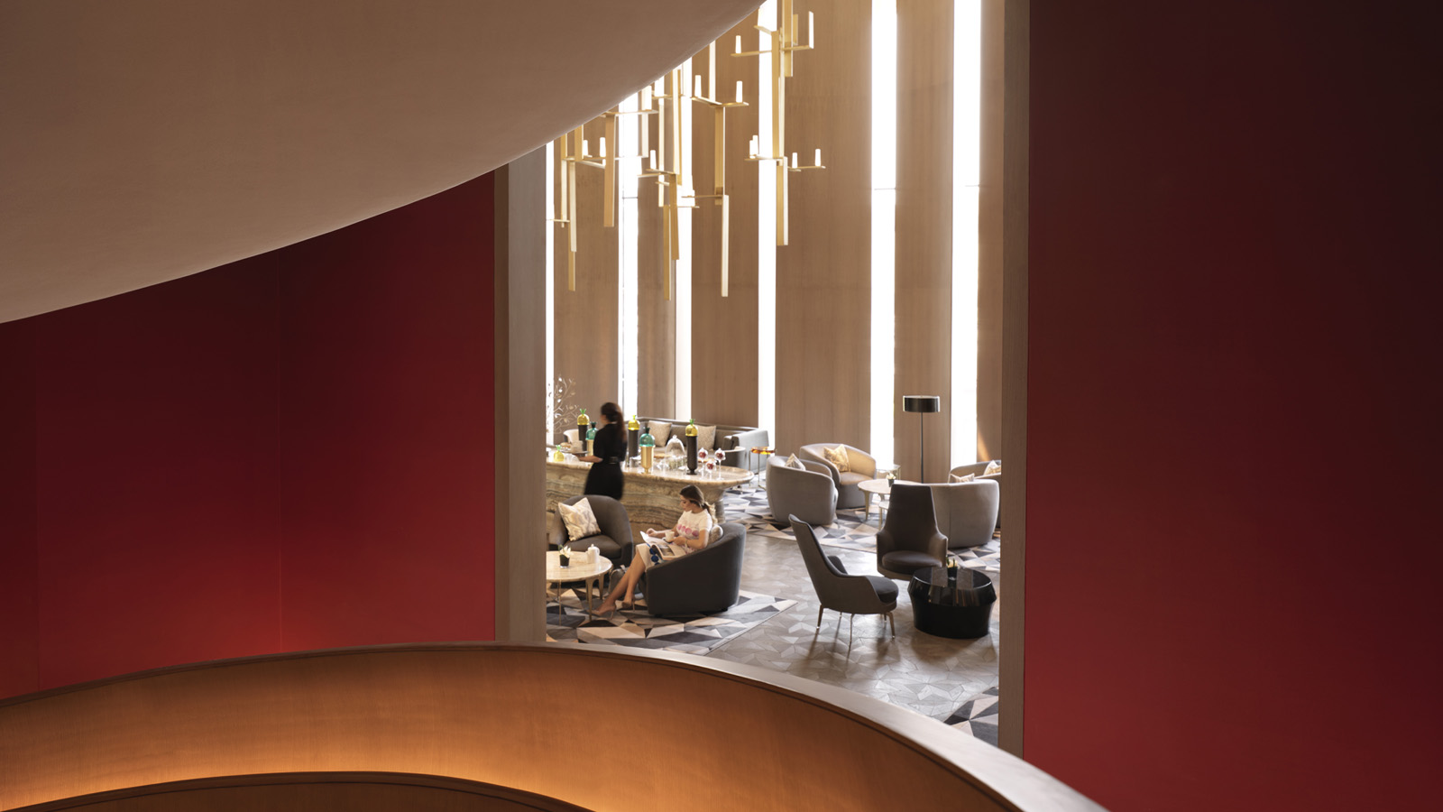
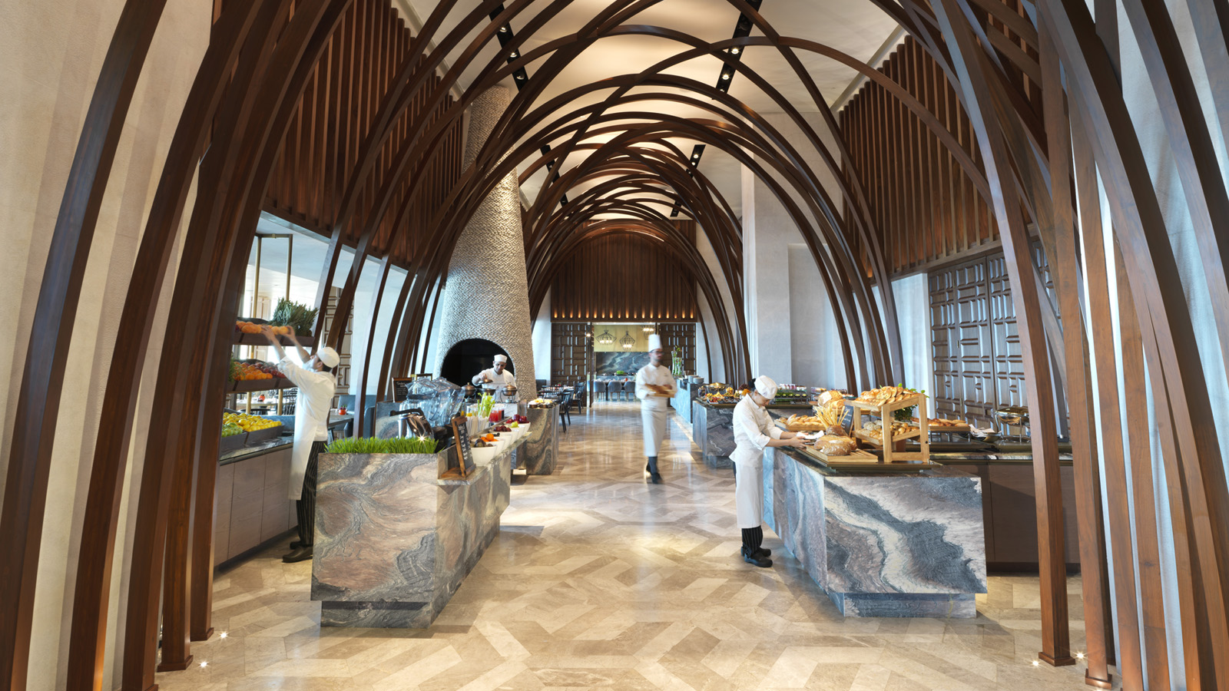 | 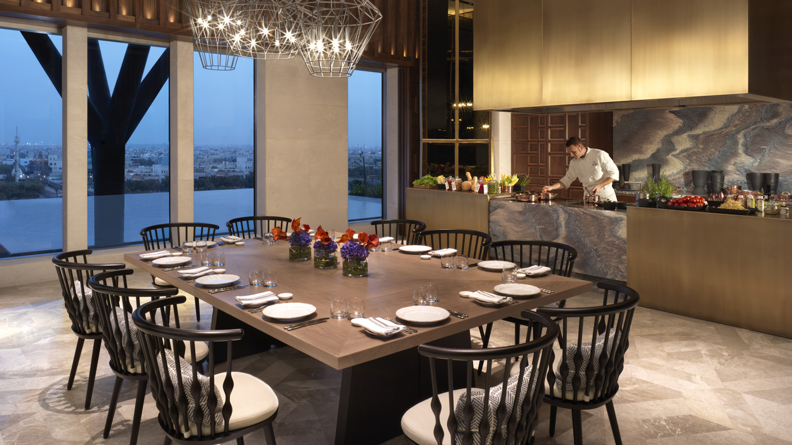 | 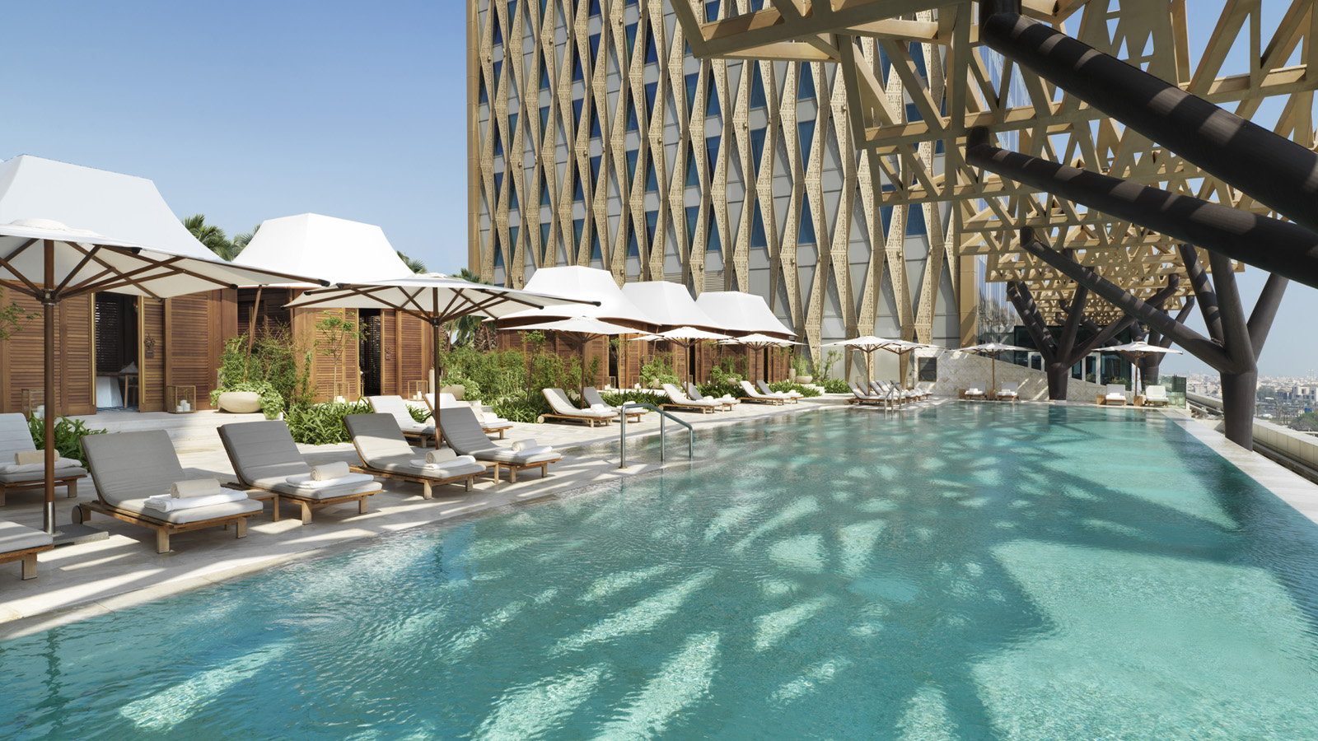
March and the first hint of spring coincide, bringing with them new beginnings and fresh starts. At Four Seasons Hotel Kuwait, it is also a month of celebrating the women and mothers who have always been the backbone of life itself.
“We consider ourselves a large family at Four Seasons, and think of our guests as extended family members. We love occasions like Women’s Day and Mother’s Day because they give us the opportunity to celebrate the powerful role that women play in our daily lives. Our skilled team of craftsmen, from all of our restaurants and the SPA are working passionately to give the warmest of welcomes to these special women at their second home at the Hotel for a royal experience fit for a queen,” says General Manager Didier Jardin.
Al Soor Lounge
With spring just around the corner, Al Soor Lounge for the monthly Global Dessert Series will be taking inspiration from the sunny land of Spain, presenting a Spanish dessert, the Catalan cream tart, a delicious vanilla tartlet with caramelised Catalan cream, garnished with fresh fruits in a “hard not to fall in love with” offering.
Elements Restaurant, March 8, 2019
Elements Restaurant is celebrating International Women’s Day by offering 20 percent savings to women at its leisurely breakfast on March 8, 2019 until 2:00 pm. The colourful, market-style venue boasts engaging buffet stations that span Arabic to Indian and Japanese to Italian, making it the perfect atmosphere for women to relax, chat, and catch up with their friends to mark the day.
Al Bandar Lounge
Welcome beautiful evening breezes and enjoy the weekly BBQ Night by dining al fresco at Al Bandar Lounge every Wednesday. The outdoor seating area offers guests a wonderful city view, while the resort-style atmosphere of the restaurant by the outdoor pool is resplendent with vacation vibes without the need to ever travel. Situated on the fourth-floor terrace of the Hotel, the lounge also offers private cabanas for creating those unforgettable moments with friends and family.
Elements Restaurant, March 21, 2019
Honouring the maternal pillar of every family, Element’s Restaurant is celebrating Mother’s Day in style on March 21, 2019. Early and late risers alike can enjoy breakfast from 7:00 am until 2:00 pm at KWD 15 per person. For this special occasion, women will receive 20 percent savings.
Or treat Mother with unforgettable dinner experience at Elements Restaurant with a dream-like setting and exquisite cuisine priced KWD 25 per person.
Al Bandar Lounge, March 22, 2019
Al Bandar Lounge will celebrate Mother`s day on March 22, 2019 with an outdoor picnic-style brunch around the pool. Guests will enjoy live music, shisha and delicious offerings at KWD 25 per person from 1:00 to 4:00 pm. Little guests will be invited to the bespoke Fereej Kids Club.
The SPA
Mothers everywhere will deeply appreciate the exclusive March 2019 offer at the SPA, specially created to say thank you and help them feel refreshed and ready to be the superheroes they always are.
The Mother’s Indulgence is a two-hour package that includes a nourishing hair mask and full body exfoliation. The detoxifying body balm from luxury brand Maroc Maroc with argan oil and orange peel will not only purify the skin also deeply moisturise it. The relaxing massage with pale rose and wild rose cream will help tired bodies and bones feel younger. Finally, the cleansing facial restores skin, giving it a healthy glow. The exclusive offer is priced at KWD 95 and will only be available for a limited time.
For expectant mothers, Harmony for Mothers-To-Be is a gentler yet fully nurturing package that is designed to be relaxing but completely safe for pregnant women. The two-hour package starts with the exfoliating jojoba body polish, followed by a comforting body wrap that helps tone tired and stretched skin, and finally a massage that soothes tense and sore muscles. This is the perfect gift for pregnant mothers and the package costs KWD 80. The fascinating treatment will be available as a gift card to be purchased.
To make a reservation, call +(965) 2200 6000 or email: reservations.kuw@fourseasons.com

RELATED

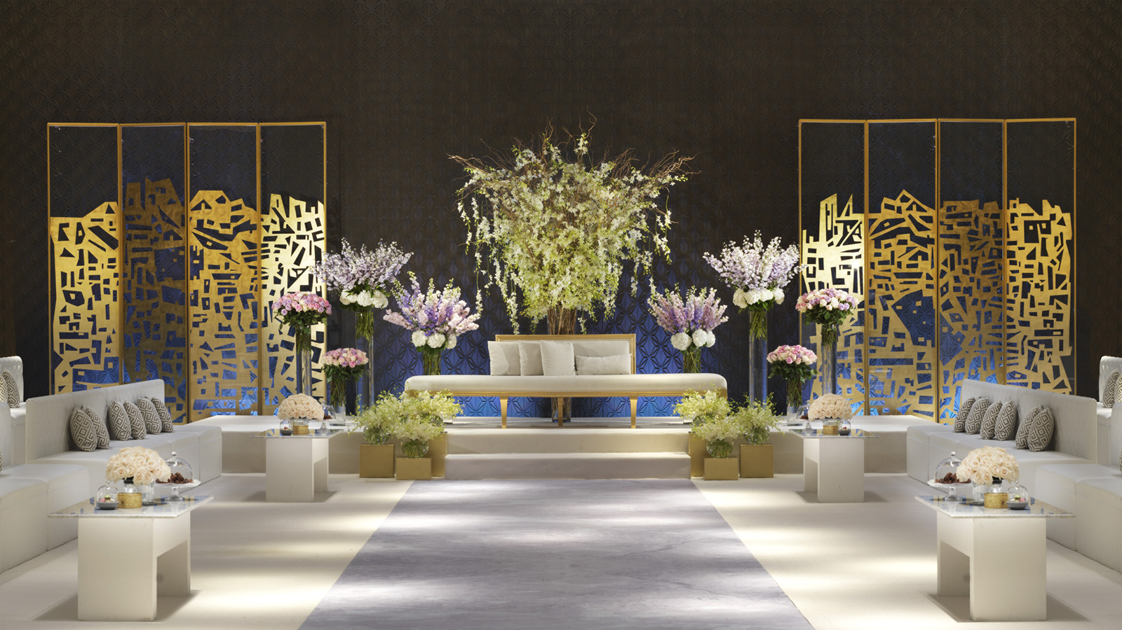 | February 4, 2019, Kuwait City, Kuwait  Say Yes to a Dream Wedding at Four Seasons Hotel Kuwait at Burj Alshaya  https://publish.url/kuwait/hotel-news/2019/wedding-package.html
February 4, 2019, Kuwait City, Kuwait
لا تفوتوا فرصة إقامة حفل الزفاف الأسطوري في فندق فورسيزونز الكويت برج الشايع
https://publish.url/ar/kuwait/hotel-news/2019/wedding-package-2.html

PRESS CONTACTS

Aynur Mamedova
Director of Public Relations and Communications
Al Soor Street, Al Mirqab
Kuwait City, P.O. Box 735, Safat
Kuwait
aynur.mamedova@fourseasons.com

+965 2200 6000

