Celebrate Valentine’s Day 2023 at Four Seasons Hotel Hong Kong

January 19, 2023, Hong Kong, China

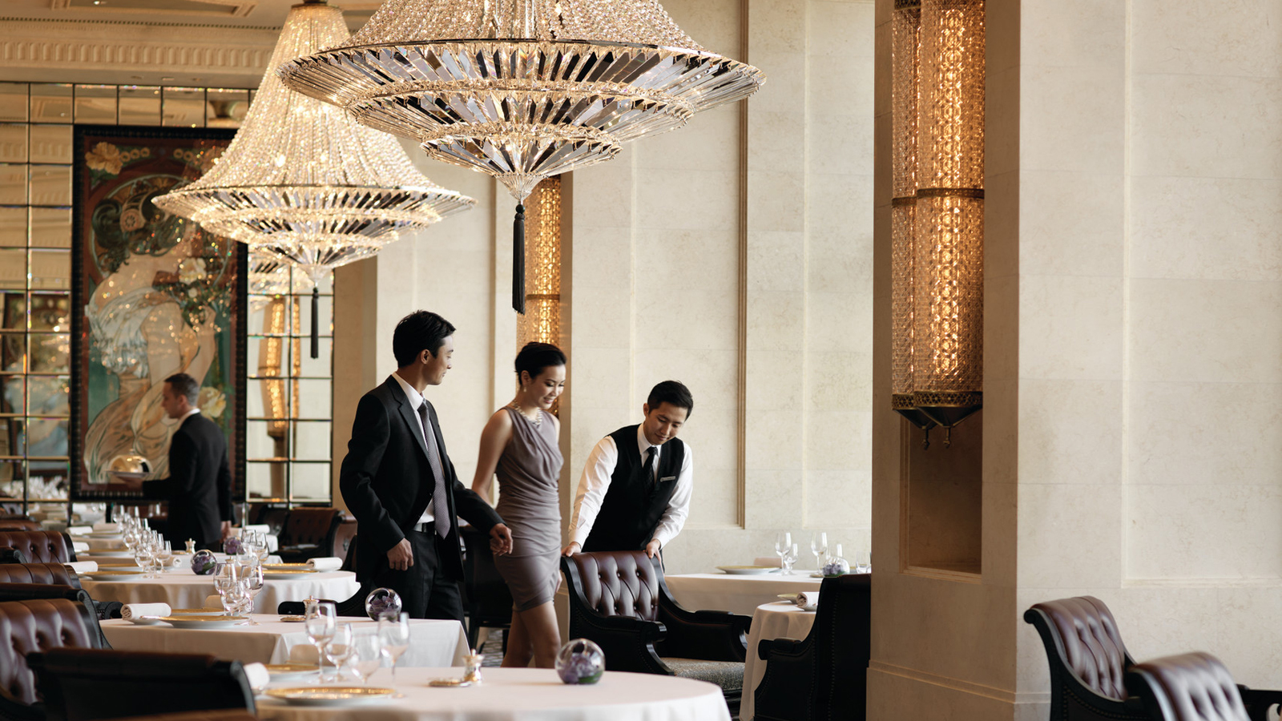
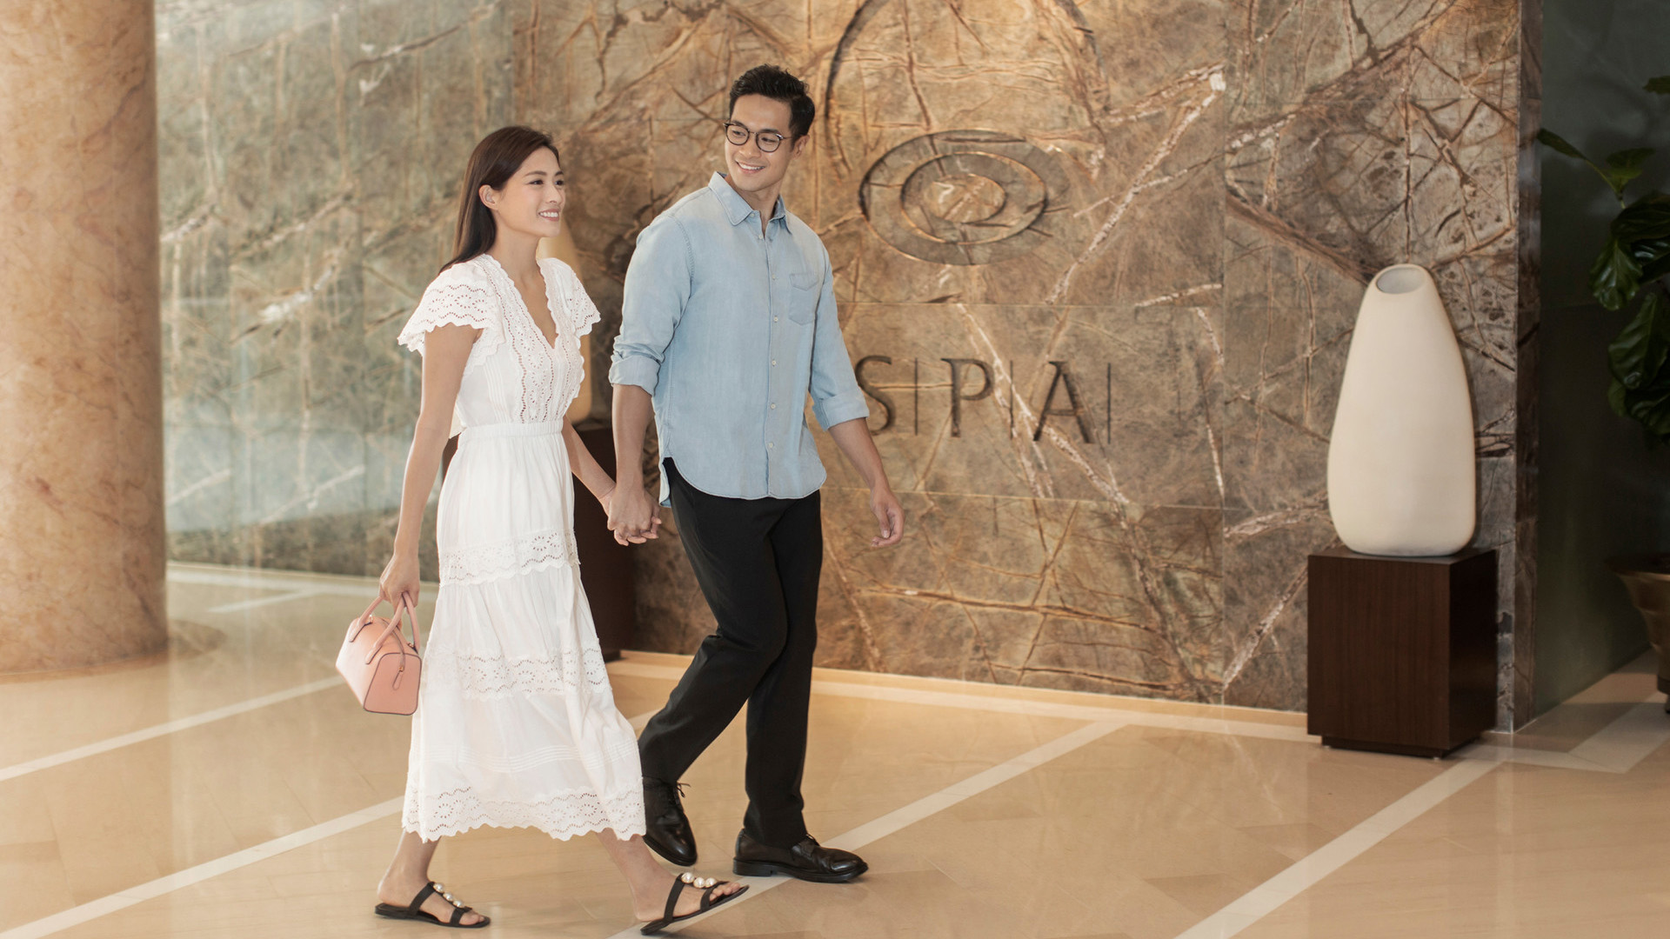
The season of love is here. From romantic staycations and luxurious couple spa treatments to Michelin-starred dining experiences that will create lasting memories, Four Seasons Hotel Hong Kong brings its guests a Valentine’s Day celebration they will remember for years to come.
The Romantic Getaway
This Valentine’s Day, Four Seasons is ready to surprise its guests and their special someone with a romantic staycation where guests can kick-off their celebrations with a complimentary bottle of champagne as they admire the breath-taking views of Hong Kong from their room; the evening continues at The Lounge where a three-course set dinner -featuring the appetising Lobster Salad, a choice of mains between Wagyu Beef Two Ways and French Sea Bass, and a refreshing dessert of Rose Champagne Parfait with Japanese White Peach - is served. The next morning, guests are welcomed to start their day with a hearty breakfast and enjoy all the facilities and amenities Four Seasons has to offer. For those who want to elevate their stay with a visit to The Spa, guests can enjoy 15 percent off spa treatments during their stay.
Available from February 4 to 14, 2023, The Romantic Getaway starts from HKD 5,380*.
The package includes:
- Daily breakfast for two
- Complimentary upgrade to Deluxe Harbour View Room (or upgrade to a Superior Harbour View Suite or Premier Harbour View Suite at a supplement)
- Three-course Valentine’s Day dinner for two at The Lounge
- One complimentary bottle of champagne
- Preserved rose teddy bear amenity
- 15 percent savings on spa treatments during the stay
For bookings, call Reservations at 3196 8333 or email res.hongkong@fourseasons.com.
Stellar Dining Experiences
Couples who bond over their love of fine food will be delighted to know that three-Michelin-starred Caprice is indulging diners with a one-night-only seven-course Valentine’s Day dinner. Roasted Brittany Blue Lobster with Celeriac and Black Truffle; Daily Wild Caught Fish with Bouillabaisse and other Chef Guillaume Galliot’s crowd-pleasing dishes are sure to please even the more discerning palate.
The special menu is priced at HKD 4,288* per person. Wine pairing is available at an additional HKD 2,480* per person. Reservations can be made at Caprice.HKG@fourseasons.com or (852) 3196 8860.
Over at Lung King Heen, the world’s first three Michelin-starred Chinese restaurant, diners can expect expertly crafted Cantonese dishes by Chef Chan Yan Tak and his team in a carefully curated special menu featuring delicacies that honour culinary traditions with an inspiring contemporary flair. Coveted highlights of the menus include Wok-fried Lobster with Lily Bulbs and Capsicum, Fried Puntalette with Racan Pigeon and Baked Cream Custard and Rose Puff.
The Valentine’s Day dinner at Lung King Heen is priced at HKD 1,980* per adult and HKD 880* per child (7 to 12 years old). Reservations can be made at (852) 3196 8882 or email dining.hkg@fourseasons.com.
Dazzling Dining to Delight
Indulging in small pleasures with one’s better half can be truly magical. This Valentine’s Day, guests can cosy up with their other half at The Lounge for its Valentine’s Day Afternoon Tea. Must-try sweet and savoury items include Violet and Citrus Cupcake, Heart-shaped Berries Chocolate Bonbon, White Peach and Champagne Verrine; and of course, Signature Four Seasons Scones with a selection of fruit jams and Devonshire cream.
Available from February 11 to 14, 2023, The Lounge Valentine’s Day Afternoon Tea is priced at HKD 495* for one and HKD 808* for two on weekdays; HKD 505* for one and HKD 848* for two on the weekend. The Lounge is also offering a three-course Valentine’s Day set dinner at HKD 1,800* per set for two, and is served between 6:30 and 9:00 pm. Guests also have the option to order from the a la carte menu.
Lovers can also opt to enjoy Valentine’s Day Afternoon Tea Treats at the welcoming Gallery. Savour morsels of delectable treats such as Pata Negra Croque-Monsieur, Baked Mini Barbecued Goose Bun, Petit Love’s Arrow (Jivara 40 percent Milk Chocolate and Cherry Crumble Cake), and Pink Lamington filled with Rose Jam. Available from February 11 to 14,2023, this menu is priced at HKD 368* per person on weekdays and HKD 398* per person on weekends and public holidays.
A Valentine’s Day Lunch Buffet (HKD 540* per adult and HKD 270* per child aged 7 to 12) will be served at ARGO on February 14, 2023, where a marvellous spread will be set up in the neoclassical, conservatory-inspired space to tantalise all the senses.
For enquiries, call dining reservations at 3196 8882 or email dining.hkg@fourseasons.com.
Sweet Moments to Share
For those who want to relish sweet moments in the comfort of their own home, Four Seasons has thoughtfully prepared the Valentine’s Day Takeaway Afternoon Tea Set for two, which includes popular sweet and savoury items as well as our signature scones. This set can be ordered at the Four Seasons eShop for HKD 778 per set.
Also available at eShop, the Rose Berries and Passionfruit Cake (1/2 pound; HKD 520 each) is perfect for guests with a sweet tooth. Both the Takeaway Afternoon Tea Set and the Cake can be elevated with a Flower Set for HKD 1,588 and HKD 1,388 respectively. 48-hour advance purchase is required. Pick up is available at the Cake Shop from February 10 to 14, 2023 from 10:00 am to 8:00 pm daily.
To order, visit Four Seasons eShop: https://shopfourseasonshk.com/
Urban Wellness Escape for Couples
For power couples who need a quiet respite to relax and unwind, The Spa’s best-selling Couple Celebration Package for two is the perfect way to say, “I love you.”
Priced at HKD 6,999, the package includes:
- 30-minute Private Couple's Treatment Room usage with a glass of champagne and slice of cake each
- 30-minute Body Scrub
- 90-minute Massage (except Four Hands) or 90-minute Facial (except Second Skin, Luminous Facial and Back Facial)
Purchase this package online at Four Seasons eShop. For reservations and enquiries, contact the Spa Concierge at 3196 8900 or email spa.hkg@fourseasons.com.

*All prices are subject to 10 percent service charge.

RELATED

January 19, 2023, Hong Kong, China
於香港四季酒店慶祝情人節2023
https://publish.url/zh_hant/hongkong/hotel-news/2023/valentines-day-2.html

January 19, 2023, Hong Kong, China
于香港四季酒店庆祝情人节2023
https://publish.url/zh/hongkong/hotel-news/2023/valentines-day-3.html

PRESS CONTACTS

Mandy Li
Assistant Director of Marketing Communications
8 Finance Street, Central
Hong Kong
China
mandy.li@fourseasons.com

(852) 3196 8307

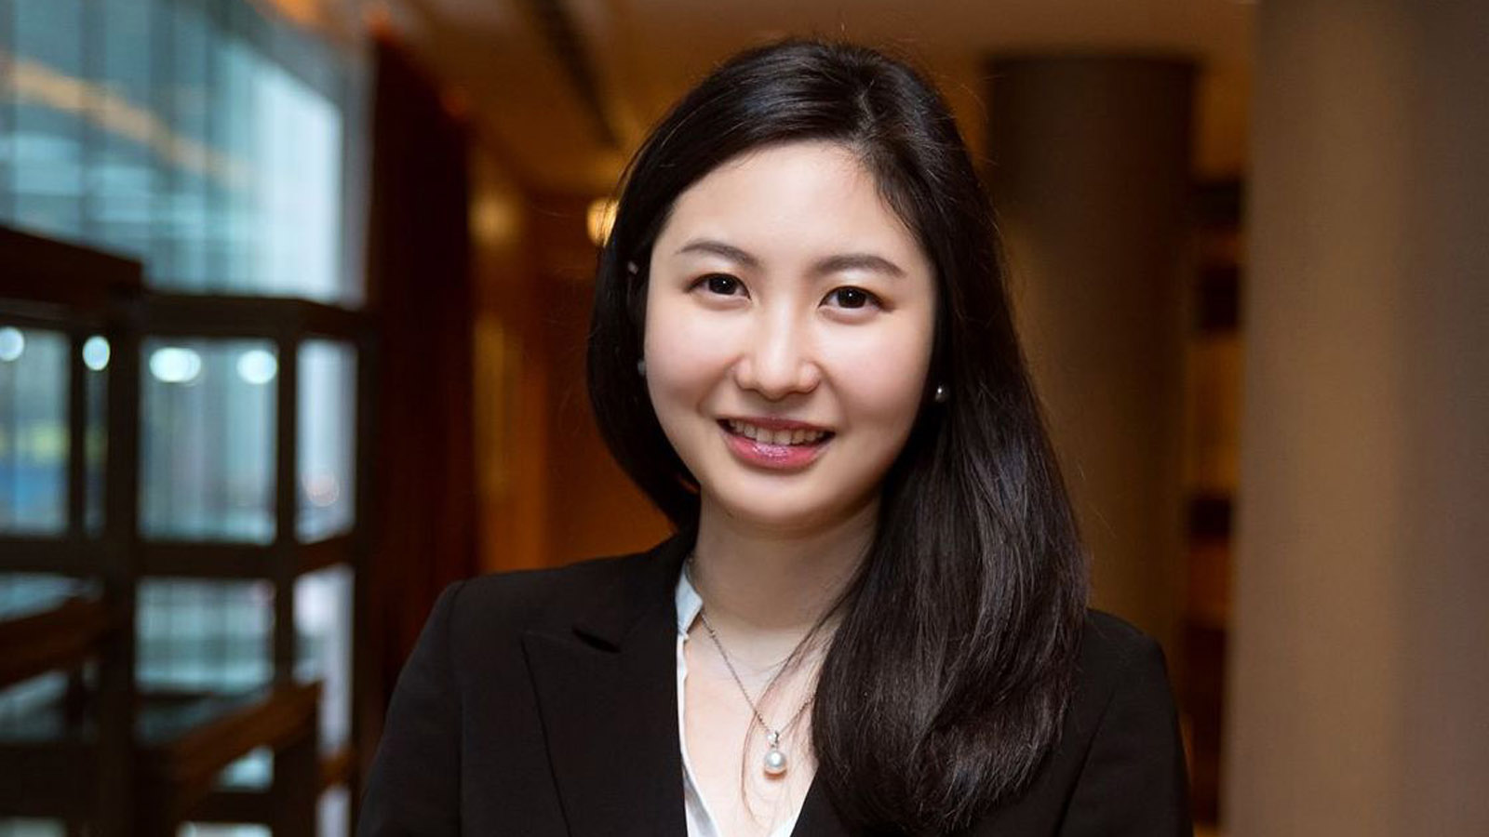 | Priscilla Chan  Assistant Public Relations Director  8 Finance Street, Central,  Hong Kong  China  priscilla.chan@fourseasons.com  (852) 3196 8306

