Four Seasons Reveals What’s New for 2021 and Beyond

As travellers plan ahead and locals explore destinations closer to home, Four Seasons provides peace of mind with the highest standards of health and safety, personalised experiences and uncompromising luxury
December 3, 2020, Toronto, Canada

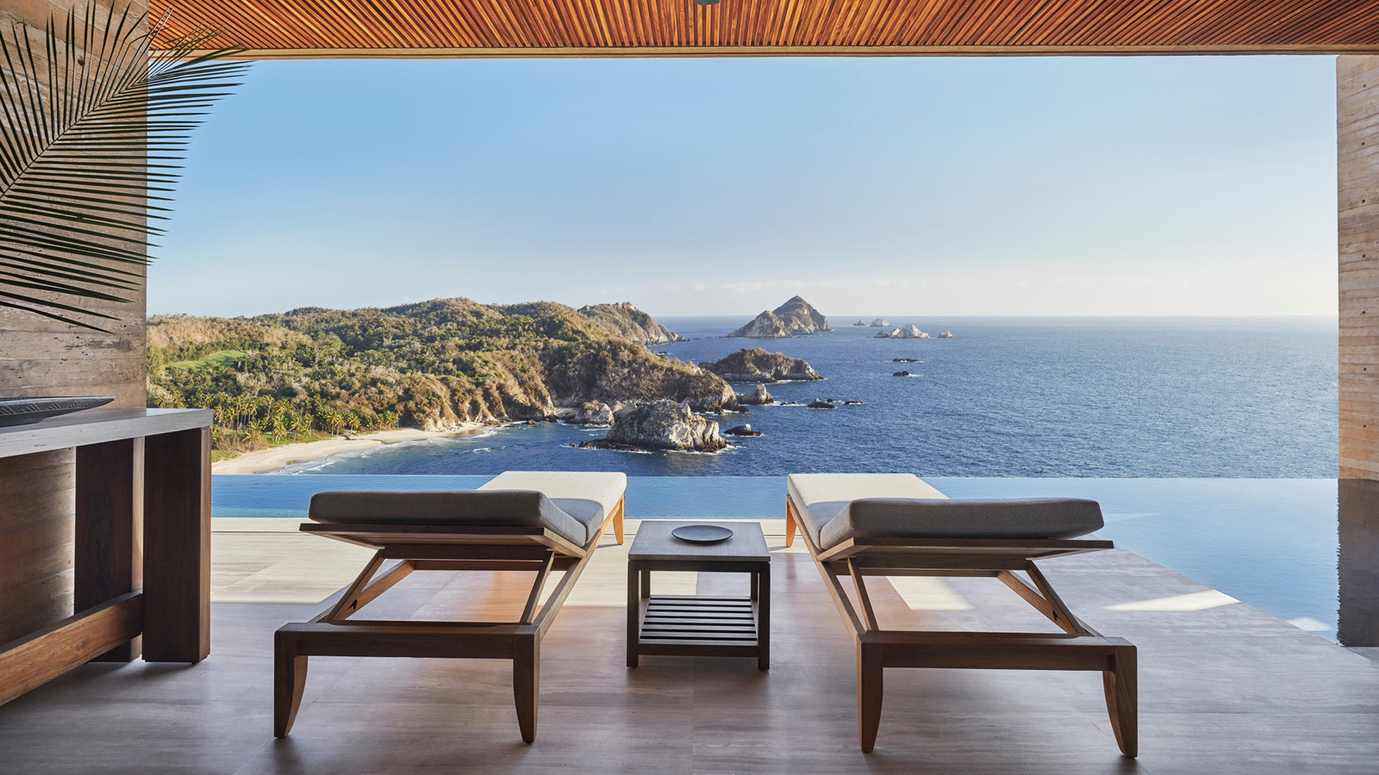
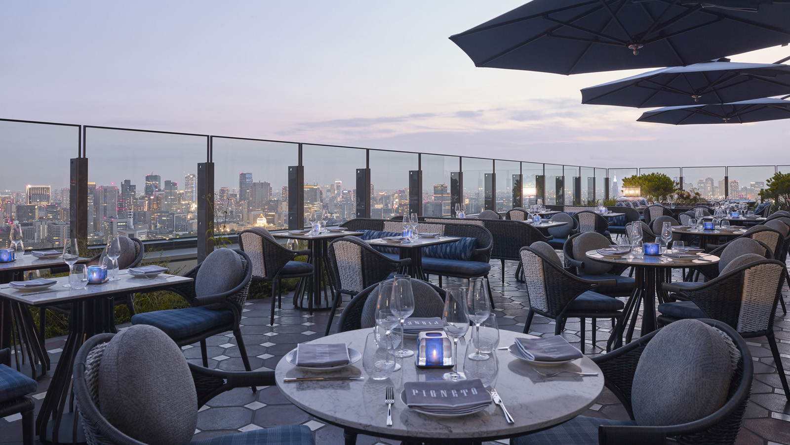 | 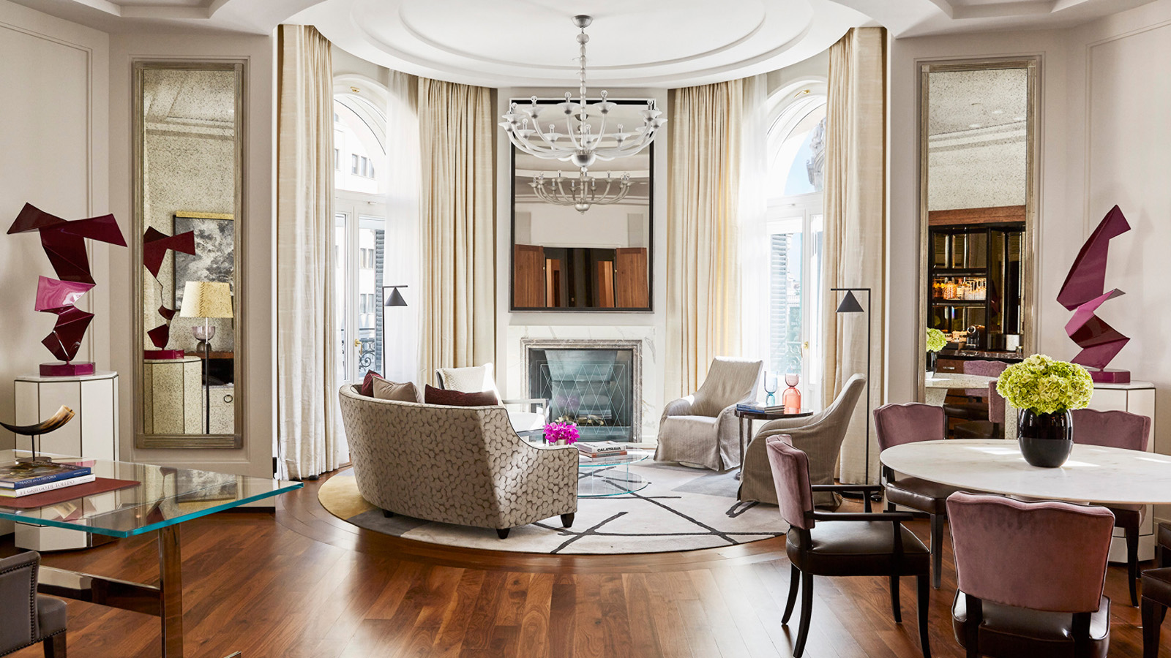 | 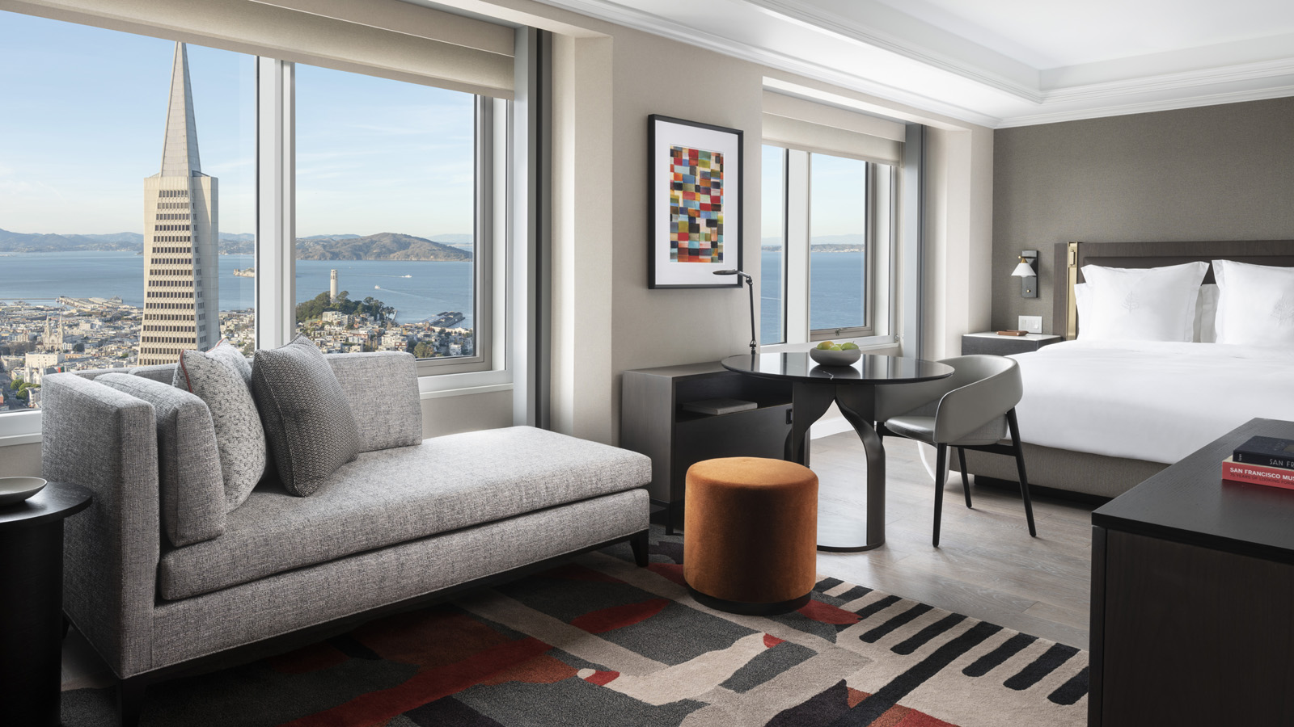
Whether making plans to travel, dreaming of future travel or simply looking to enjoy a new local experience, Four Seasons Hotels and Resorts reveals what to look forward to from the world’s leading luxury hospitality company next year.
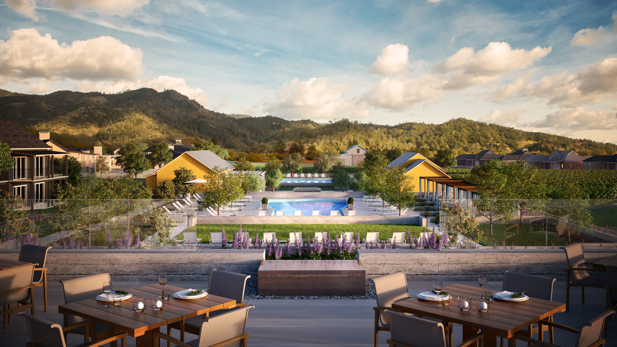 | 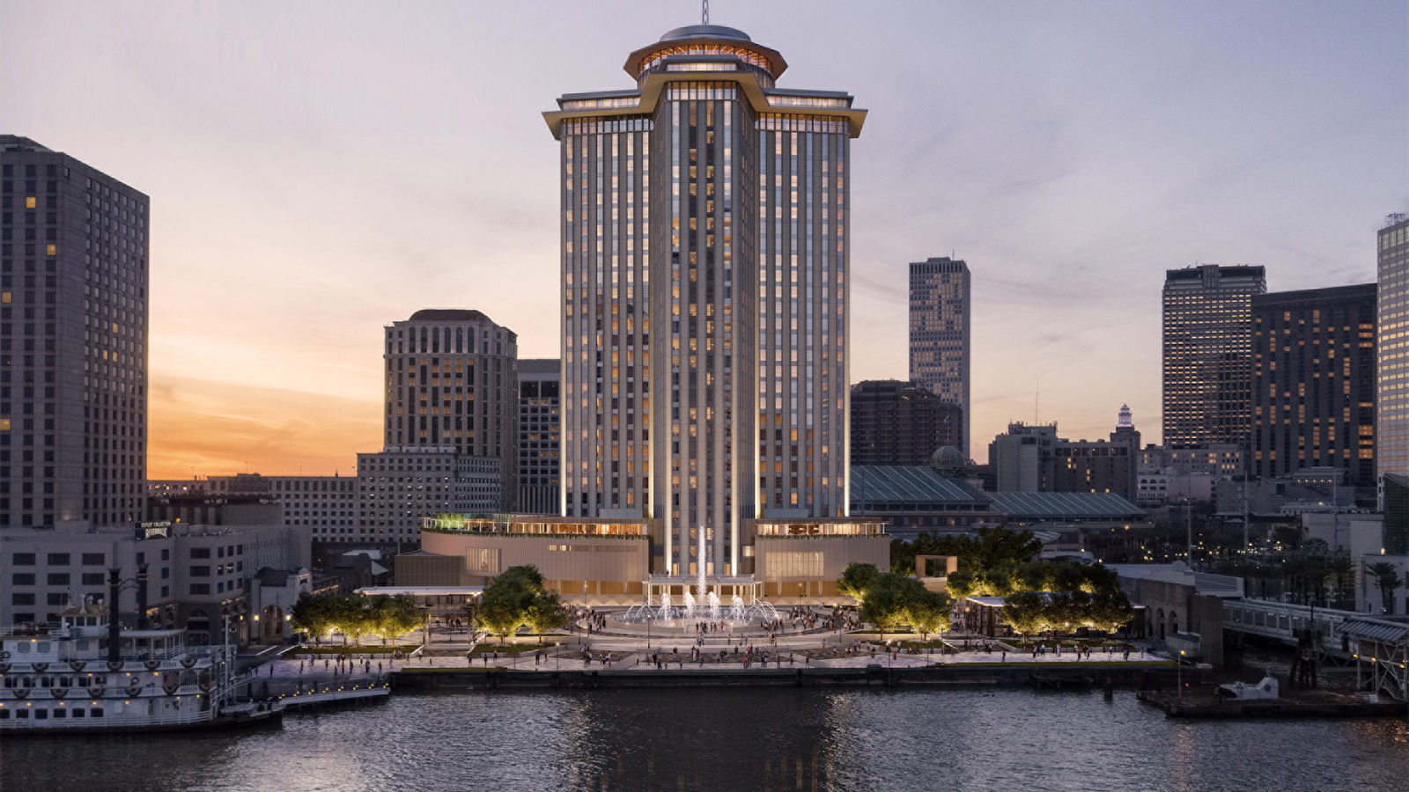
“Exciting new hotel openings, renovations and enhancements are progressing across the portfolio, all with a focus on creating the most exceptional luxury experiences while welcoming guests safely,” says Christian Clerc, President, Global Operations for Four Seasons Hotels and Resorts. “Regardless of the destination, Four Seasons guests can take comfort in knowing that their health and safety is our highest priority.”
In May 2020, the company introduced Lead With Care, an enhanced global health and safety program for employees, guests and residents that responds to the evolving nature of the pandemic in concert with local health authorities. Given the fluid and unique situation in each local market, Four Seasons also created Welcome Back, a centralised place to find the latest information about property reopenings and current facility availability, including any temporary changes to the on-property experience.
Recent New Openings
- Four Seasons Hotel Tokyo at Otemachi – The company’s third location in Japan is a glittering, all-new hotel overlooking the Imperial Palace and Gardens in the Otemachi district, highlighted by four new food and beverage concepts as well as a stunning spa designed by Jean-Michel Gathy.
- Four Seasons Hotel and Residences Madrid - The long-anticipated Spanish debut of Four Seasons completes the stunning restoration of a collection of seven historic buildings in the heart of the capital, plus Michelin-starred celebrity chef Dani Garcia’s newest restaurant concept, Dani, featuring a year-round outdoor terrace atop the Hotel.
- Four Seasons Hotel San Francisco at Embarcadero – A recent conversion to the brand brings a second address in the city featuring fully reimagined rooms by design firm Marzipan and sweeping panoramic views across the city and Bay near the dynamic Embarcadero waterfront. Coming soon - a brand-new restaurant featuring local produce and California wines.
- Four Seasons Hotel and Residences Bangkok at Chao Phraya River – Opening December 18, 2020, the imminent return of Four Seasons to the Thai capital will be nothing short of spectacular with an all-new riverside hotel and residences designed by Jean-Michel Gathy featuring six restaurant and bar concepts and an expansive wellness centre.
Anticipated Openings in 2021
- Four Seasons Resort and Residences Napa Valley – Located in the charming community of Calistoga, the next addition to the diverse Four Seasons California Collection will include wine country’s first Four Seasons resort with an on-site winery and vineyard, in partnership with Thomas Rivers Brown. Featuring 85 luxurious accommodations designed by Erin Martin, two outdoor pools, and a distinctive wellness-focused spa concept, Spa Talisa, the property will also introduce the highly-anticipated TRUSS Restaurant and Bar led by Michelin-starred chef Erik Anderson. Anticipated opening in early 2021.
- Four Seasons Hotel and Private Residences New Orleans – The first Four Seasons in one of America’s culinary capitals has just announced its partnership with award-winning chef Alon Shaya, who is developing a signature restaurant concept for the new 34-storey riverfront hotel in the World Trade Center, which will also include additional food and beverage outlets, a full-service spa, an outdoor pool deck and expansive event spaces. Anticipated opening in spring 2021.
- Four Seasons Resort Tamarindo, México – Set on more than 800 hectares (2,000 acres) of an eco-reserve on the Pacific coast, this contemporary-style cliffside resort and golf club will be a pristine oasis with abundant recreational opportunities and access to multiple beaches and private coves to discover. Anticipated opening in 2021.
- San Domenico Palace, Taormina, A Four Seasons Hotel – Four Seasons recently announced that the legendary San Domenico Palace will soon debut as a Four Seasons experience in the seaside Sicilian town of Taormina. Adding to the brand’s exceptional collection of European hotels in historic settings, the popular hillside hotel overlooking the Ionian Sea will also be home to award-winning Principe Cerami restaurant. Anticipated opening in 2021.
- Four Seasons Hotel and Private Residences Fort Lauderdale – The brand’s collection of hotels, resorts and residences in the Sunshine State continues to grow with the addition of a Kobi Karp-envisioned oceanfront hotel with interiors by Tara Bernerd and Martin Brudnizki, and landscape design by Fernando Wong. Anticipated opening in late 2021.
Renovations and Enhancements in the Americas
- Four Seasons Hotel Austin – The urban resort on the shores of Lady Bird Lake has just unveiled a new look for its year-round outdoor pool with the addition of plush daybeds and airy cabanas, capping off a multi-year transformation of the entire hotel.
- Four Seasons Hotel Chicago – Adorn, a globally-inspired restaurant in partnership with James Beard Award-winning chef Jonathon Sawyer, is one of many reasons to celebrate the completion of this multi-year, top-to-bottom renovation on the Magnificent Mile.
- Four Seasons Resort Costa Rica at Peninsula Papagayo – The latest enhancements to the enclave of Peninsula Papagayo on Costa Rica's North Pacific Coast are the eco-friendly Prieta Bay villas and estate homes, bookable through Four Seasons.
- Four Seasons Hotel Houston – Earlier in 2020 this long-time favourite unveiled new guest room designs to be completed in early 2021, and most recently in its multi-year renovation program, the bold transformation of its Grand Ballroom by designers Meyer Davis.
- Four Seasons Resort Hualalai – A multi-million-dollar enhancement program is touching nearly every aspect of the Hawaii Island resort. Highlights include a complete rooms renovation, a dramatic update of the King’s Pond swimmable aquarium, a new culinary academy and significant expansion of its golf program, led by the new 275 square metre (3,000 square foot) golf hale.
- Four Seasons Resort Nevis, West Indies – A resort-wide transformation was completed a year ago, while enhancements continue to be made at this Caribbean hideaway, featuring newly designed guest rooms and suites, a new look for the resort’s pools, and new dining programs, along with additional experiences to discover.
- Four Seasons Hotel New York Downtown – Lower Manhattan’s preferred address has just unveiled the sophisticated new Empire Suite. Designed by Tara Bernerd, it features 180-degree views from the 24th floor, offering the ultimate urban sanctuary with media room, a full catering kitchen and more.
- Four Seasons Resort Punta Mita, Mexico – Debuting the results of a multi-year renovation last summer, this oceanfront oasis on a private peninsula is now showcasing newly-renovated casita-style accommodations, private villas and beach homes, the refreshed Nuna pool, and expanded wellness, fitness and family programming.
- Four Seasons Resort and Residences Whistler – The newly renovated Canadian mountain resort completes a property-wide enhancement with the launch of Braidwood Tavern, a craft kitchen and social house conceived in collaboration with celebrated chef and restauranteur Richard Sandoval, along with a re-imagined SIDECUT Steakhouse, both designed by Box Interior Design.
Renovations and Enhancements in Europe, Middle East and Africa
- Four Seasons Hotel Amman – In the Jordanian capital, Four Seasons has unveiled newly refurbished guest rooms that reflect the city’s intersection between Arabic, Islamic and Western cultures. The hotel’s original designers, Richmond International, incorporate advanced technologies in rooms flooded with natural light, offering a heightened guest experience when rediscovering the best of Jordan.
- Four Seasons Hotel Doha – In early 2020, this beachfront urban hotel in the heart of the Qatari capital reopened with a whole new look conceived by Pierre-Yves Rochon across guest accommodations, dining outlets, lobby and public spaces, highlighted by numerous bespoke details.
- Four Seasons Hotel Hampshire – Earlier this year this Grade II-listed country estate set on 200 hectares (500 acres) debuted a completely new look for its expansive selection of event spaces by RPW Design with a nod to the area’s rich history while introducing a modern aesthetic.
- Four Seasons Hotel Istanbul at Sultanahmet – The beloved boutique hotel will reopen in 2021 with a fresh new look that honours the building’s storied history and connects even more deeply with the surrounding Old City.
- Four Seasons Hotel Megève – Excitement is in the French Alpine air as multi-Michelin starred chef Anne-Sophie Pic partners with the Rothschild family to create a new culinary experience at La Dame de Pic – Le 1920, drawing particular inspiration from the rich surrounding terroir.
- Four Seasons Hotel Milano - Loyal guests of the intimate historic hotel will soon enjoy newly enhanced spaces by architect Patricia Urquiola, as well as a new restaurant and bar by April next year. Remodelled gardens by Flavio Pollano and renovated rooms and suites are among the other enhancements guests can look forward to before the end of 2021.
- Four Seasons Hotel Ritz Lisbon – Renovations are continuing as three floors of newly renovated rooms are unveiled this month, along with the addition of an outdoor pool and bar, infusing an exciting new energy into the neighbourhood. Lisbon’s most iconic address has also recently launched Cura, a temple of modern art and Portuguese fine dining inspired by the local bounty of land and sea.
- Four Seasons Hotel Riyadh at Kingdom Centre – The first stage of an extensive renovation features revamped rooms and suites by Hirsch Bedner Associates, reflecting modern Saudi culture and featuring advanced technologies.
Renovations and Enhancements in Asia Pacific
- Four Seasons Resort Bali at Jimbaran Bay – At this beachfront resort, the new 2,000 square metre (21,500 square foot) Healing Village Spa, 18 months in the making, is a destination for traditional and modern spa offerings, and also plays host to visiting wellness practitioners.
- Four Seasons Resort Bora Bora – A resort-wide enhancement program is completed with the debut of reimagined beachfront villa estates that feature abundant indoor-outdoor space including large infinity pools and complete privacy. In addition, overwater bungalow accommodations, dining experiences and resort shopping have all been upgraded at this award-winning property in French Polynesia.
- Four Seasons Hotel Hong Kong – As of spring 2021, guests can enjoy redesigned guest rooms and suites, a new arrival experience in the lobby including a new lobby café, and a highly anticipated cocktail bar that aims to break new ground with innovative programming and inspired cocktails.
- The Grand Suites of Four Seasons – Adjacent to Four Seasons Hotel Macao is a new 40-storey, all-suites product offering residential services to guests. Featuring one-to-three-bedroom suites as well as duplex suites with a private pool, these exclusive accommodations boast features such as top-end kitchen appliances, full walk-in closets, private fitness rooms and more. In-suite services include an elegant Chinese Tea Ceremony and meals prepared by Michelin-starred chefs.
Four Seasons Private Retreats Offer Luxury Vacation Home Rentals That Pair Seclusion and Service
Whether looking for a family escape, group getaway with friends, romantic retreat, staycation or road trip, Four Seasons Private Retreats are perfect for those seeking more space and privacy complemented by round-the-clock Four Seasons services and amenities. From beachfront hideaways to spectacular mountain retreats, guests can choose from more than 750 luxury villas and residences in the world’s most desirable destinations. The Private Retreats experience offers guests the opportunity to savour precious time together with friends and family in spaces tailor-made for sharing quality moments.
Extended Stays with Four Seasons
For those who are looking for a change of scenery while staying connected, or those simply looking for an opportunity to relax and rejuvenate, Four Seasons has just introduced Extend Your Stay, which offers an array of exclusive benefits for those who wish to make Four Seasons their home for 30 days or more. Guests will have a designated concierge throughout their stay, and the option to create a tailored wellness plan with the property’s culinary and spa teams, plus ground transfers, complimentary parking, premium Wi-Fi and private fitness sessions.
In addition, many Four Seasons hotels are now offering stay or day packages tailored to the needs of those working or learning remotely. Inquire directly for details.
A New Four Seasons Private Jet Experience
The new, fully customised Four Seasons Private Jet takes flight in 2021 with around-the-world itineraries that offer a total Four Seasons experience, from jet to accommodations, unique experiences in incredible destinations, and the services of a full on-board team including executive chef, a concierge who will personalise the trip for each guest, and ajJourney physician. Reconfigured to just 48 seats with 2 metres (6.5 feet) of personal space for greater comfort, the spacious Airbus A321neo-LR aircraft’s interior is equipped with a state-of-art, hospital-grade air filtration system that renews the cabin air every two to three minutes and removes 99.9 percent of particles, viruses and bacteria. Limited space is available for some 2021 journeys, and the first itineraries for 2022 have just been announced.
Enhanced Health and Safety, and Contactless Service with the Four Seasons App
Four Seasons Hotels and Resorts continues to welcome guests with Lead With Care, the company’s enhanced global health and safety program. Grounded in health care expertise and enabled by access to leading technologies and tools, Lead With Care establishes procedures that educate and empower employees take care of guests and each other. For more information about Four Seasons Lead With Care program as well as specific details of property protocols and facility updates, click here.
Four Seasons Mobile App and Chat also provides a convenient and contactless way for individuals to customise their stay. With Four Seasons service available in 100+ languages, guests have the ability to make and manage reservations, request luggage pickup, airport transfers, room service, housekeeping requests, and more.

RELATED

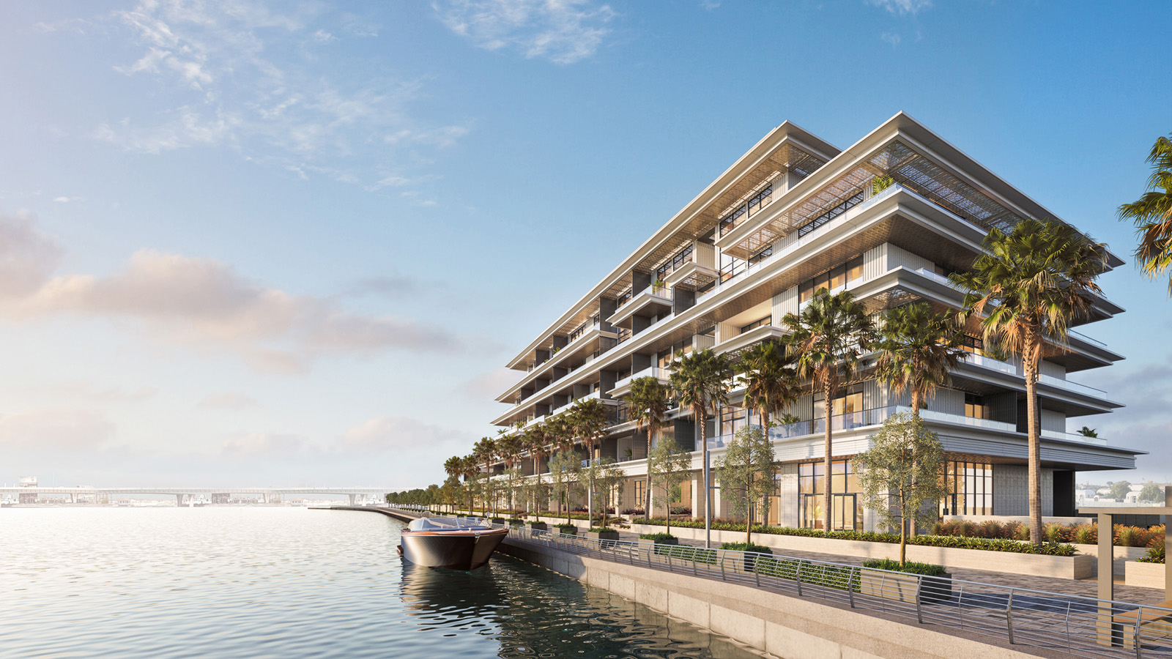 | December 7, 2021, Toronto, Canada  Four Seasons and Bright Start Announce Standalone Private Residences in Dubai  https://publish.url/news-releases/2021/new-private-residences-in-dubai.html
December 7, 2021, Toronto, Canada
Four Seasons und Bright Start kündigen eigenständige Privatresidenzen in Dubai an
https://publish.url/news-releases/2021/new-private-residences-in-dubai-2.html

PRESS CONTACTS

Sarah Tuite
Vice President, Corporate Public Relations
1165 Leslie Street
Toronto
Canada
prsm@fourseasons.com

+1 416 441 4350

