Take the Leap, Take Your Time: Leap Year Promotions at Four Seasons Hotel Hong Kong

February 18, 2020, Hong Kong, China

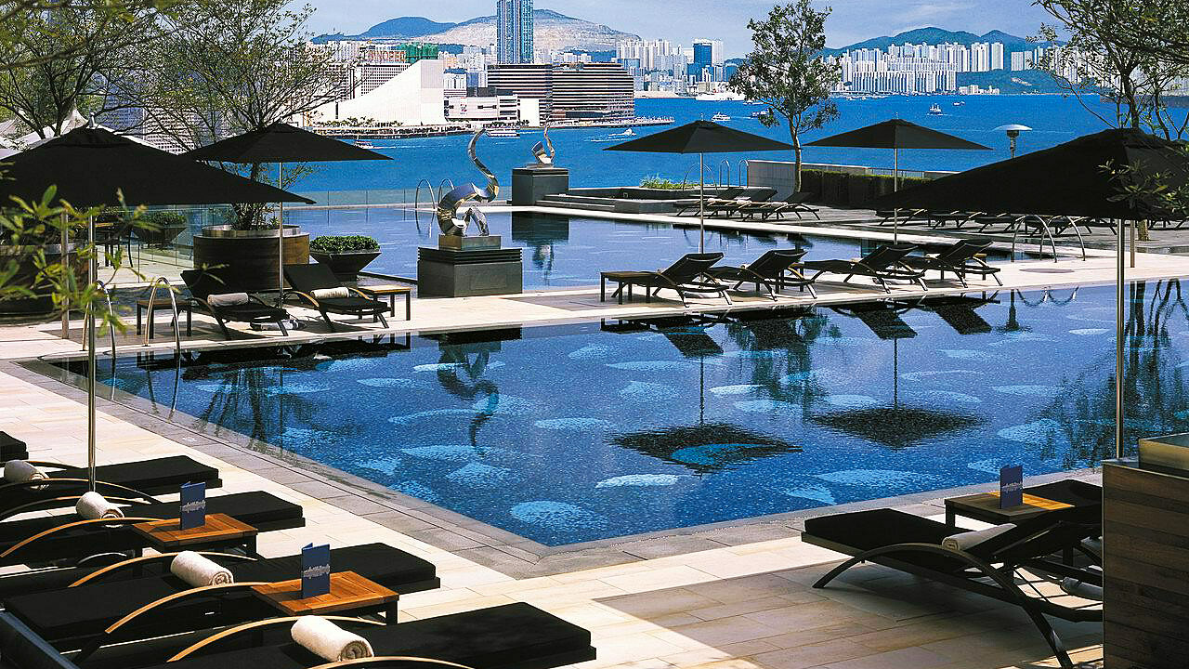
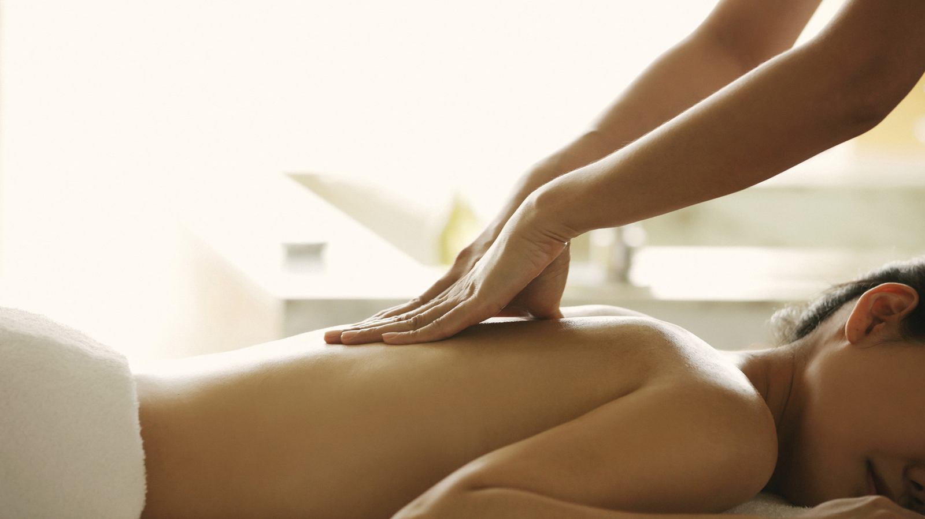 | 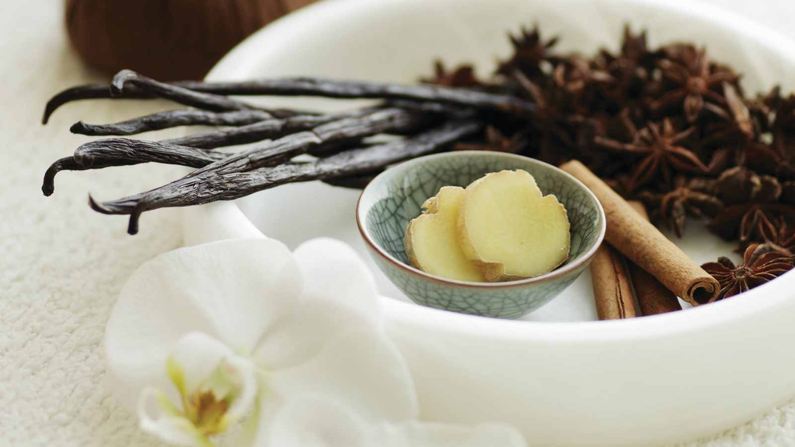 | 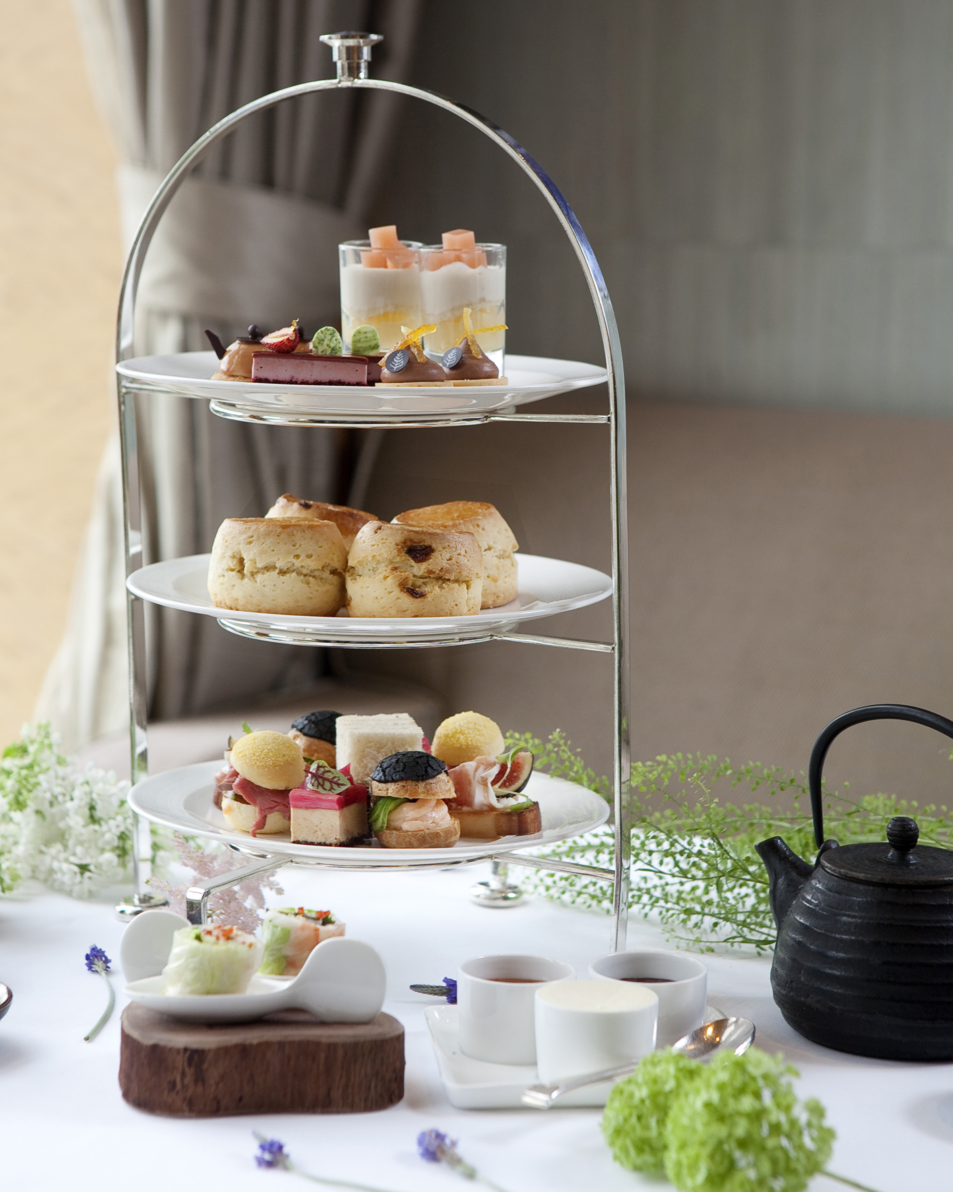
To celebrate the gift of an extra day in 2020 with 366 days, Four Seasons Hotel Hong Kong invites guests to Take the Leap, Take Your Time and be treated to curated experiences that are exclusively available on the Hotel’s e-shop and official website from February 17 to 29, 2020. Guests will enjoy 29 percent savings off the retail price on room bookings, dining and bar experiences, and spa treatments. Plan ahead for special occasions and gift gifting with convenient shopping at one's fingertips.
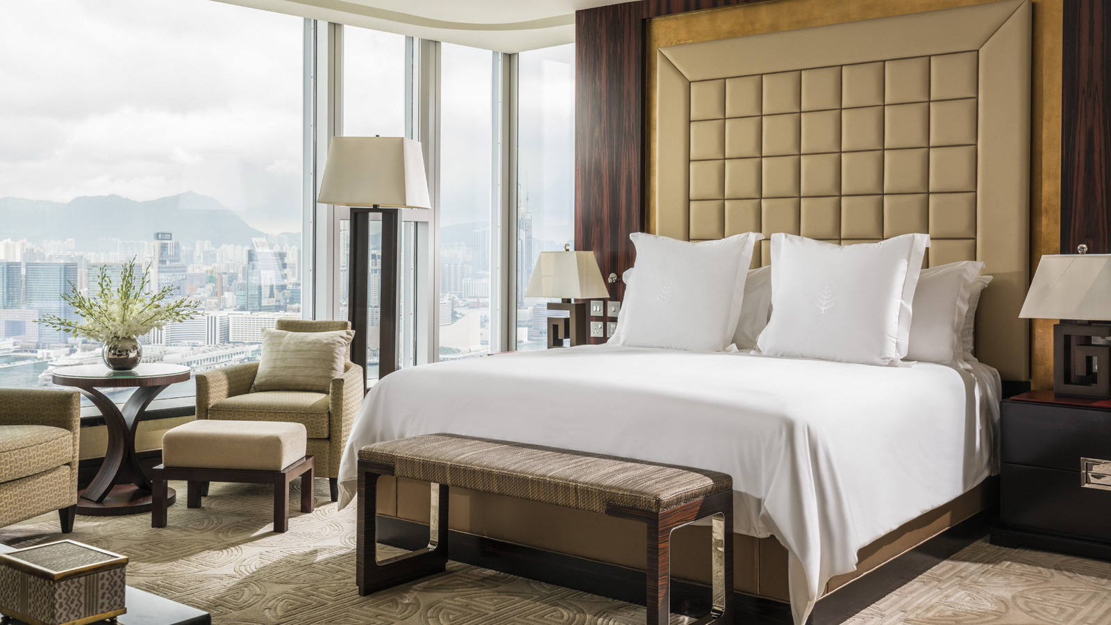 | 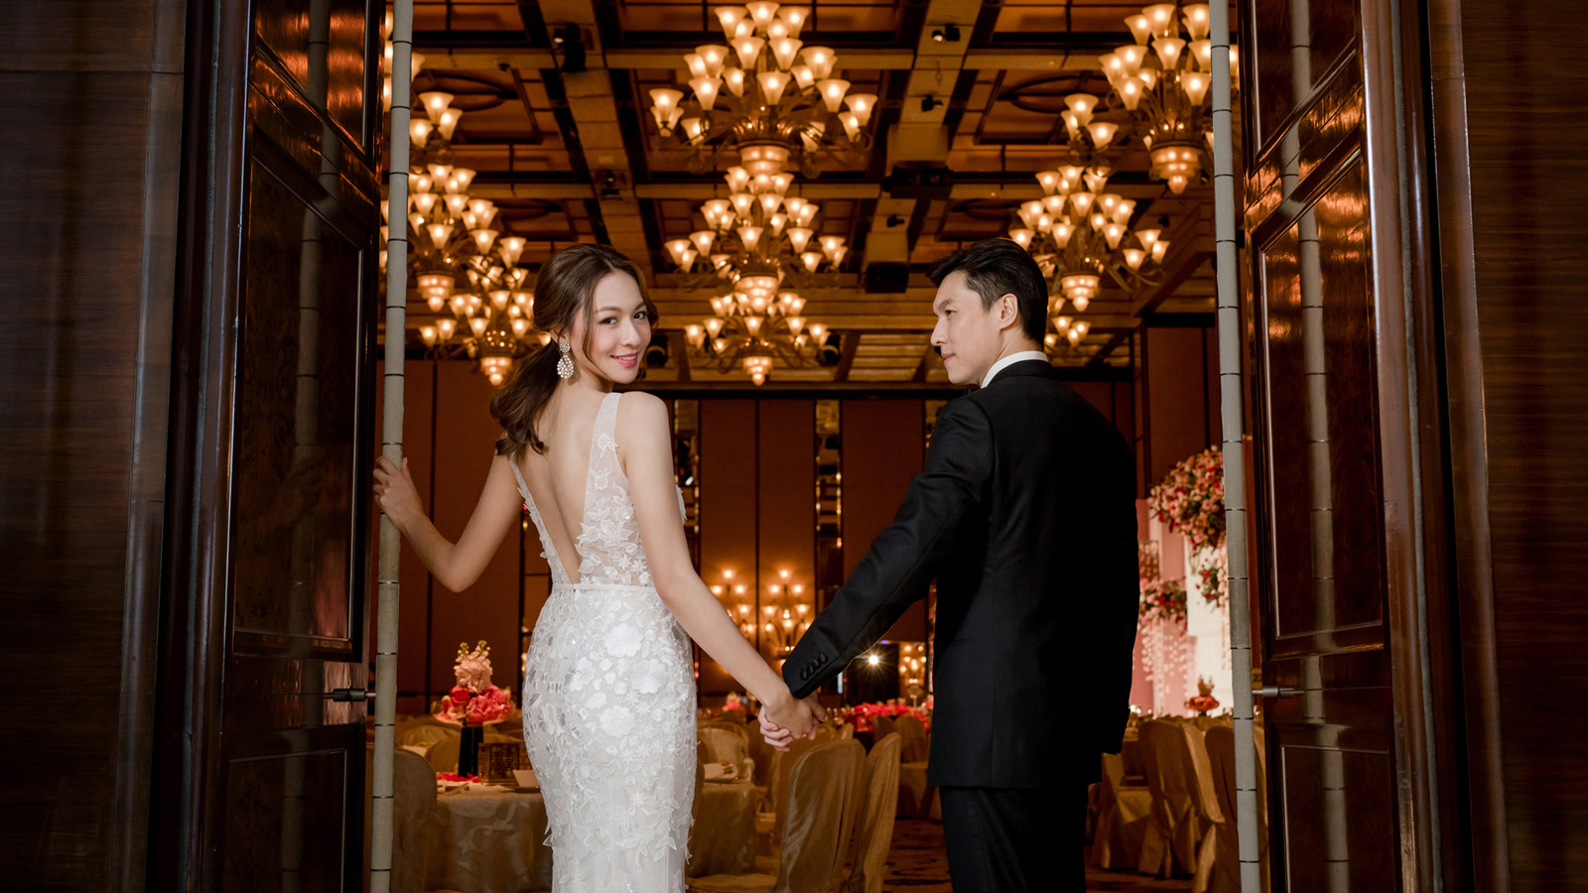
A Holiday at Four Seasons
Take Your Time to meaningfully connect with loved ones while discovering the world with Four Seasons service and outstanding amenities. Make a booking on FourSeasons.com from February 17 to 29, 2020 and enjoy 29 percent savings on a room stay.
- Bookable via Four Seasons official website
- Stay period is until December 31, 2020 (subject to availability and black out dates apply)
Gourmet Haven
Take Your Time to create memories to last a lifetime with the culinary team at The Lounge. Enjoy 29 percent savings for the Afternoon Tea Set and a three-course dinner set menu at The Lounge.
- Bookable via Four Seasons e-shop
- Redemption period is between February 29 to December 31, 2020 (subject to availability and blackout dates apply)
Deep Rejuvenation
Take Your Time for moments of pure joy to relax and rediscover oneself at The Spa. Book a spa treatment of 90 minutes and above and enjoy 29 percent savings. The offer is valid from Mondays to Fridays.
- Bookable via Four Seasons e-shop
- Redemption period valid until July 31, 2020 (subject to availability and blackout dates apply)
A Milestone Celebration
Celebrate life’s little moments and create precious memories with A Milestone Celebration at Four Seasons Hotel Hong Kong. The 10-course menu created by three Michelin star Chef Chan Yan Tak is priced at HKD 15,388 per table, subject to 10 percent service charge. Book a minimum of four tables and receive a gift voucher of HKD 2,020, redeemable at The Lounge or Blue Bar.
- Booking period: now until February 29, 2020
- Dining period: May 1 to June 30, 2020
For enquiries or reservations, email catering.hkg@fourseasons.com or call 3196 8338.

RELATED

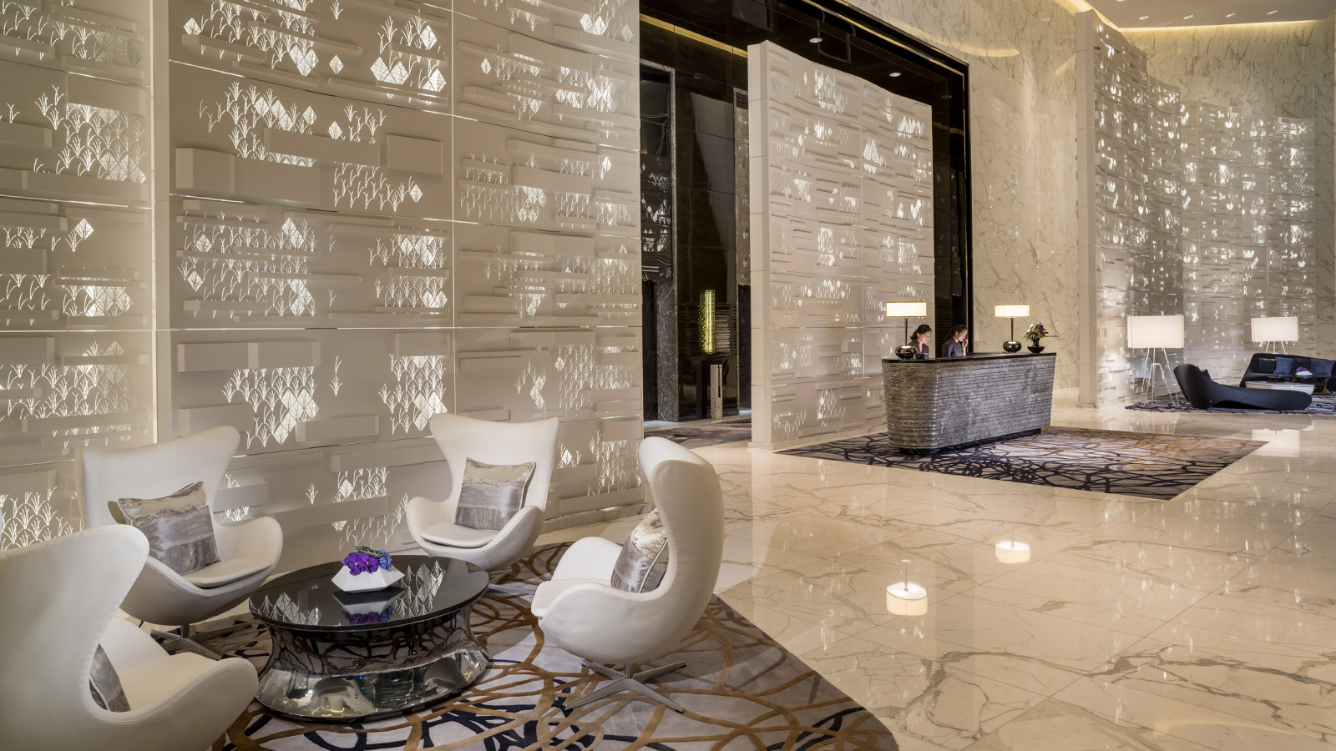 | February 19, 2020, Guangzhou, China  广州四季酒店连续第六年荣获福布斯五星酒店称号  https://publish.url/zh/guangzhou/hotel-news/2020/forbes-five-star-hotel-2.html
February 19, 2020, Guangzhou, China
Four Seasons Hotel Guangzhou Retains Five-Star Rating from the 2020 Forbes Travel Guide Awards
https://publish.url/guangzhou/hotel-news/2020/forbes-five-star-hotel.html

PRESS CONTACTS

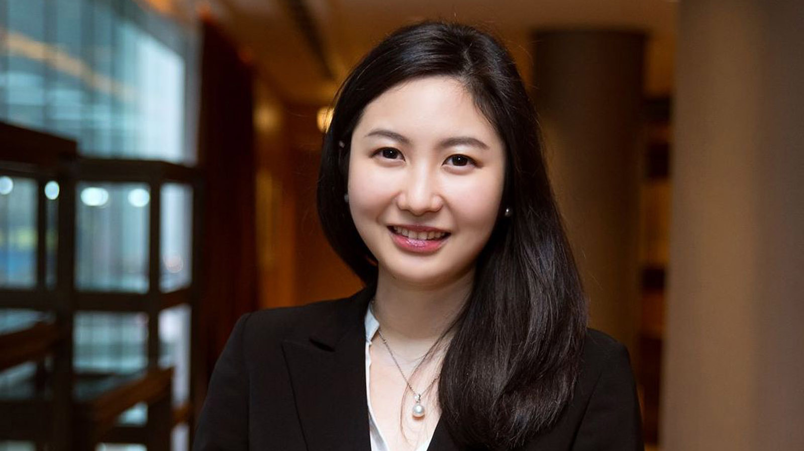 | Priscilla Chan  Assistant Public Relations Director  8 Finance Street, Central,  Hong Kong  China  priscilla.chan@fourseasons.com  (852) 3196 8307

