Four Seasons Hotel New York Celebrates Toques in Black with the Chef’s Connection

Enjoy an intimate dining experience at The Garden featuring guest Chefs Radisha Rowe and Christopher Faulkner
March 2, 2020, New York, U.S.A.

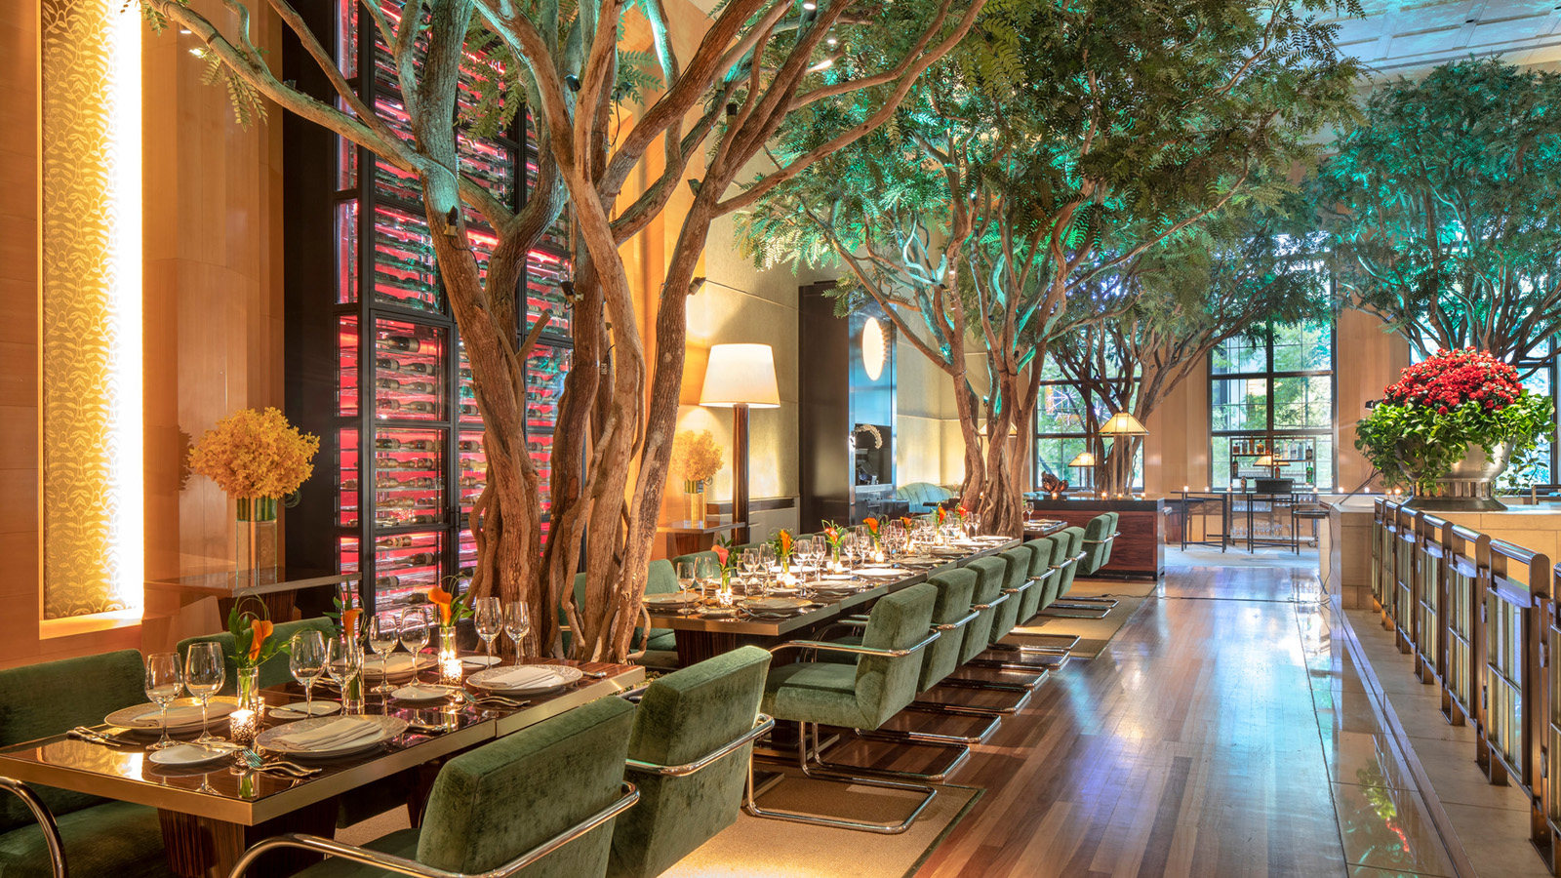
 | 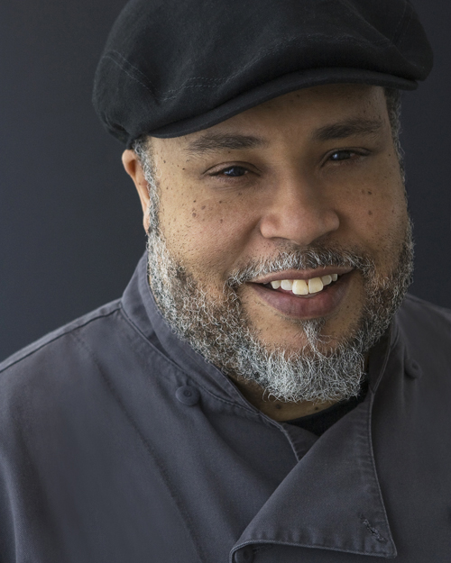 | 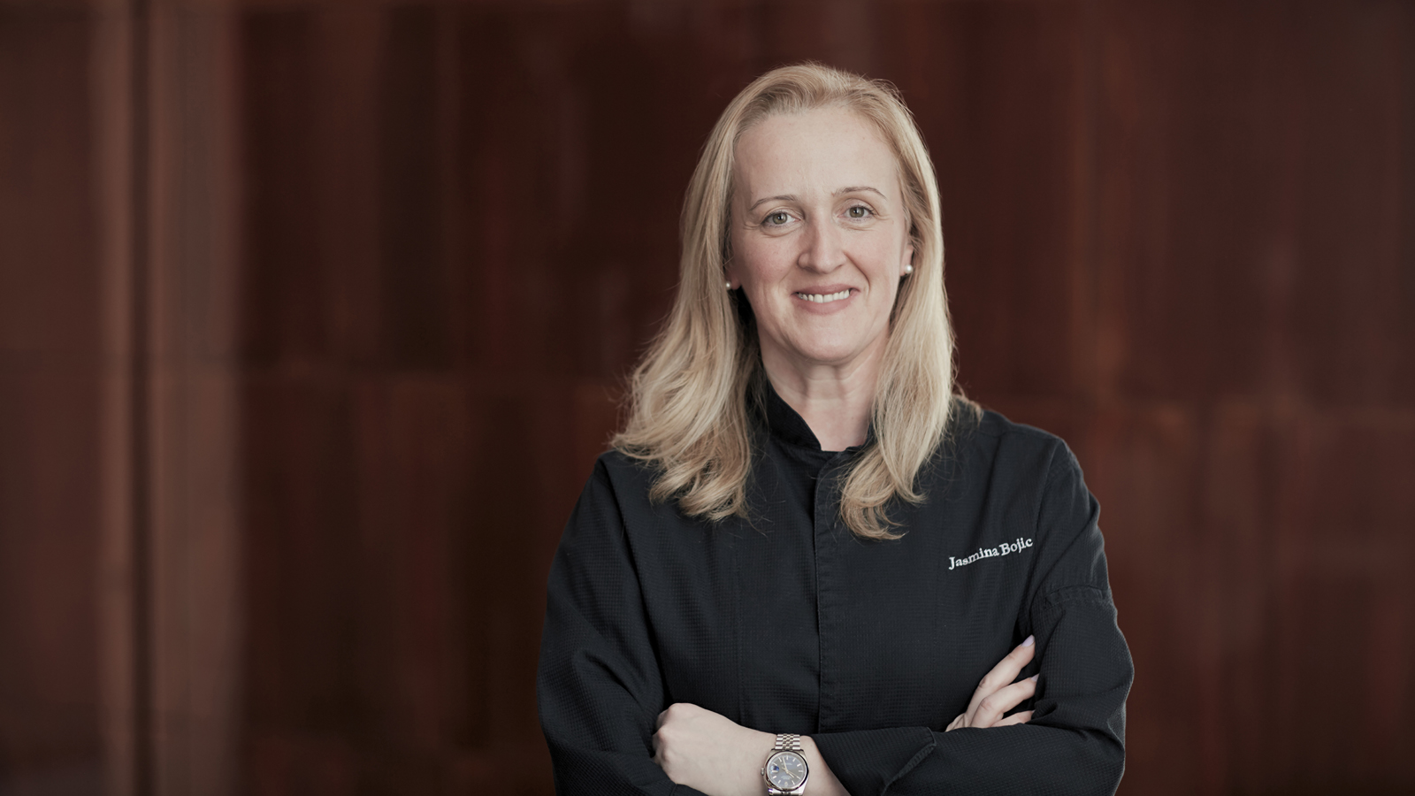
To celebrate the launch of the Chef’s Connection’s Toques in Black book, Four Seasons Hotel New York will host an intimate dining experience at The Garden featuring a four-course dinner by Christopher Faulkner, Executive Chef of Soho Diner and Radisha Rowe, Executive Sous Chef at Cipriani Grand Central in collaboration with the hotel’s Executive Chef John Johnson. The event takes place on Monday, March 16, 2020 at 7:00 pm.
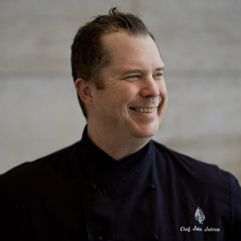
Rowe will show off her plant-based approach and Faulkner will incorporate international culture and ingredients found in the regional cuisines of the Americas, Africa, Australia, the Caribbean and Europe. The collaborative menu will be paired with the FACUNDO Rum Collection, a limited release of four rare blends of the finest aged sipping rums, sourced from the Bacardi family’s private rum reserves.
Overlooking the Hotel’s I.M. Pei-designed lobby surrounded by African acacia trees, The Garden serves as a unique venue for special occasions. A portion of the ticket sales will benefit The Chef’s Connection’s Line Cook Program, an initiative that places candidates in roles at leading restaurants.
Toques in Black Menu
- Amuse-bouche: shrimp and yam sauce shooter and sugar snap peas and ramp fritter with slow-roasted tomato and basil
- First Course: black kale and green papaya salad (orange, sweet potato, spiced sugarcane)
- Second Course: jerk jackfruit croquette with a scotch bonnet tamarind glaze, coconut cilantro reduction
- Third Course: choice of wild mushroom gemelli with artichoke truffle cream and fried sage; or, grilled goat chop, green onion ash potato, molasses vinaigrette
- Fourth Course: Pastry by Executive Pastry Chef Jasmina Bojic
Each course will be paired with one of the four expressions from the FACUNDO Rum Collection. FACUNDO’s National Brand Ambassador Robert Nieves will curate the cocktails in collaboration with the Hotel’s Director of Beverage Cara Maldonado.
Each blend from the FACUNDO Collection is a testament to the Maestro’s ability to create balanced rums that still retain their own unique characteristics. In creating the FACUNDO Rum Collection, BACARDI Maestro de Ron (Master Blender) Manny Oliver chose from 300 hand-selected blends sourced from the Bahamas to select those to include in this series.
Tickets are USD 350++ per person and can be purchased via Tock. For any inquiries, email Renee Ward at renee.ward@fourseasons.com or call 212 758 5700. Seating is limited to 30. Menu subject to change.
On Tuesday, March 17, 2020, The Chef’s Connection will also celebrate the book with their main event, The Great Gathering of Chefs, at the Prince George Ballroom.

RELATED

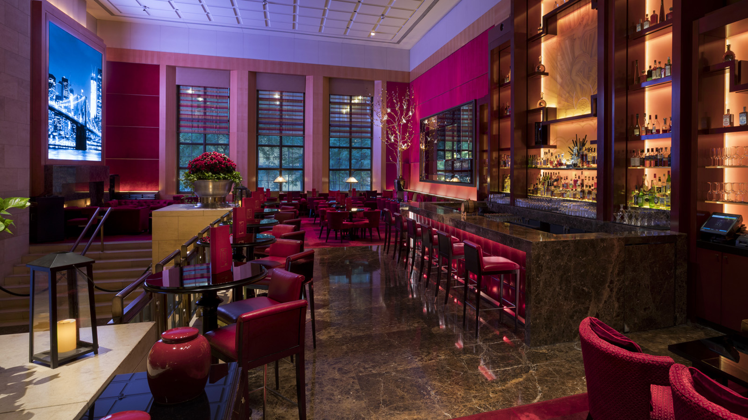 | February 24, 2020, New York, U.S.A.  Celebrate Leap Day at Four Seasons Hotel New York  https://publish.url/newyork/hotel-news/2020/take-your-time.html
February 12, 2020, New York, U.S.A.
Four Seasons Hotel New York Named Five-Star Hotel in Forbes Travel Guide’s 2020 Star Awards
https://publish.url/newyork/hotel-news/2020/forbes-five-star-hotel.html

PRESS CONTACTS

Nieves Alvarez
Digital Marketing Manager
57 East 57th Street
New York
U.S.A.
nieves.alvarez@fourseasons.com

+1 (212) 350-6207

