An Elegant Self-Care Staycation: Artful Helena Rubenstein Skin Care Meets Luxury Hospitality at Four Seasons Hotel Guangzhou

December 5, 2022, Guangzhou, China

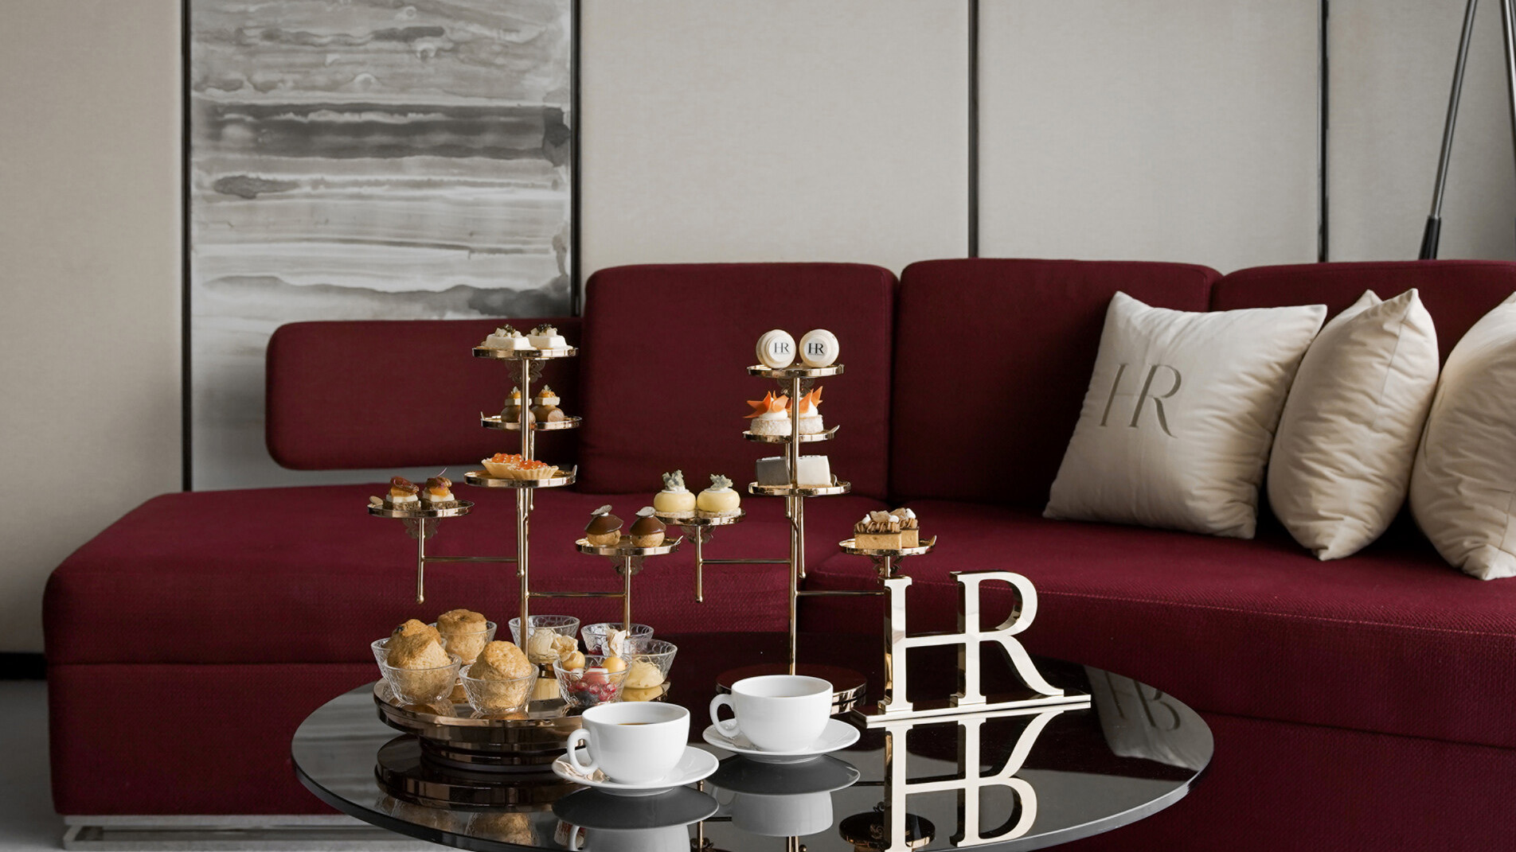
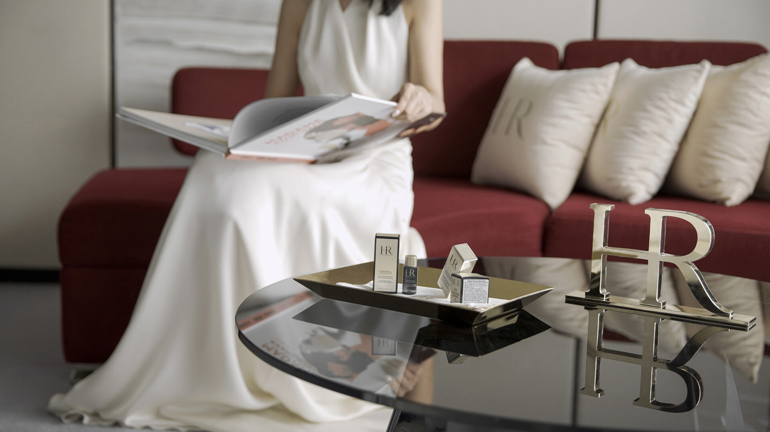 | 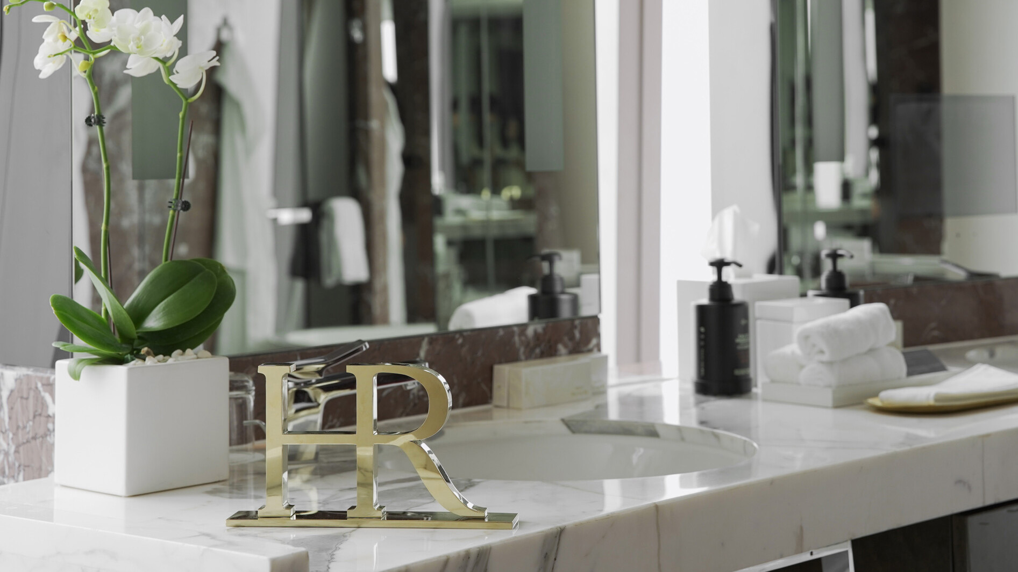 | 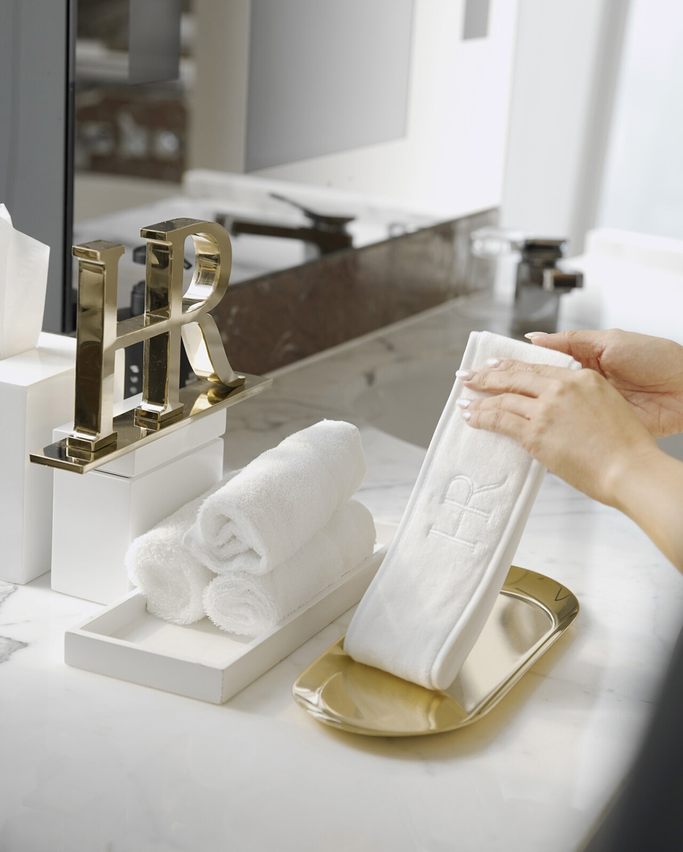
It has been ten years since Four Seasons Hotel Guangzhou opened its doors to discerning guests in the heart of Zhujiang New Town – and ten years since the iconic beauty brand Helena Rubenstein launched its signature product: Replasty Age Recovery Night Cream. To celebrate their joint anniversaries, the two luxury icons have united to create a unique experience for guests of Four Seasons Hotel Guangzhou: a self-care staycation with a difference.
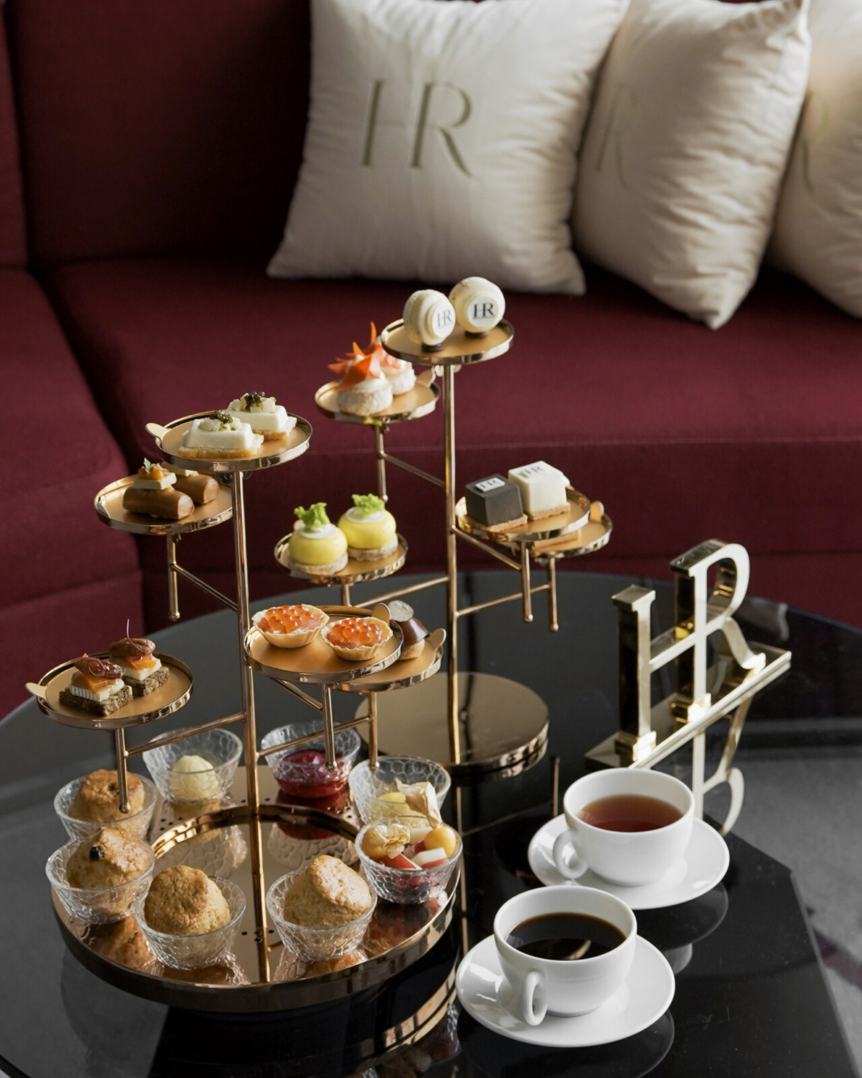
A timely reminder of the importance of self-care in these challenging times, the Helena Rubenstein (HR) Theme Room package is based around a rejuvenating one-night stay in the Hotel’s uniquely themed Helena Rubenstein Premier Room River View – a luxurious haven with floor-to-ceiling views of the shimmering Pearl River.
The Helena Rubenstein brand has been empowering women through beauty since 1902 with its cutting-edge science and personalised approach. The HR package at Four Seasons Hotel Guangzhou is designed to encourage couples or friends to kick off their shoes, turn off the news, and focus on relaxation, beginning with a selection of Helena Rubenstein product samples for self-care facials including Replasty Age Recovery Accelerating Night Care and Powercell Skinmunity Reinforcing Serum. HR package guests will also enjoy a unique HR in-room Afternoon Tea for two, not available anywhere else in the Hotel. Crafted by Pastry Chef Keng Seng Mak, it pays homage to the brand’s artistic lineage with bite-size beauty in the form.
Other thoughtful Helena Rubenstein themed room additions include scatter cushions; a Madame Avant-Garde coffee table book; floor mats; an expansive window sticker – for Instagrammable moments high above the Guangzhou skyline – and two pairs of take-home HR logo slippers.
“We are living our lives at such a fast pace these days that many of us forget the importance of a 24-hr rest and reset from time to time. Our 10th anniversary collaboration with Helena Rubenstein is an invitation to enjoy in-room rest and refinement with no outside pressure or expectations. Guests can even order in-room dining for a 24-hour hideaway that’s all about curling up with face products, a gorgeous book, delicious treats and your loved one or best friend. We challenge anyone not to feel better as a result,” says Four Seasons Hotel Guangzhou General Manager David Macklin.
Helena Rubenstein (HR) Theme Room packages are available starting from CNY2,999* per stay, exclusive of 16.6% of government tax and service fees. Bookings are subject to availability. To reserve, contact Four Seasons Hotel Guangzhou at 86 (20) 8883-3881.

RELATED

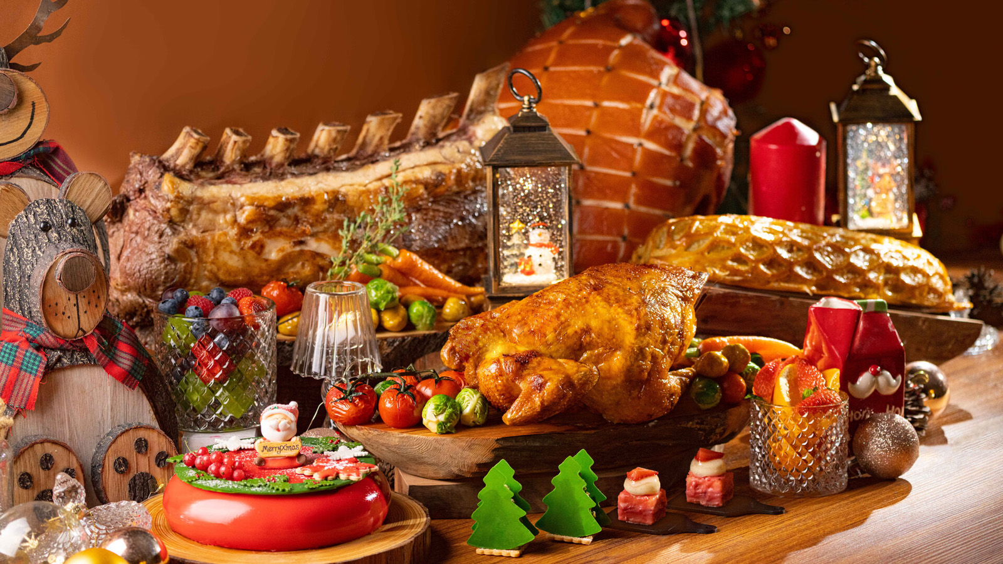 | November 29, 2022, Shenzhen, China  深圳四季酒店呈献岁末节庆礼遇  https://publish.url/zh/shenzhen/hotel-news/2022/festive-season-2.html
November 29, 2022, Shenzhen, China
Festive Feasting, Four Seasons Style at Four Seasons Hotel Shenzhen
https://publish.url/shenzhen/hotel-news/2022/festive-season.html

PRESS CONTACTS

Yvonne Ye
Manager of Public Relations
5 Zhujiang West Road, Pearl River New City, Tianhe District
Guangzhou
China
yvonne.ye@fourseasons.com

86 (20) 8883-3901

