Spring in Seoul

Seeking a city that really does have it all for a long-awaited springtime break? Visit Seoul during April and May for a cherry blossom extravaganza that is as tasty as it is spectacular
April 1, 2022, Seoul, Korea

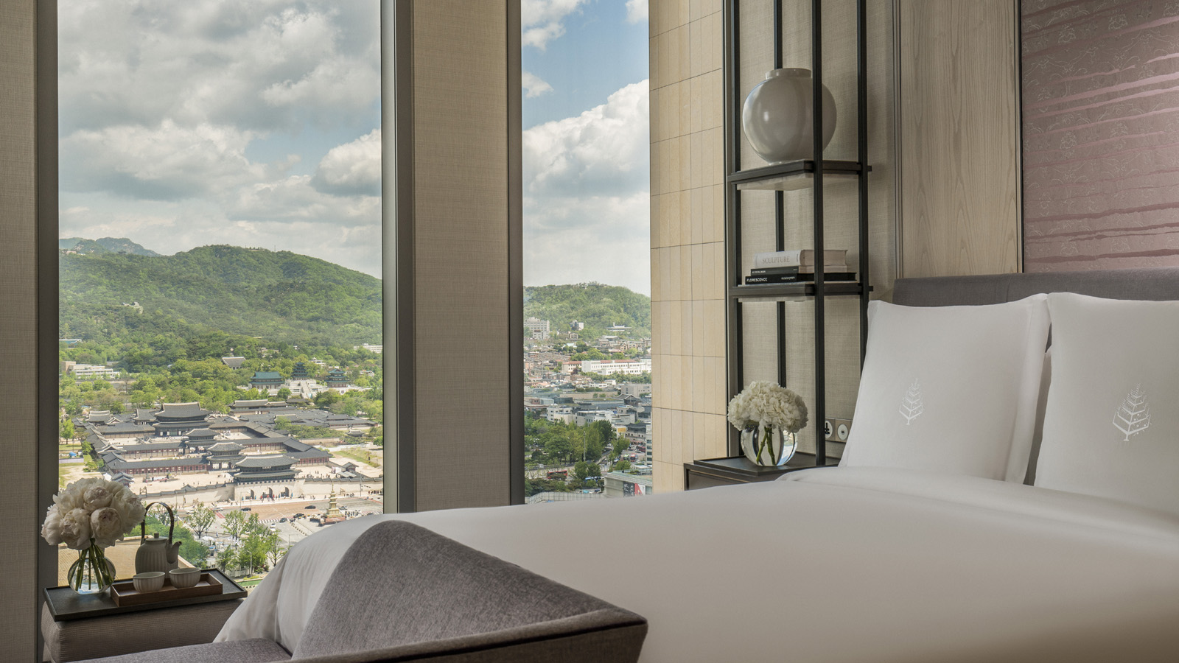
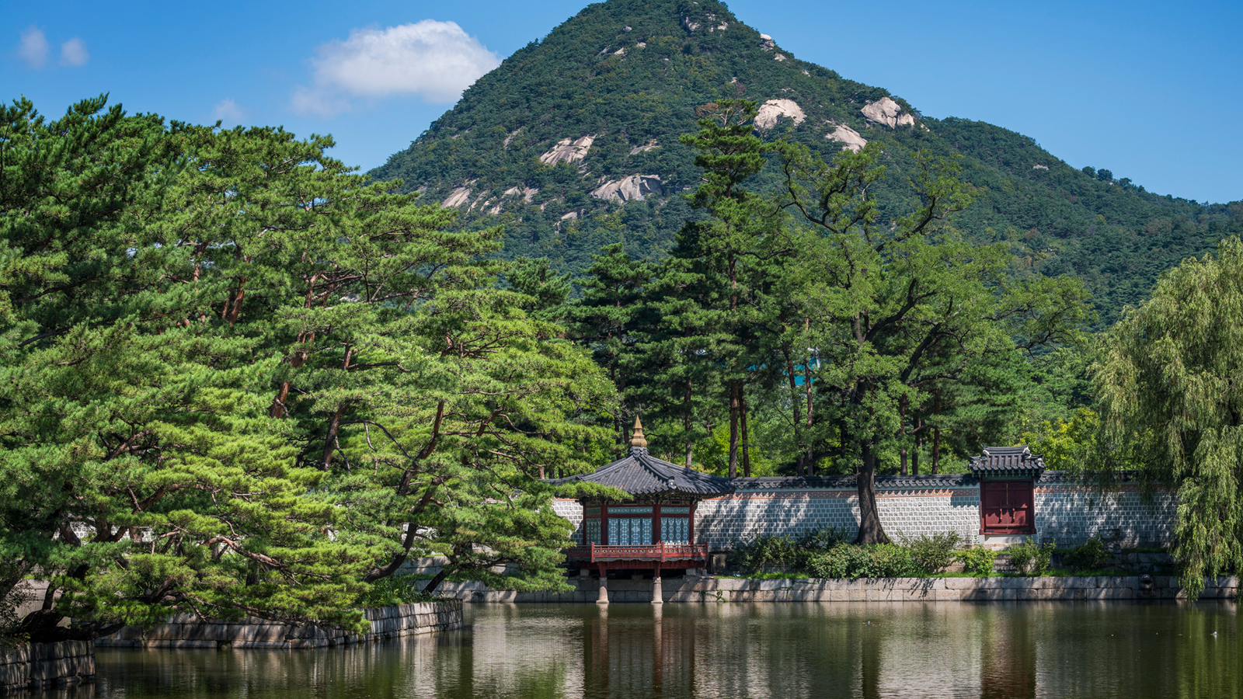 | 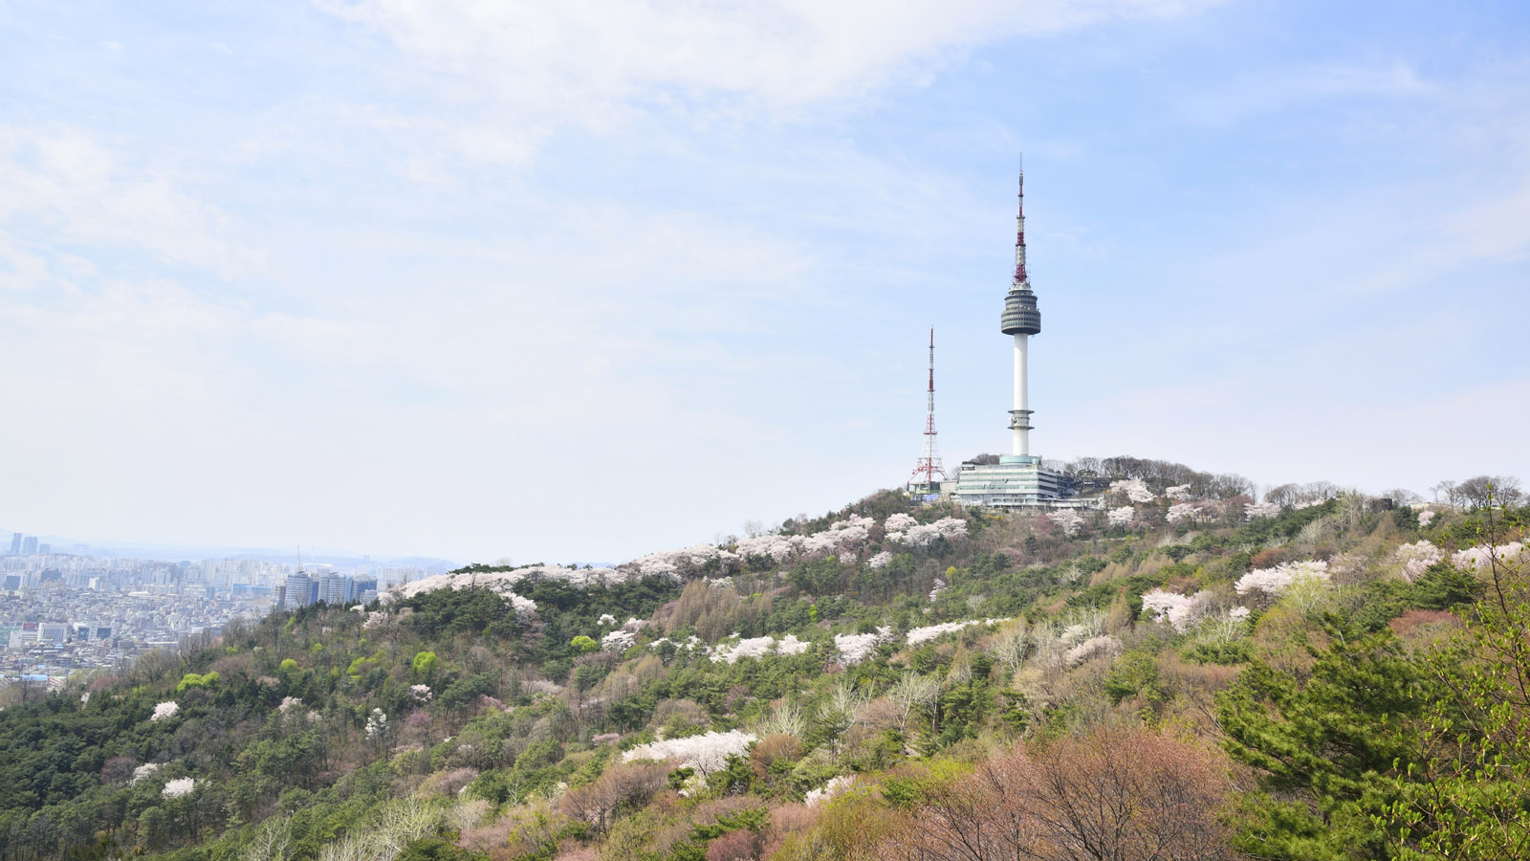 | 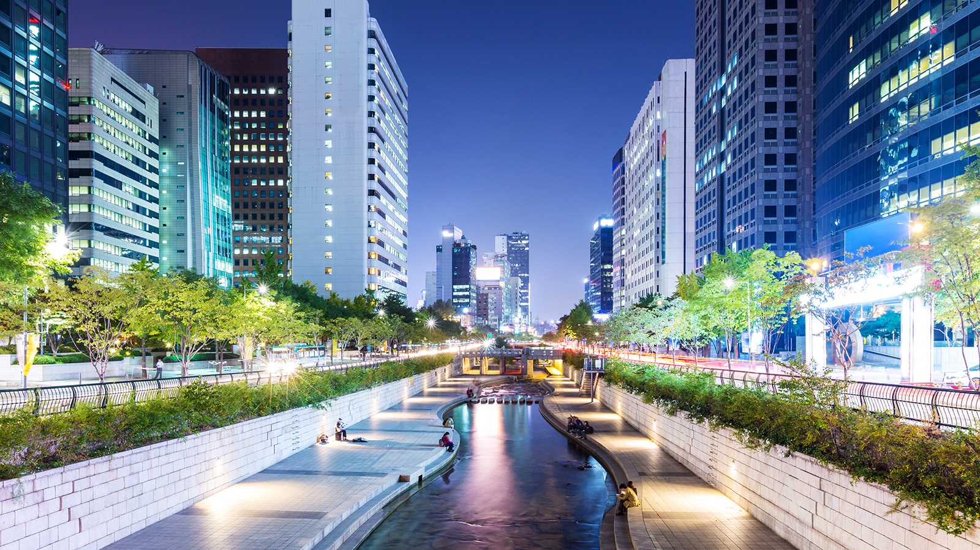
As Korea opens its borders to international travel, visitors are welcomed by a profusion of blossom and beauty alongside uplifting festivals, national holidays and an array of seasonal delicacies. At Four Seasons Hotel Seoul – at the geographical heart of the city – you’re perfectly placed to access the best blooms and buzzing events of the season of new beginnings.
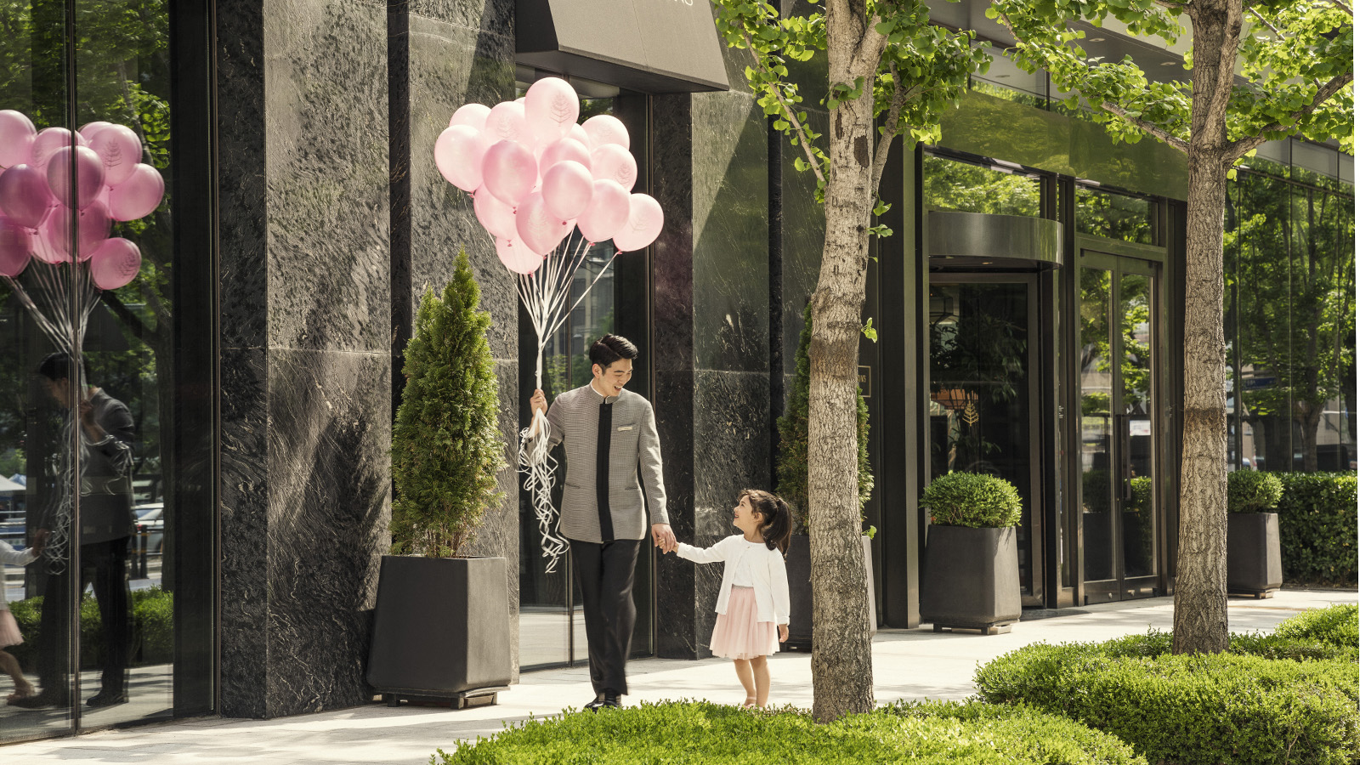 | 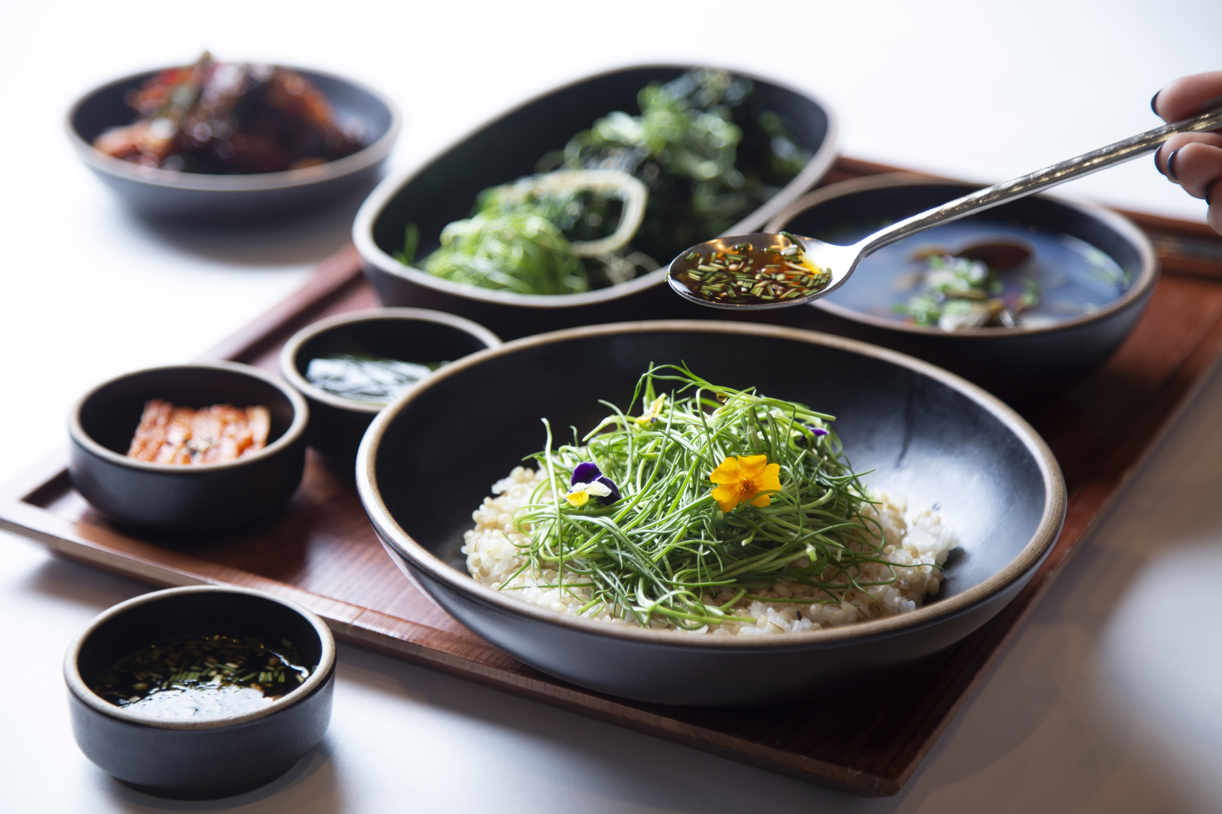
Here are our three favourite ways to immerse yourself in the colour, joy, and flavour of springtime in one of the world’s most exciting cities:
1. Savour blossoming beauty
Juxtaposing the ultra-modern and the historical, Seoul’s architecture is a striking backdrop to the city’s springtime cherry blossom spectacle. Less than 10 minutes’ walk from Four Seasons Hotel Seoul, the central lake of Gyeongbokgung Palace is one of the top spots to appreciate it, with its fringe of delicate pink froth during April and May; hire a beautiful hanbok (traditional Korean clothing) for Insta-worthy pictures.
Take a nightly tour around the illuminated palace for heightened seasonal atmosphere. Or for the ultimate in royal treatment, book the Hotel’s Palace-View Executive Suite and bask in the majestic view from the elevated privacy of your bathtub.
Equally close by, Deoksu Palace’s 900-metre (2,950 foot) Stone Wall Path is a tucked-away bench-lined promenade flanked by 130 blossoming trees. For the healing serenity of artisanal and natural beauty, Sungkok Art Museum’s sculpture garden is also exquisite when its cherry trees are in bloom. Other great places to enjoy the blossom are Unhyeongung Palace and the Secret Garden at Changdeok Palace – both within a 10-minute drive of the Hotel.
2. Enjoy springtime like the locals
Spring has a special place in the hearts of Seoulites after the cold months of winter. Join city-insiders for uplifting 360-degree blossom-festooned views at the top of Namsan Mountain (a 10-minute drive from the Hotel) – the site of Korea’s first general radio broadcast from the iconic N Seoul Tower. Put a spring in your step on the invigorating 60-minute walking trail to the top, or jump in a cable car for a leisurely ascent.
Back in the city, don’t miss Seoul’s thriving café culture, spanning happening hotspots, hidden gems and converted hanoks (traditional houses). From April to May, many cafés serve a range of cherry blossom flavoured treats including lattes, cakes, green teas and ice cream. Let our Concierges direct you to the best bites, or pop into Confections at Four Seasons Hotel Seoul where seasonal delights are best enjoyed on the sun-warmed terrace.
3. Discover uplifting national holidays
The Korean national holiday, Children’s Day, on May 5 is a great time to soak up the energy of the city’s amusement parks and cinemas, or head to Seoul Grand Park with its hills and hiking trails, peaceful rose garden, two zoos and the Seoul Museum of Modern Art.
Celebrating this special time of year, the Hotel’s Kids For All Seasons package includes all sorts of benefits for travelling families: inspiring activities and classes at the Kids for All Seasons lounge; kid-sized slippers and gowns, complimentary meals for children aged 6 and under, and half price breakfasts for children aged 7 to 12. Don’t miss the gold-plated chocolate fountain in The Market Kitchen on the Hotel’s lower level!
Having spoiled the kids, it’s the adults’ turn to indulge on May 8 during Parents’ Day. Tuck into treats from Confections at Four Seasons or traditional spring fare at Maru in the Hotel’s Lobby – along with a special celebratory gift from the Hotel. Falling on the same day, Buddha’s Birthday is celebrated city-wide; just a few minutes’ drive from the Hotel, 14th century Jogyesa Temple hosts one of the city’s most beautiful and colourful events.

RELATED

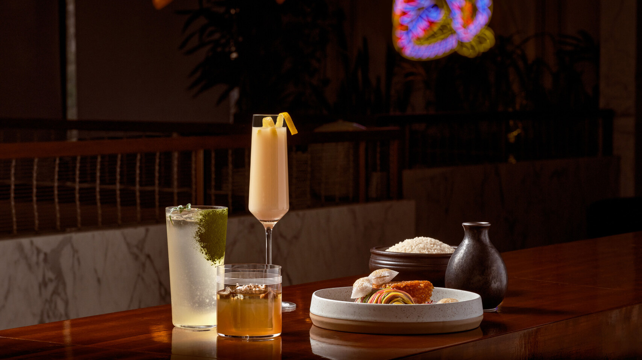 | February 8, 2024, Seoul, Korea  Rice Reimagined: An Artistic Alliance Between Four Seasons Hotel Seoul and Photographer-Artist Jinju Kang  https://publish.url/seoul/hotel-news/2024/artisti-collaboration-at-oul-2.html
February 8, 2024, Seoul, Korea
포시즌스 호텔 서울, 한국식 컨템포러리 바 ‘오울’, 아티스트 강진주 작가와 ‘쌀의 순환’을 주제로 협업
https://publish.url/kr/seoul/hotel-news/2024/artisti-collaboration-at-oul.html

PRESS CONTACTS

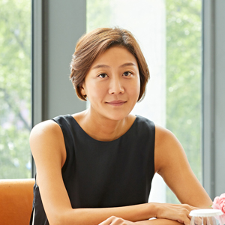 | Inyoung Moon  Director of Public Relations and Communications  97 Saemunan-ro, Jongno-gu  Seoul  Korea  inyoung.moon@fourseasons.com  82-6388-5041
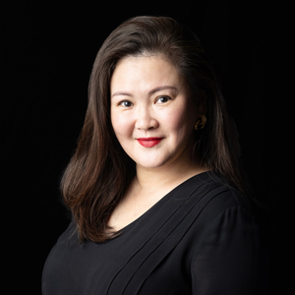 | Kelly Wong  Director of Marketing  97 Saemunan-ro, Jongno-gu  Seoul  Korea  kelly.wong@fourseasons.com  82 2 6388 5001

