Four Seasons Resort Mauritius at Anahita Reopens with Elevated Beachfront Dining and Transformed Culinary Experiences

October 1, 2021 marks the destination’s border reopening for quarantine-free stays for fully vaccinated travellers
October 1, 2021, Mauritius

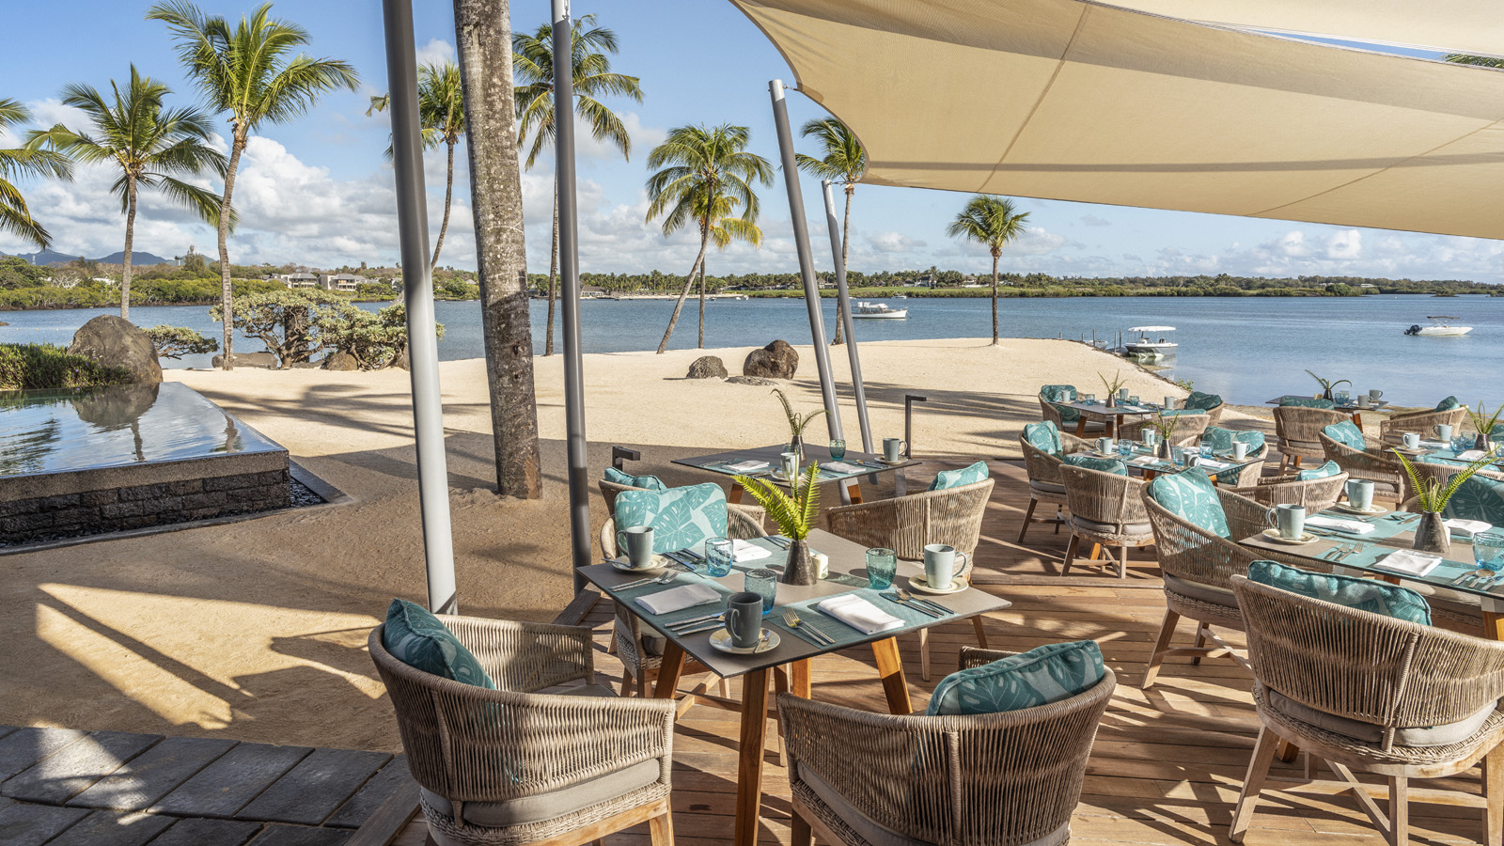
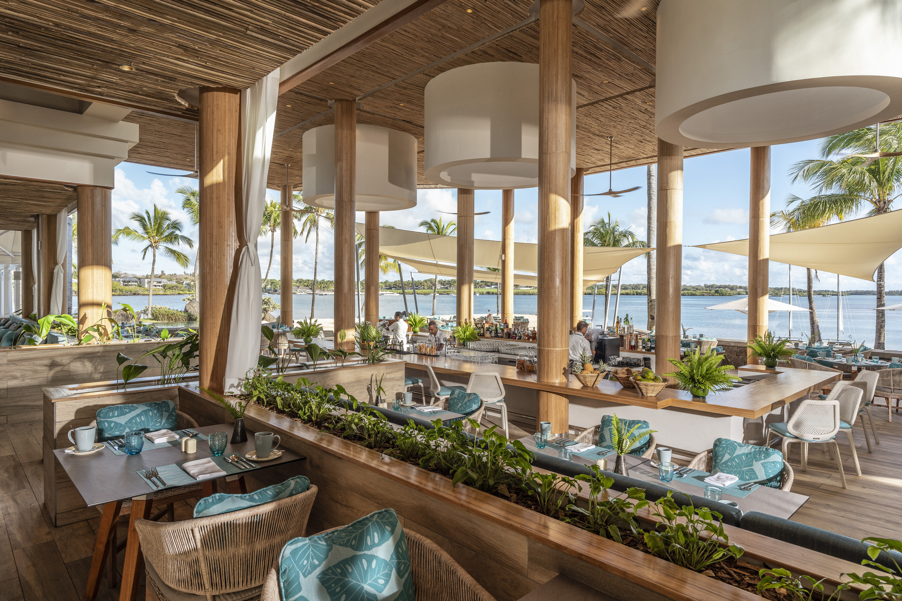 | 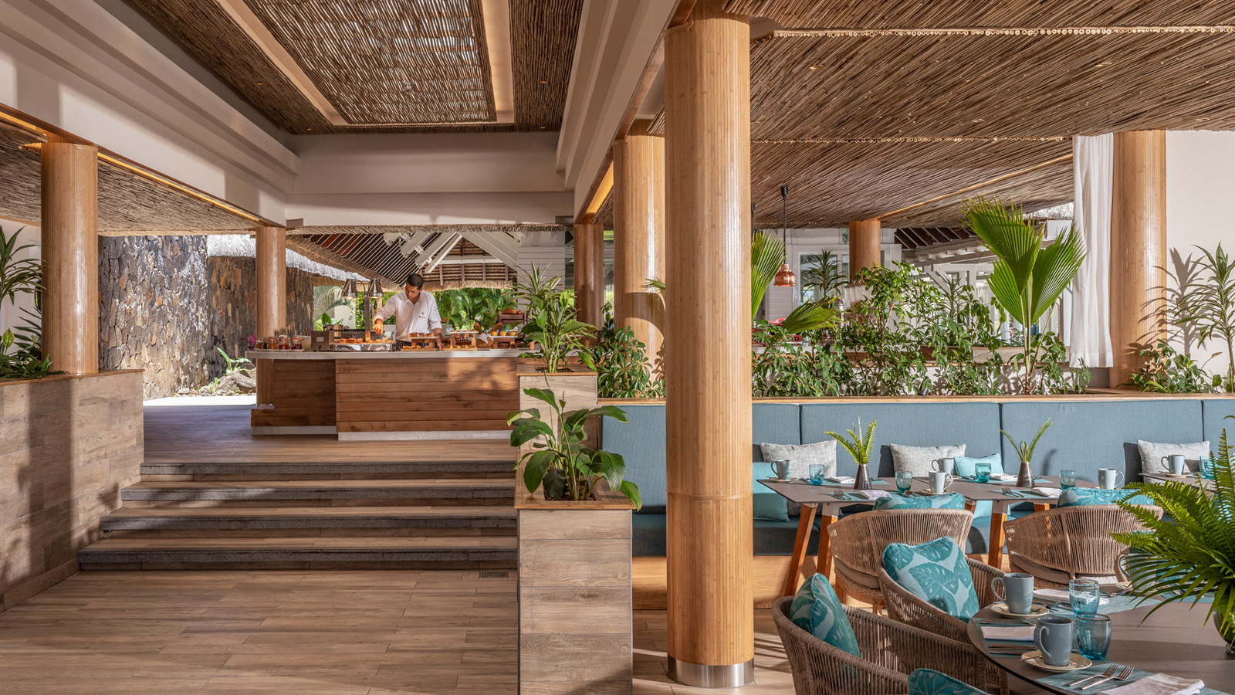 | 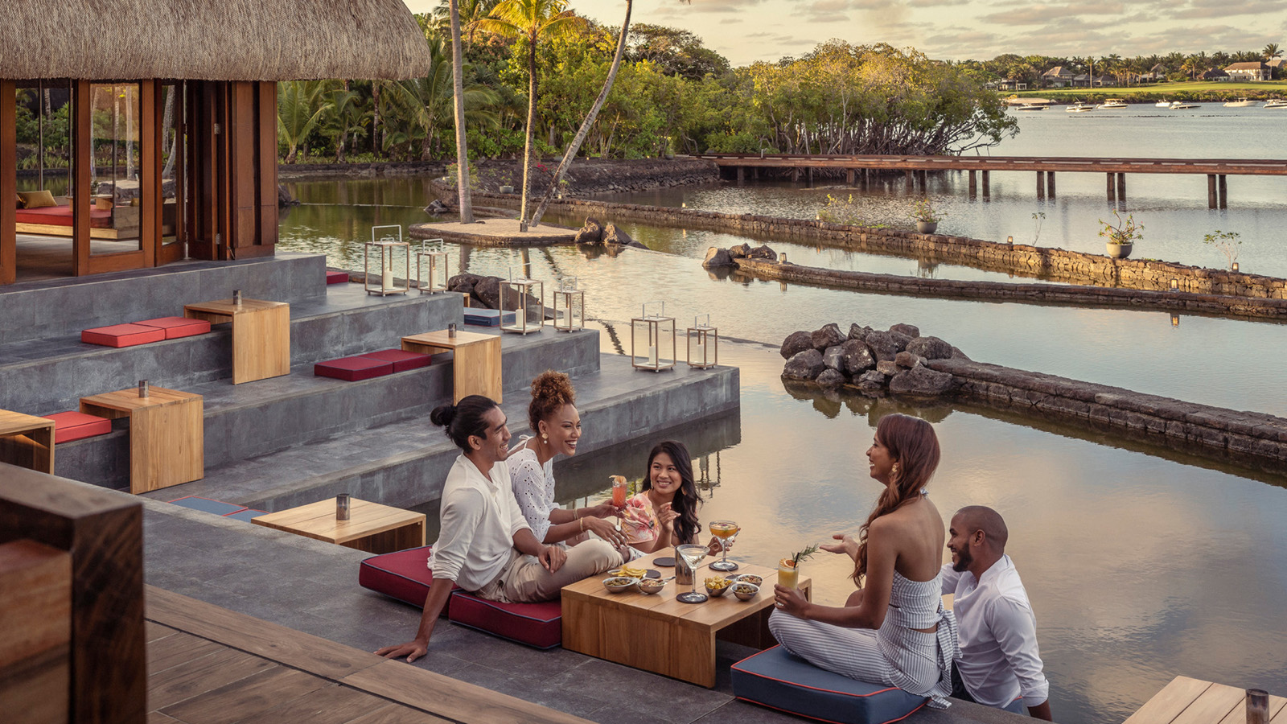
In unison with the second phase of border reopening in Mauritius, Four Seasons Resort Mauritius at Anahita reopens its doors today, October 1, 2021, to welcome back guests from around the world to enjoy the island’s exotic vibrancy and a brand new range of culinary experiences in the all pool villa Resort.
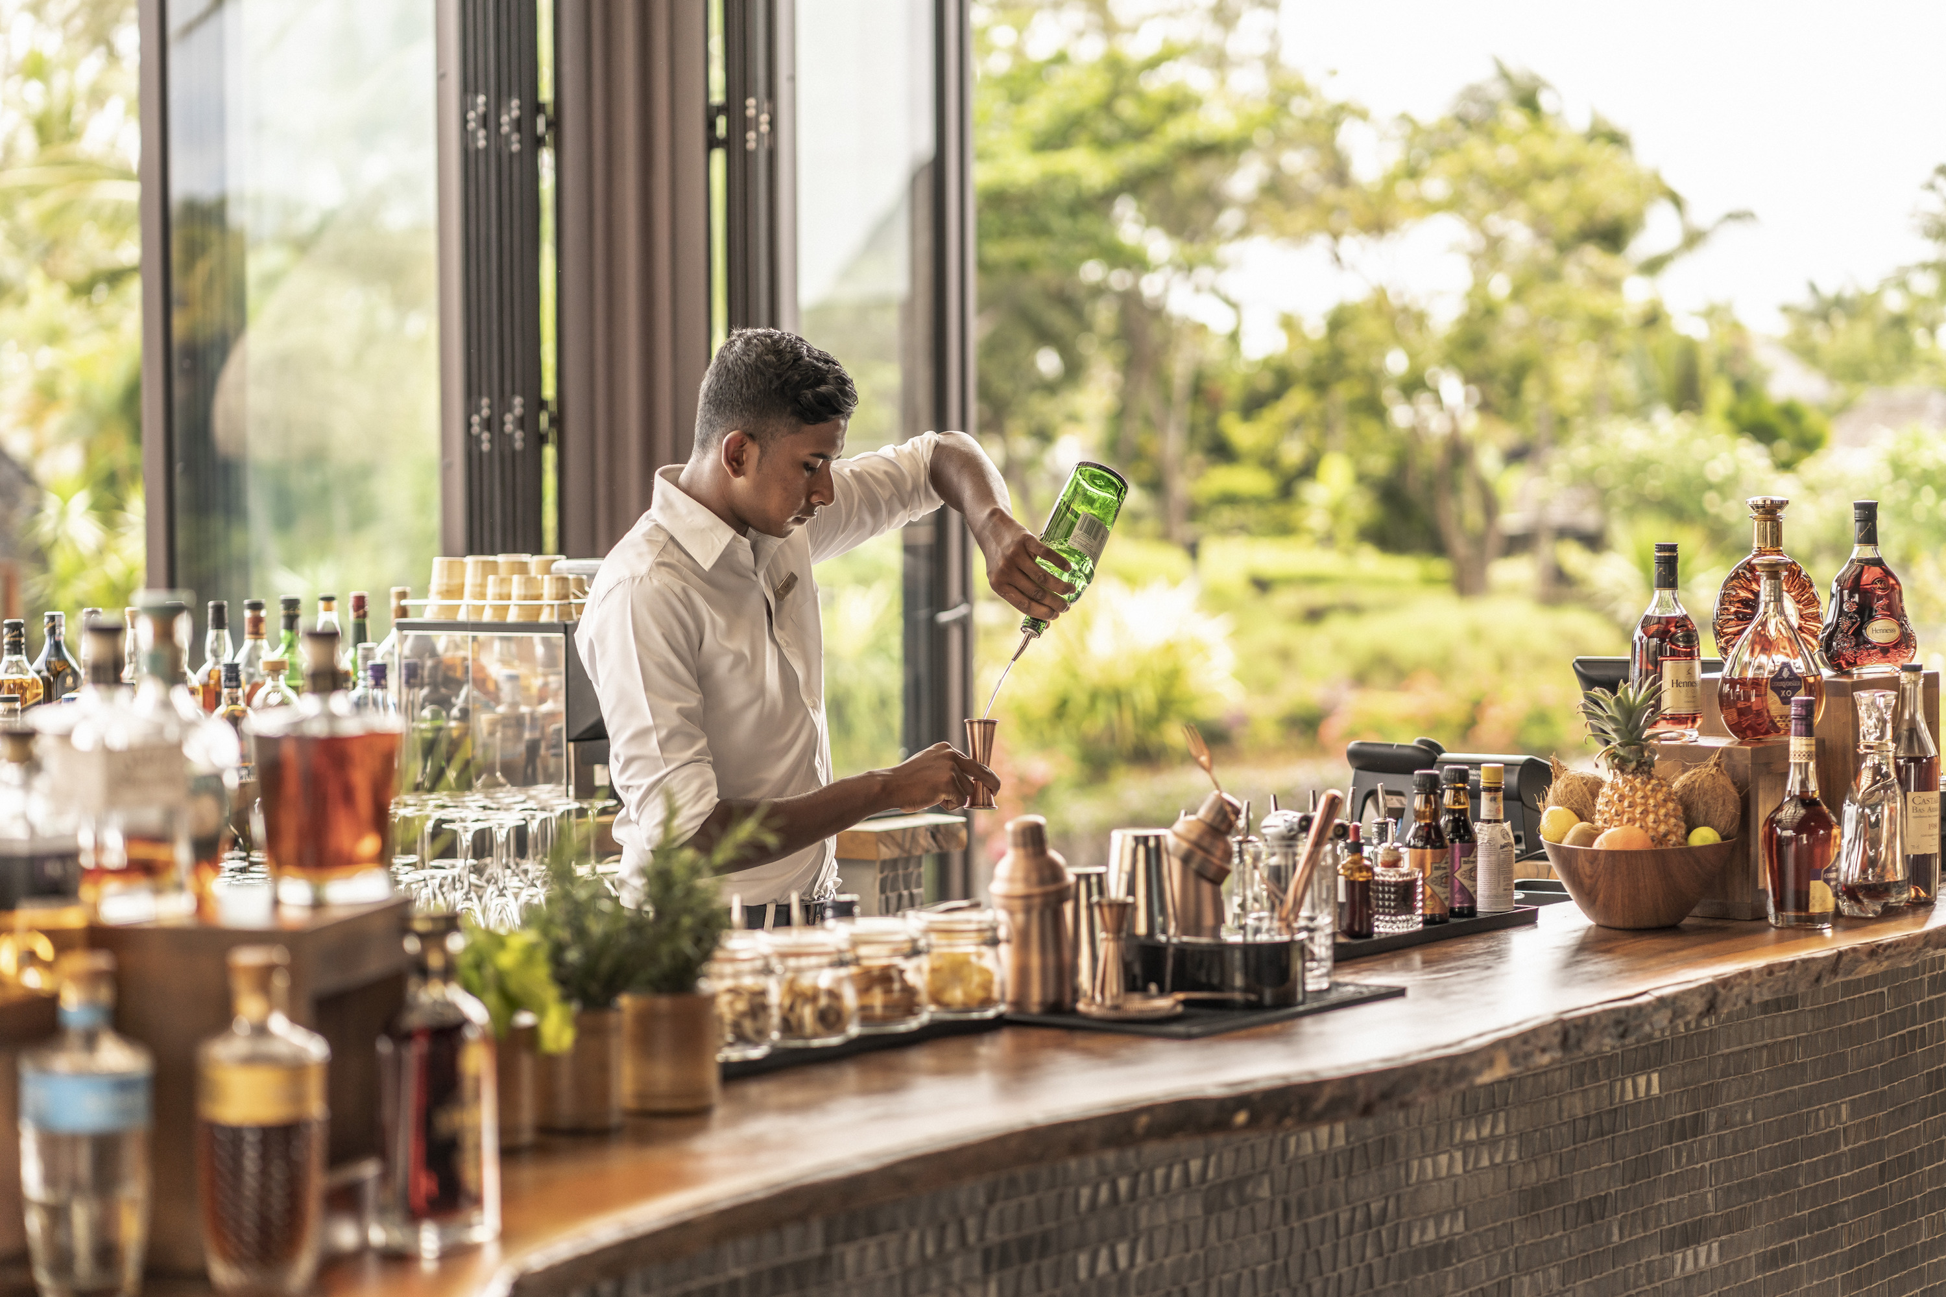 | 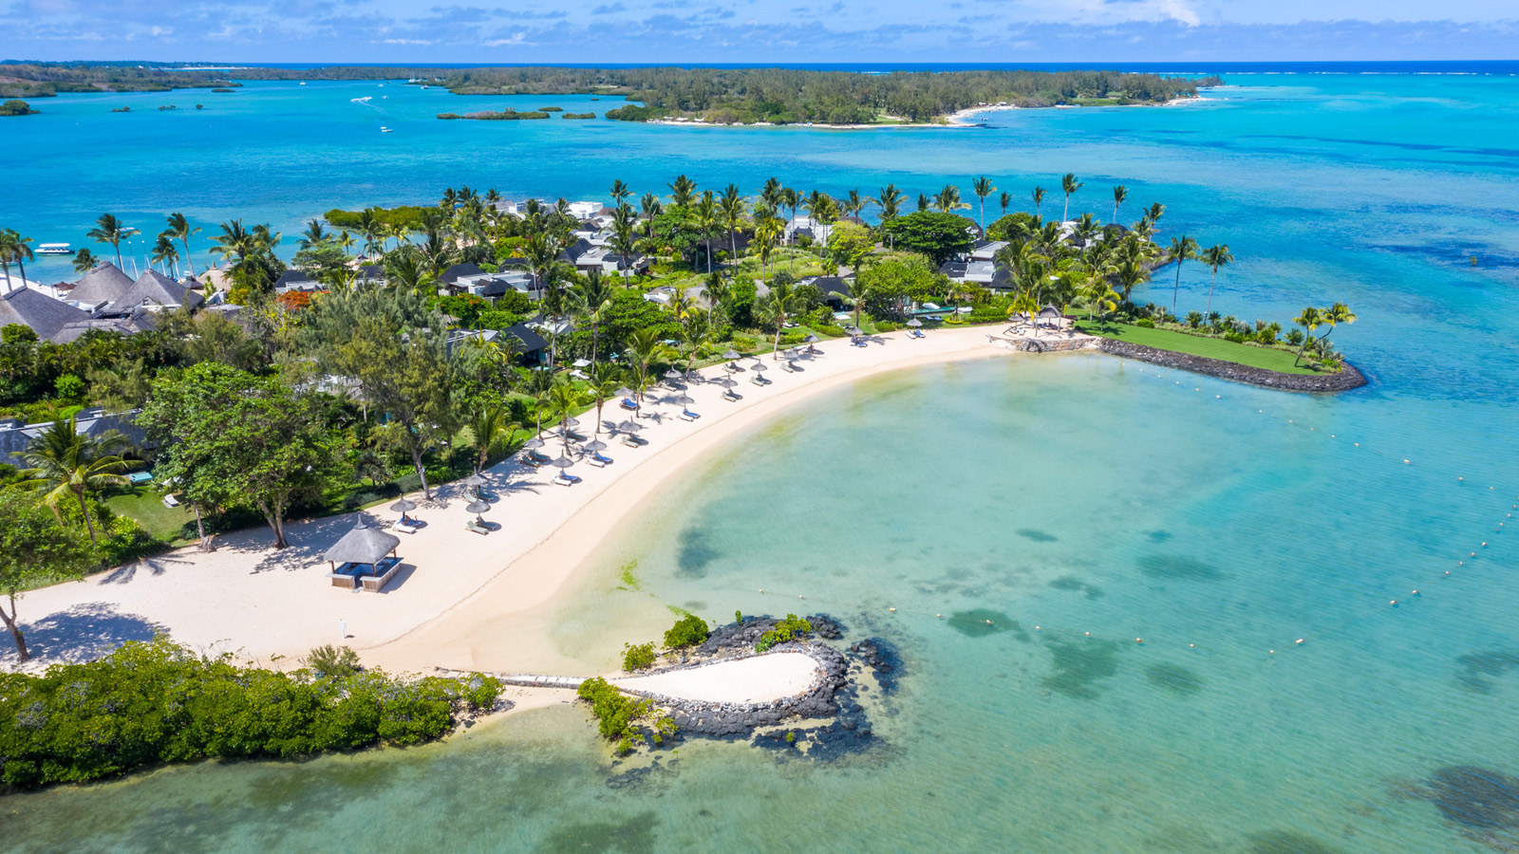 | 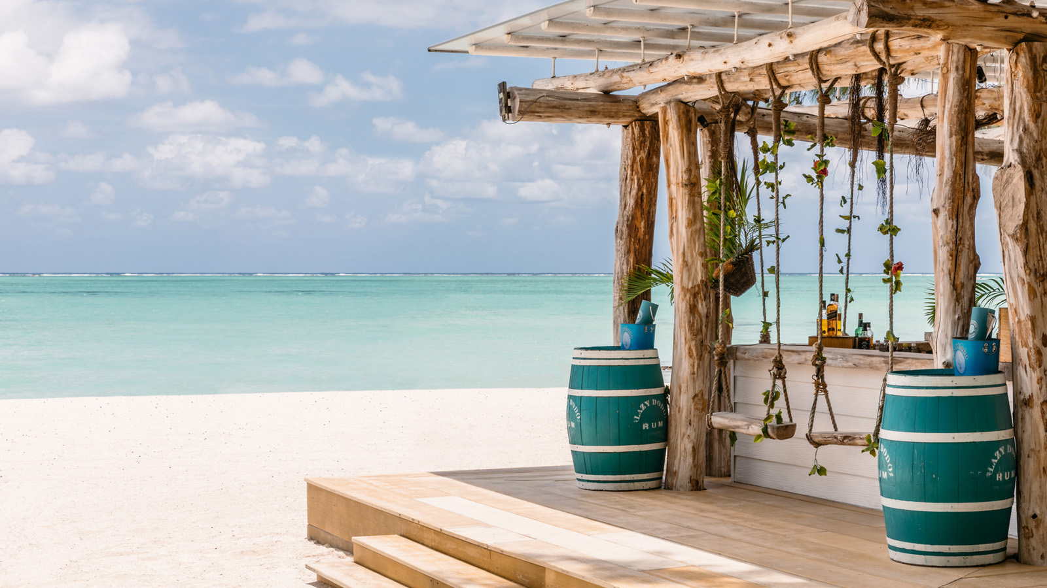
On the picturesque east coast, Four Seasons Resort Mauritius at Anahita is unveiling the transformation of its central beach hub, Bambou Restaurant, which has undergone a significant expansion to provide a choice of atmospheric seating areas that capitalise on the variety of beach and poolside views afforded by its prime location.
Now the home of the Resort’s breakfast offering, Bambou offers the perfect venue from which to begin a day of carefree island adventures, with an abundance of inspiration offered by the surrounding secluded beaches and inviting Indian Ocean lagoon. At lunch, a Mediteranean menu proposes an array of grills and seafood, salads and freshly baked flatbreads, to be enjoyed at beachfront tables or in the poolside cabanas, while by evening, a modernly refined approach to the local Creole cuisine is artistically presented in an a la carte menu of Mauritian specialites.
A brand new bar at the heart of the Resort’s newly elevated dining options promises to be abuzz with social connection and hand-crafted cocktails, while the ever-popular La Plaz Beach Grill on the Four Seasons Exclusive Beach at Ile aux Cerfs will welcome guests for blissful days of castaway relaxation via a 15 minute speed boat transfer.
From October 1, 2021 onwards, Mauritius reopens its borders for quarantine-free stays for fully vaccinated travellers, allowing guests to enjoy the plethora of cultural, adventure and culinary activities across the island to complement relaxation in the destination’s year-round tropical climate. Covering 64 exotic acres (26 hectares), Four Seasons Resort Mauritus at Anahita offers unrivalled recreational activities, with complimentary access to two championship golf courses available to all guests, water sports that range from stand up paddle boarding to waterskiing, plus tennis, cycling, and a Fitness Centre with a 82 foot (25 metre) outdoor lap pool.
An extensive overwater Spa is interwoven into the landscape and offers a diverse range of rejuvenating treatments that draw from local ancestrual wisdom to promote natural healing and relaxation. Multi-bedroom Residence Villas are the perfect family accommodations, and entertainment for younger guests is found at the Hobbit Village Kids’ Club and Karokan Young Adult Centre. Meanwhile for couples, One Bedroom Villas with private pools and tropcial gardens are intimate hideaways, with views ranging from Beach to Ocean, Garden to Mangrove.

RELATED

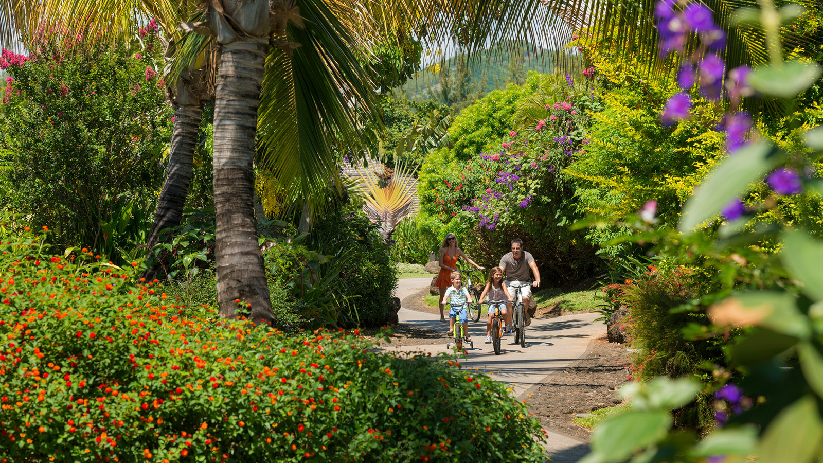 | November 25, 2021, Mauritius  The Shine of Festive Season Awaits at Four Seasons Resort Mauritius at Anahita  https://publish.url/mauritius/hotel-news/2021/festive-season.html
November 24, 2021, Johannesburg, South Africa
The Festive Season is All Wrapped Up at Four Seasons Hotel The Westcliff Johannesburg
https://publish.url/johannesburg/hotel-news/2021/festive-season.html

PRESS CONTACTS

Debbie Duval
Senior Director of Public Relations and Communications

Beau Champ
Mauritius
debbie.duval@fourseasons.com

(230) 402 3100

Beatrice Tsang
Public Relations Coordinator

Beau Champ
Mauritius
beatrice.tsang@fourseasons.com

+230 4023100

