Global Wellness Day at Four Seasons Hotel Tunis

May 30, 2019, Tunis

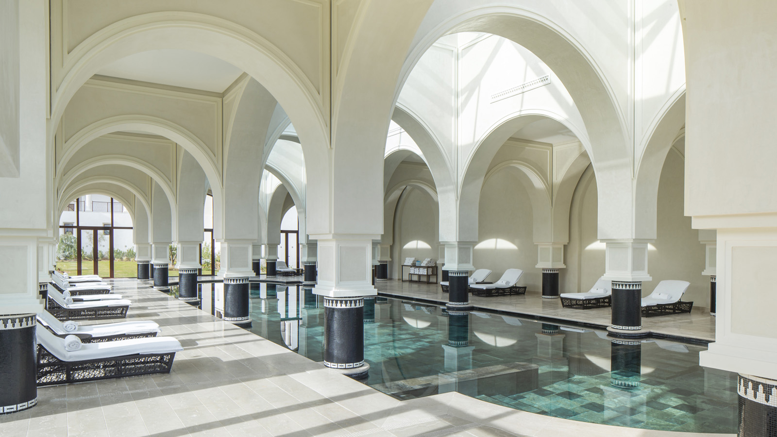
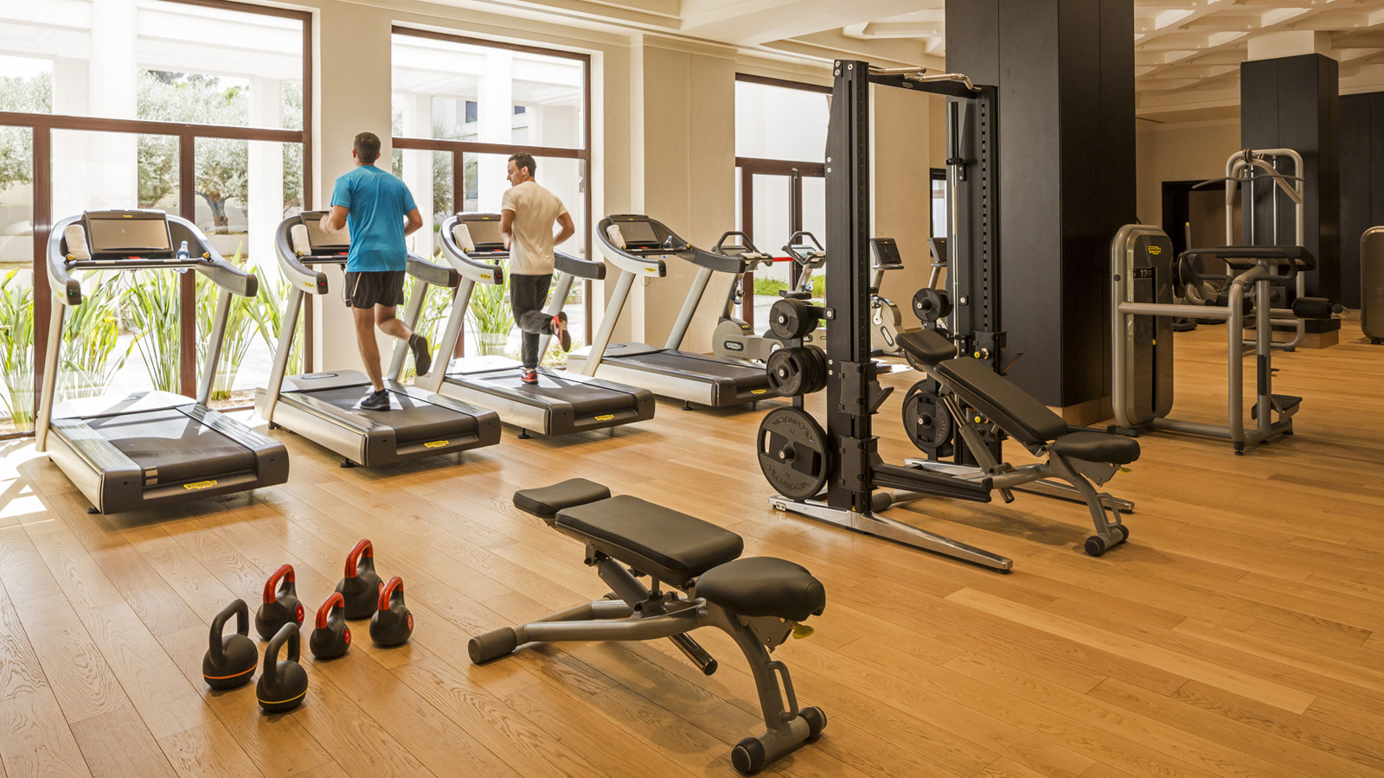
This year marks the for the second consecutive year that Four Seasons Hotel Tunis will celebrate Global Wellness Day. On June 8, 2019, the Hotel is delighted to introduce a rich program fully tailored by its SPA Team. Meet the Tunisian National Athletes’ Marwa and Nader, as well as the Yoga Master Rached at THE SPA and its private gardens where you will be taken through a journey of peace for body and soul.
Yoga and Meditation — 7:00 am
by Yoga Master Rached
Fitness — 10:00 am / 6:00 pm
20 minutes of stretching followed by 20 minutes cross training and finally 20 minutes of collective games outdoor to enjoy the warmer weather
Essential Oils Benefits
An introduction to the benefits on how essential oils can impact wellbeing
Healthy Corner
A variety of innovative detox juices crafted by our Beverage Manager, Aziz Hathout
Four Seasons Hotel Tunis this year will extend the same benefit to its own employees by educating them on how wellbeing and efficiency go together. “Work hard, train harder” will be the slogan, the manifesto as recommended by Global Wellness Day:
- Walk for an hour.
- Drink more water.
- Don’t use plastic bottles.
- Eat healthy food.
- Do a good deed.
- Have a family dinner with your loved ones.
- Sleep at 10:00 pm.

RELATED

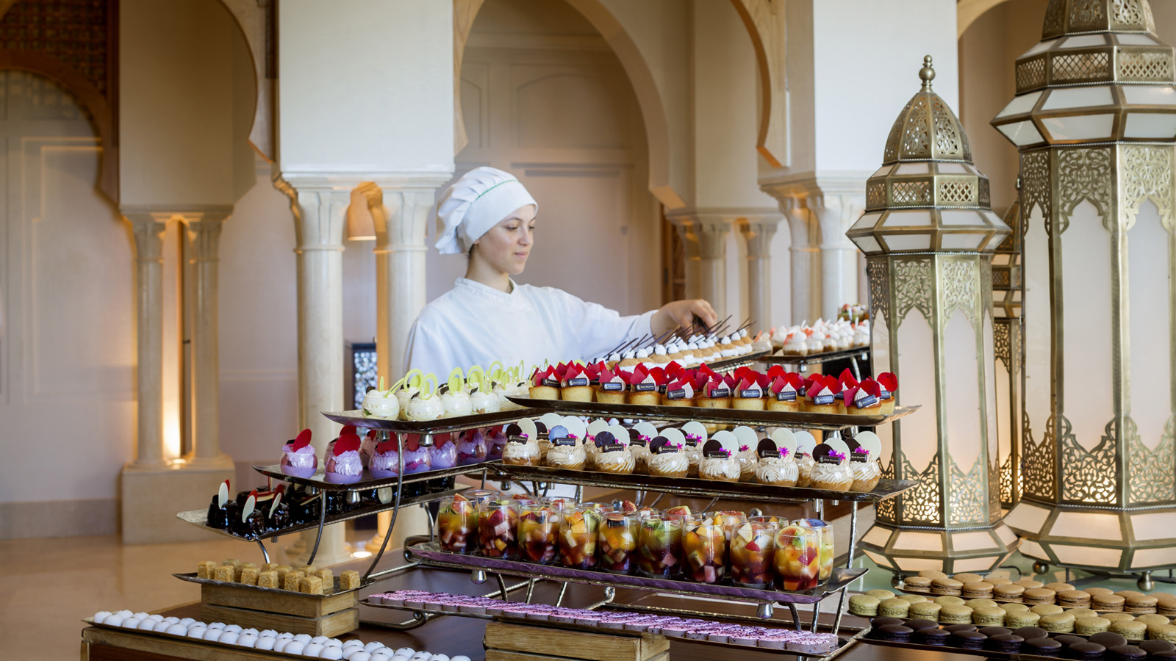 | January 3, 2019, Tunis  Four Seasons Hotel Tunis Presents Winter Weekend Brunch at AZUR  https://publish.url/tunis/hotel-news/2019/winter-weekend-brunch.html
December 21, 2018, Tunis
Four Seasons Hotel Tunis Unveils Wedding Atelier
https://publish.url/tunis/hotel-news/2018/wedding-atelier.html

PRESS CONTACTS

Raja Bennaceur
Public Relations Executive
Zone Touristique Cap Gammarth
La Marsa, Tunis
Tunisia
raja.bennaceur@fourseasons.com

+216 58 555 776

