Celebrate the Holiday Season with Four Seasons Hotel Houston

November 6, 2017, Houston, U.S.A.

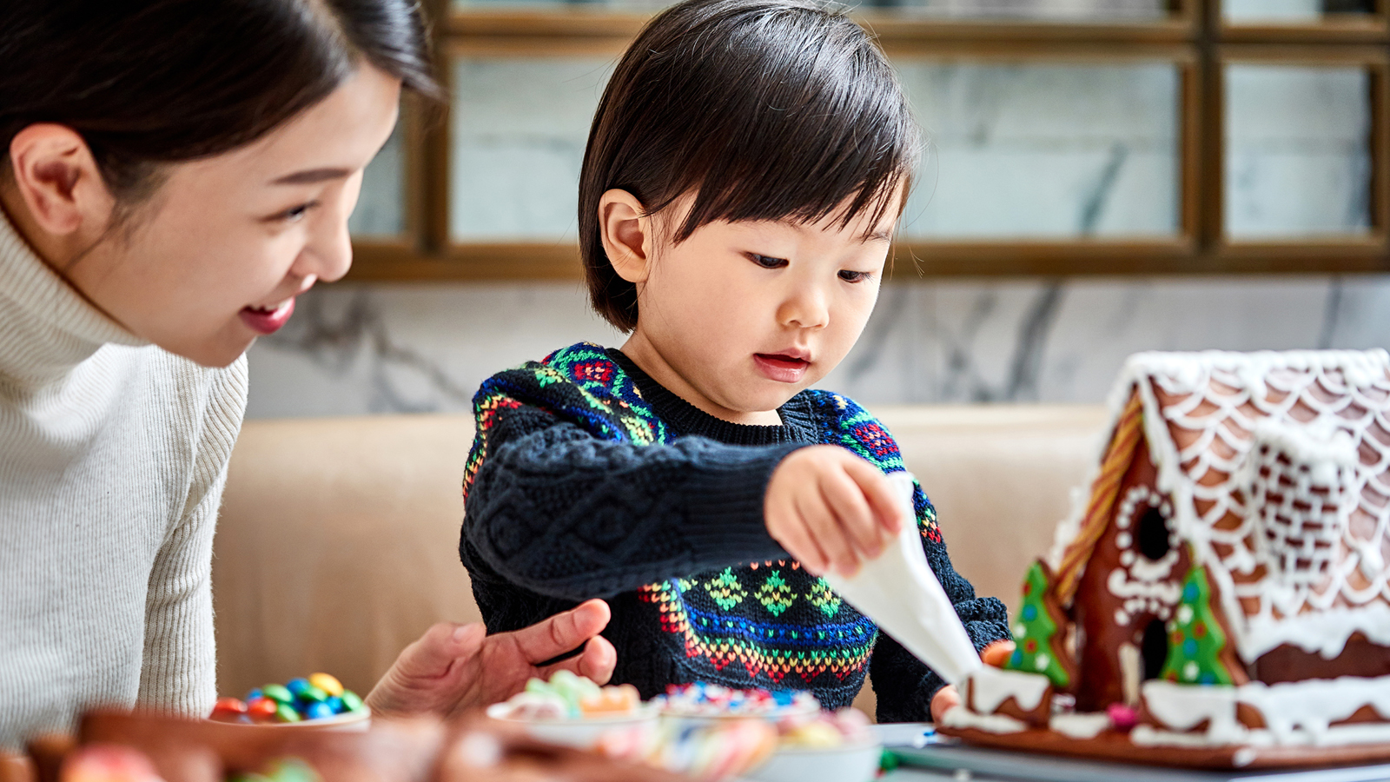
The festive season is here and
Four Seasons
Hotel Houston has pulled out all the stops to make it a memorable one. From a holiday tree lighting ceremony to an extravagant Thanksgiving brunch, and even a gingerbread-themed afternoon tea, there is no better place to come together to celebrate the holidays.
Tree Lighting Ceremony
- November 21, 2017, 5:00–6:00 pm
Four Seasons
Hotel Houston is inviting guests to kick off the festive season with new traditions at the Hotel’s holiday tree lighting featuring live entertainment, cookies, hot cocoa and champagne. The event will take place on November 21 from 5:00 to 6:00 pm with the tree lighting ceremony beginning at 5:45 pm. This event is complimentary and open to the public.
Thanksgiving Brunch and Dinner
- November 23, 2017
Quattro at Four Seasons Hotel Houston will be celebrating Thanksgiving with its annual extravagant Thanksgiving Brunch featuring live music. Guests can enjoy more than 85 selections of holiday favourites such as a raw bar, sushi, Quattro's famous turkey with all the traditional accompaniments and myriad desserts. This event will take place on Thanksgiving Day from 10:00 am to 3:30 pm and is USD 105 for adults, USD 49 for children ages 6 to 12, and complimentary for children ages 5 and below.
Guests can enjoy Thanksgiving dinner at Quattro with a special holiday menu, delicious buffet stations and wine pairing options. USD 68 per person and an additional USD 40 per person for optional wine pairing. Dinner will be offered from 6:00 to 10:00 pm.
Gingerbread Tea
- December 2, December 9, December 16, December 23, 2017
Guests are invited to join Quattro at
Four Seasons
Hotel Houston for a gingerbread-themed afternoon tea throughout the month of December. In addition to traditional tea offerings, there will be activities for children such as ornament and cupcake decorating and gingerbread house building. This event will take place on December 2, December 9, December 16 and December 23, 2017 from 12:00 noon to 4:00 pm. Gingerbread teas are USD 85 for adults, and USD 65 for children under 12.
Christmas Day Brunch
- December 25, 2017
The team at
Four Seasons
Hotel Houston is excited to host its annual Christmas Day Brunch in Quattro Restaurant. Featuring holiday favourites such as carved beef, sushi, raw bar, charcuterie, lamb and fish along with a buffet of desserts, the Christmas Day Brunch is not to be missed. The brunch will take place on Christmas Day from 10:00 am to 3:30 pm and is USD 105 for adults, USD 49 for children ages 6 to 12, and complimentary for children ages 5 and below.
Christmas Eve and Christmas Day Dinner
- December 24 and 25, 2017
For those who cannot make brunch, there will be a Christmas Eve Dinner and a Christmas Day Dinner in Quattro with a special holiday menu, delicious buffet stations and wine pairing options. USD 68 per person and an additional USD 40 per person for optional wine pairing. Both dinners will take place from 6:00 to 10:00 pm.
New Year’s Celebrations
- December 31, 2017
Guests of
Four Seasons
Hotel Houston will have two wonderful New Year's Eve events to choose from.
- Quattro will be hosting a five-course tasting menu with seatings beginning at 7:00 pm. In addition to live music, there will be party favours and a champagne toast at midnight. USD 125 per person and an additional USD 60 per person for optional wine pairing.
- Bayou & Bottle is throwing it back to the 80s to ring in the New Year. Beginning at 9:00 pm, guests can enjoy an 80s themed New Year's Eve celebration complete with live music, party favours and a champagne toast at midnightat Bayou & Bottle. A themed food menu will be available for guests to enjoy a la carte. Cover charge starting at 9:00 pm is USD 30 per person if purchased in advance and USD 38 per person if purchased at the door. Table reservations will be taken with a USD 400 minimum spend per table, not including ticket price.

RELATED

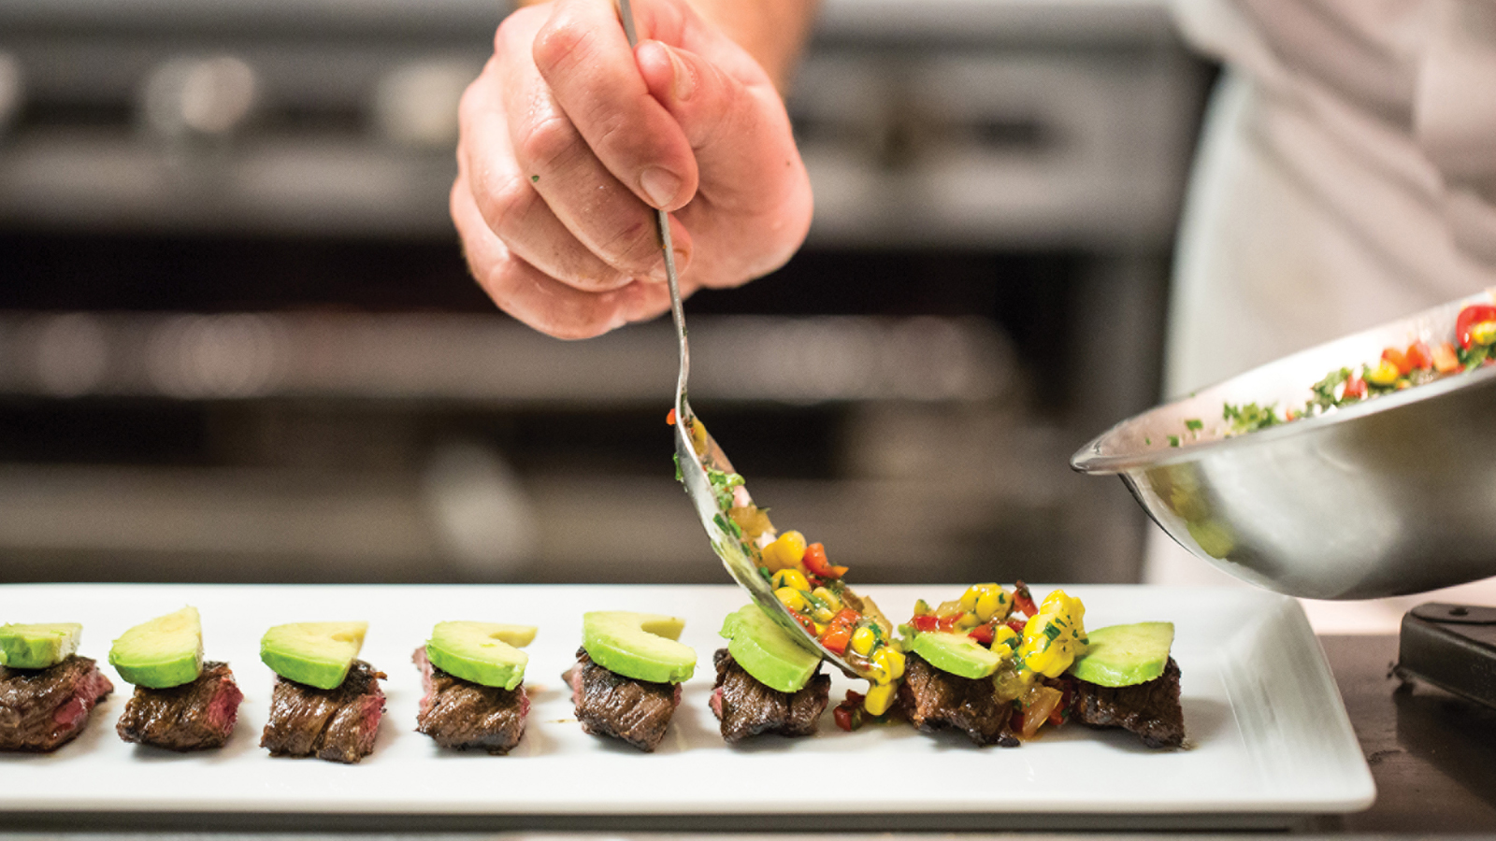 | October 5, 2017, Houston, U.S.A.  Four Seasons Hotel Houston Hosts Chefs Unmasked: Houston's Most Awarded Chefs Team Up with National Restaurateurs for Charity Dinner  https://publish.url/houston/hotel-news/2017/chefs-unmasked-charity-dinner.html
May 29, 2017, Houston, U.S.A.
Four Seasons Hotel Houston Rolls Out Summer Social Series
https://publish.url/houston/hotel-news/2017/summer-social-series.html

PRESS CONTACTS

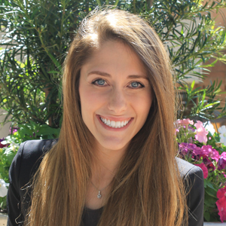 | Hilary Helfman  Public Relations Manager  1300 Lamar Street  Houston  U.S.A.  hilary.helfman@fourseasons.com  +1 (713) 652-6249

