Kick Off the Festive Season with Thanksgiving Offerings at Four Seasons Hotel Denver

Come together for a Thanksgiving to remember at EDGE Restaurant & Bar
September 30, 2022, Denver, U.S.A.

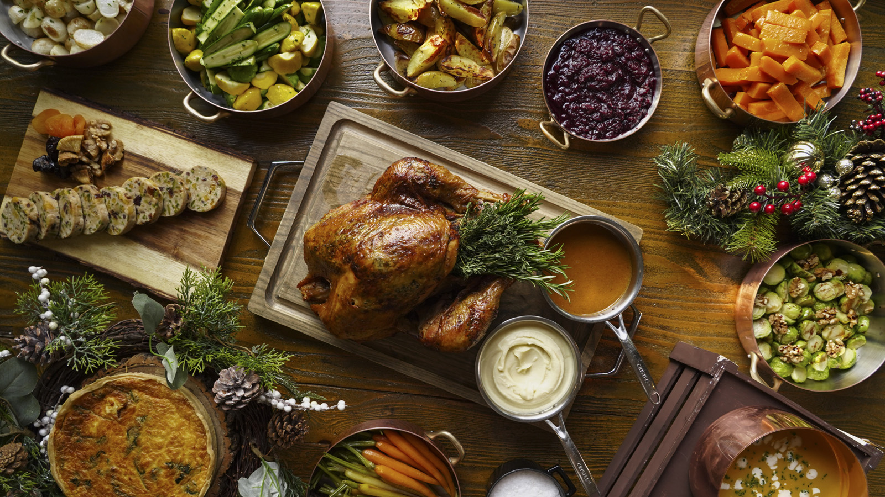
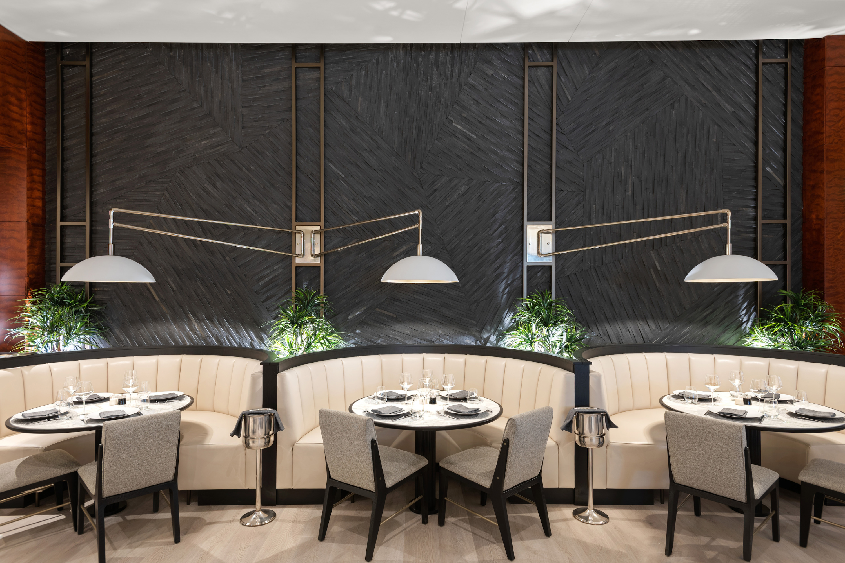 | 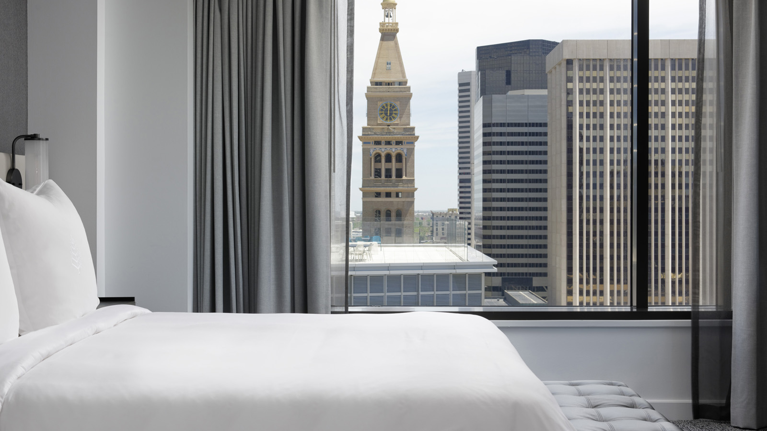 | 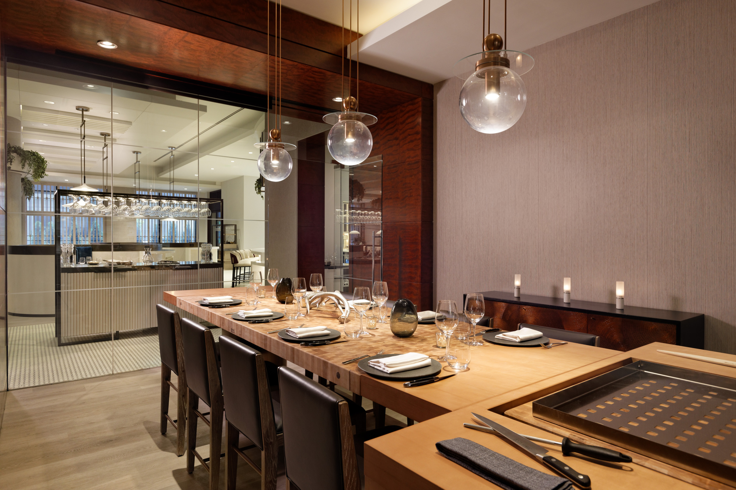
Located in the heart of the Mile-High City, Four Seasons Hotel Denver and EDGE Restaurant & Bar will offer a skillfully curated traditional Thanksgiving menu.
EDGE Restaurant & Bar will transform into a plentiful harvest of Thanksgiving delights featuring culinary stations. An array of starters, traditional entrées, carving and dessert stations and raw bar enhancements crafted by Executive Chef Craig Dryhurst and EDGE Restaurant Chef Andrew Lauer will be displayed for this full-of-warmth celebration. In addition, a carefully chosen kids’ buffet will include healthy options, sugar cookies, and treats.
Guests will end the Thanksgiving meal on a sweet note with a lineup of decadent house-made desserts created by Assistant Executive Pastry Chef Monica Kobe and Pastry Chef de Partie Molly Cohen, such as brown sugar cranberry cheesecake, chocolate bourbon pecan bar, pumpkin pie parfait, apple upside down cake, and white chocolate chai cream puff.
View the Thanksgiving Menu here.
The elaborate culinary stations will be offered on November 24, 2022, from 11:00 am to 4:00 pm and from 5:00 to 9:00 pm. In addition, to add a touch of whimsy to this special occasion, guests will enjoy live music performed by a local Mile High musician from 3:00 to 7:00 pm.
“Thanksgiving is a time of togetherness and gratitude. We are thrilled to welcome our guests and their families back to EDGE for this very special holiday,” says Julia Chaland, Director of Food and Beverage at Four Seasons Hotel Denver. “From the expansive buffet offering to the live musician we will have performing throughout the afternoon, we are sure this will be a memorable meal for all who attend.”
To make a reservation, call EDGE Restaurant & Bar directly at 303 389 3050. An elevated buffet is available for adults at USD 129 and children 12 and under at USD 39.
Private Dining at EDGE Restaurant & Bar
Make this year's Thanksgiving celebration a true one-of-a-kind experience with private dining rooms available for 10 to 34 guests. Appointed and designed with bespoke cutlery and china, this lively yet intimate experience will make it a holiday to remember. To make a reservation, contact the sales team directly at 303 389 3149 or by sending a request for information by clicking here.

RELATED

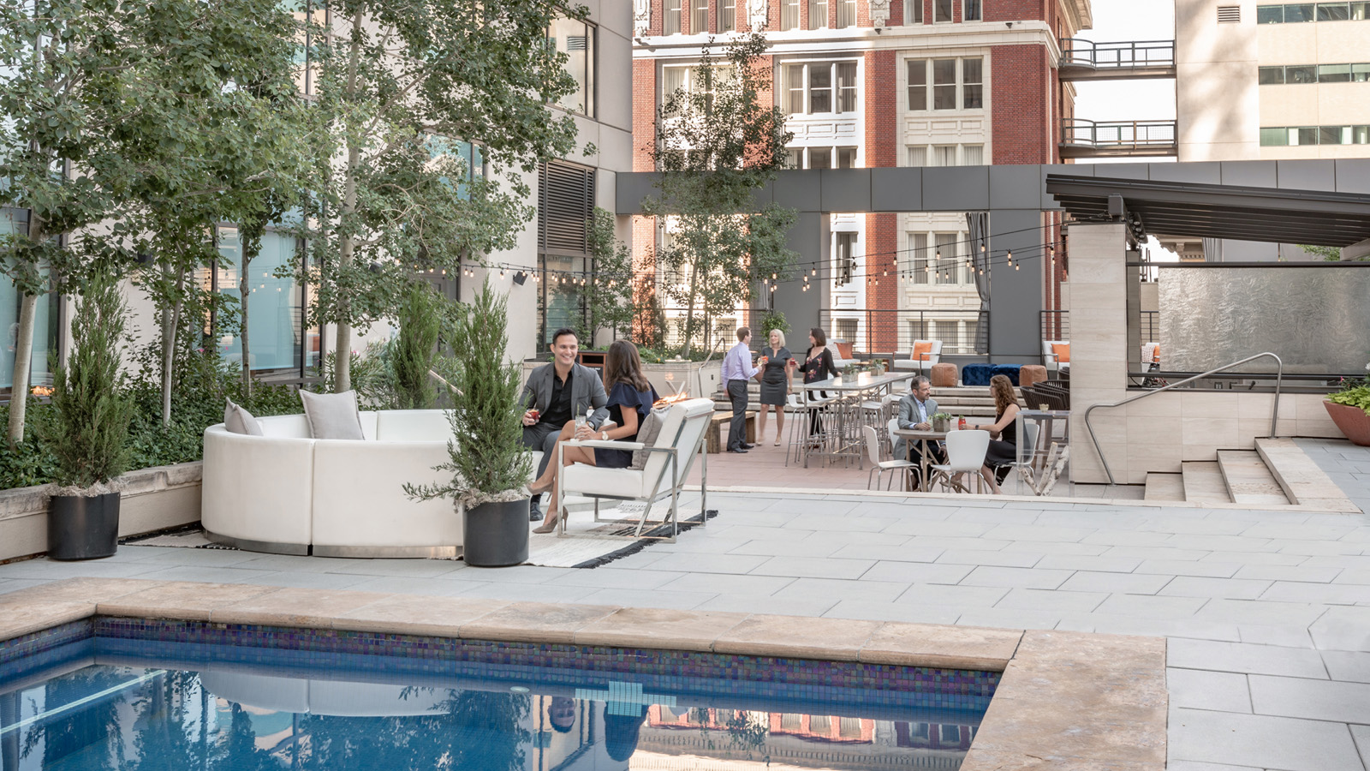 | August 24, 2022, Denver, U.S.A.  Four Seasons Hotel Denver Invites Guests to the End of Summer Bash BBQ Event  https://publish.url/denver/hotel-news/2022/bbq-event.html
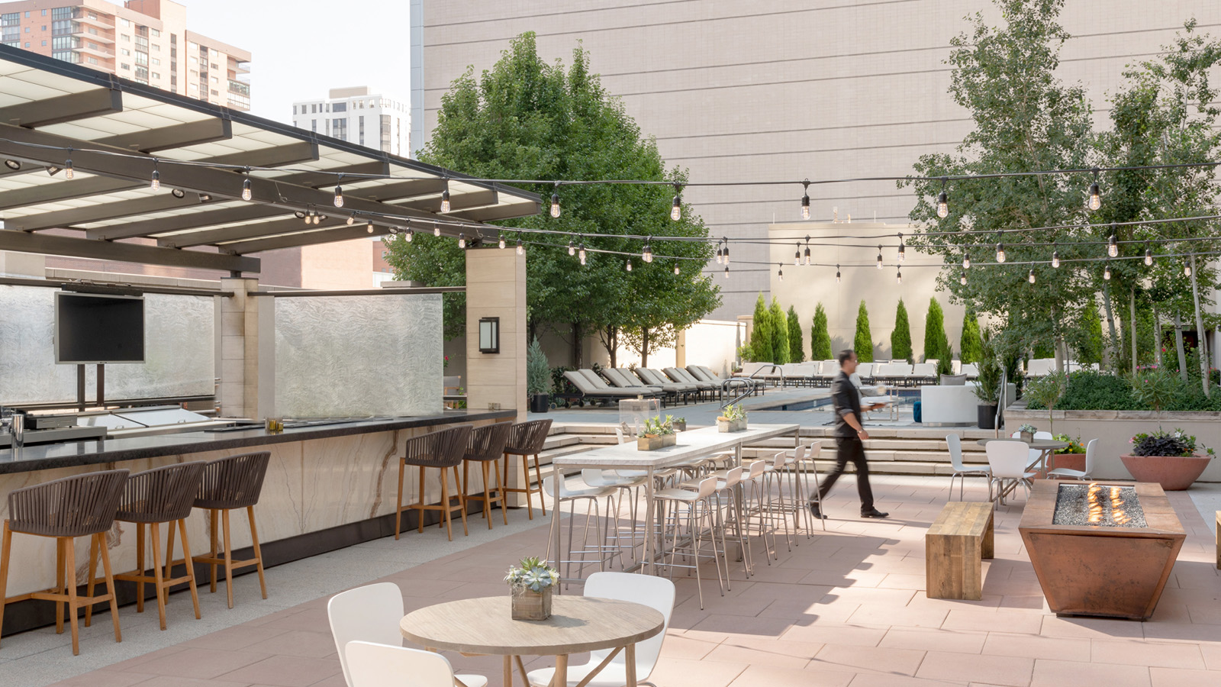 | July 28, 2022, Denver, U.S.A.  Four Seasons Hotel Denver Announces Outdoor Cocktail Venue  https://publish.url/denver/hotel-news/2022/the-terrace-outdoor-bar-and-restaurant.html

PRESS CONTACTS

Ocean Bryant
Public Relations Coordinator
1111 14th Street
Denver
USA
ocean.bryant@fourseasons.com

+1 720 979 1735

