Ready, Set, Play! Yun House at Four Seasons Hotel Kuala Lumpur Redefines Cantonese Dining with Fresh Flair

KL’s premier Cantonese restaurant is set to dazzle in a brand-new avatar, featuring creative plates, modern cocktails and an oh-so-cool vibe
November 15, 2021, Kuala Lumpur, Malaysia

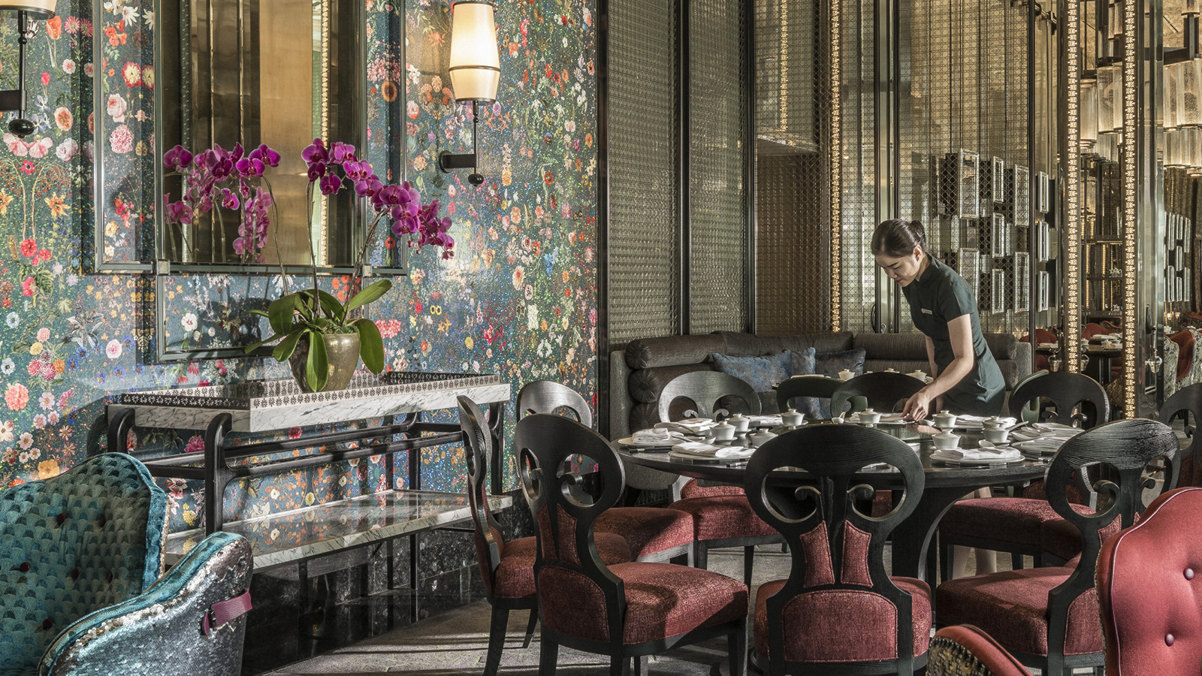
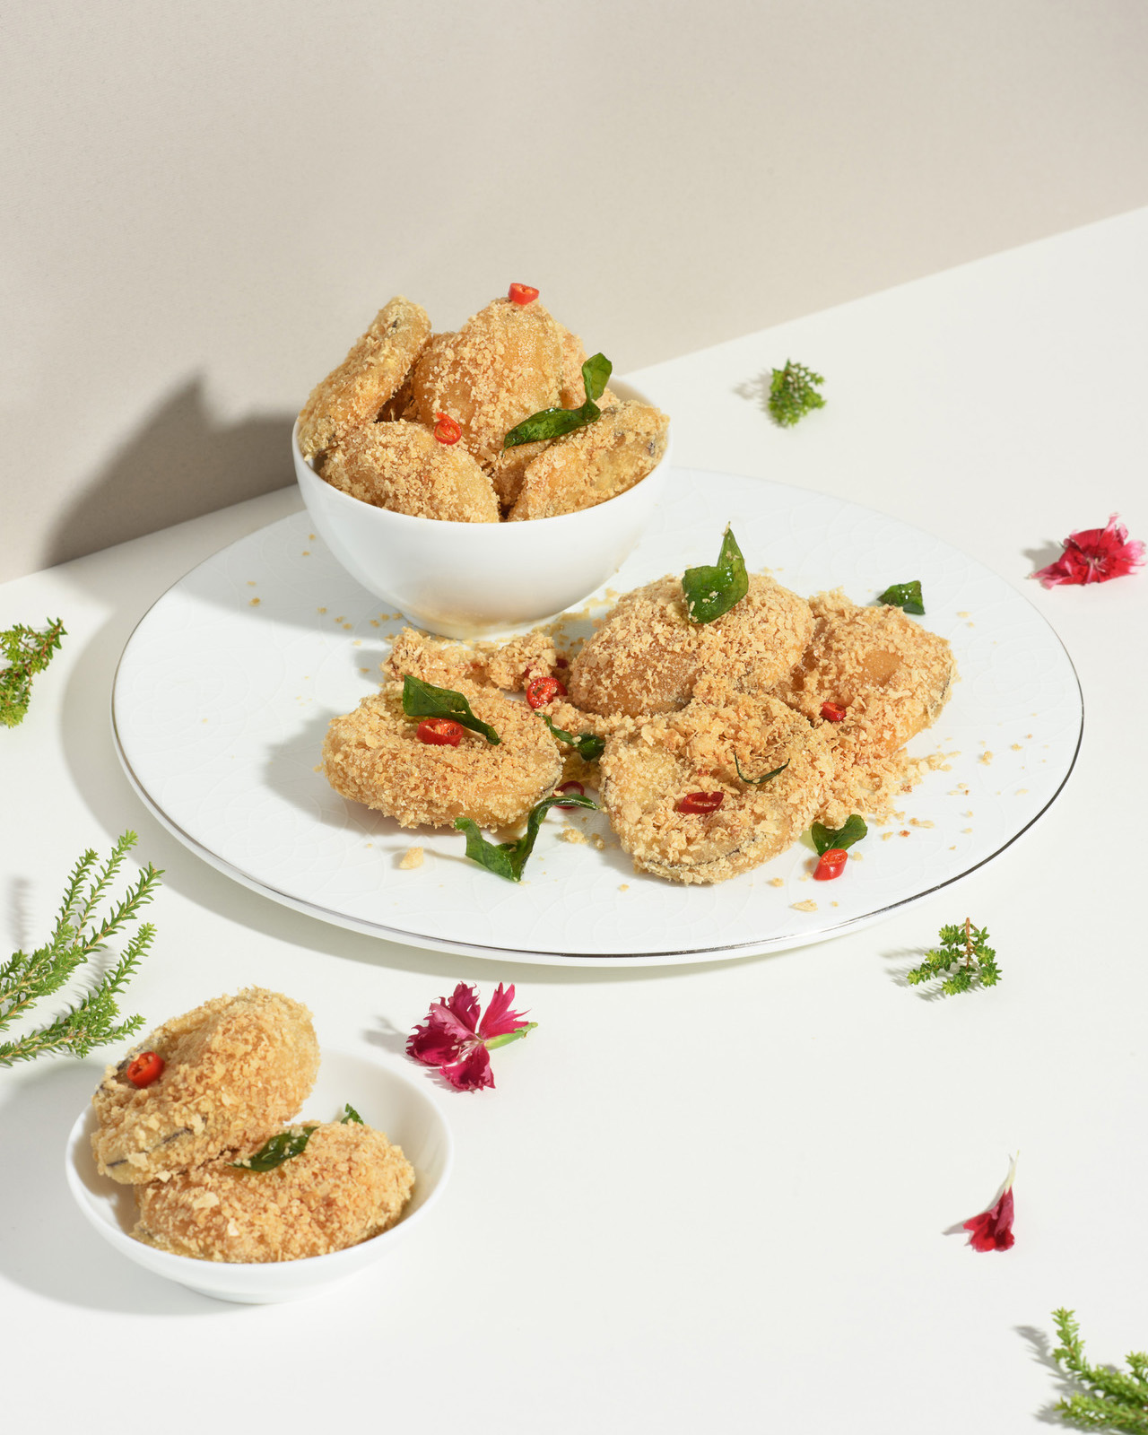 | 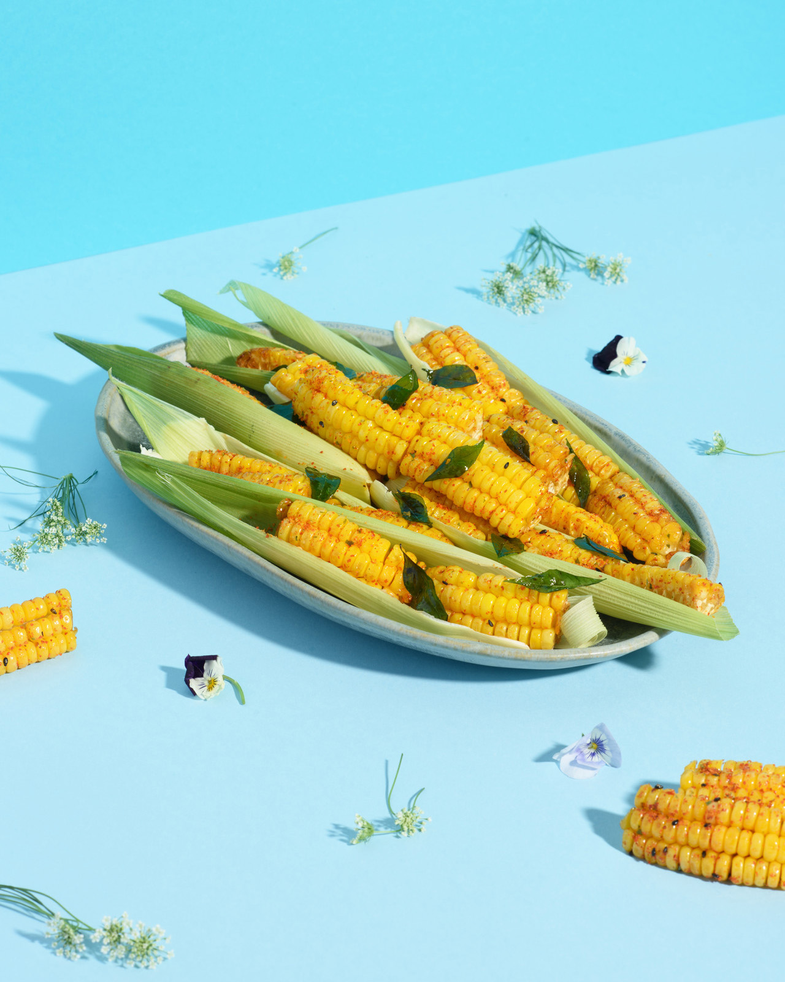 | 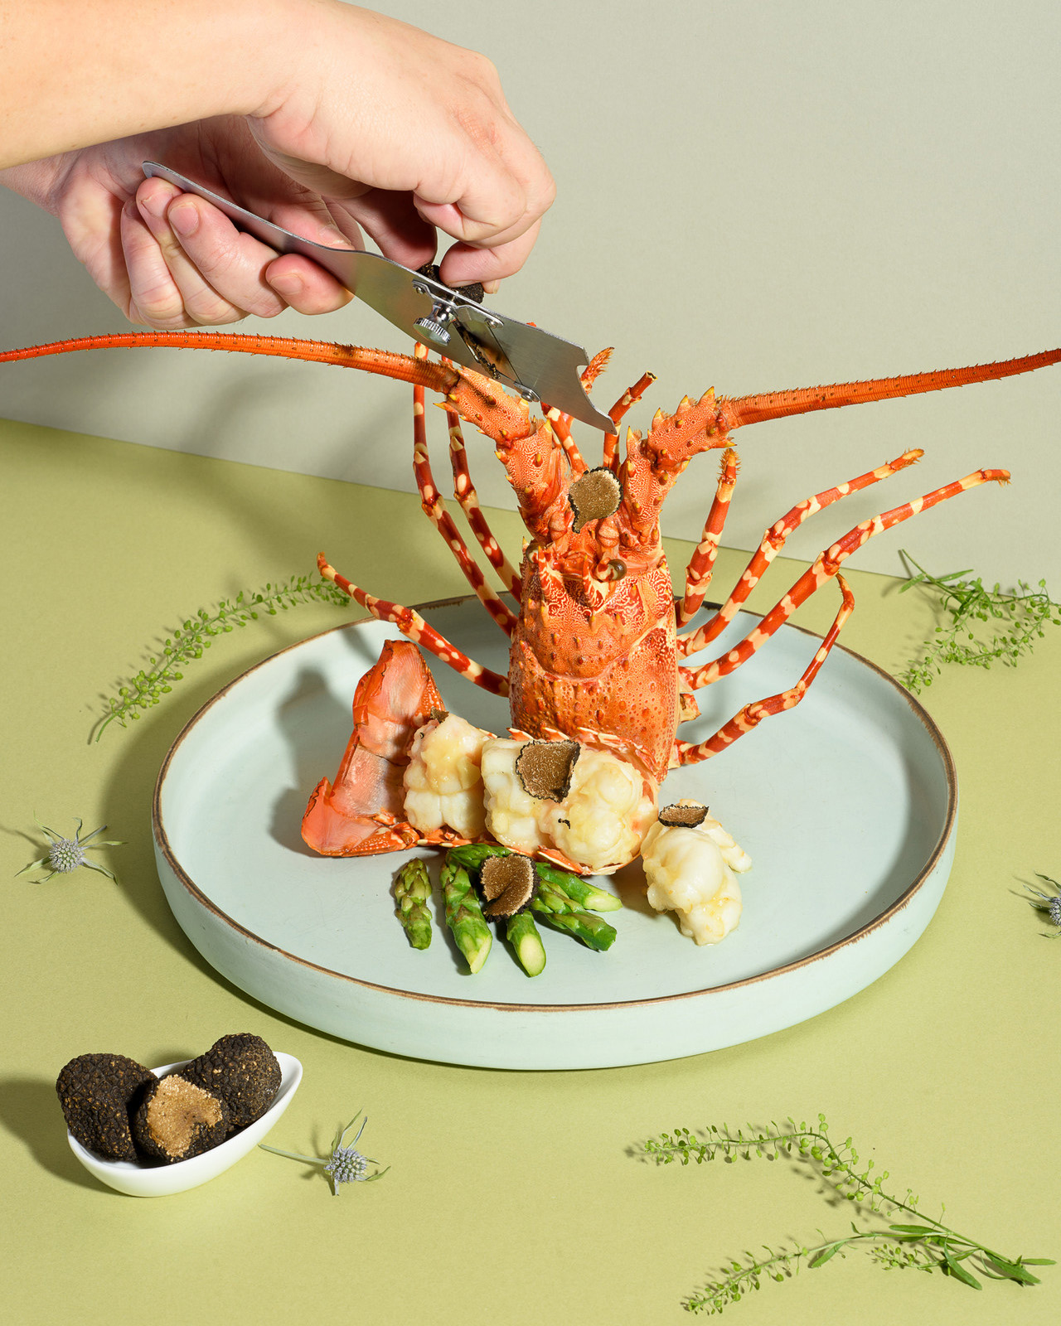
Four Seasons Hotel Kuala Lumpur is delighted to introduce Yun House with a reinvented look-and-feel that’s hip, fresh and designed for sizzling Instagram reels. In other words, here is a complete breakaway from the staid atmosphere of high-end Chinese restaurants, especially those that are housed in luxury hotels.
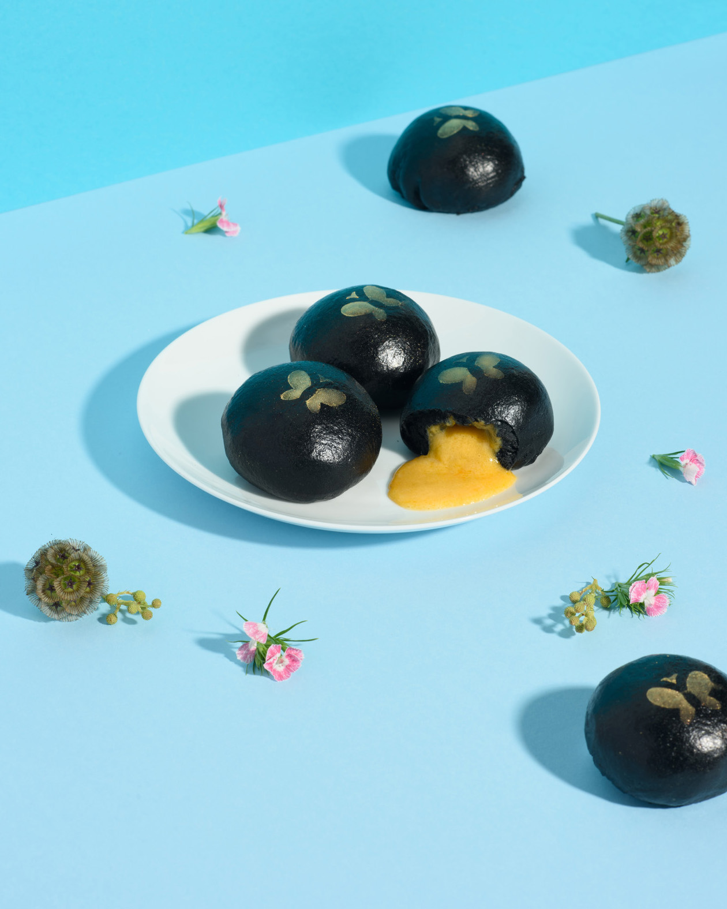 | 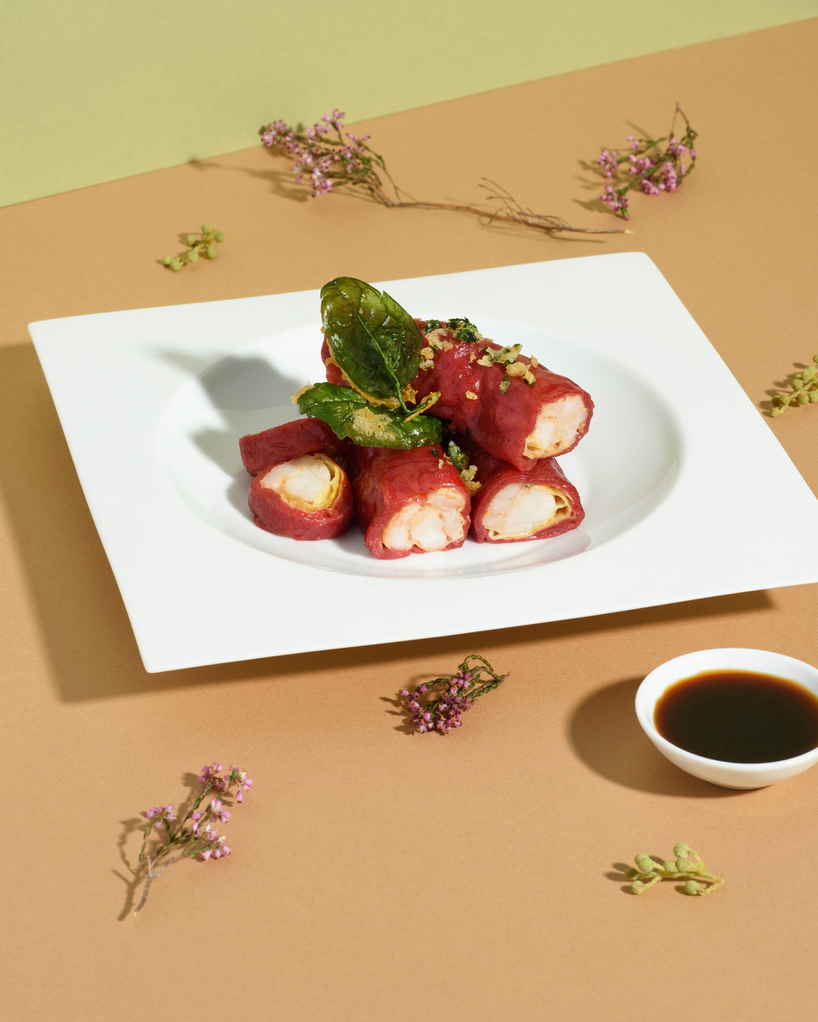 | 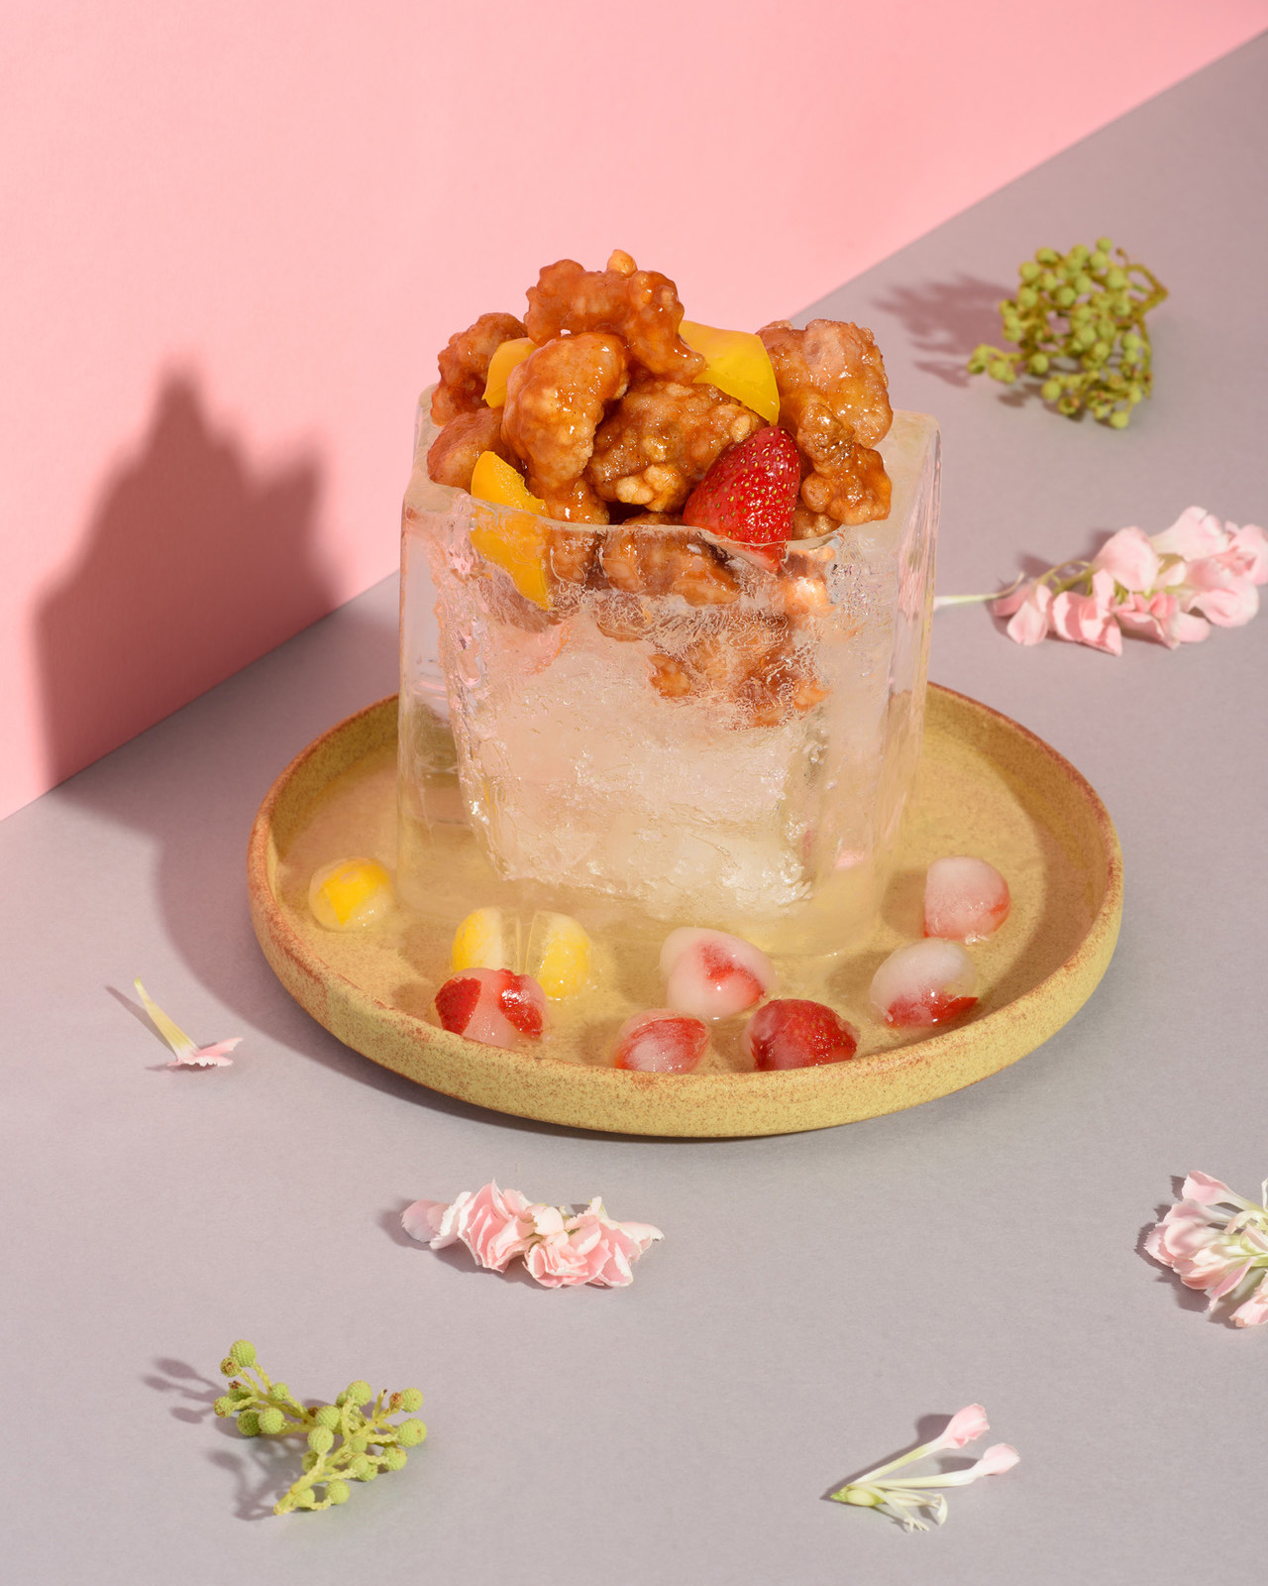
“We wanted to offer our guests a refreshing alternative, an exciting spot to meet and celebrate with family and friends,” explains Executive Chinese Chef Jimmy Wong, who has spent the last few months with his team devising novel ways to present much-loved specialties. “We’ve updated an array of traditional Cantonese recipes with tons of fun and flair. Look out for the little surprises and whimsical touches!”
Platefuls of wonder and style
A peppy, playful aesthetic infuses the dining experience at Yun House. Whether it’s the popular Peking Duck, the authentic Bean Curd Roll or the luxe Lobster + Truffle, dishes are plated in a chic and quirky fashion that instantly catches the eye.
Also on the menu are #FSKLFlavourBomb dishes – delectable treats packed with tongue-tickling flavours and ingredients. Think Charcoal Lava Bun, Chicken on Ice, and Cereal Eggplant. Yes, they look and taste as fabulous as the names suggest!
“We were inspired by carpe diem, a Latin phrase meaning ‘seize the day,’” says Restaurant Manager Pauline Chan with a smile. “Sharing a meal offers a precious opportunity to make new memories with your favourite people. At Yun House, we’re all about creating special moments filled with delight and wonder.”
Effortlessly engaging
The team’s warm and friendly service puts guests at ease, letting the laughter and good times flow. Skilful servers unveil signature dishes with panache and put finishing touches right at the table, framed by beautiful backdrops of KLCC Park and the restaurant’s vibrant floral wall.
Let’s not forget the drinks: Bartender Kah Hong Choo - known as Jerry - mixes up modern cocktails and mocktails, brimming with unexpected tastes and vivid hues. Whether one is in the mood for a light summer cooler, a Canton-inspired concoction or simply a classic cocktail, Jerry delivers it in his inimitable style – with a touch of drama, and a splash of colour.
Gatherings at Yun House promise to be more delicious, lively and photogenic than ever before. “We can’t wait to welcome our guests back!” says Chef Jimmy, eyes sparkling with enthusiasm. “There’s so much that’s new to discover, share and celebrate.”
Plan the perfect get-together with friends and family at Yun House. Chat via the Four Seasons App for reservations or enquiries.

RELATED

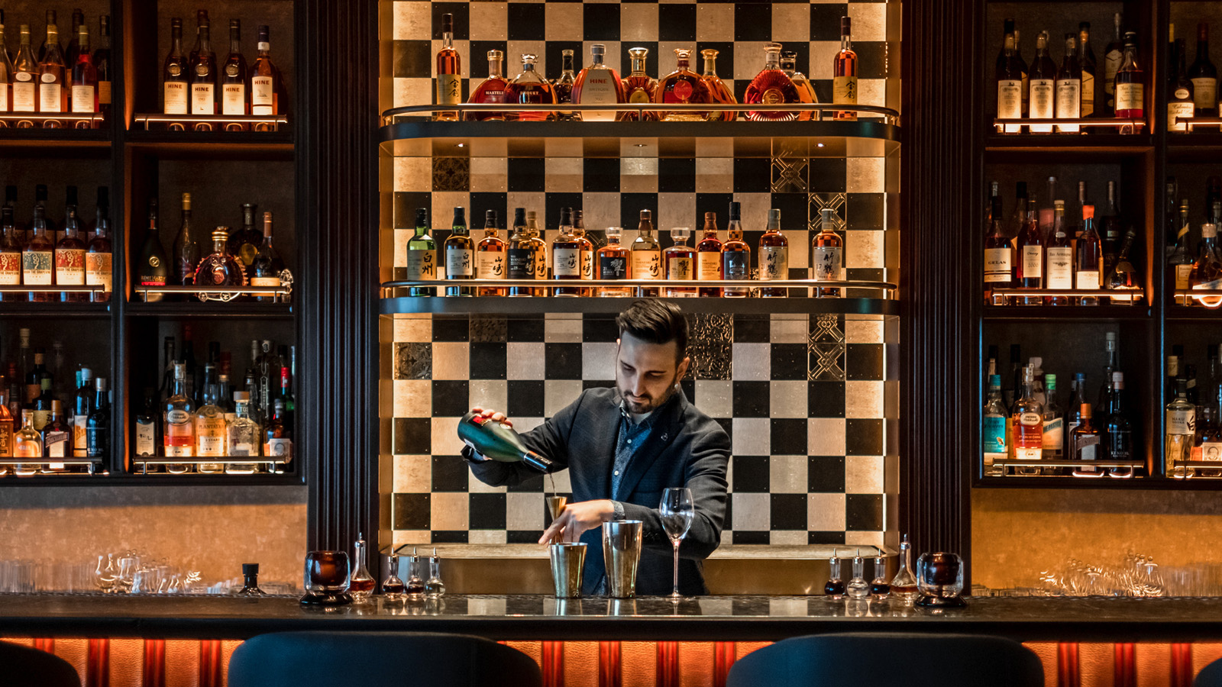 | November 12, 2021, Singapore  Four Seasons Celebrates Asia with Six Cocktails from Some of the Region’s Best Bars  https://publish.url/news-releases/2021/poured-by-four-seasons.html
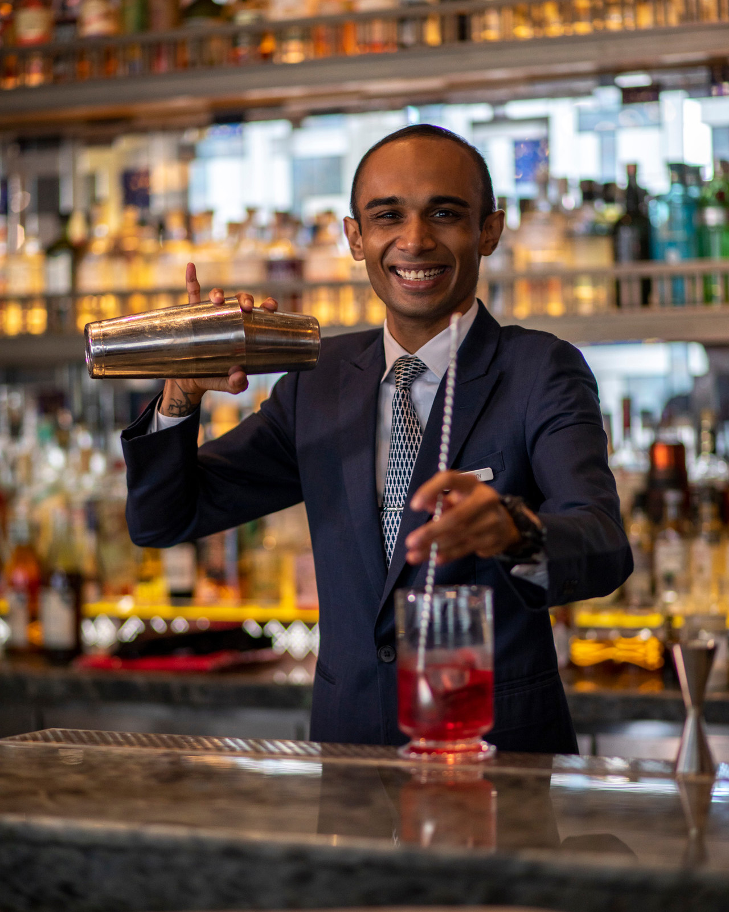 | November 1, 2021, Kuala Lumpur, Malaysia  Bar Trigona at Four Seasons Hotel Kuala Lumpur Presents the Dynamic Duo  https://publish.url/kualalumpur/hotel-news/2021/new-head-bartender-shawn.html

PRESS CONTACTS

Kanchana Ganglani
Director of Public Relations
145 Jalan Ampang
Kuala Lumpur
Malaysia
kanchana.ganglani@fourseasons.com

+6(03) 2382 8740

