Four Seasons Hotel des Bergues Geneva Launches “In Census,” an Innovative Wellness Program in Exclusive Collaboration with Hôpital de la Tour in Geneva

Including a personalised medical assessment, In Census combines medical expertise with physical and Spa activities to restore optimum health
June 11, 2020, Geneva, Switzerland

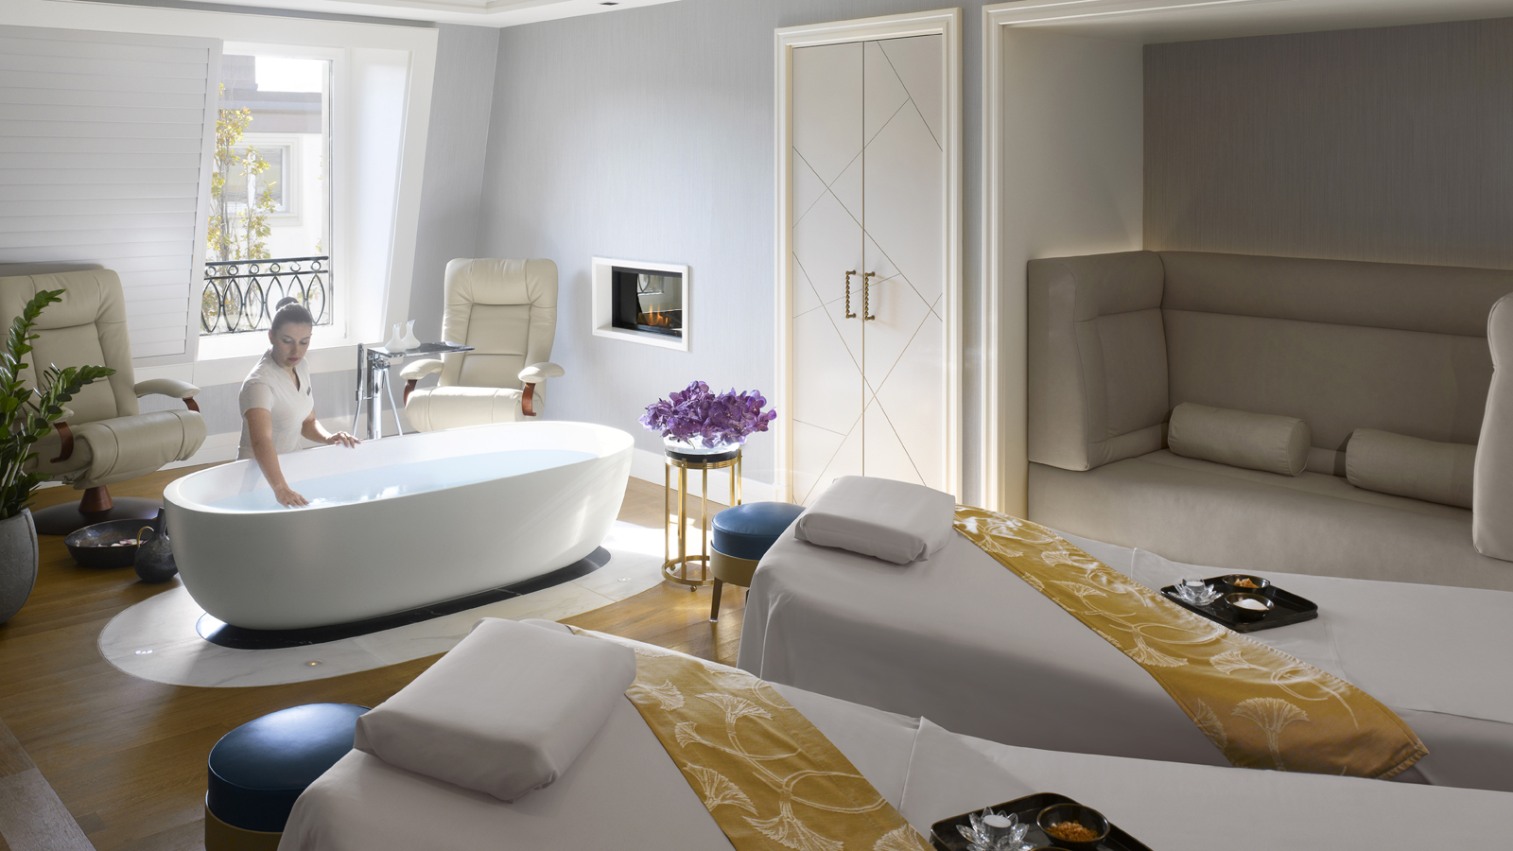
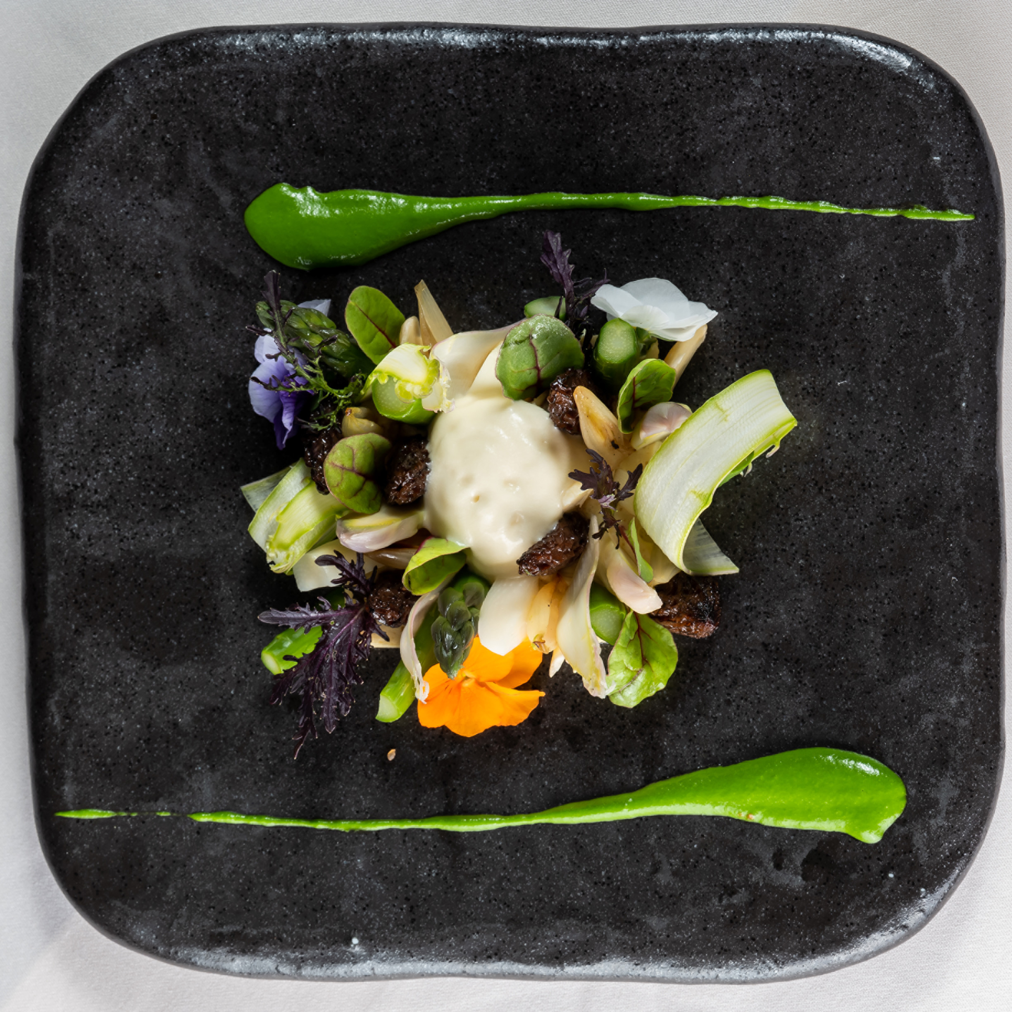 | 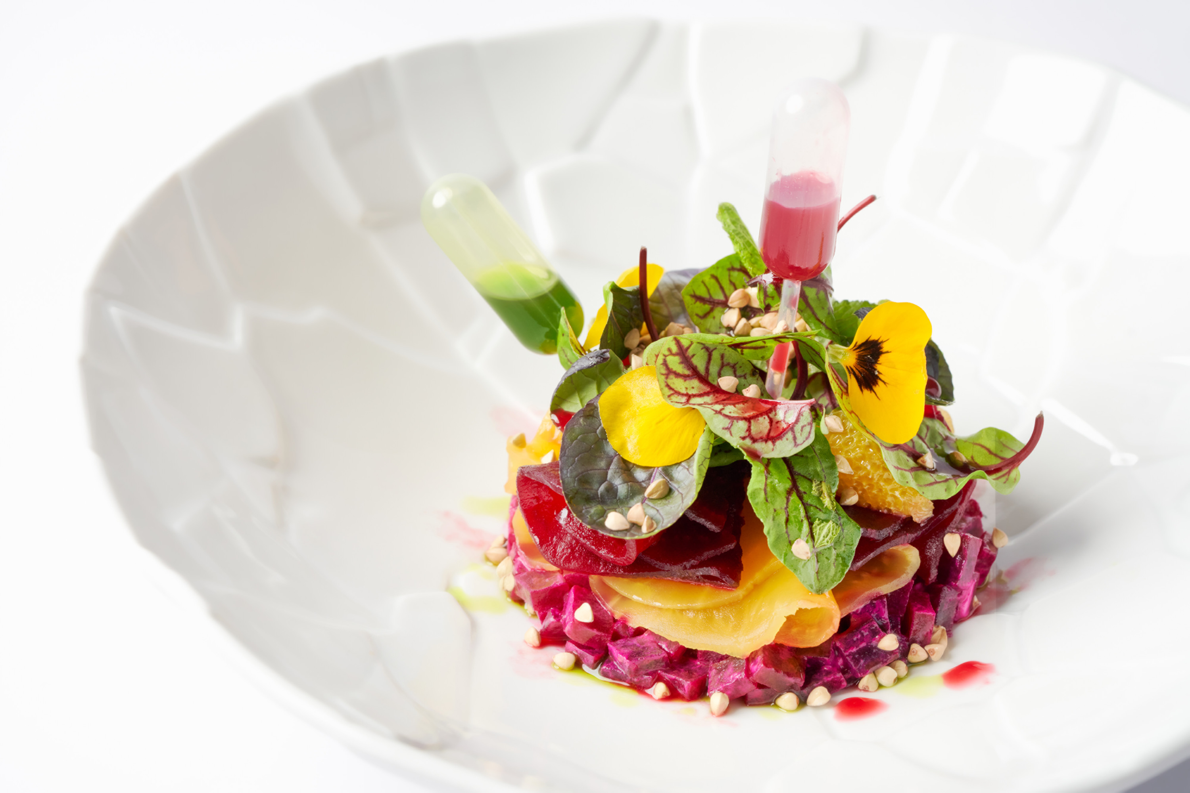
Four Seasons Hotel des Bergues Geneva has launched In Census, a wellness program in exclusive collaboration with the prestigious Hôpital de la Tour in Geneva. A recognised Swiss Olympic Medical Center, the Hospital is renowned for its high level of expertise and longstanding experience in providing consultations and treatment in the field of sports medicine. In Census features a personalised medical check-up and assessment to meet well-defined needs and objectives. The program is aimed at everyone who wishes to get back into shape, escape the stress of everyday life, and recover vital energy. In Census encourages participants to take care of their bodies and get back into shape, thanks to a holistic approach that takes in both physical and mental wellness.
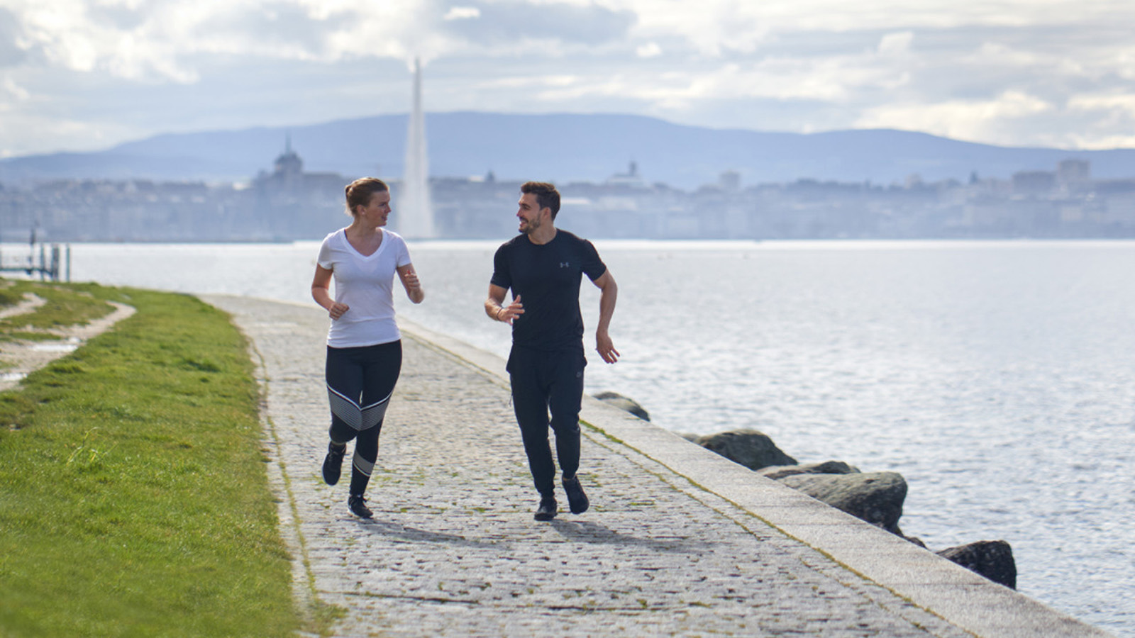

RELATED

June 11, 2020, Geneva, Switzerland
Le Four Seasons Hotel des Bergues Geneva annonce une collaboration exclusive avec l’Hôpital de La Tour à Genève et lance « In Census »
https://publish.url/fr/geneva/hotel-news/2020/in-census-wellness-program-2.html

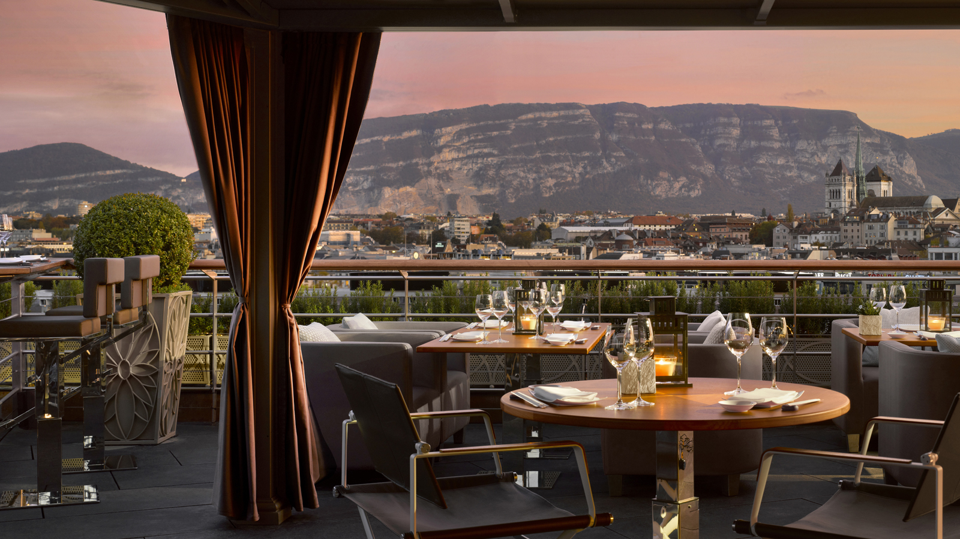 | May 15, 2020, Geneva, Switzerland  Izumi Getaway al Four Seasons Hotel des Bergues Geneva  https://publish.url/it/geneva/hotel-news/2020/izumi-getaway-3.html

PRESS CONTACTS

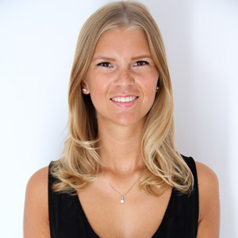 | Fanny Marmorat  Community Manager  33, Quai des Bergues  Geneva  Switzerland  fanny.marmorat@fourseasons.com  +41 22 908 71 11
Caroline Mennetrier
Director of PR and Marketing Communication
33, Quai des Bergues
Geneva
Switzerland
caroline.mennetrier@fourseasons.com

00 33 6 26 39 96 76

