Adventure Awaits This Summer at Four Seasons Resort Costa Rica at Peninsula Papagayo

Switch on vacation mode with adventures for the whole family, ultimate relaxation and special offers
May 13, 2022, Costa Rica

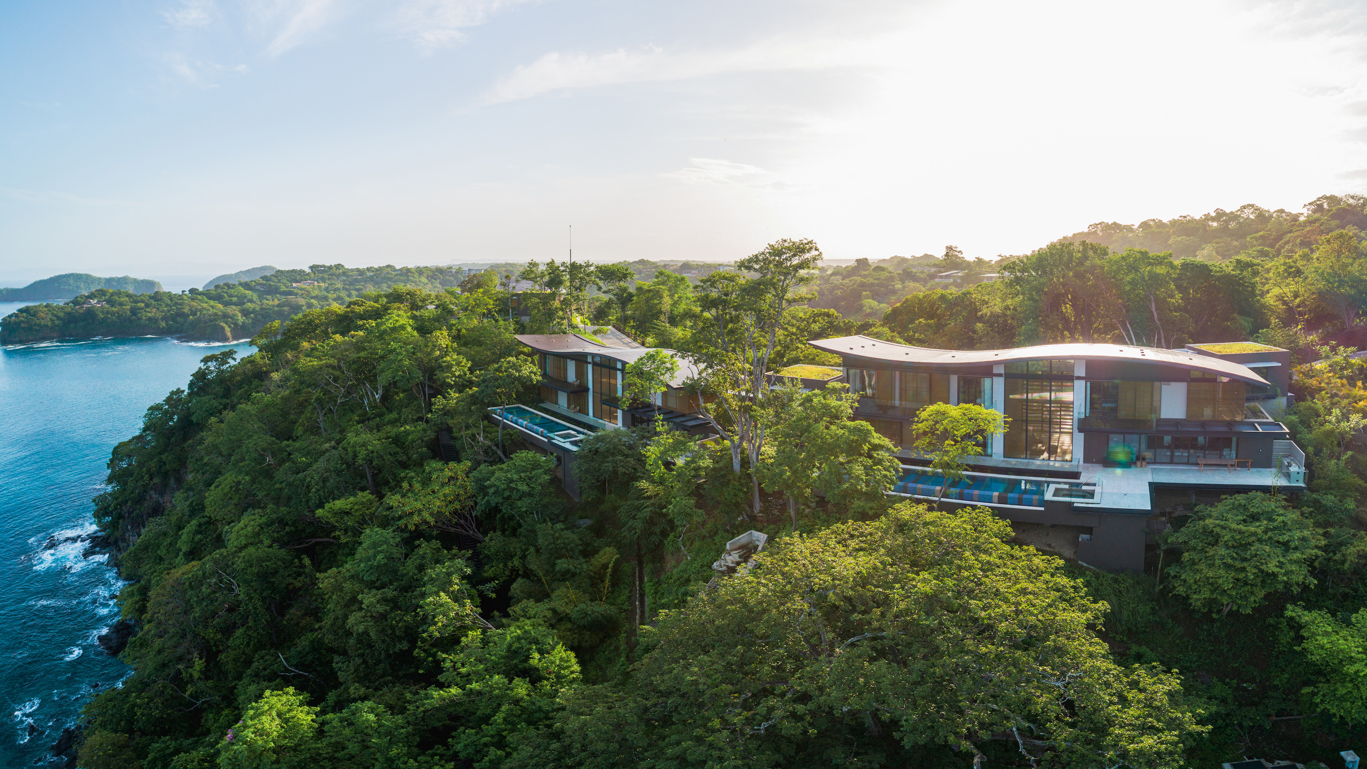 | 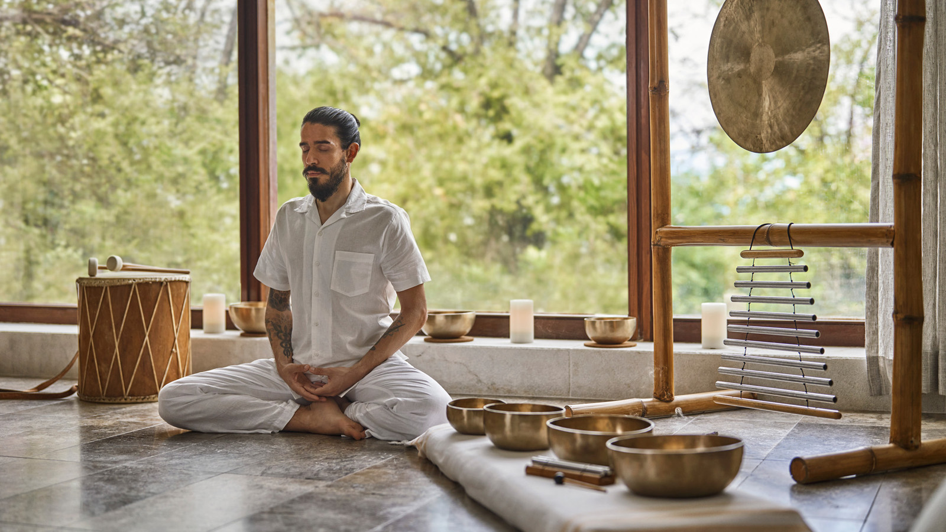
Embrace international travel and venture to Four Seasons Resort Costa Rica at Peninsula Papagayo, Latin America’s ultimate coastal retreat, offering unparalleled access to nature, adventure, and relaxation. Families can retreat to private homes and enjoy up to 30 percent off when staying four nights or more.
The Forbes Five Star Resort offers countless family-friendly programs all summer long. The Resort's activity outfitters The Explorers provide Four Seasons guests the best of Costa Rica:

RELATED

May 4, 2022, Costa Rica
Experience an Authentic Latin American Asado, A Pop-Up Culinary Event at Four Seasons Resort Costa Rica at Peninsula Papagayo
https://publish.url/costarica/hotel-news/2022/asado-culinary-event.html

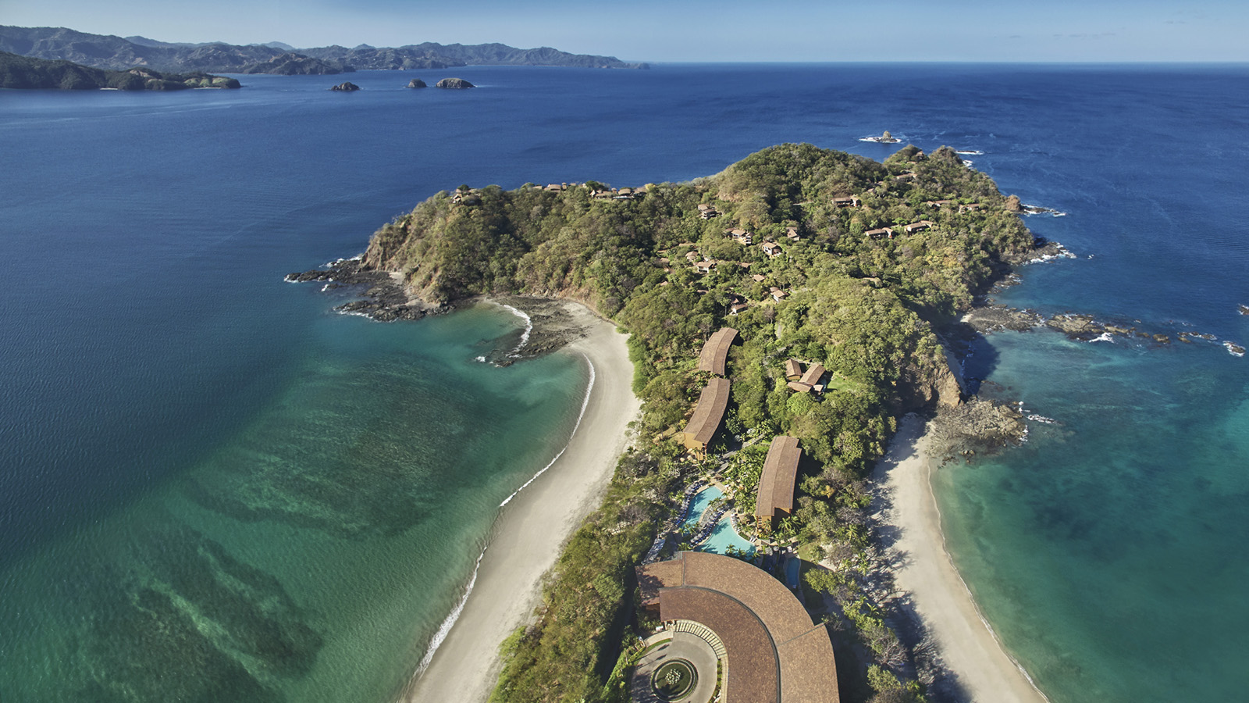 | April 26, 2022, Costa Rica  Four Seasons Resort Costa Rica at Peninsula Papagayo is Awarded Forbes Travel Guide Five Star Rating and Holds this Honour Exclusively in Costa Rica and Central America  https://publish.url/costarica/hotel-news/2022/forbes-five-star-hotel.html

PRESS CONTACTS

Melissa Quiñones DeShields
Public Relations Director

Peninsula Papagayo
Costa Rica
melissa.quinones@fourseasons.com

+506 8510 9242

