Forbes Travel Guide Awards Four Seasons Resort Costa Rica Five Stars for Third Consecutive Year as the Only Five Star Resort in Central America

Five Star designation from only independent, global rating system for luxury hotels comes on the heels of the Resort's USD 35 million renovation and December 2017 reopening
February 20, 2018, Costa Rica

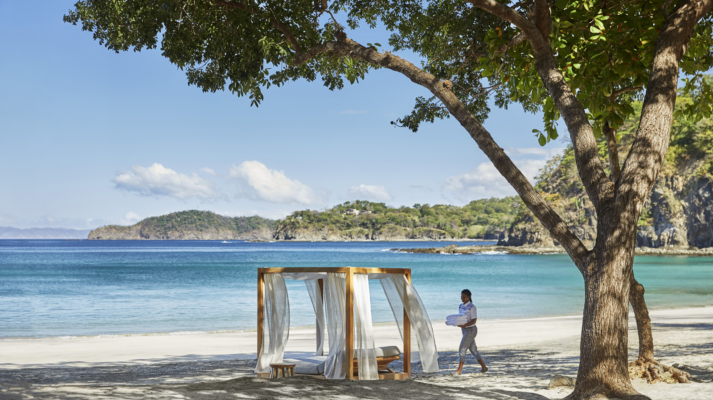
Four Seasons
Resort Costa Rica at Peninsula Papagayo has received Forbes Travel Guide’s highest rating – Five Stars – for a third consecutive year on its 2018 Star Rating list that was announced today. Following a USD 35 million renovation and December 2017 reopening on the 1,400-acre (570 hectare) Peninsula Papagayo in northwest Costa Rica, Four Seasons Resort Costa Rica remains the only property in Central America to receive this prestigious designation.
As an independent global authority on luxury travel, Forbes Travel Guide releases an annual Star Rating system recognising top luxury hotels, restaurants and spas across the world as determined by anonymous professional inspectors who independently visit and rate each property based on up to 900 objective standards. Five Star hotels are defined by Forbes Travel Guide as “outstanding, often iconic properties with virtually flawless service and amazing facilities.”
“Receiving this Five Star recognition from Forbes Travel Guide for the third consecutive year is a tremendous honour for our team,” said General Manager Michael Mestraud. “This tribute is a deep reflection of the pura vida spirit that guides our gracious approach to service and our exciting new interpretation of eco-luxury that has resonated with guests since the December completion of our Resort-wide re-imagination.”
As the crown jewel of Peninsula Papagayo on the North Pacific Coast of Costa Rica, the Resort now features 182 re-imagined guest rooms, suites and villas; a modernised lobby with striking open-air gathering space and updated retail area; four new culinary concepts featuring locally-sourced cuisine and redesigned spaces; and an enhanced signature pool area with new luxury cabanas, amenities and programing. Renowned New York City-based Meyer Davis Design Studio has brought a handcrafted approach to effortlessly integrating the Resort’s renowned indoor-outdoor spaces with Peninsula Papagayo’s vibrant tropical landscape.
Four Seasons
Resort Costa Rica is showcased among the 2018 Star Rating recipients on ForbesTravelGuide.com. To learn more about how Forbes Travel Guide compiled its 2018 Star Rating list, click here.

RELATED

December 4, 2017, Costa Rica
Four Seasons Resort Costa Rica at Peninsula Papagayo Debuts Sweeping USD 35 Million Re-Imagination
https://publish.url/costarica/hotel-news/2017/renovations-complete.html

September 18, 2017, Costa Rica
Four Seasons Resort Costa Rica at Peninsula Papagayo Appoints Michael Mestraud as General Manager
https://publish.url/costarica/hotel-news/2017/new-gm-michael-mestraud.html

PRESS CONTACTS

Danielle Finnegan
Director of Public Relations
Peninsula Papagayo
Guanacaste
Costa Rica
danielle.finnegan@fourseasons.com

+1 (786) 655-9898

Carolina Insignares
Marketing Coordinator
Peninsula Papagayo
Guanacaste
Costa Rica
carolina.insignares@fourseasons.com

+1 (786) 655-8502

