Four Seasons Hotel Kuala Lumpur Presents an Afternoon Tea with Tiffany

A sparkling afternoon with signature Tiffany blue allure
April 14, 2019, Kuala Lumpur, Malaysia

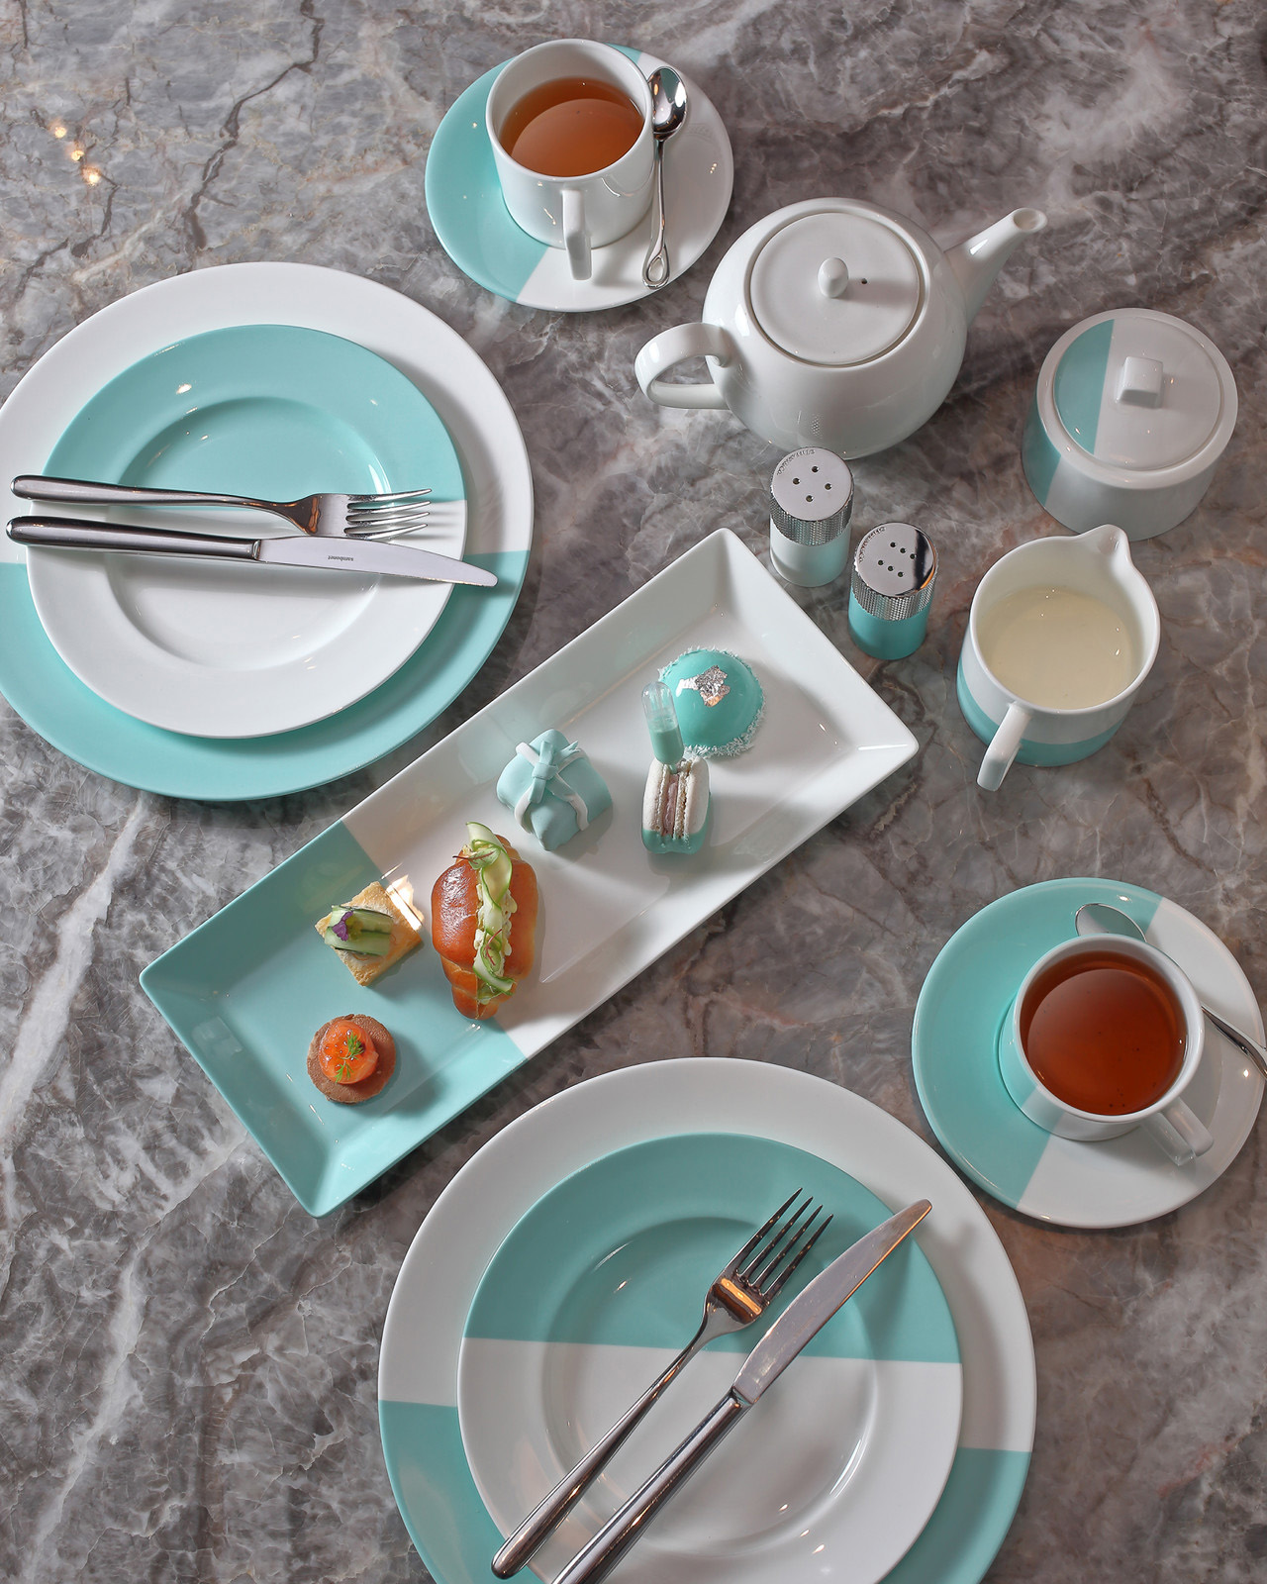
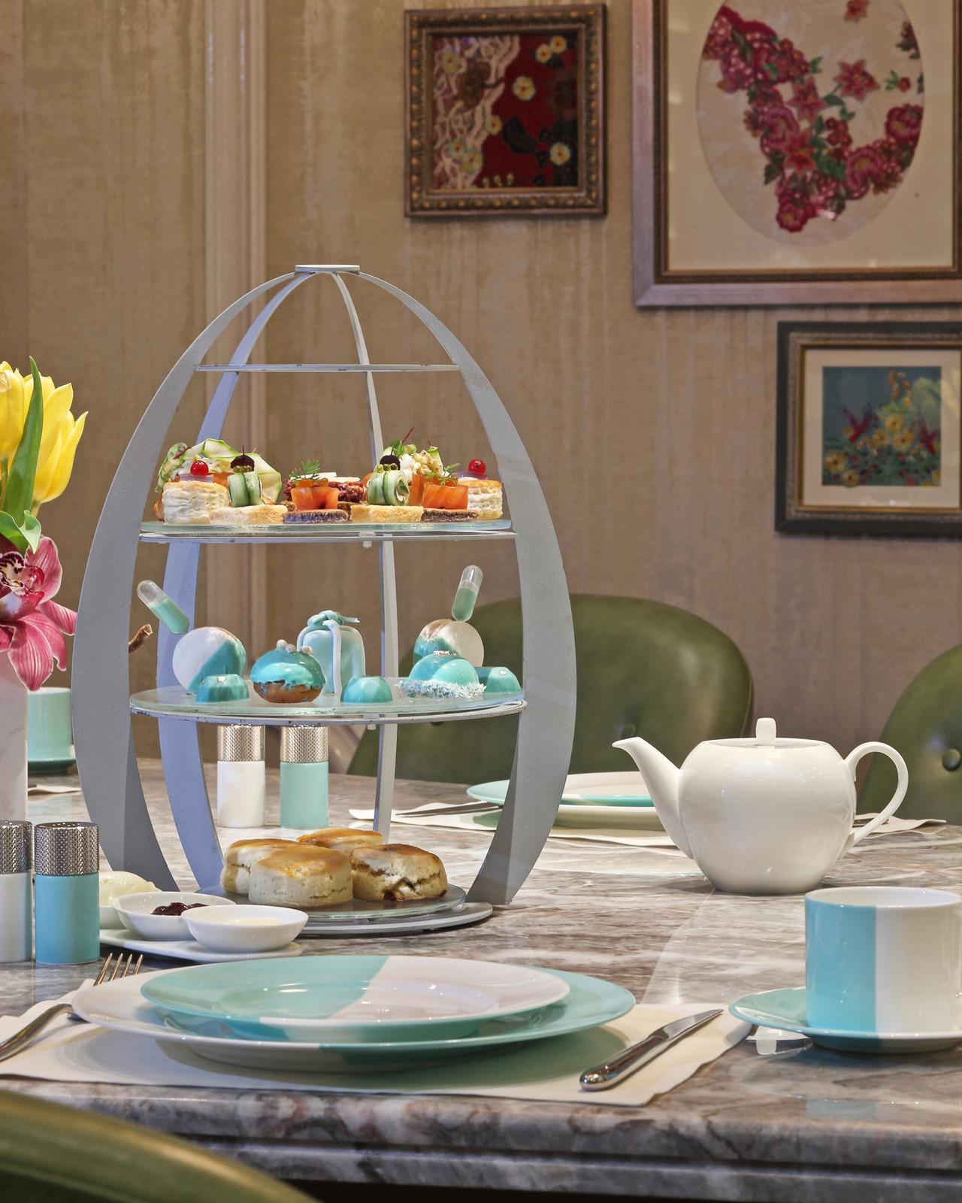 | 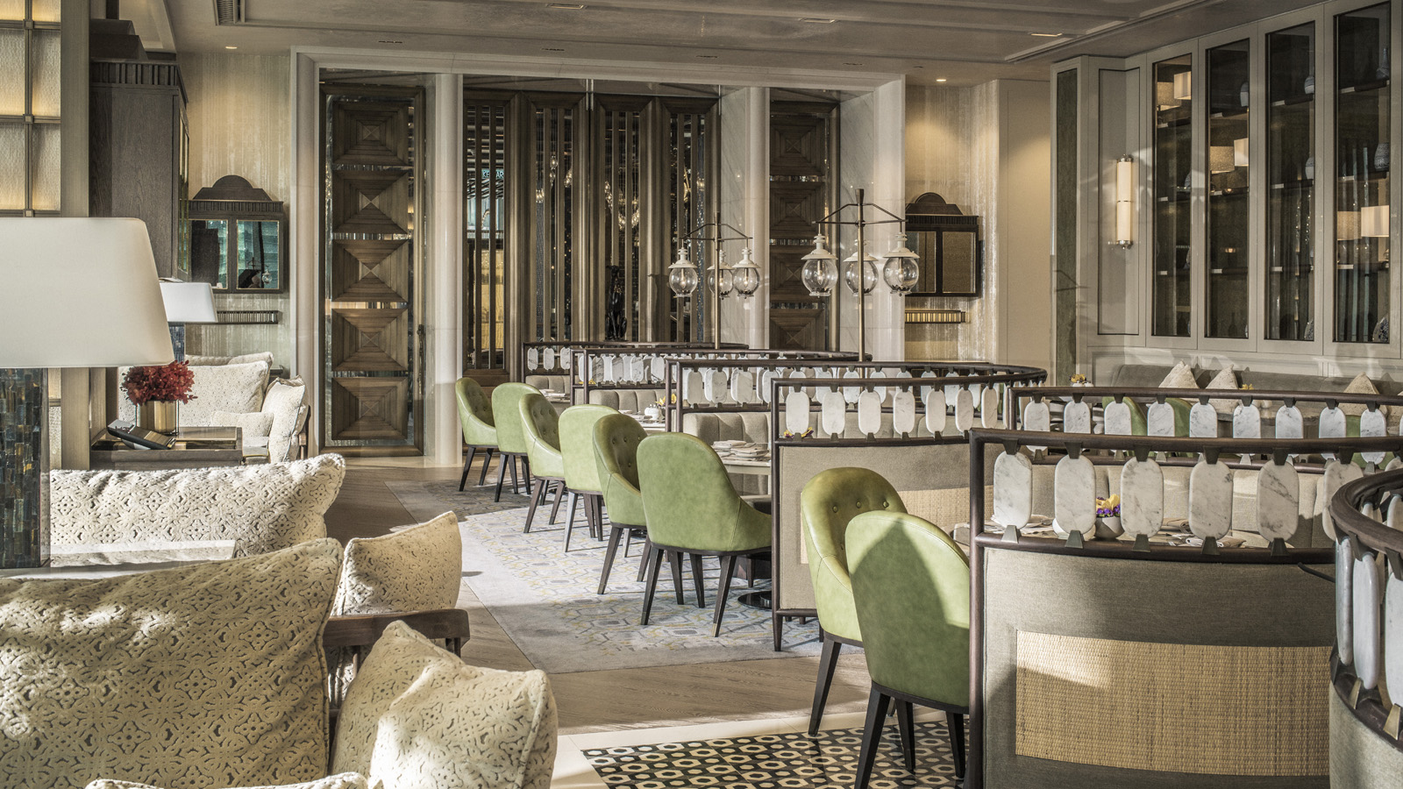
From April 15 to June 16, 2019, experience afternoon tea in iconic Tiffany style at Four Seasons Hotel Kuala Lumpur. Crafted in collaboration with Tiffany & Co., this fabulous dining experience combines the culinary prowess of Four Seasons with the whimsical glamour of the Tiffany brand.
Savour fragrant brews, along with a scrumptious selection of Tiffany-inspired desserts and savoury treats, served at The Lounge. Inspired by the brand’s legacy of handcrafted sophistication, the elegant tea set reflects the highest standards of craftsmanship – and, of course, boasts the legendary Tiffany blue.
Over its history of more than 175 years, the signature turquoise hue has come to represent luxury, love and joy – all wrapped up in a delightful Tiffany gift box. Now, the robin’s-egg blue lights up Four Seasons afternoon tea with its inimitable charm. The delectable spread is served at an authentic Tiffany’s table, brought all the way from The Blue Box Cafe at Tiffany’s on Fifth Avenue, New York.
Executive Chef Junious Dickerson’s menu pays homage to beloved tea traditions, with a playful nod to Tiffany’s latest jewellery line, “Believe in Love.” The vibrant shades of the new collection are translated into a fresh array of afternoon tea delights. Indulge in gorgeous desserts such as blueberry macaroons with mascarpone crème, royal spice cake in a Tiffany box, and chocolate praline with mandarin orange gel – they taste as good as they look!
The savouries are equally tempting: sample miniature New York rueben with peppered pastrami, and foie gras mousse in bouche with blue pea flower jewels. Of course, don’t miss out on the hallmark of any classical afternoon tea – warm scones with Devonshire clotted crème, strawberry jam and Lescure Butter.
An afternoon of visual glamour and exquisite flavours awaits at Four Seasons Hotel Kuala Lumpur – perfect for an unforgettable dining experience with family or friends.
Available from April 15 to June 16, 2019, Tiffany’s Tea will be served at The Lounge daily from 2:30 to 5:30 pm and is priced at MYR 158 (inclusive of taxes). For reservations of 8 guests or more, enjoy the limited edition Tiffany tableware. Reservations are highly recommended – call +603 2382 8650.

RELATED

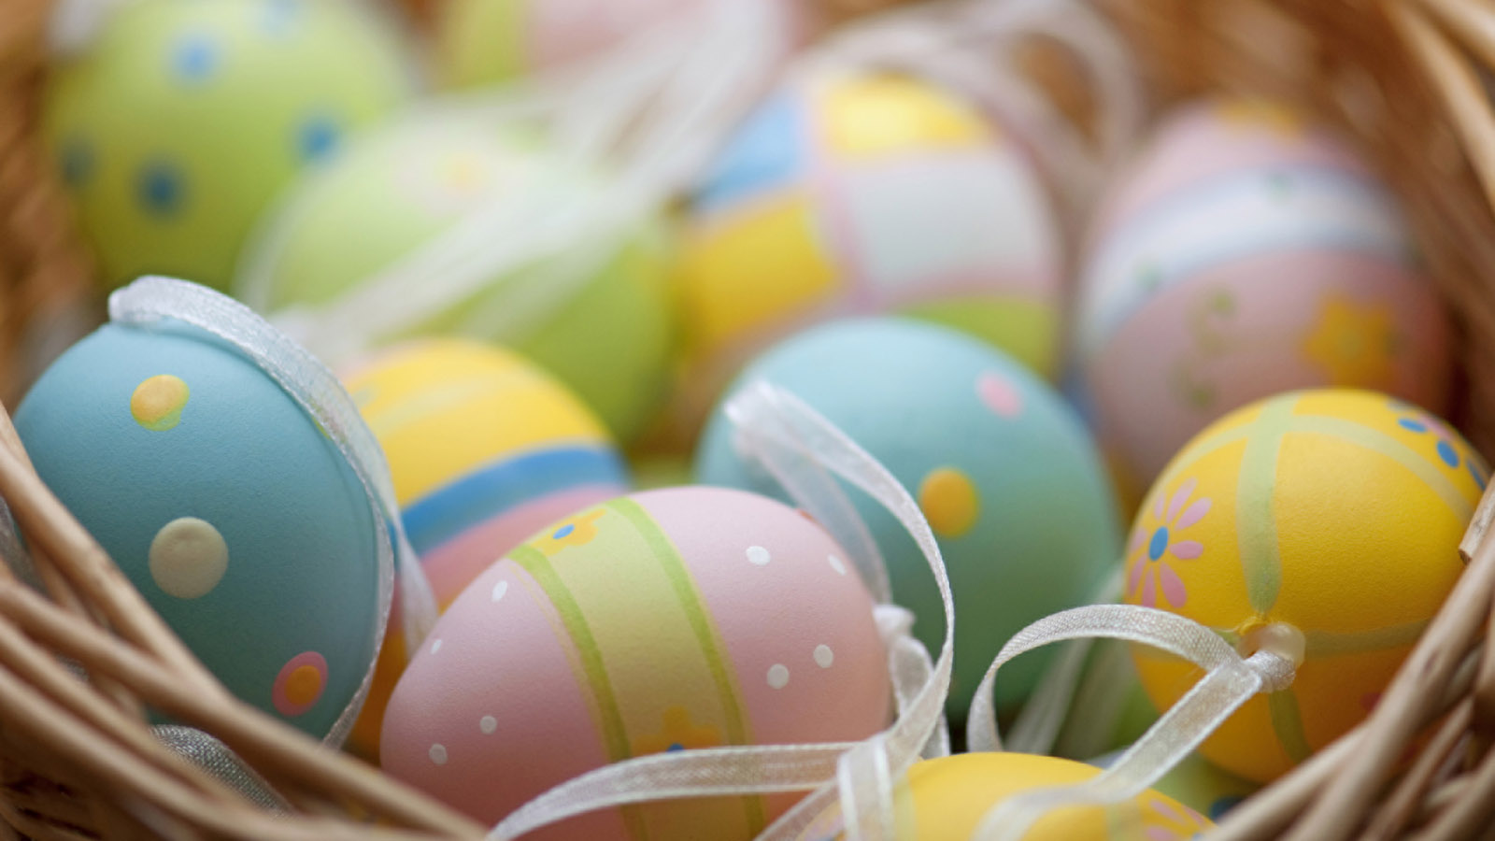 | April 16, 2019, Kuala Lumpur, Malaysia  Celebrate an Egg-cellent Easter at Four Seasons Hotel Kuala Lumpur  https://publish.url/kualalumpur/hotel-news/2019/easter.html
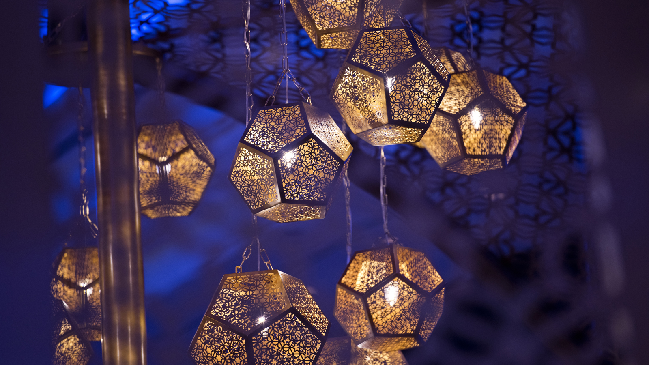 | March 25, 2019, Kuala Lumpur, Malaysia  Celebrate Sajian Nusantara with a Culinary Journey at Four Seasons Hotel Kuala Lumpur  https://publish.url/kualalumpur/hotel-news/2019/sajian-nusantara-menu-at-curate.html

PRESS CONTACTS

Kanchana Ganglani
Director of Public Relations
145 Jalan Ampang
Kuala Lumpur
Malaysia
kanchana.ganglani@fourseasons.com

+6(03) 2382 8740

