Four Seasons Safari Lodge Serengeti Launches New Community Outreach Projects to Support Local Communities and Wildlife

Safari Lodge to manage new Discovery Centre and Fruitful Orphanage Funds
July 15, 2016, Serengeti, Tanzania

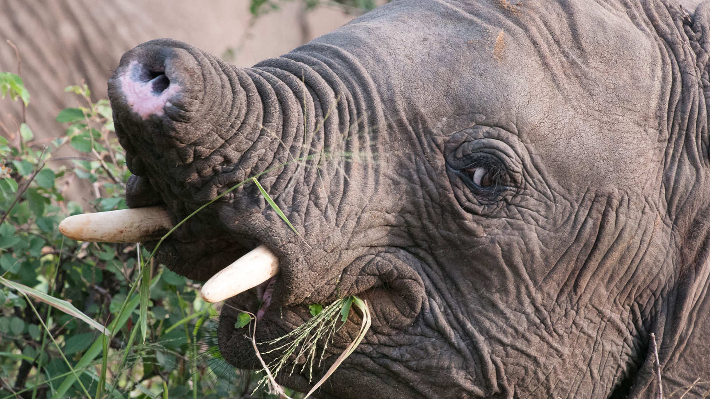
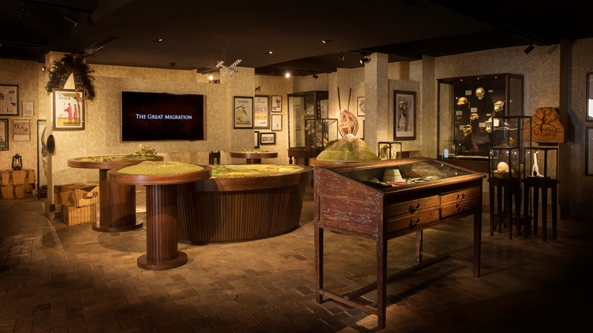 | 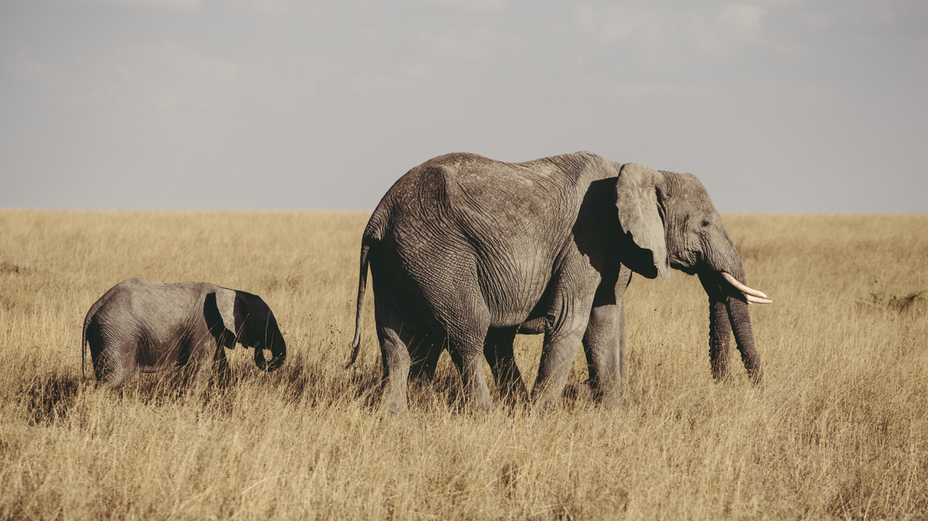 | 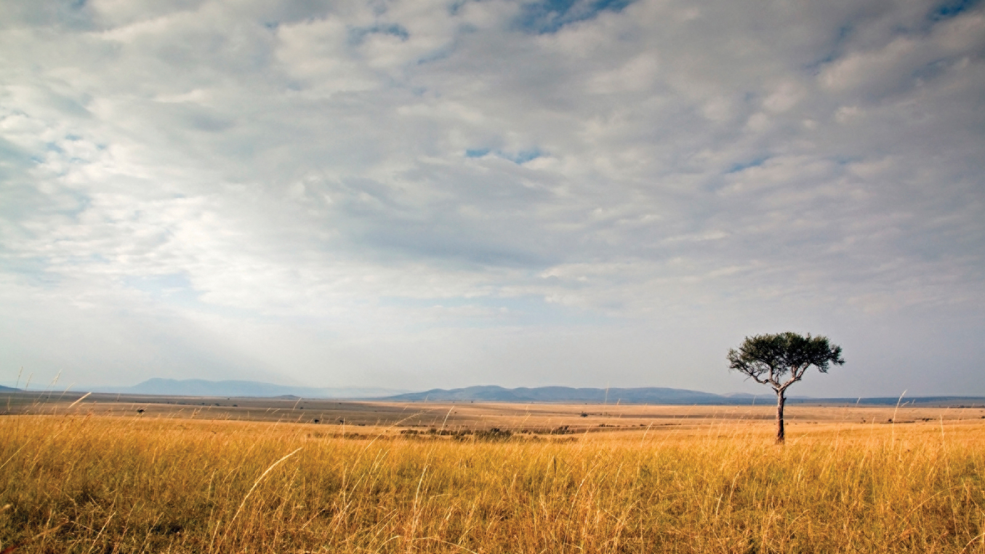
To help preserve and protect its location in the heart of the Serengeti National Park,
Four Seasons
Safari Lodge Serengeti has launched two new community outreach funds to provide ongoing support to local wildlife and social projects.
The new community outreach projects are designed to engage guests and employees in environmentally, socially and economically sustainable practices that conserve natural resources, reduce the Lodge’s environmental impact, and help protect the Serengeti National Park and the communities within and surrounding it. To date, sustainable initiatives in place include a water filtration system that allows guests to drink tap water, thus reducing plastic water bottles waste; an award-winning waste water management system; and a green linen program.
The new community outreach projects are divided into the Discovery Centre Fund, which focuses on the wildlife, nature and developing tourism students of the Serengeti National Park; and the Fruitful Orphanage Fund, which supports an orphanage in the nearby town of Arusha that is home and school for more than 30 children.
Discovery Centre Fund
At the onsite Discovery Centre, the Lodge aims to raise awareness for local wildlife conservation and research projects. Through the work of the new Discovery Centre Fund, Four Seasons will be actively involved with the work of many local organisations, including the de-snaring of injured animals and helping to develop the future leaders of Tanzania tourism through offering visits and internships to local students from Serengeti Tourism College, several times a year.
The Discovery Centre Fund has been formed in partnership with Tanzania National Parks (TANAPA), Frankfurt Zoological Society (FZS), Tanzania Wildlife Research Institute (TAWIRI) and Serengeti Tourism College (SETCO), and has two specific aims: conservation and education. All funds raised will go towards anti-poaching initiatives in the Park, as well as wildlife and hospitality education programs for young members of the community across the Serengeti.
Fruitful Orphanage Fund
Established in 2014 by Isaac Sumary, Fruitful Orphanage provides food, shelter and education to more than 30 orphaned children in Arusha. Isaac, himself an orphan, created this project to help ensure that children in his position do not have to face the same hardship he did. Isaac's vision is to provide for the basic needs of orphaned children, while seeking new families and a permanent home for each child. Through a peaceful environment and access to education, Isaac hopes the children will go on to live happy and productive lives.
With the launch of the Fruitful Orphanage Fund, every month donations from
Four Seasons
Safari Lodge Serengeti will be made to contribute to the cost of food and hygiene supplies for every child, animal feed for the Orphanage's chickens and basic classroom equipment. This new Fund also aims to assist with providing a better water and electricity supply to the Orphanage, and helping to construct larger and better equipped living accommodations and classrooms. A further initiative to support the children of Fruitful Orphanage includes the opportunity to sponsor a child's education.
Both of the new community outreach projects will be funded by donations, which guests may choose to contribute as an addition to their folio upon check out.

RELATED

March 13, 2017, Dubai, U.A.E.
New Activities and Offers at Four Seasons Hotels and Resorts in Europe, Middle East and Africa for an Exciting Easter This Year
http://publish.url/news-releases/2017/easter-in-emea.html

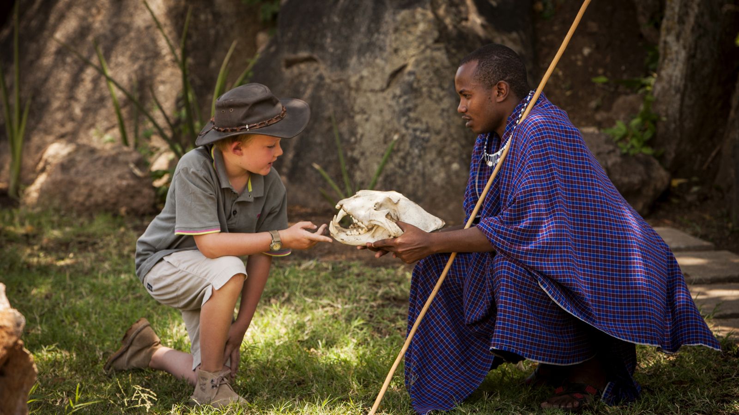 | March 2, 2017, Serengeti, Tanzania  From Maasai Olympics to Wildlife Treasure Hunts, Family Fun Awaits at Four Seasons Safari Lodge Serengeti This Easter  http://publish.url/serengeti/hotel-news/2017/easter.html

PRESS CONTACTS

Debbie Duval
Director of Public Relations and Communications

Beau Champ
Mauritius
debbie.duval@fourseasons.com

(230) 402 3100

