AFAR Names Four Seasons Resort Bora Bora “Best for an Epic Stay” in the World in 2020 Travelers’ Awards

Private island resort receives honour for fourth consecutive year
December 7, 2020, Bora Bora, French Polynesia

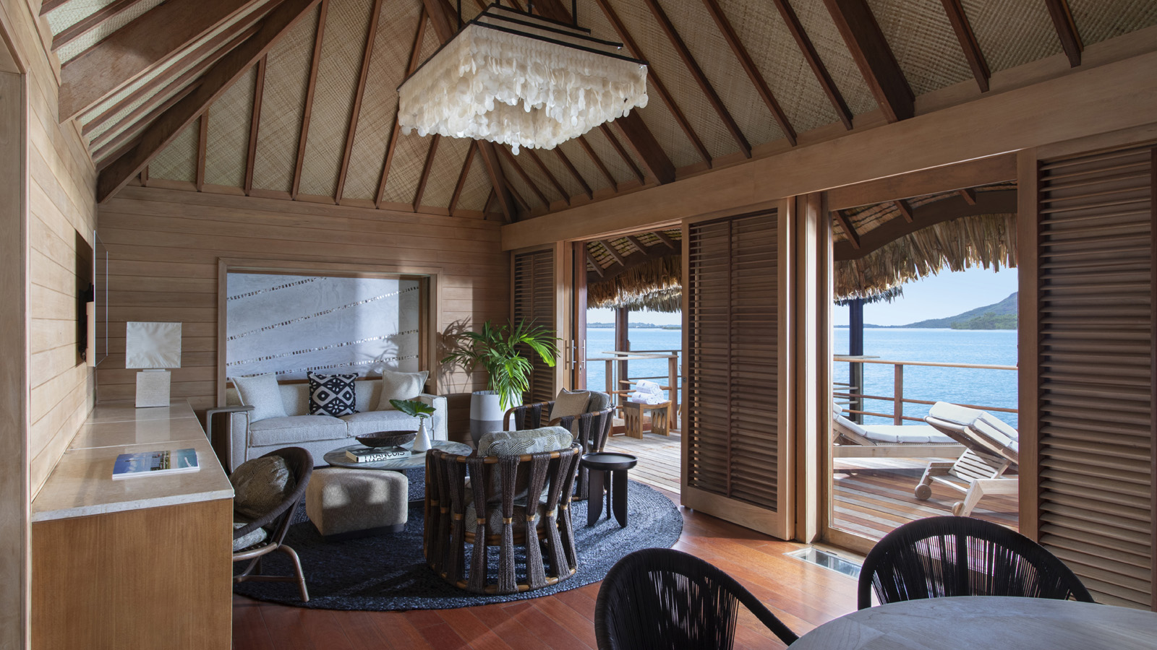
AFAR has named Four Seasons Resort Bora Bora as the Best for an Epic Stay in the World in its annual Travelers’ Awards, for the fourth consecutive year.
Casting more than 150,000 votes for their favourite hotels, cruise lines, airlines, trips and destinations, the magazine’s readers decided on the travel experiences they deem to be the best in the world. The full list of winners is available on AFAR.com, as well as in the January/February 2021 print issue of AFAR.
"We are simply thrilled to again be chosen by the esteemed readers of AFAR as the Best Epic Stay in the World,” says Diego Stembert, General Manager of Four Seasons Resort Bora Bora. “With the recent completion of our two-year enhancement, the Resort is now better than ever, offering a naturally distanced, truly epic experience for our guests.”
In celebration, the Resort is offering the Fourth Night Free package, which includes a complimentary fourth night. Guests may choose to stay in an overwater bungalow suite or beachfront villa estate, while also enjoying complimentary offerings such as daily breakfast at Tere Nui restaurant, and shared airport transfers. For reservations, book online, call 800 819 5053 or contact your travel professional (chain code FS).

RELATED

November 18, 2020, Bora Bora, French Polynesia
‘Tis the (Festive) Season – Celebrate in Paradise at Four Seasons Resort Bora Bora
https://publish.url/borabora/hotel-news/2020/festive-season.html

November 12, 2020, Bora Bora, French Polynesia
Four Seasons Resort Bora Bora Debuts Enhanced Beachfront Villa Estates
https://publish.url/borabora/hotel-news/2020/enhanced-beachfront-villa-estates.html

PRESS CONTACTS

Brad Packer
Director of Public Relations
350 South Beverly Drive, Suite 100
Beverly Hills
USA
brad.packer@fourseasons.com

+1 310 712 1493

