Ring in the New Year at Four Seasons Hotel Firenze with Michelin-Starred Cuisine and a Legendary Themed Party by Vincenzo Dascanio

October 12, 2019, Florence, Italy

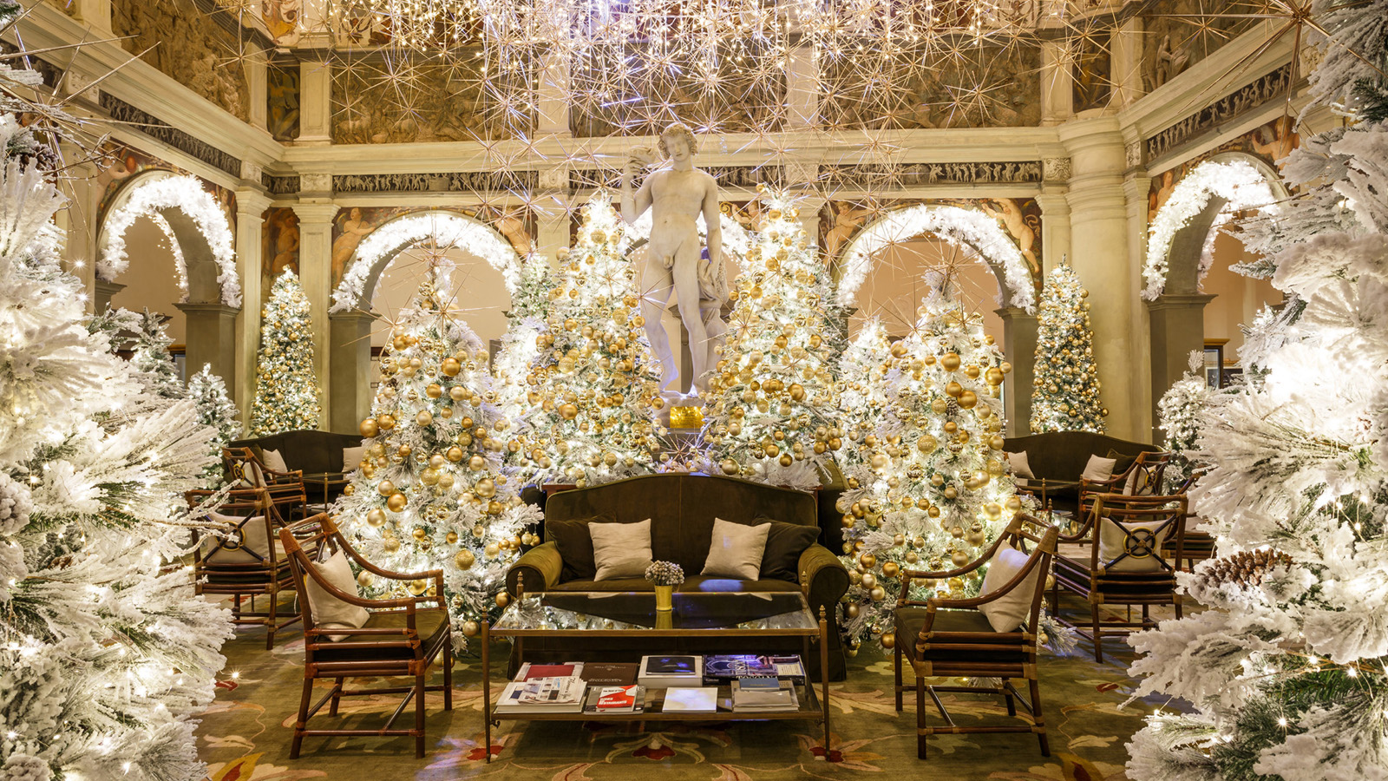
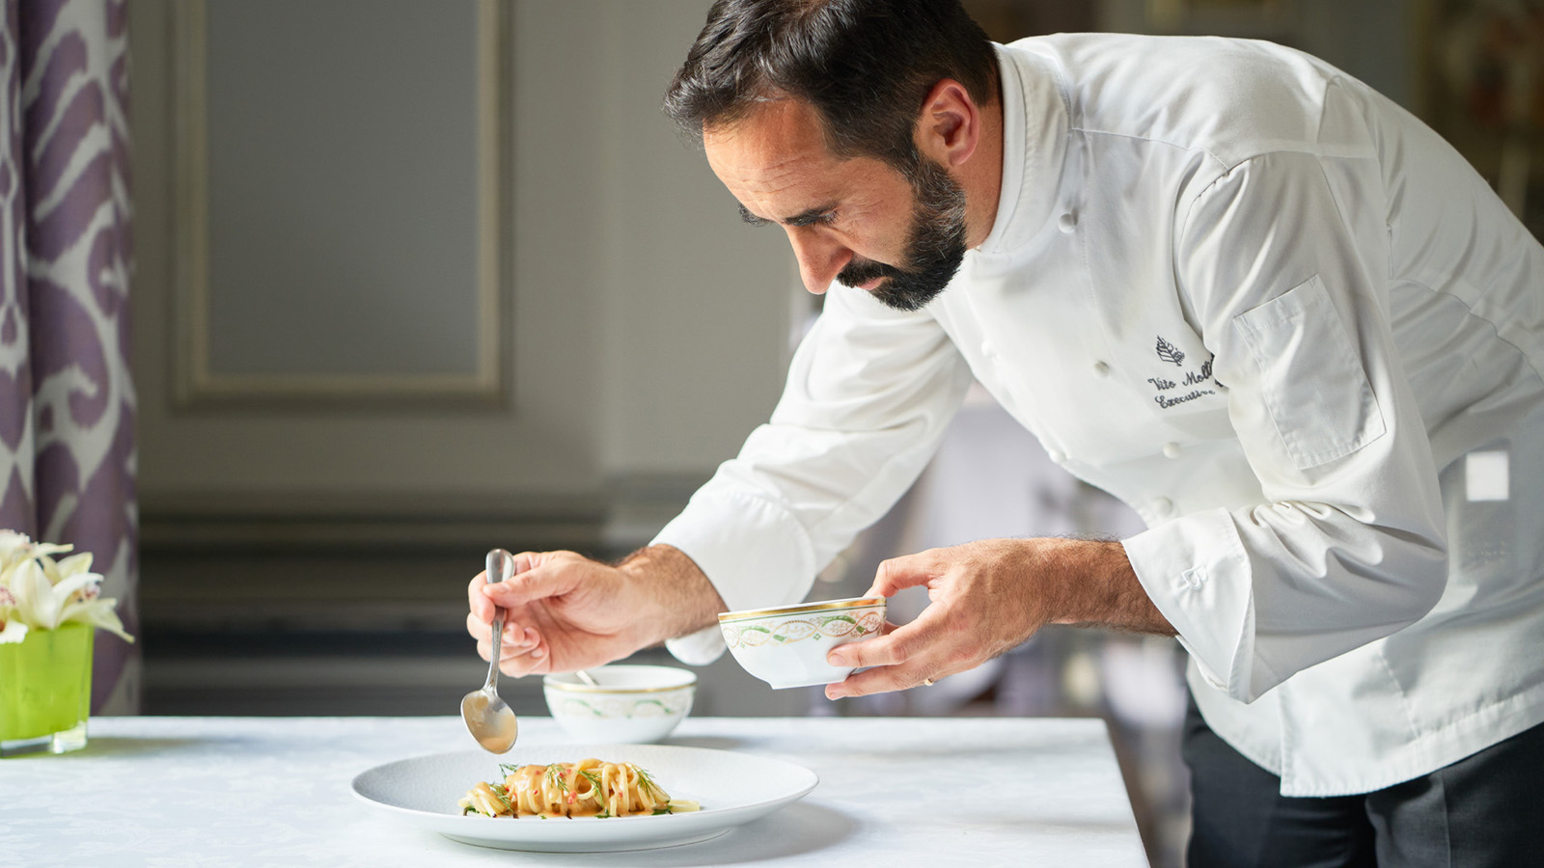
With its festive atmosphere and profusion of cultural highlights, the city of Florence is a perfect destination to spend the holidays and enjoy a memorable New Year’s Eve celebration. Fall and winter are the best times of year to enjoy easy access to the city landmark museums and get immersed into the rich Renaissance culture and history - away from the summer crowds - and warm up with delicious winter Tuscan specialties.
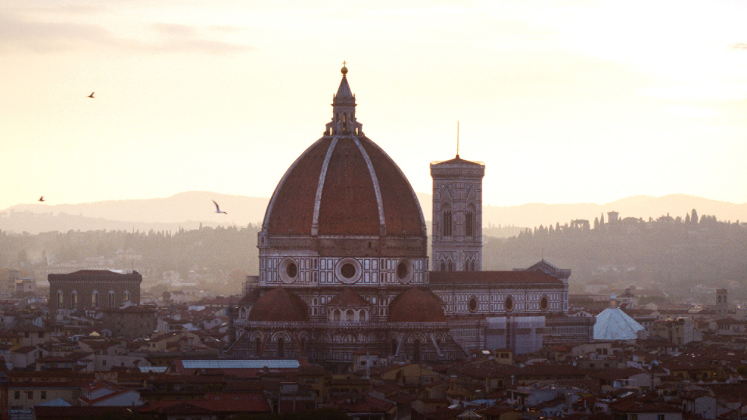 | 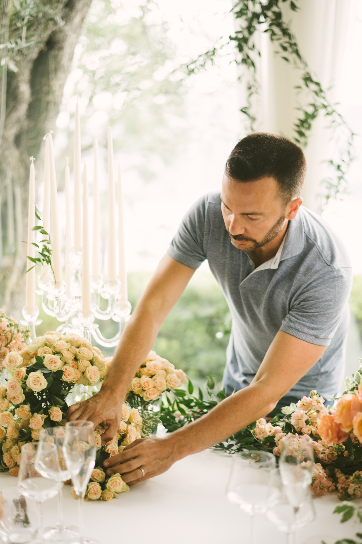
This holiday season, local theatres offer divine concerts and museums display unique exhibitions, from the Leonardo da Vinci themed exhibition at the Palazzo Vecchio to the classic dance shows at the Maggio Musicale Fiorentino Theatre. The city itself turns into a wonderful scene lit with Christmas lights. As recommended by Four Seasons Hotel Firenze Head Concierge Paul Lydka: “The best way to feel the Tuscan festive spirit is to simply stroll through the Florentine roads sipping a home-made mulled wine at a traditional Christmas Market with beloved ones, and for the little ones, enjoy fun ice skating at the Florence Winter Park."
After a busy day of sightseeing, the cosy atmosphere of Four Seasons Hotel Firenze awaits guests with impressive displays created by acclaimed Event Designer Vincenzo Dascanio. Each year, the Hotel’s festive decorations become a local must-see, for the magnificence of the public spaces completely transformed into a colourful fairytale. Surrounded by this festive atmosphere, guests can enjoy a rich afternoon tea or a sparkling aperitivo at the Atrium Bar, before indulging in a relaxing treatment at the Spa.
The perfect ending to this winter day is a Michelin-starred dinner at Il Palagio to taste the exquisite cuisine of Chef Vito Mollica, a staunch advocate of Italian food, offering Italian traditional recipes with a twist, made with the best seasonal ingredients.
As traditionally, the Hotel’s legendary New Year’s Eve Party will be held in the Hotel garden under a majestic marquee, with décor specially created by Vincenzo Dascanio. Themed after a “Florence Rouge” party, the event promises cascades of red velvet and a memorable night in the spirit of the Moulin Rouge spiced up by live entertainment, a five-course menu by Vito Mollica, and a midnight DJ-set to dance all night under a spectacular fireworks show.
Alternatively, guests can choose to attend the exclusive dinner at Palazzo della Gherardesca, organised by the Michelin-starred restaurant Il Palagio, featuring unique festive decorations and live music entertainment. A dedicated New Year’s Eve menu featuring a five-course dinner is available to taste Vito Mollica’s cuisine at its best, made with a selection of local and Italian excellences such as steamed lobster, seafood fregola pasta, roasted monkfish and sirloin of Japanese wagyu.
On January 1, 2020, the Hotel’s iconic New Year’s Brunch will welcome guests with its open kitchen concept, offering different options of first and second courses as well as the best Italian specialties and local-produced salami and cheeses, a wide section of raw fish, and delightful desserts by the Hotel’s Pastry Chef Domenico di Clemente.
Book the special New Year’s Eve in Florence package, including two nights in Deluxe room including breakfast, New Year’s Eve Dinner and Party Celebration.
The New Year’s Eve in Florence is available from December 31, 2019 to January 2, 2020, starting from EUR 2600 based on double occupancy in a Deluxe room, including:
- Two nights including breakfast
- New Year's Eve dinner and party celebration: two seats at the New Year's Eve dinner party celebration with five-course menu by Michelin starred Chef Vito Mollica including wine pairing, soft drinks and aperitif before dinner - additional preferred drinks at a supplement. Live music entertainment and fireworks to celebrate the New Year.

RELATED

October 12, 2019, Florence, Italy
Natale e Capodanno a Four Seasons Hotel Firenze con Cene Stellate e una Festa di Capodanno a Cura di Vincenzo Dascanio
https://publish.url/it/florence/hotel-news/2019/new-years-eve-2.html

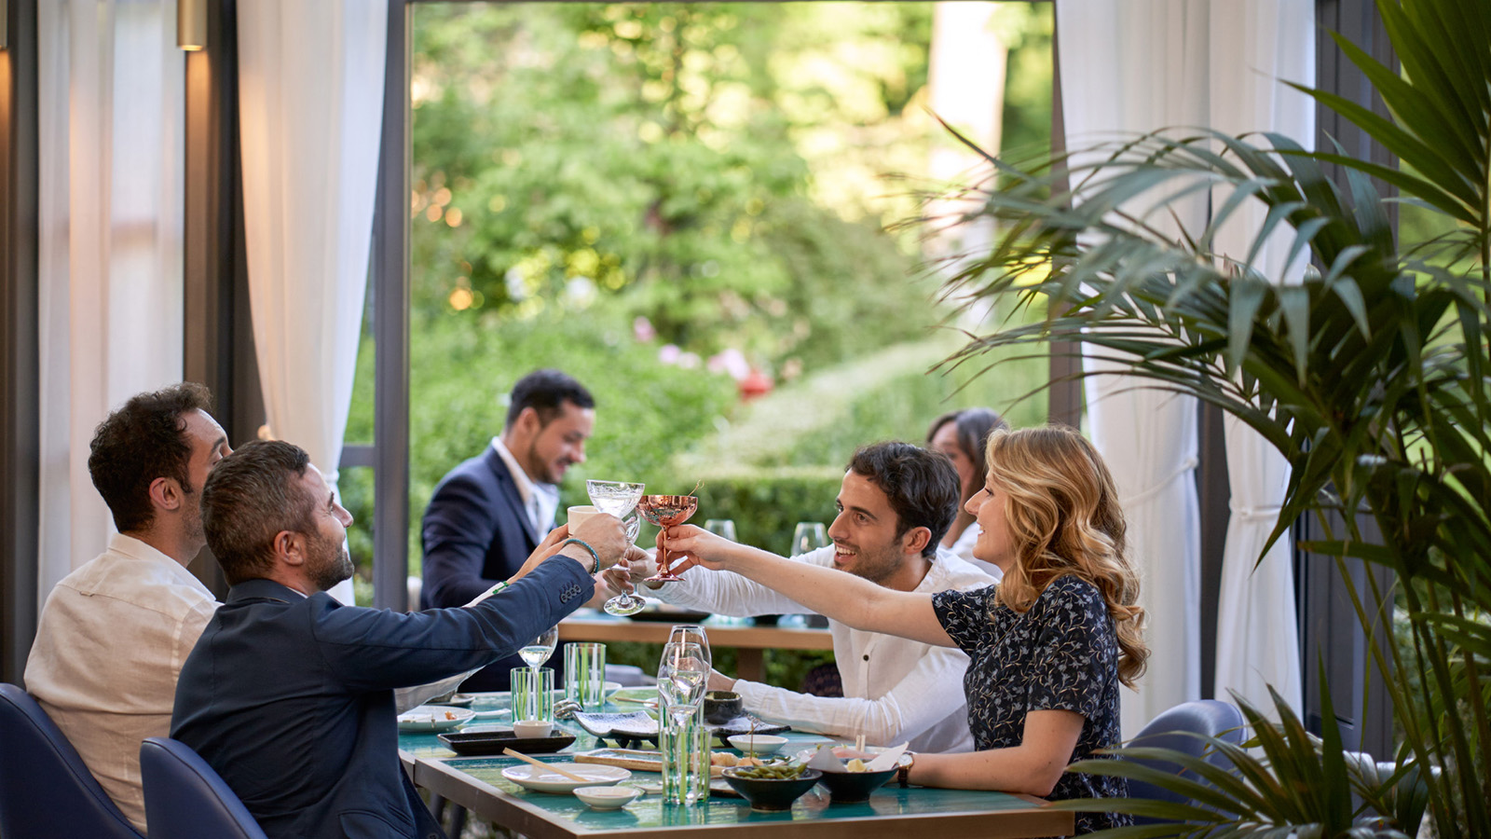 | September 19, 2019, Florence, Italy  Four Seasons Firenze lancia il brunch “Asiatico” alla Magnolia  https://publish.url/it/florence/hotel-news/2019/brunch-options-at-il-palagio-and-magnolia-2.html

PRESS CONTACTS

Martina Nesti
Public Relations and Marketing Communications Coordinator
Borgo Pinti, 99
Firenze
Italy
martina.nesti@fourseasons.com

+39 055 2626222

Caroline Mennetrier
Director of PR and Marketing Communication
Borgo Pinti, 99
Firenze
Italy
caroline.mennetrier@fourseasons.com

+33 6 26 39 96 76

