Discover the Art of Cheese-Making with Chef Sebastiano and Friends at Four Seasons Hotel Kuwait at Burj Alshaya

Executive Chef Sebastiano Spriveri, visiting Chefs Giuseppe Pappalardo, Enrico Carretta and Cheesemonger Biagio Floro, and Dai Forni’s resident Chef de Cuisine Daniele Bartolo are putting on a live demonstration of the preparation of fresh mozzarella, burrata cheese, stracciatella and a wide selection of fresh cheeses that will be used as ingredients in the dishes for the special menu created for the occasion from January 20 to 26, 2019
January 8, 2019, Kuwait City, Kuwait

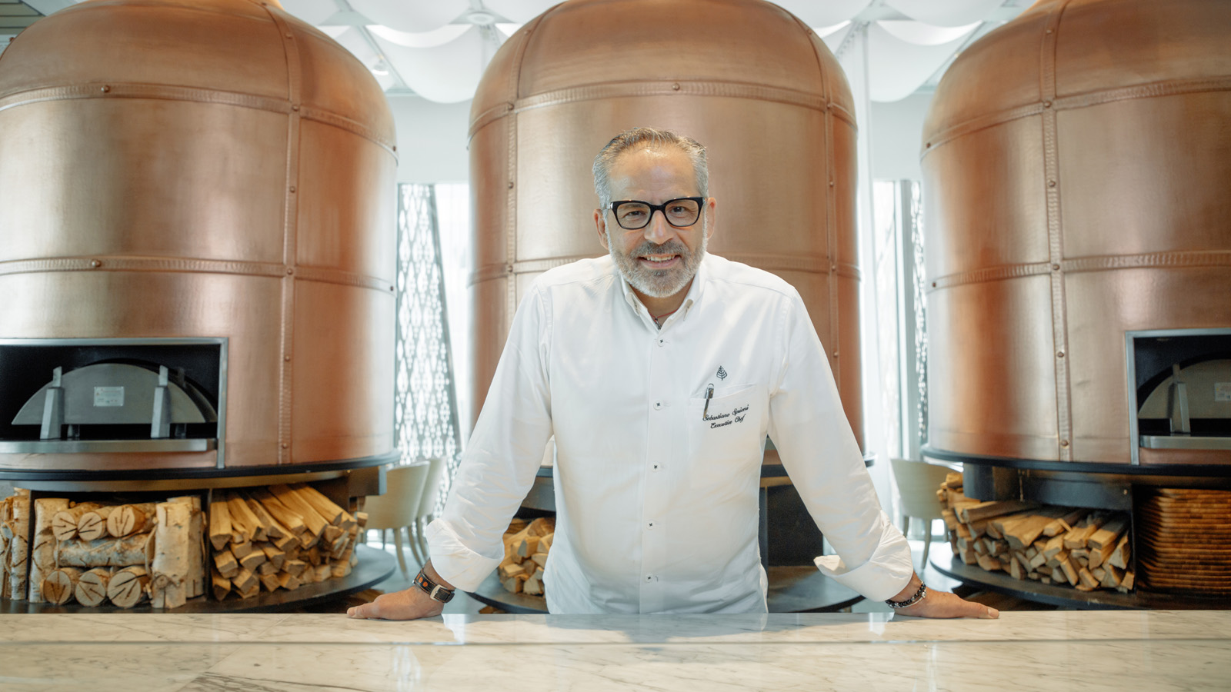
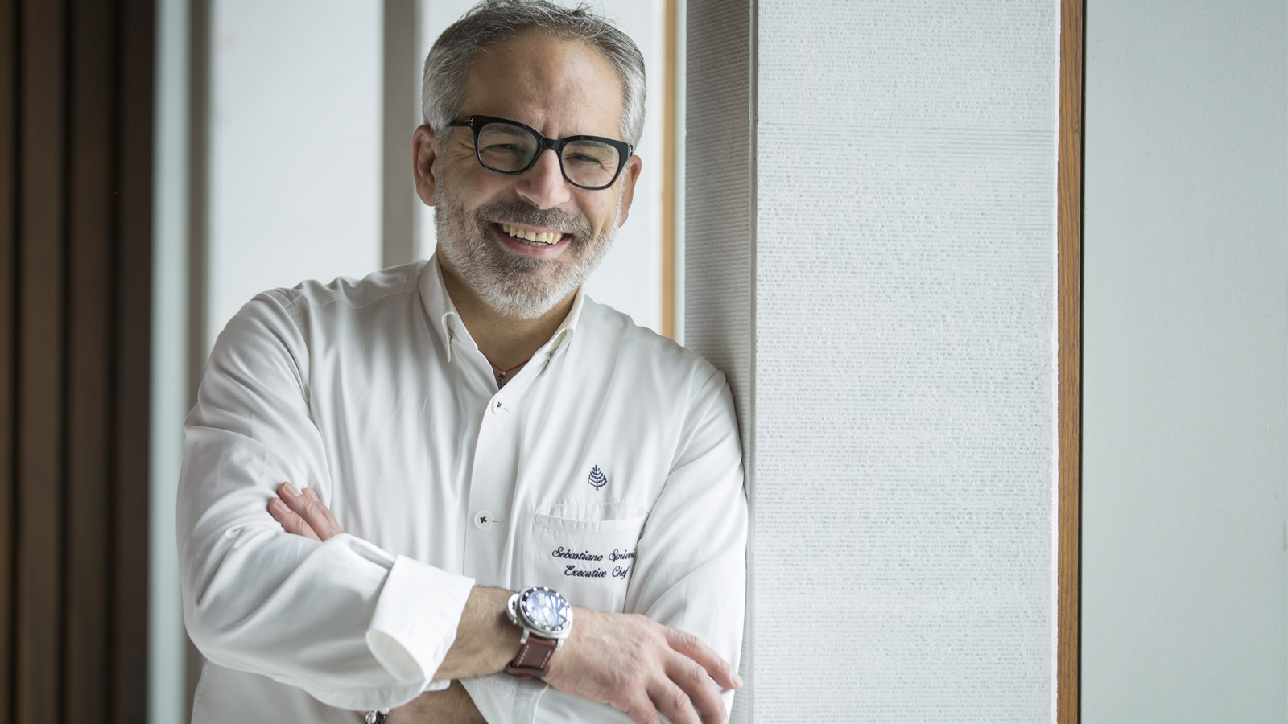
Four Seasons Hotel Kuwait at Burj Alshaya Executive Chef Sebastiano Spriveri is happy to extend an invitation to all gourmands for his special Sebastiano and Friends event. The upcoming Sebastiano and Friends event promises diners an interactive Sicilian feast and an unforgettable experience at Dai Forni restaurant: talented Chef Giuseppe Pappalardo has crafted a special menu that celebrates Sicilian culinary heritage, and a demonstration of mozzarella making with Chef Enrico Carretta and cheese monger Chef Biagio Floro in a live show of skills for everyone to enjoy.
Unlike store-bought, machine-made cheese, the real thing is made with love and dexterous, trained hands to create a delicacy that can be appreciated by everyone, and not just epicureans. Pappalardo and his Dairyman Corner will showcase the age-old traditional art of making mozzarella and burrata as guests watch and learn, and they will be offered the chance to sample the freshly made cheeses, making for a truly enlightening and unforgettable experience.
"Sebastiano and Friends is the culinary event of the season that you mustn’t miss! This promotion is an introduction of the culinary heritage of Italy to Kuwait where the cheese-monger and Chefs will be working side by side to craft delicacies that will satisfy all of our guests. You will watch as Biagio and Enrico work alongside myself and our Chef de Cuisine Daniele Bartolo to bring Italy here," says Chef Spriveri.
Chef Giuseppe Pappalardo is the descendant of a long line of traditional bakers, and he understands the importance of conserving time-tested culinary arts. While also respecting the role of science and formal education, he sought a degree in Hotel Management from the IPSSART School in Syracuse.
After a successful career in the food and hospitality industry as a professional chef over several decades in Italy and abroad, he decided that teaching was his calling. Pappalardo has created and collaborated on crafting professional training for would-be chefs within the European community. The chef makes use of his abilities and training to organise important fund-raising dinners for charity organisation Ibiscus that aims to finance research for the fight against children’s leukaemia.
His most recent passion has been the study of native Sicilian alimentary products, which he promotes as the manager of TantoQuantoBasta Srl. A local society, which specialises in the trade of traditional Sicilian products for haute cuisine, TantoQuantoBasta Srl also offers professional consulting services for restaurants.
“I've always had a passion for mozzarella. After graduating, I worked as a consultant in an audit firm, but every time my dad asked me what I wanted to do in life, my answer was always the same: mozzarella. Now we are here in Kuwait to present our master craft to the local community and create delightful dishes where each one follows an original and authentic Italian recipe,” adds Enrico Carretta.
Italian cuisine is one of the most delicious and exquisite in the world, and Sebastiano and Friends offer spectators a delightful and surprising live performance of authentic handcrafted dairy traditions in the Dairyman Corner. Dairyman Biagio Floro will be showing the audience the real art of making mozzarella by creating hundreds of mozzarelle and burratine, where they will also have the unique opportunity to taste the freshly made cheese.
Don’t miss this whirlwind adventure created by Chefs Sebastiano Spriveri, Giuseppe Pappalardo, Enrico Carretta, Biagio Floro and Daniele Bartolo that begins with fresh milk transformed to curds, arriving at stretchy, melty mozzarella and buttery, soft burrata cheese that everyone craves and loves. Because fresh is always best, cheeses like mozzarella and burrata are much more flavourful than the ready-made variety, making them prized artisanal additions to any salad, fresh sourdough bread, as a pizza topping or with a classic pasta.
The Chef Sebastiano and Friends Dairyman Corner with Giuseppe Pappalardo, Enrico Carretta, Biagio Floro and Daniele Bartolo starts on January 20, 2019 and ends on January 26.
To reserve a table at Dai Forni Restaurant and feel a though one is in Italy, call +(965) 2200 6000 or email reservations.kuw@fourseasons.com.

RELATED

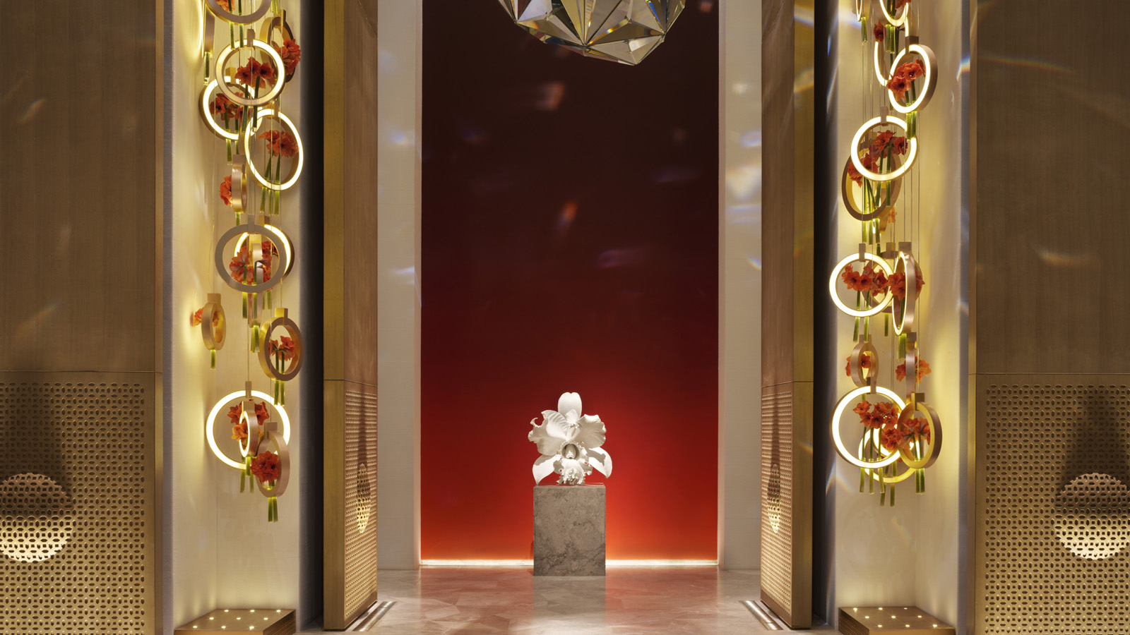 | December 4, 2018, Kuwait City, Kuwait  Ring in the New Year in Style at Four Seasons Hotel Kuwait at Burj Alshaya  https://publish.url/kuwait/hotel-news/2018/new-year.html
December 4, 2018, Kuwait City, Kuwait
إستقبلوا عامكم الجديد بالرفاهية والفخامة مع فندق فورسيزونز الكويت برج الشايع
https://publish.url/ar/kuwait/hotel-news/2018/new-year-2.html

PRESS CONTACTS

Aynur Mamedova
Director of Public Relations and Communications
Al Soor Street, Al Mirqab
Kuwait City, P.O. Box 735, Safat
Kuwait
aynur.mamedova@fourseasons.com

+965 2200 6000

