Four Seasons Resort Hualalai Named Best American Hotel by Hemispheres Magazine’s 2021 Readers’ Choice Awards

September 1, 2021, Hawaii, Hualalai, U.S.A.

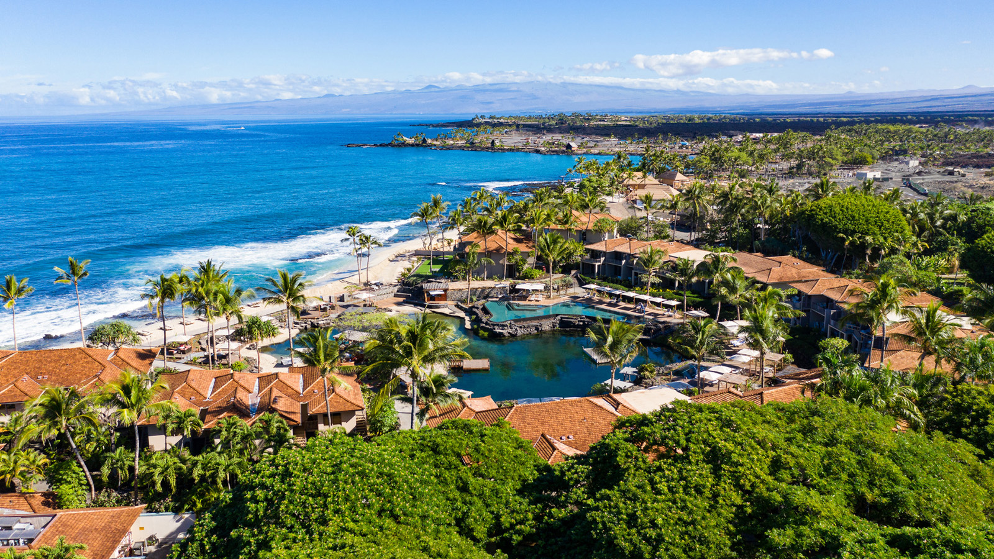
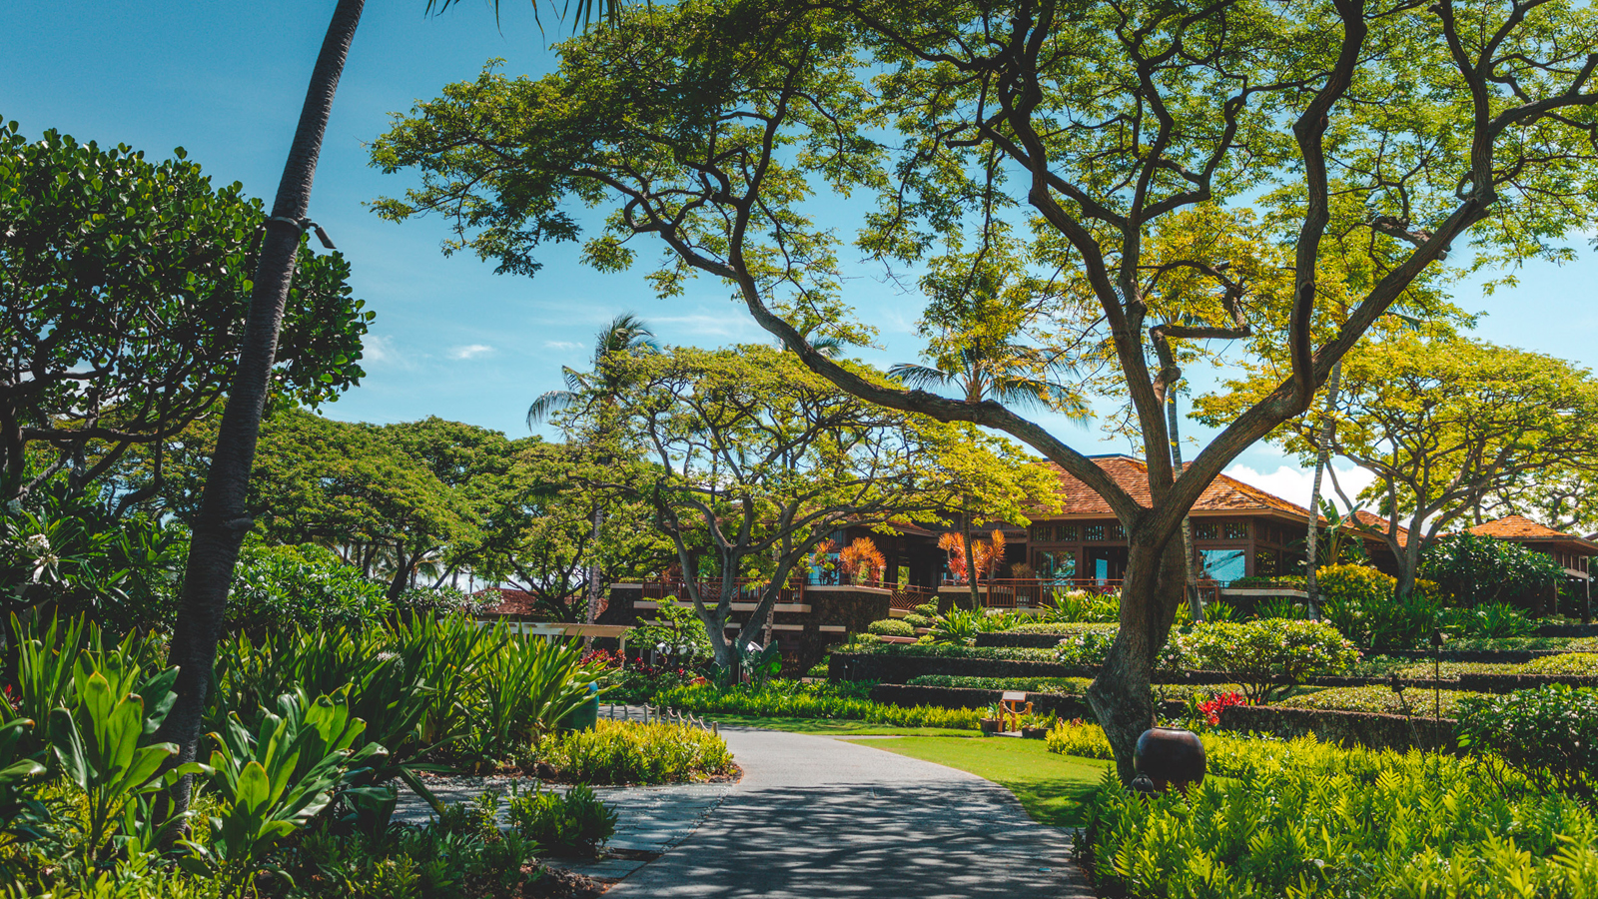 | 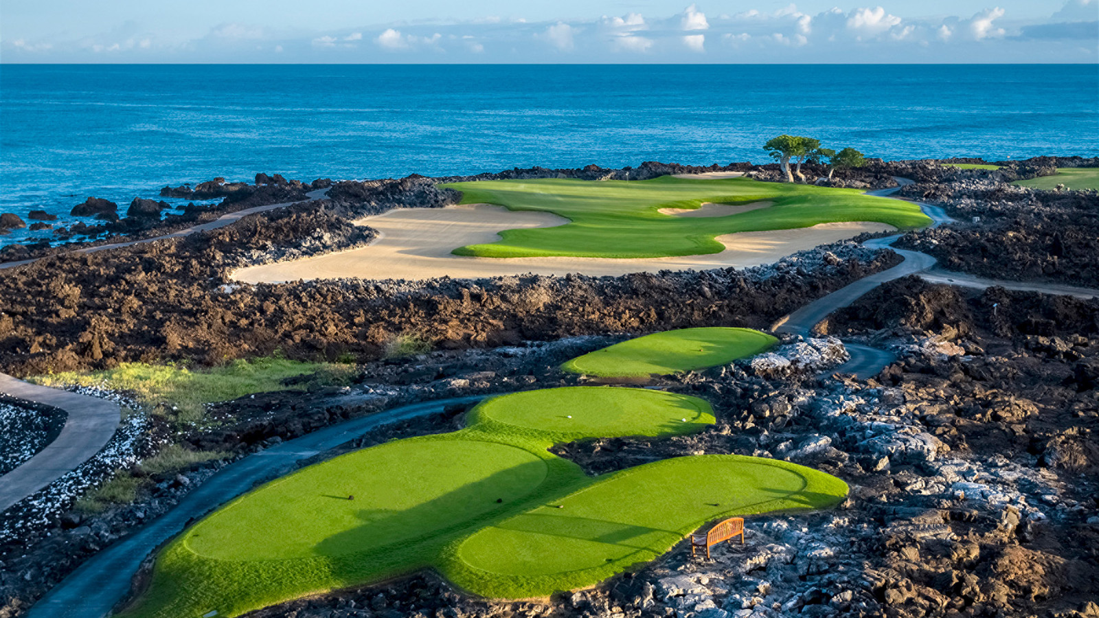 | 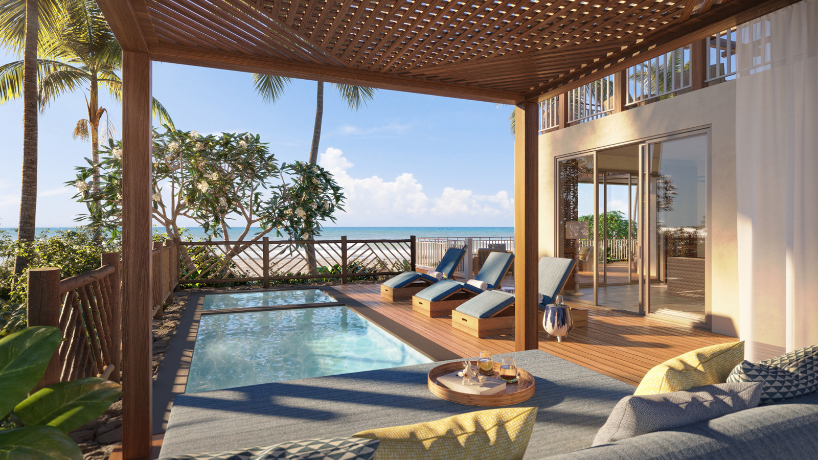
Four Seasons Resort Hualalai, the idyllic oceanfront oasis located on the pristine Kona-Kohala coast of the island of Hawaii, has been recognised as the Best American Hotel by Hemispheres’ 2021 Readers’ Choice Awards.
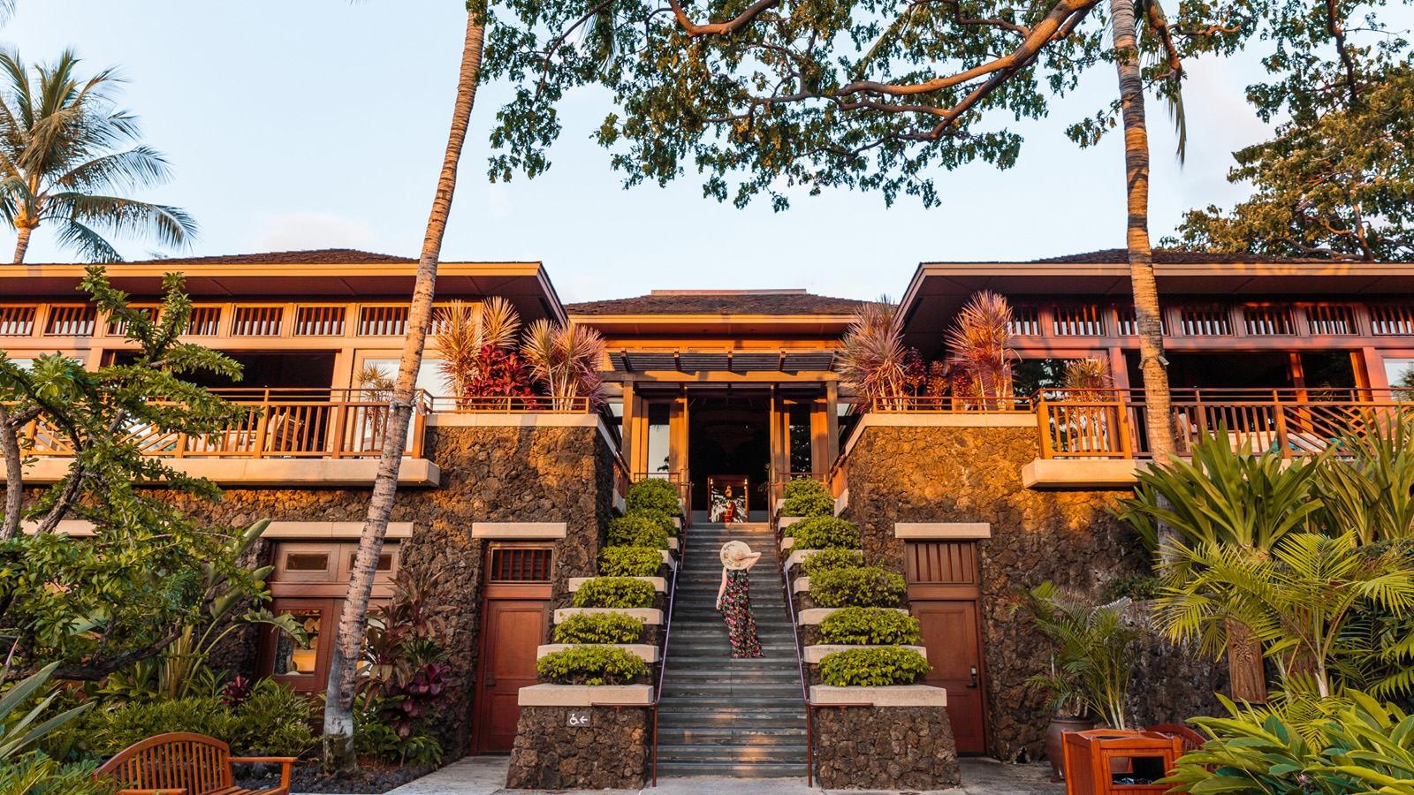
Voted directly by United Airlines passengers and Hemispheres readers, the magazine’s second-annual Readers’ Choice Awards showcases the best travel has to offer, spanning hotels, resorts, destinations and more. This year, the awards received thousands of submissions, and upon tally of the top three nominees in each category, readers then voted for their favourite. The award-winning on-board magazine for United Airlines, Hemispheres covers global culture, adventure, business, entertainment and sports. Winners are featured in the publication’s September issue, out now.
“On behalf of our Four Seasons Resort Hualalai ohana, we are honoured to be selected by our beloved guests for this prestigious award,” says Four Seasons Resort Hualalai General Manager Charlie Parker. “Our team is passionate about delivering genuine hospitality and a one-of-a-kind experience, and we’re thrilled this commitment continues to reflect via the guest experience.”
Recently, Four Seasons Resort Hualalai introduced an enhanced look following a USD 100+ million property-wide renovation, marking its first large-scale renovation since its debut. The transformation contemporises its aesthetic while holding onto the essence of Hualalai’s authentic Hawaiian architecture and design. This includes updates to all 249 guest rooms and suites; a new, elevated infinity pool and lounge deck at King’s Pond, Hualalai’s 1.8-million-gallon (6.8 million litre) swimmable aquarium; the introduction of the Kumu Kai Marine Center, home to six on-staff Marine Biologists who lead a curriculum of marine life experiences; a new gourmet poolside menu from Executive Chef Richard Polhemus; a transformation of the Hualalai Golf Course and the launch of the Hualalai Golf Hale, a 3,000 square-foot (280 square metre) instruction, practice and entertainment facility.
The final phase of Resort’s renovation will be introduced this month with newly reimagined floorplans for its top three villas, Hawaii Loa Presidential Villa, Makaloa Villa and Ho’onanea Villa. With design helmed by San Francisco-based BAMO, each villa is being expanded to add a second level, indoor-outdoor living space and private plunge pools, among other unique design elements, from slate floors to hardwood trim and beautiful local art pieces. Upon debut, Four Seasons Resort Hualalai will host the largest and most luxurious villa room product in all of Hawaii.
For reservations, book online or call 808 325 8000.

RELATED

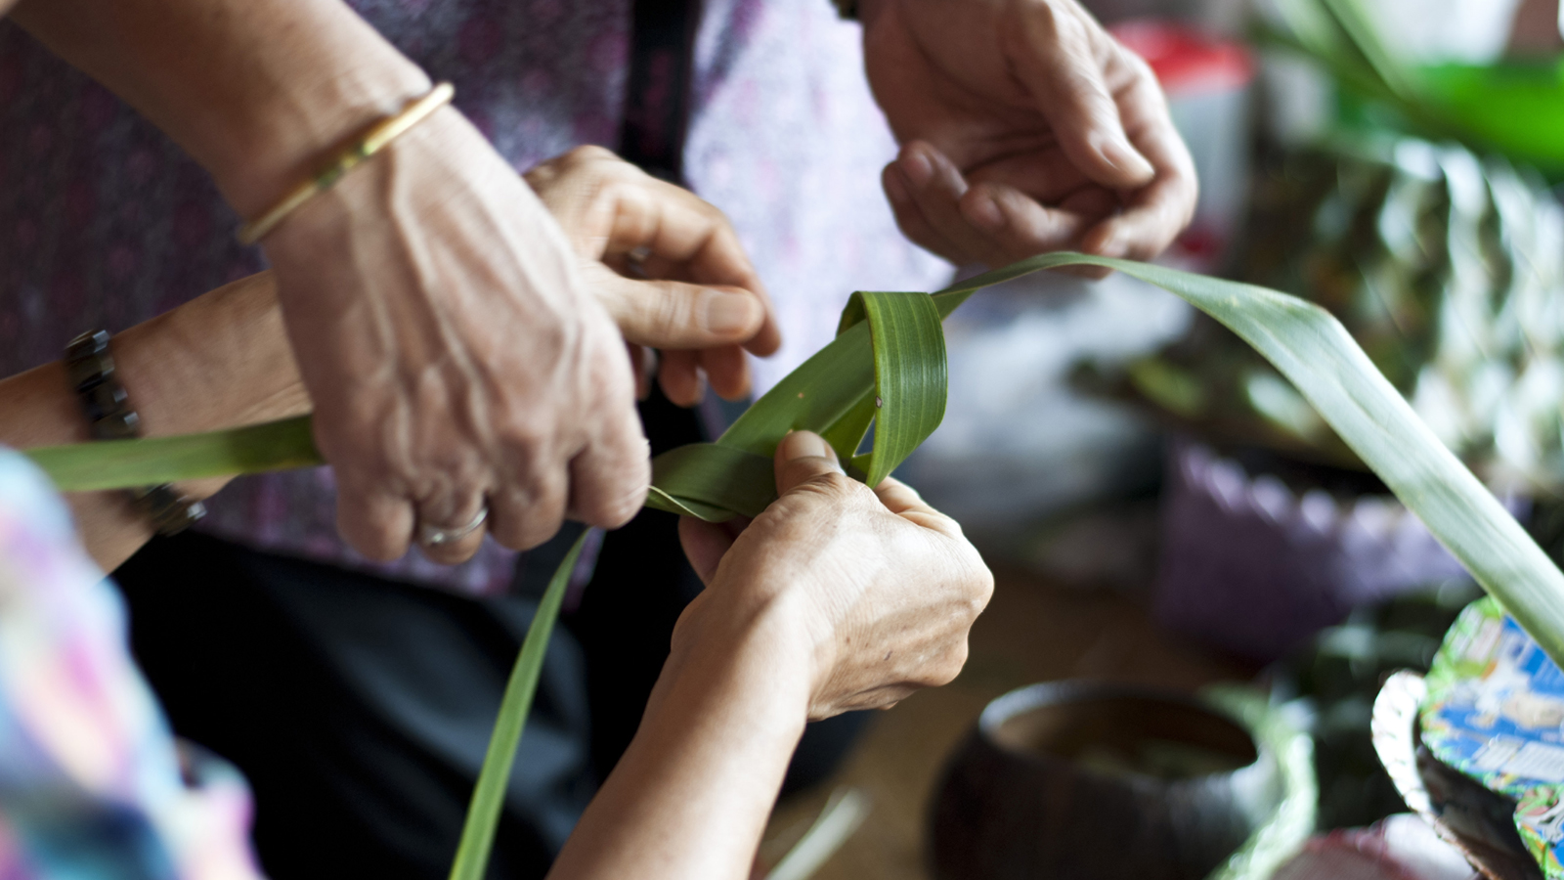 | August 17, 2021, Hawaii, Lanai, U.S.A.  Love Lanai Culture Workshops Bring History and Heritage to Life Through Complimentary Hoolauna Program at Four Seasons Resort Lanai  https://publish.url/lanai/hotel-news/2021/new-culture-workshops.html
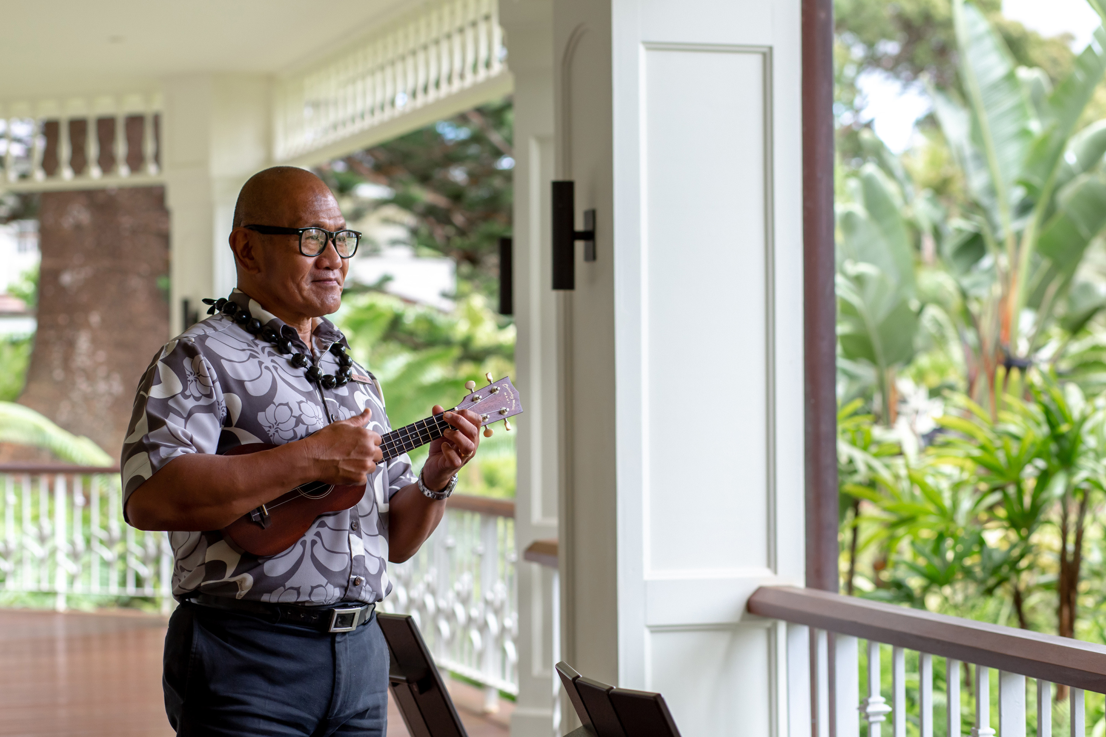 | August 17, 2021, Hawaii, Lanai (Sensei), U.S.A.  Sensei Lanai, A Four Seasons Resort Introduces New Cultural Tours and Activities  https://publish.url/sensei/hotel-news/2021/new-cultural-tours-and-activities.html

PRESS CONTACTS

Morgan Suzuki
Regional Director of Public Relations and Communications
72-100 Ka'upulehu Drive
Kailua Kona
USA
morgan.suzuki@fourseasons.com

1 808 557 5909

