Discover the Art of Mindfulness with Four Seasons

Celebrate the present with Four Seasons in Vietnam, Hong Kong and Chiang Mai
March 13, 2019, Hong Kong

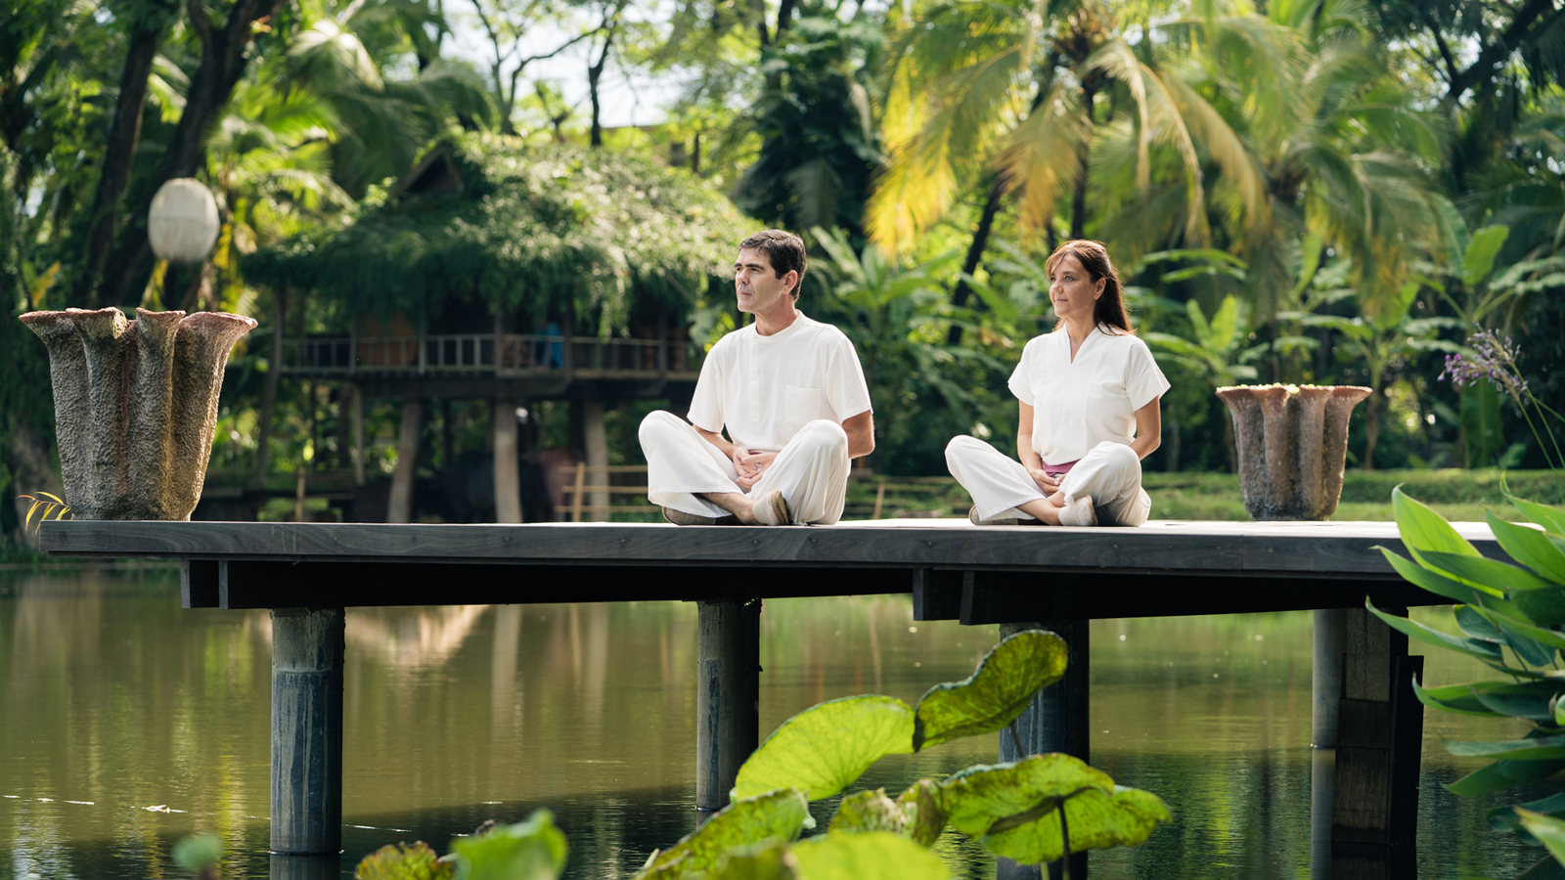
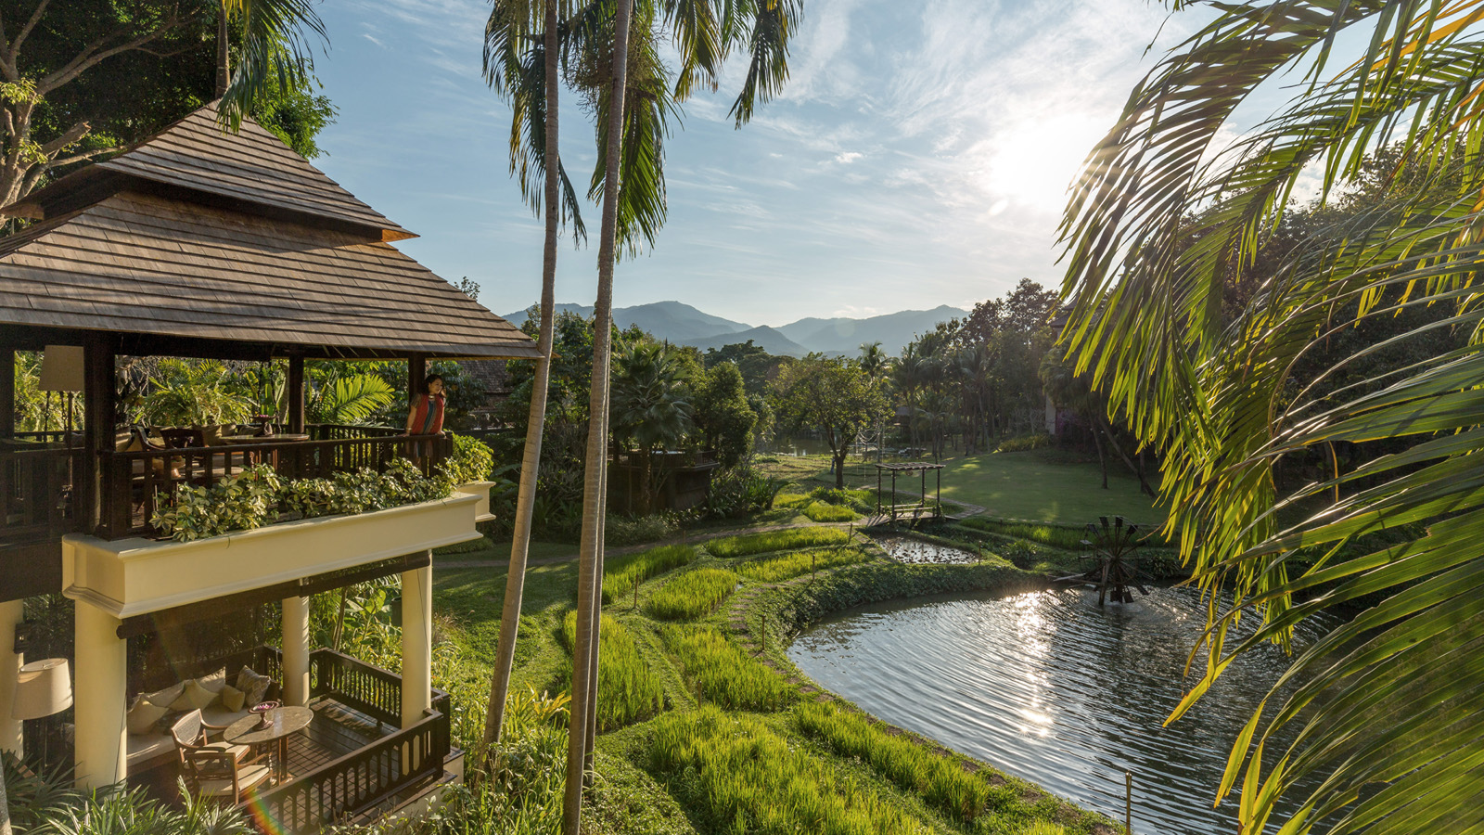 | 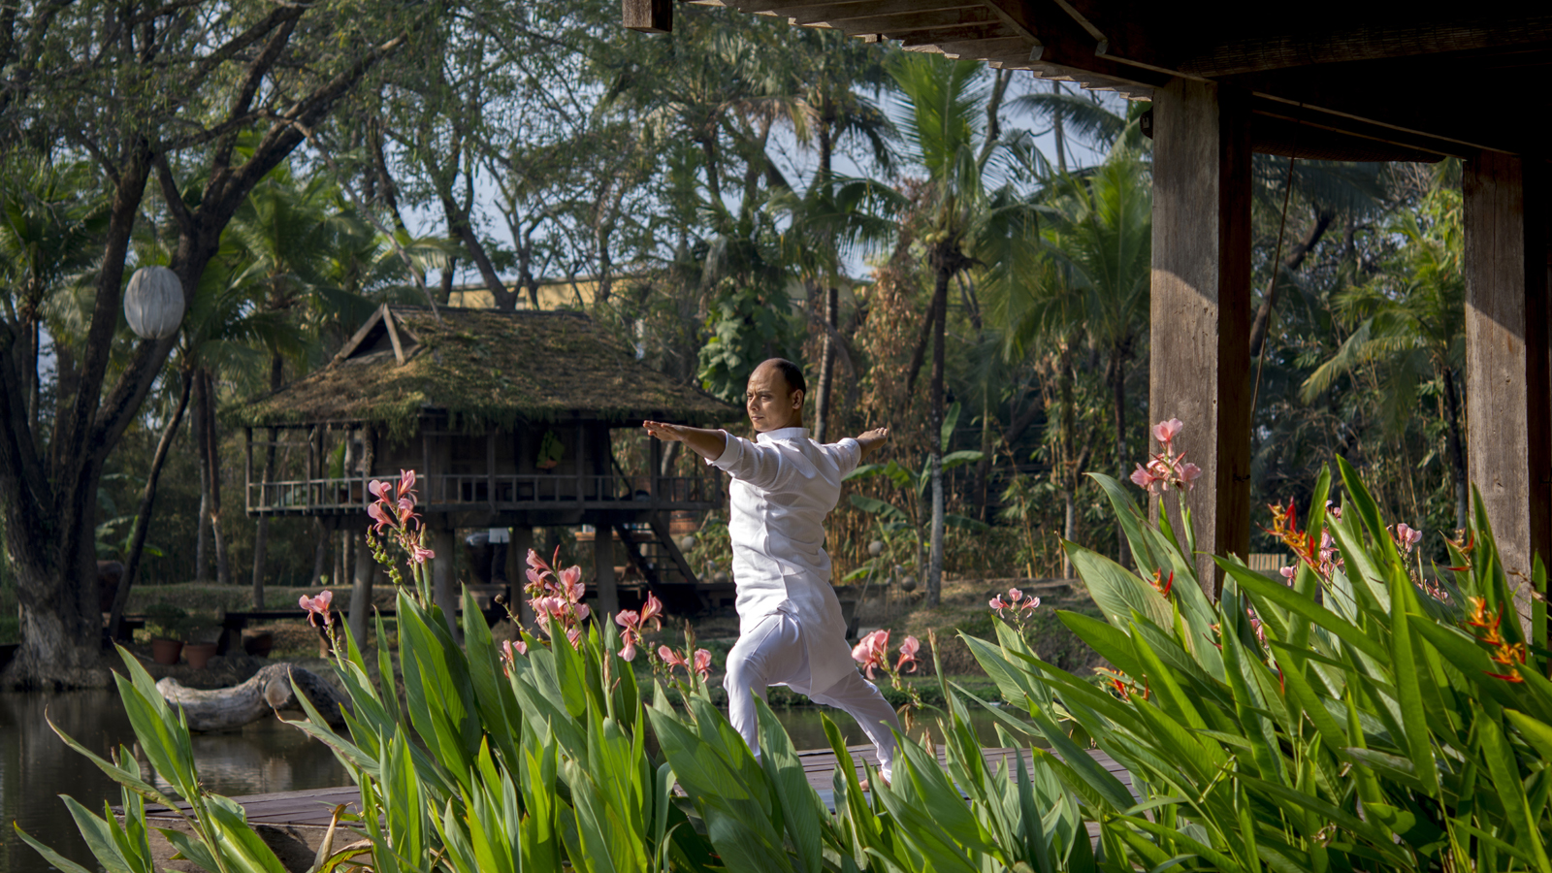 | 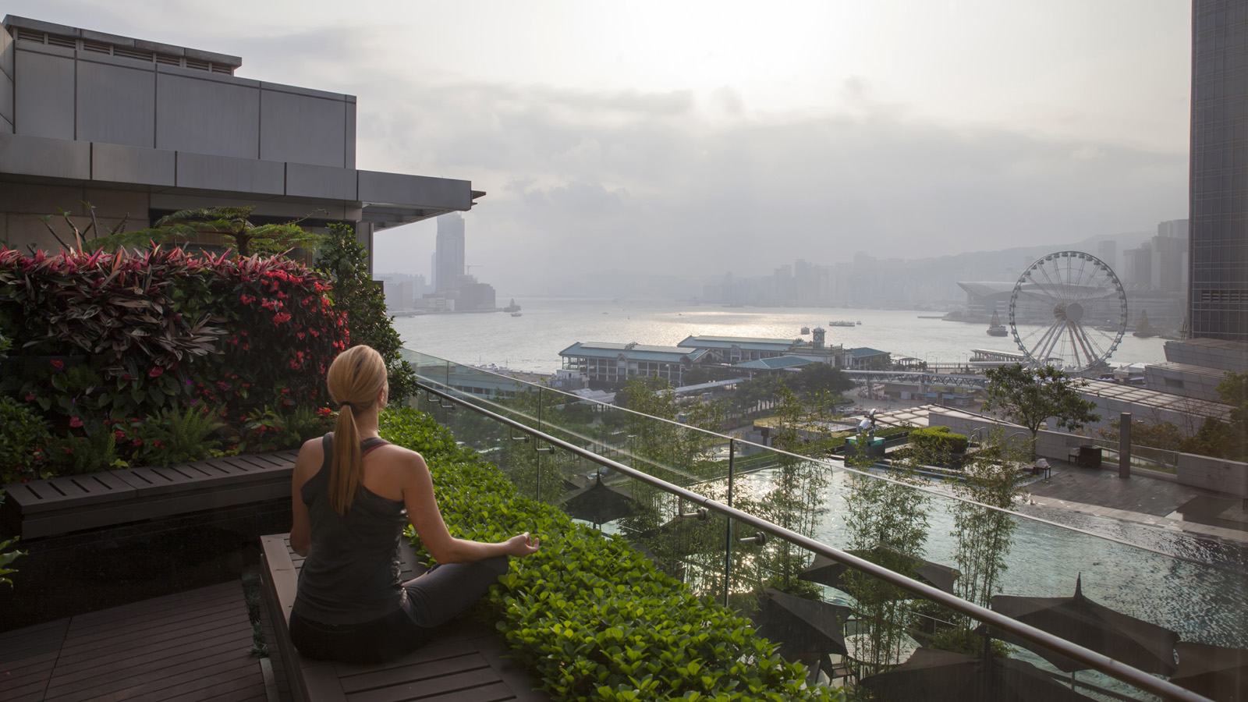
Awaken to the power of the present, with Four Seasons as guide, through three thoughtfully devised offers that open the gateway to Asia’s profound beauty and compelling consciousness.
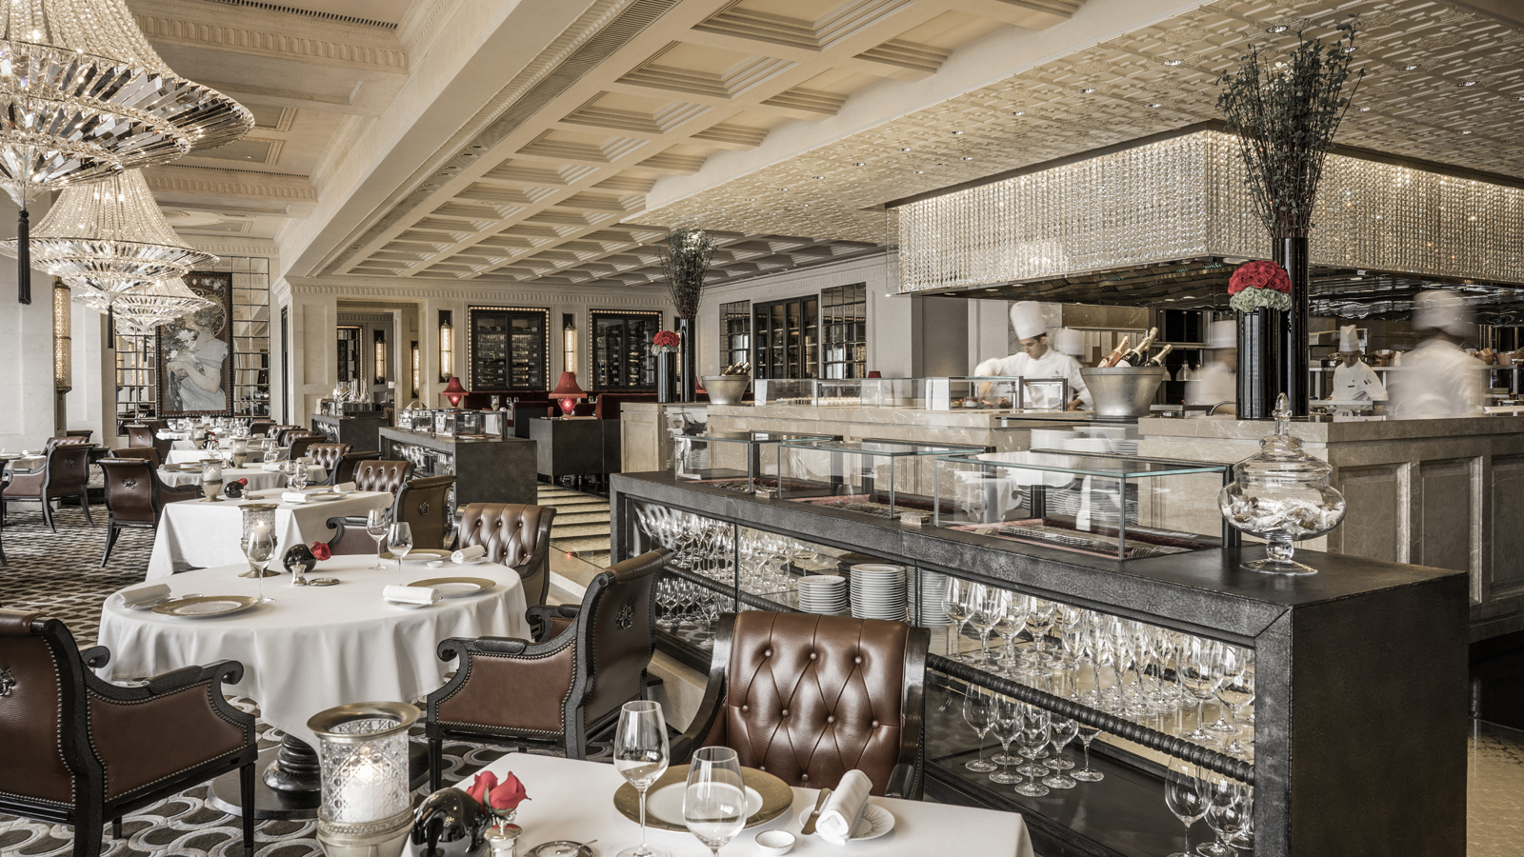 |  | 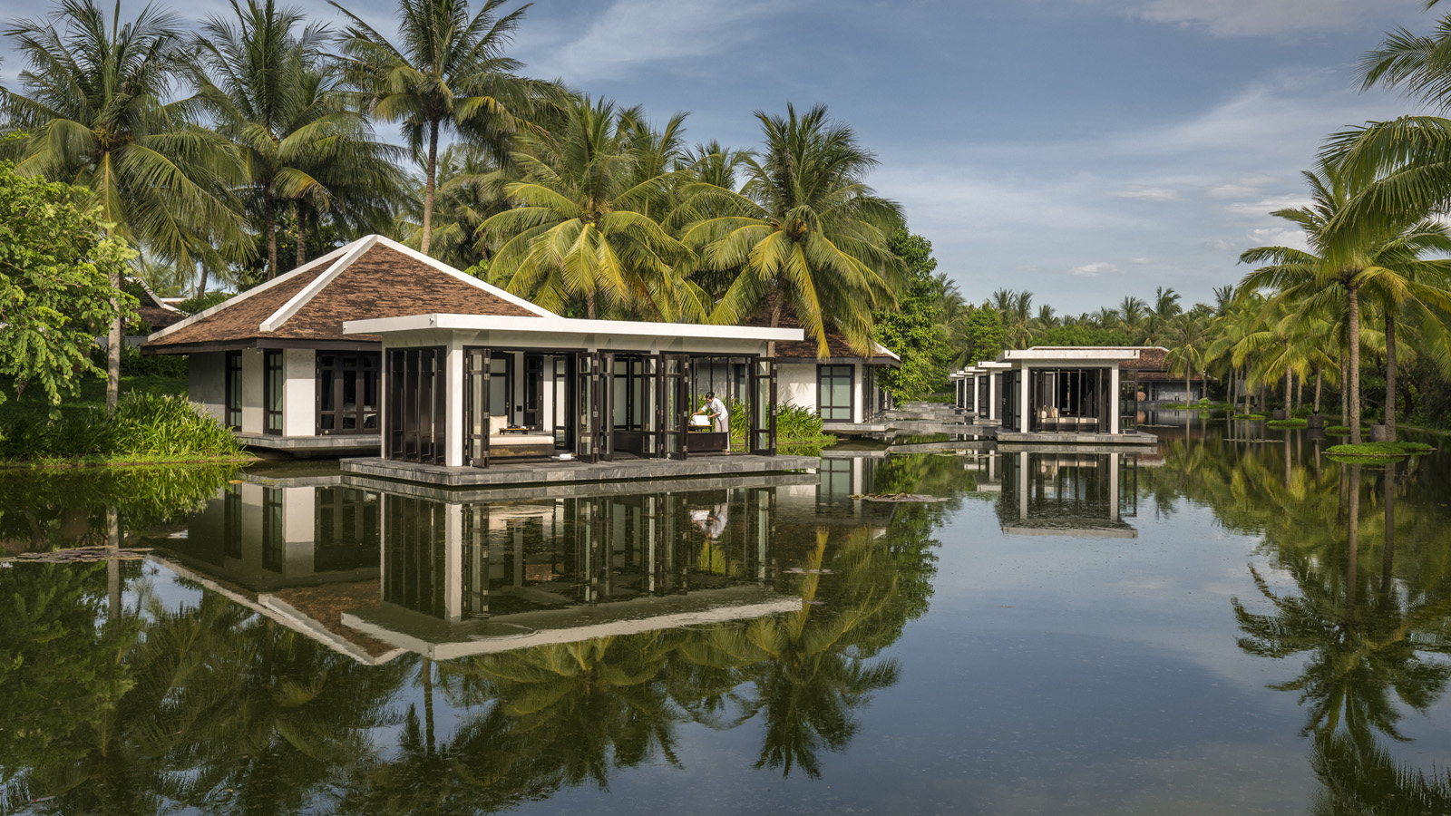
Mindfulness is an art anyone can master. Intensely personal, like the creation and appreciation of art, it’s an inward journey – taken solo with the intention of encountering oneness. There are many paths.
From Kundalini awakening in the mystical Mae Rim Valley and mindful Michelin-starred moments in high-energy Hong Kong, to sound-induced stillness in Vietnam’s central heartland: choose the place, people and program that resonates most.
Four Seasons Resort Chiang Mai, Thailand
Connect with the present in the breathtaking Mae Rim valley, one of the world’s most powerfully spiritual environments. Within the magical grounds of Four Seasons Resort Chiang Mai, where terraced rice fields flow into lush tropical gardens, wellbeing comes naturally. Against a backdrop of mighty mountains, bespoke experiences and expert instructors unite to deliver a rare sense of renewal.
“There is no better place to clear your mind and rediscover the age-old rhythms of nature – and yourself,” says Dheeraj Patwal, the Resort’s insightful resident yogi, who mastered meditation and yoga in the ashrams of India.
The Art of Mindfulness offer: Nourish mind, body and spirit with private pranayama and yoga classes, skilfully guided by Dheeraj. Awaken dormant energy and awareness with an enlightening Kundalini therapy at the Spa, followed by a personalised dinner to suit one’s own journey of wellbeing and turndown amenities for restorative sleep: a carefully crafted program for blissful rebalancing.
Four Seasons Hotel Hong Kong
On the edge of storied Victoria Harbour, the landmark Four Seasons Hotel Hong Kong is an urban powerhouse that encapsulates the city’s irresistible energy: where eight Michelin stars and a Zen-inspiring Spa help heighten awareness to the bounty and brilliance of living mindfully in every situation.
"Spa is everywhere and can be everything. Relax," shares Shoshana Weinberg, Senior Director of Spa, rebuking the idea that appreciation of the present moment can only take place in peaceful surrounds.
The Art of Mindfulnesshttps://www.fourseasons.com/hongkong/offers/art-of-mindfulness/ offer: Rouse the body with a leisurely breakfast. Journey deep within during a half-day Spa immersion – an Energy Crystal Healing treatment packed with the therapeutic powers of Reiki and sound therapy; meditative tea ceremony; and scent-stimulating healing floral bath. Then mindfully taste every 3-star Michelin mouthful during a nutritionist-devised wellness dinner at French fine dining restaurant Caprice.
Four Seasons Resort The Nam Hai, Hoi An, Vietnam
A seaside sanctuary, Four Seasons Resort The Nam Hai is firmly establishing itself as one of Asia’s leading centres of mindfulness and connection: an inward journey that begins with an in-room Interbeing program and continues through a heart-expanding line-up at The Heart of the Earth Spa: the world’s Best Emotional Recovery Space and Top 5 Spas in the World (Condé Nast Traveller Spa Awards 2019). Resident Singing Bowl Artist, Oanh Ngo, is the mindful master of the Spa’s 8-octave set of crystal singing bowls that is able to palpably alter the vibration of the Resort.
The Art of Mindfulness offer: Attune to self and surrounds during private yoga and meditation classes in the Thanh Tĩnh Yoga Pavilion: “peaceful” in name and nature. Mindfully prepare a healthy Vietnamese meal during a Cooking Academy session. Then align with internal rhythm with nature’s healing vibrations during an exclusive Nam Hai Earth Song ritual, comprising cleansing smoke, sound bath, scrub, gem-tipped tuning fork, massage and more.

RELATED

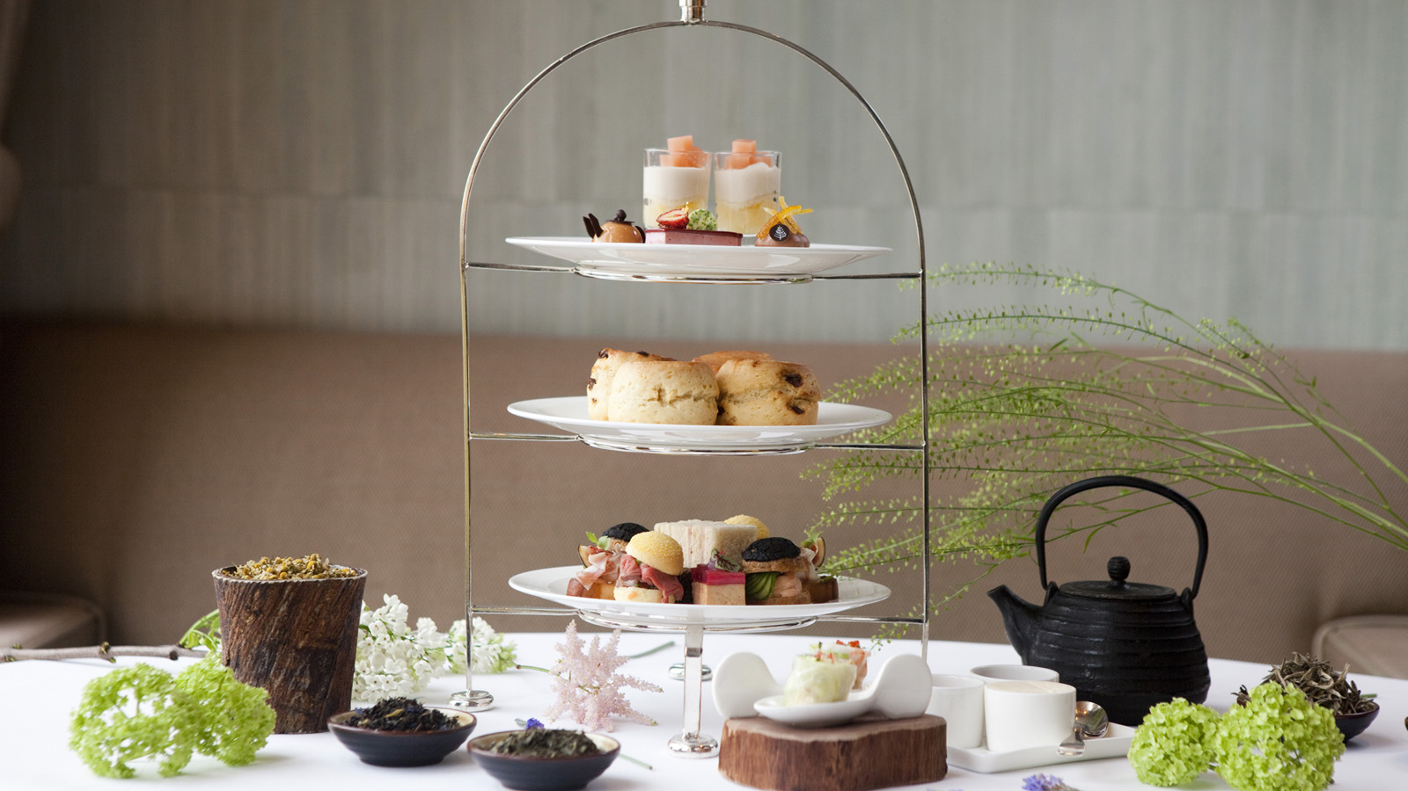 | March 8, 2019, Hong Kong, China  香港四季酒店迎接藝壇盛事  https://publish.url/zh_hant/hongkong/hotel-news/2019/art-themed-promotions-2.html
March 8, 2019, Hong Kong, China
香港四季酒店迎接艺坛盛事
https://publish.url/zh/hongkong/hotel-news/2019/art-themed-promotions-3.html

PRESS CONTACTS

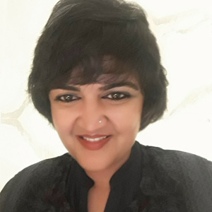 | Karuna Amarnath  Director of Public Relations and Communications  3/F, 159 Rajadamri Road  Bangkok  Thailand  karuna.amarnath@fourseasons.com  +66 2207 8916
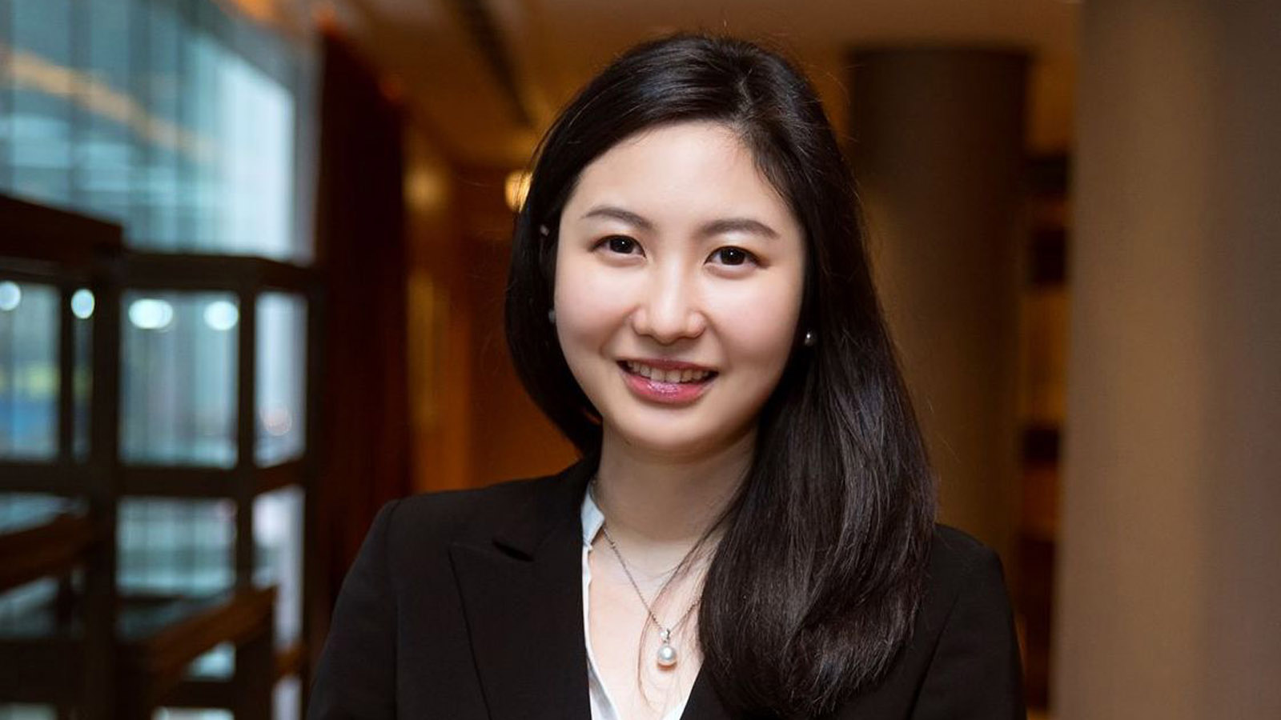 | Priscilla Chan  Public Relations Manager  8 Finance Street, Central,  Hong Kong  China  priscilla.chan@fourseasons.com  (852) 3196 8307
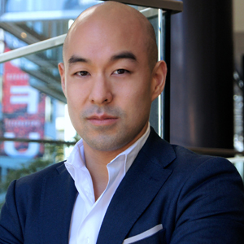 | Shingo Kido  Director of Public Relations and Communications  Block Ha My Dong B, Dien Duong Ward  Dien Ban Town  Vietnam  shingo.kido@fourseasons.com  +84 9 0570 7665

