From Four Seasons Resort Rancho Encantado Santa Fe, With Love

January 27, 2021, Santa Fe, U.S.A.

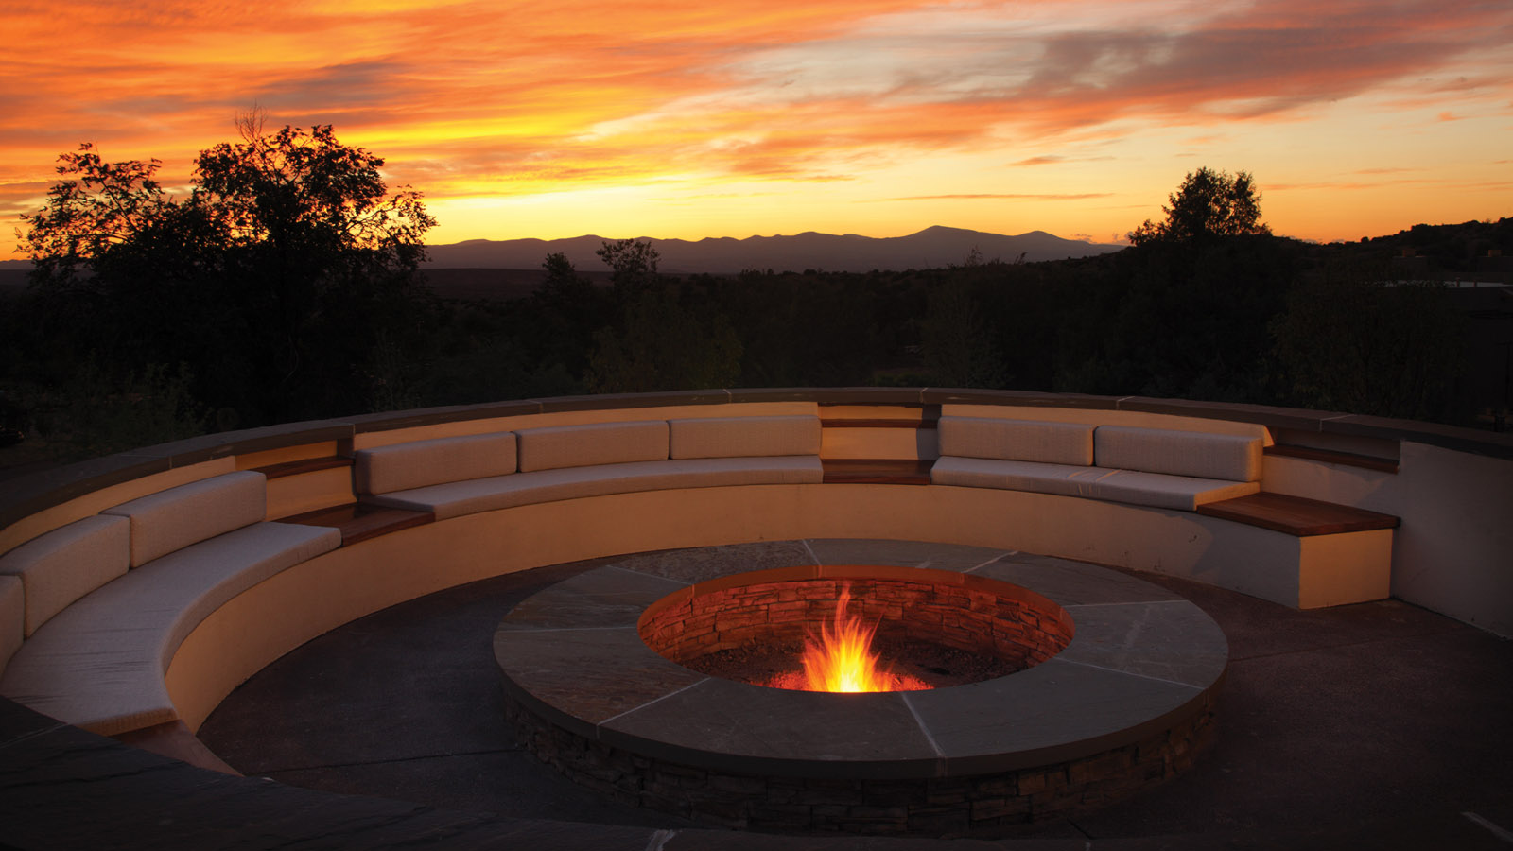
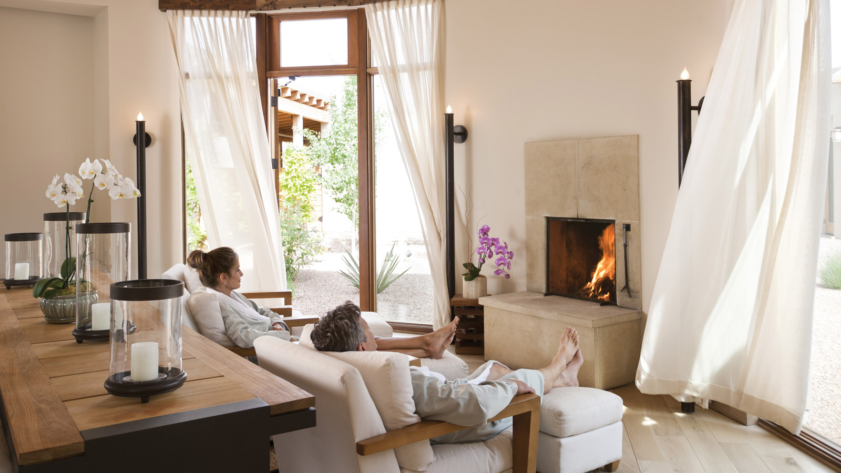 | 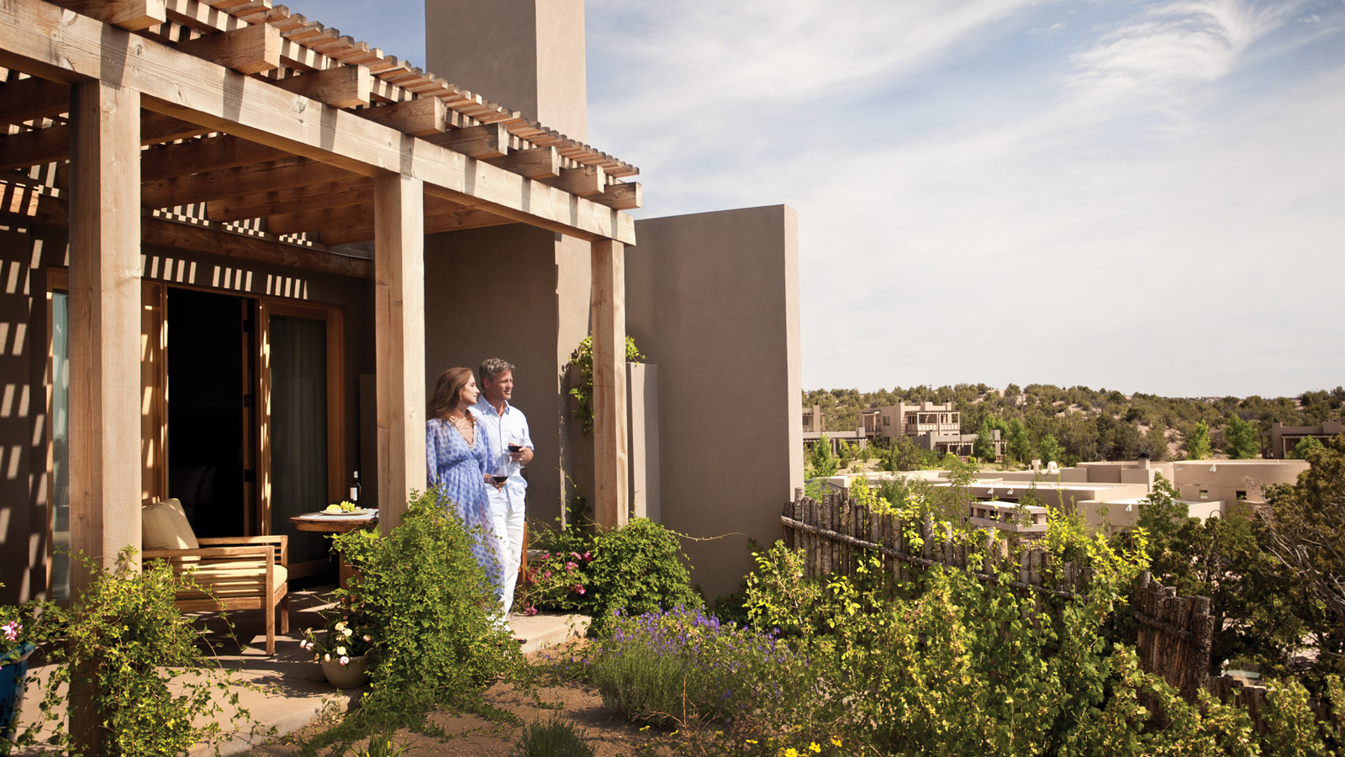
This February 2021, Four Seasons Resort Rancho Encantado invites guests to celebrate the art of romance with a series of new Valentine’s offerings - from culinary specials to a luxurious couple's spa experience, plus a getaway package for two.
 | 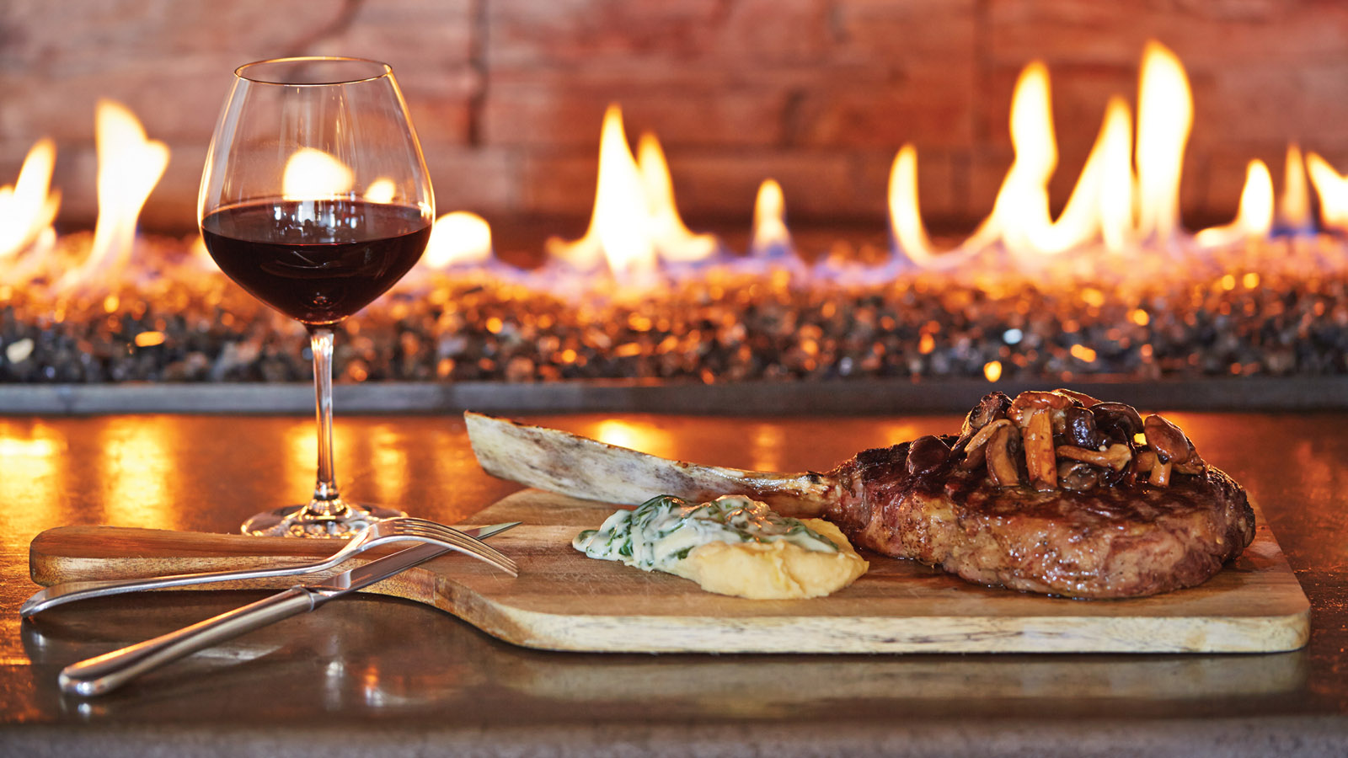 | 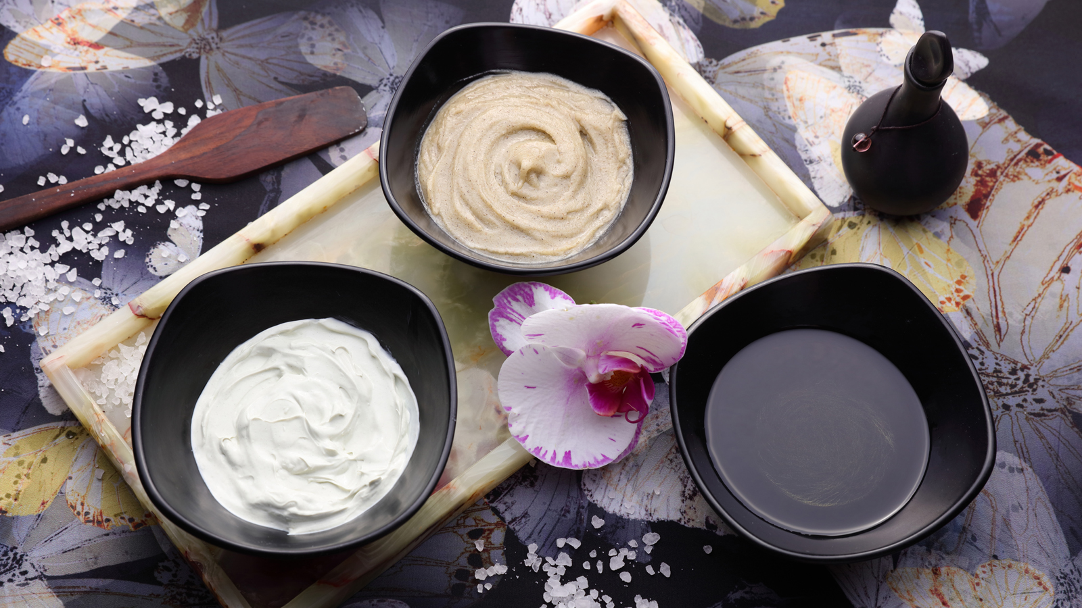
Couples “Ultimate Romance” Spa Retreat
Valentine’s Day is no longer about the cliche box of chocolates or flowers. It’s all about having an unforgettable experience. This year, think outside the box and inside the spa — and give a special someone the gift of the ultimate relaxation experience with a romantic spa day retreat for two at The Spa at Four Seasons Resort Rancho Encantado.
Take some time to unwind, reconnect and get away from it all with a series of indulgent spa experiences to enjoy together. Begin with a rejuvenating 60-minute Chocolate Truffle Body Wrap treatment, followed by a tranquil, restorative 80-minute Head-to-Toe Massage. Complete the experience with a 60-minute Relaxation Session in a private spa courtyard with a hot tub and sauna, while enjoying Whispering Angel ros&eacute; and chocolate covered strawberries. Plus, receive a special Spa gift bag to take home.
- Price for two people: USD 950
- Package is available entire month of February 2021
- To book a reservation, call The Spa at: 505 946 5890
Terra’s “Be Our Valentine” Dinner
Whether dining fireside at sunset on the restaurant’s expansive terrace, in the newly renovated courtyard lounge, or enjoying a private experience in one of the Resort’s spacious casitas, the talented culinary team at Terra has curated a multi-course gourmet Valentine’s menu featuring a selection of delicious dishes to please every palate, including a choice of appetisers, entrees and sides, and a “Cupid’s Arrow” dessert that will leave guests surprised and delighted. Plus, enjoy a complimentary glass of Beau Joie Champagne for both guests.
For Locals: Valentine’s Dinner To-Go
Don’t feel like dining out? Celebrate Valentine’s Day weekend in the comfort of home with Terra restaurant’s new Valentine’s Dinner To-Go.
This holiday, let Terra do all the work and then sit back, relax and enjoy a memorable meal. The special Valentine’s To-Go menu offers a wide variety of dishes to choose from to create a perfect feast together, complete with a shareable chocolate-covered strawberry “bouquet” dessert to end the evening.
- Valentine’s Dinner Menus will be available all weekend, from February 12 to 14, 2021
- To book a reservation or order takeout, call Terra at 505 946 5800
Romantic Getaway Package
Escape to Four Seasons Rancho Encantado to enjoy an intimate retreat for two. Get cosy in a romantic casita, complete with a private patio, indoor/outdoor wood-burning fireplaces, a spa-inspired bathroom with deep soaking tub, and personalised services and amenities to enhance the stay.
This special offer includes:
- Romantic welcome amenity
- Upgrade to next highest accommodation category
- Guaranteed late check-out until 2:00 pm
- Booking assistance from the Resort’s Romance Concierge
- Special savings on select services in the spa
- Complimentary valet parking
To make a reservation, book online.

RELATED

September 10, 2020, Santa Fe, U.S.A.
Four Seasons Resort Rancho Encantado Santa Fe Launches New “Back-to-School” Program Offering a Bespoke Remote Learning Vacation Experience
https://publish.url/santafe/hotel-news/2020/schoolcations.html

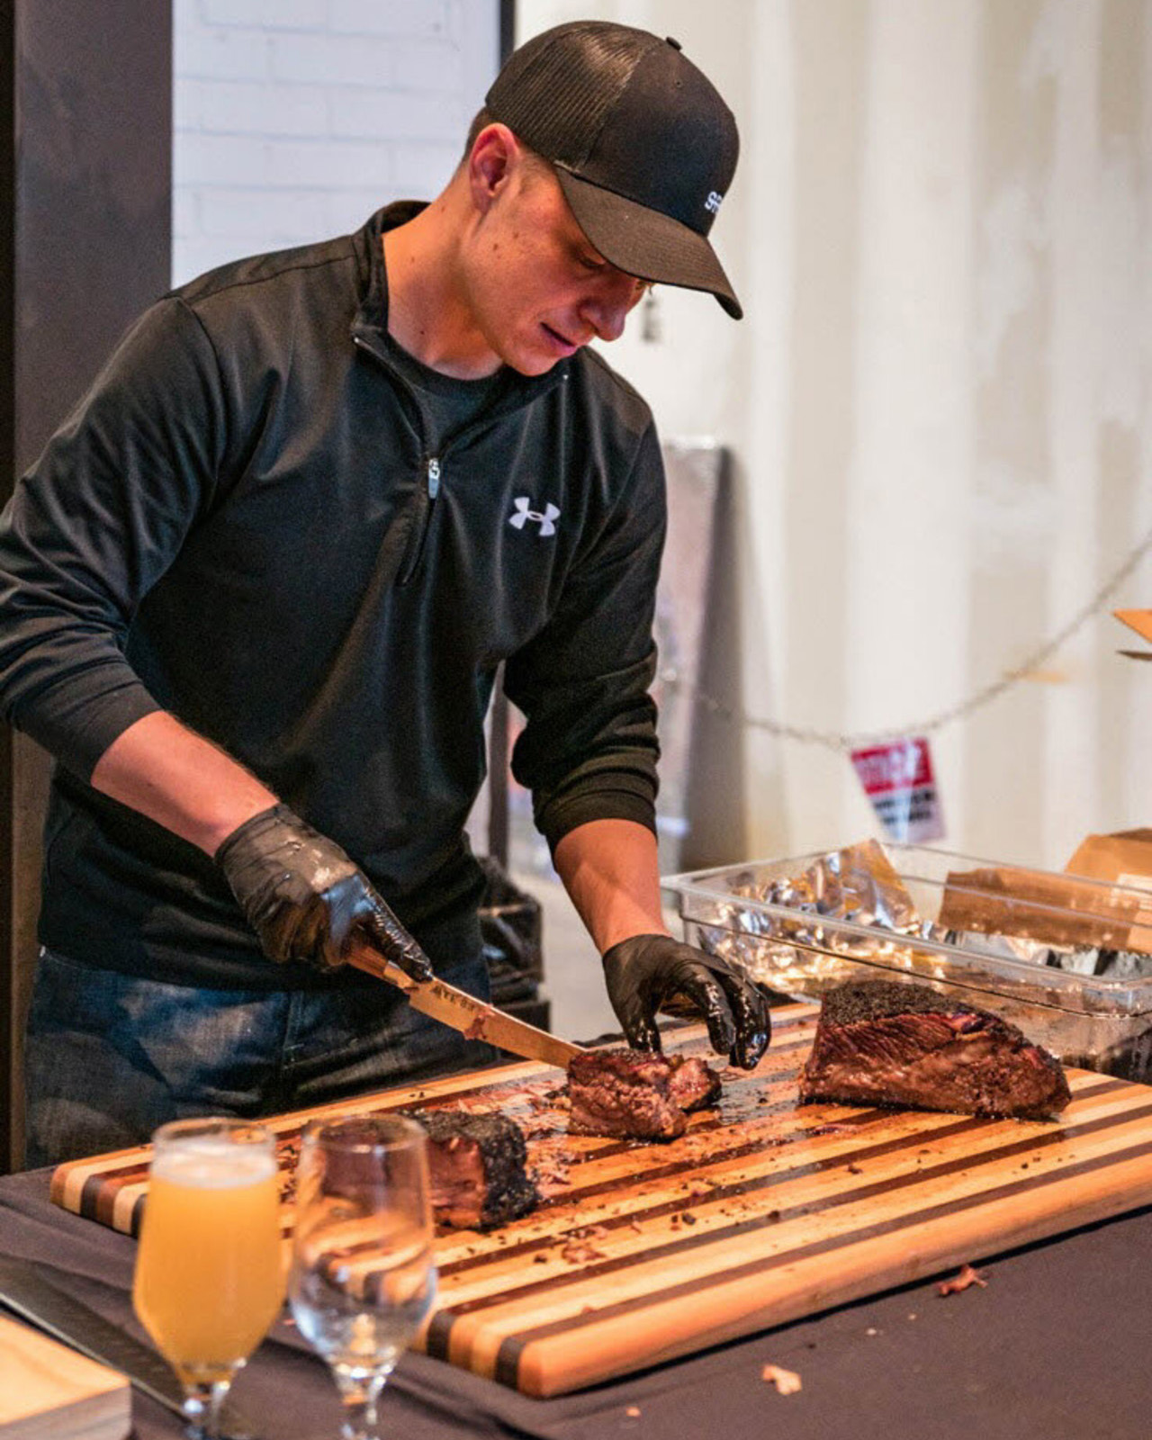 | August 31, 2020, Santa Fe, U.S.A.  Celebrate Santa Fe Wine & Chile Festival with Two Original “Fiesta” Dinner Events at Four Seasons Resort Rancho Encantado  https://publish.url/santafe/hotel-news/2020/santa-fe-wine-and-chile-festival-dinners.html

PRESS CONTACTS

Michelle Duncan
Director of Public Relations
198 State Road 592
Santa Fe
USA
michelle.duncan@fourseasons.com

+1 646 229 2797

