Love is in the Air at Four Seasons Hotel Tokyo at Otemachi

February and March bring a season of sky-high indulgences for couples
February 3, 2023, Tokyo, Japan

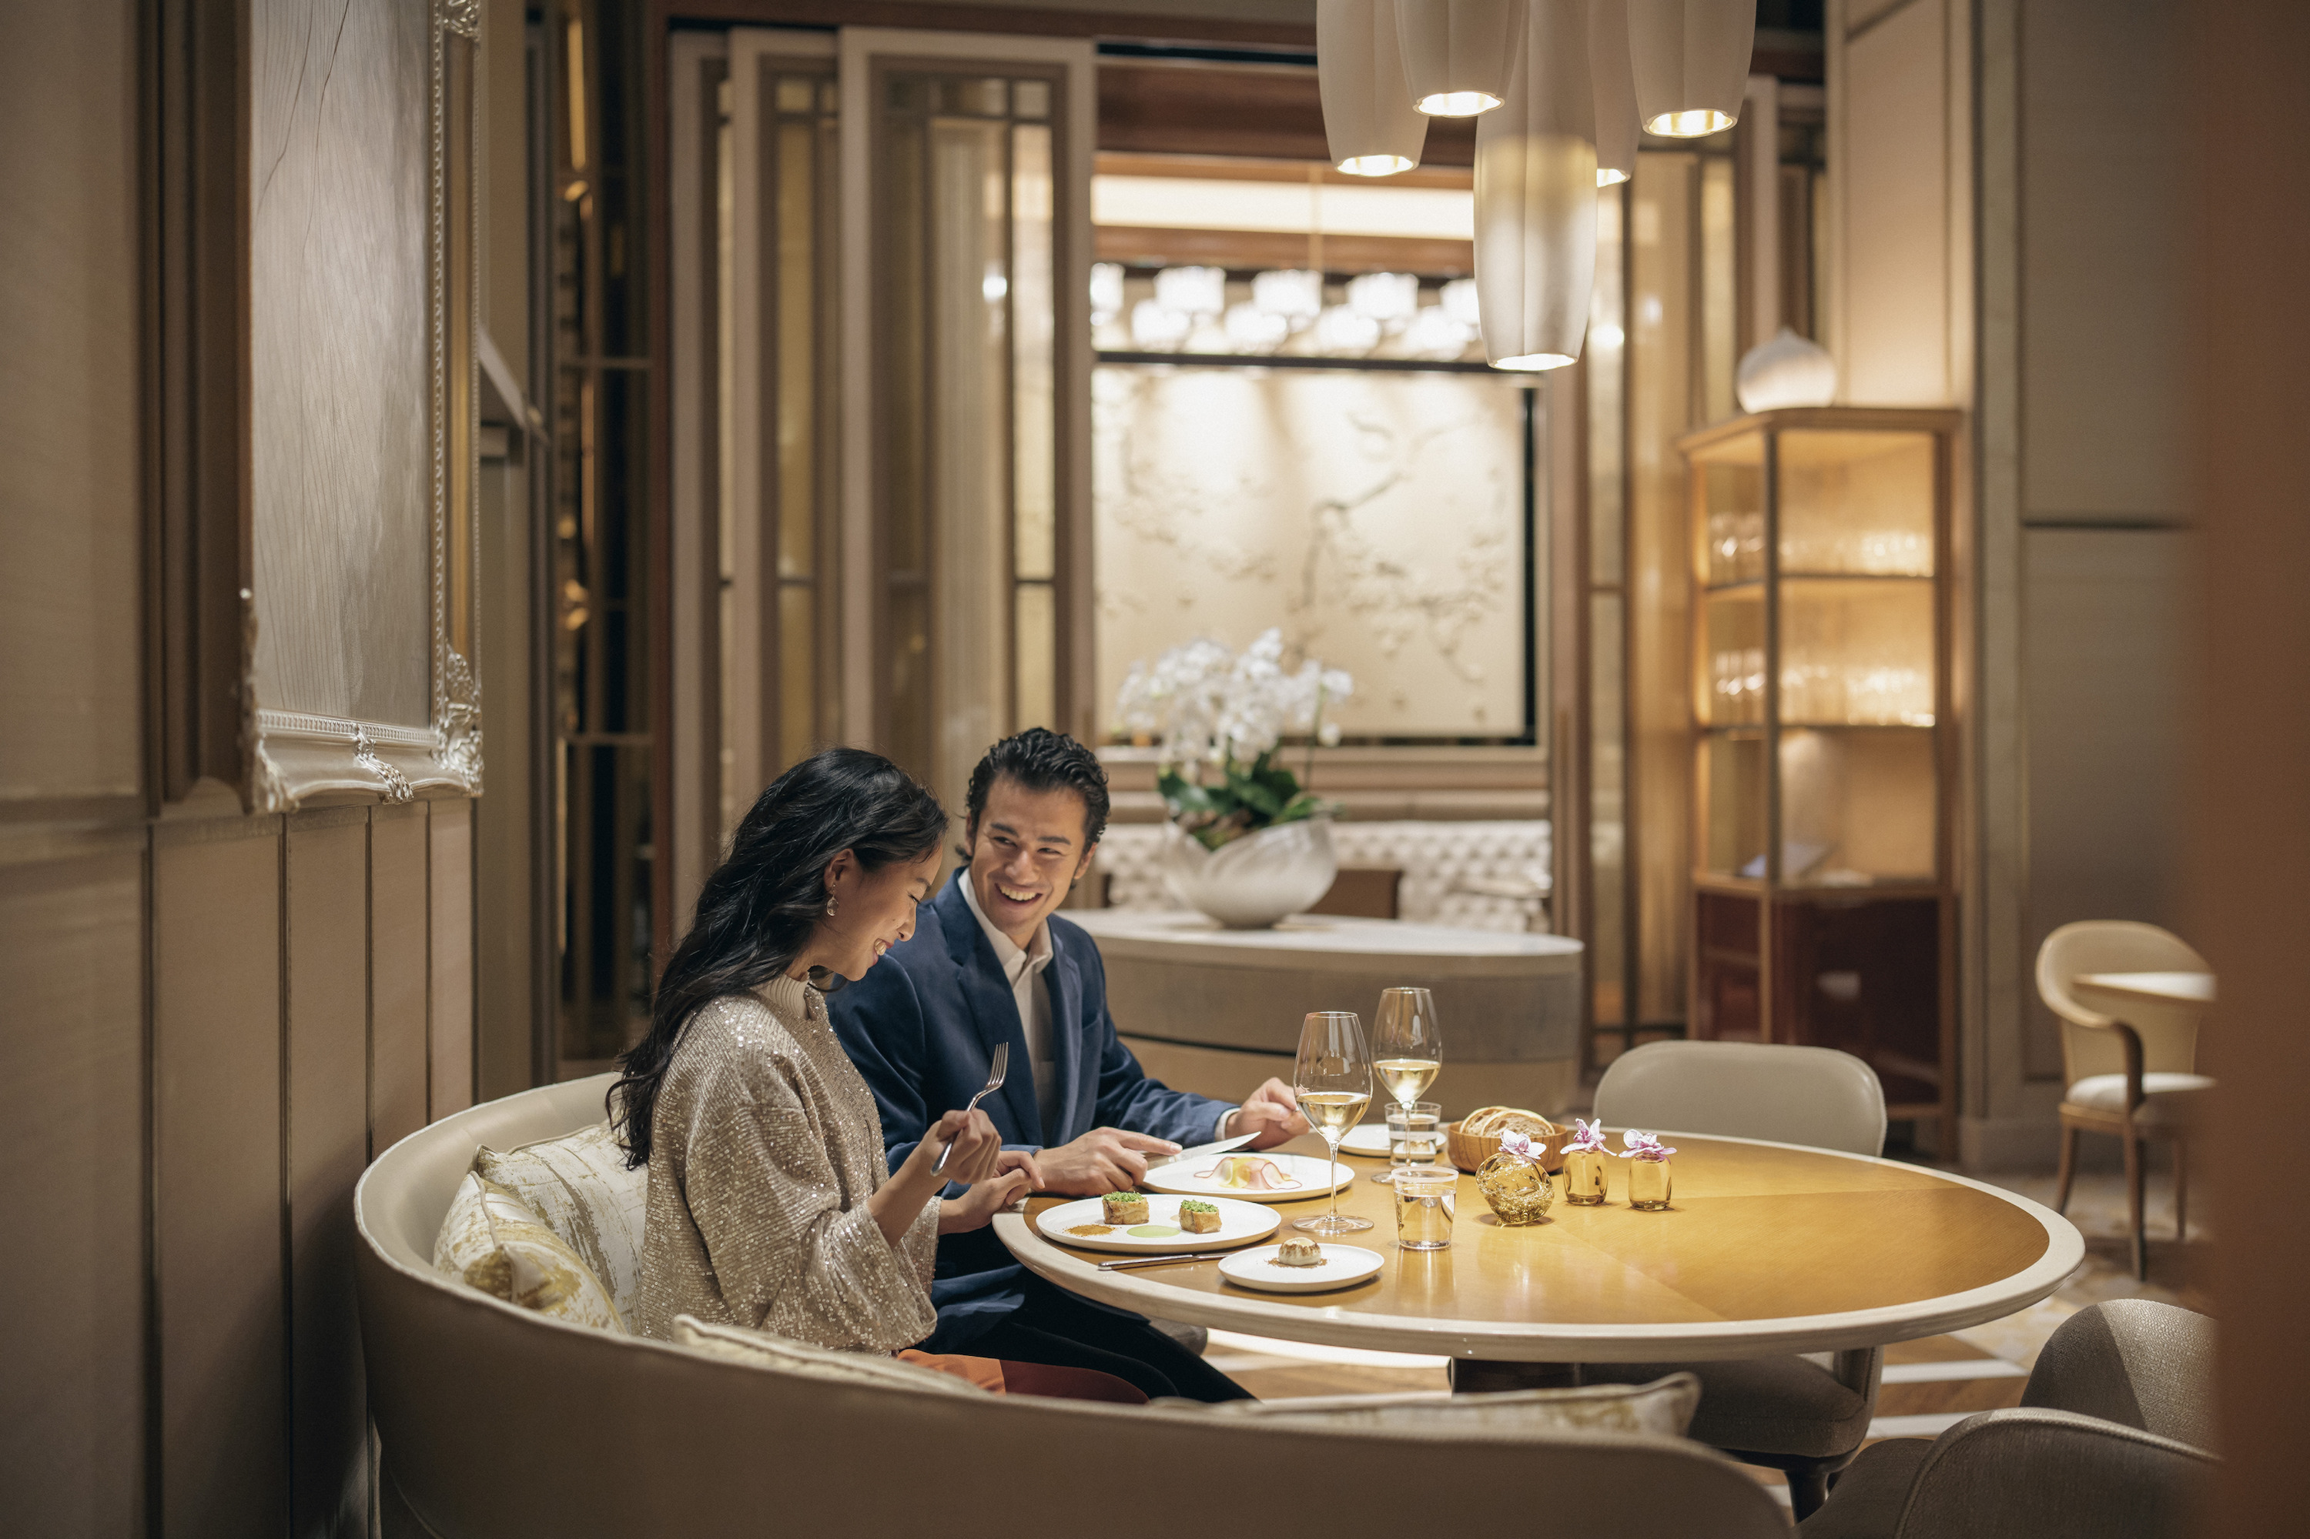
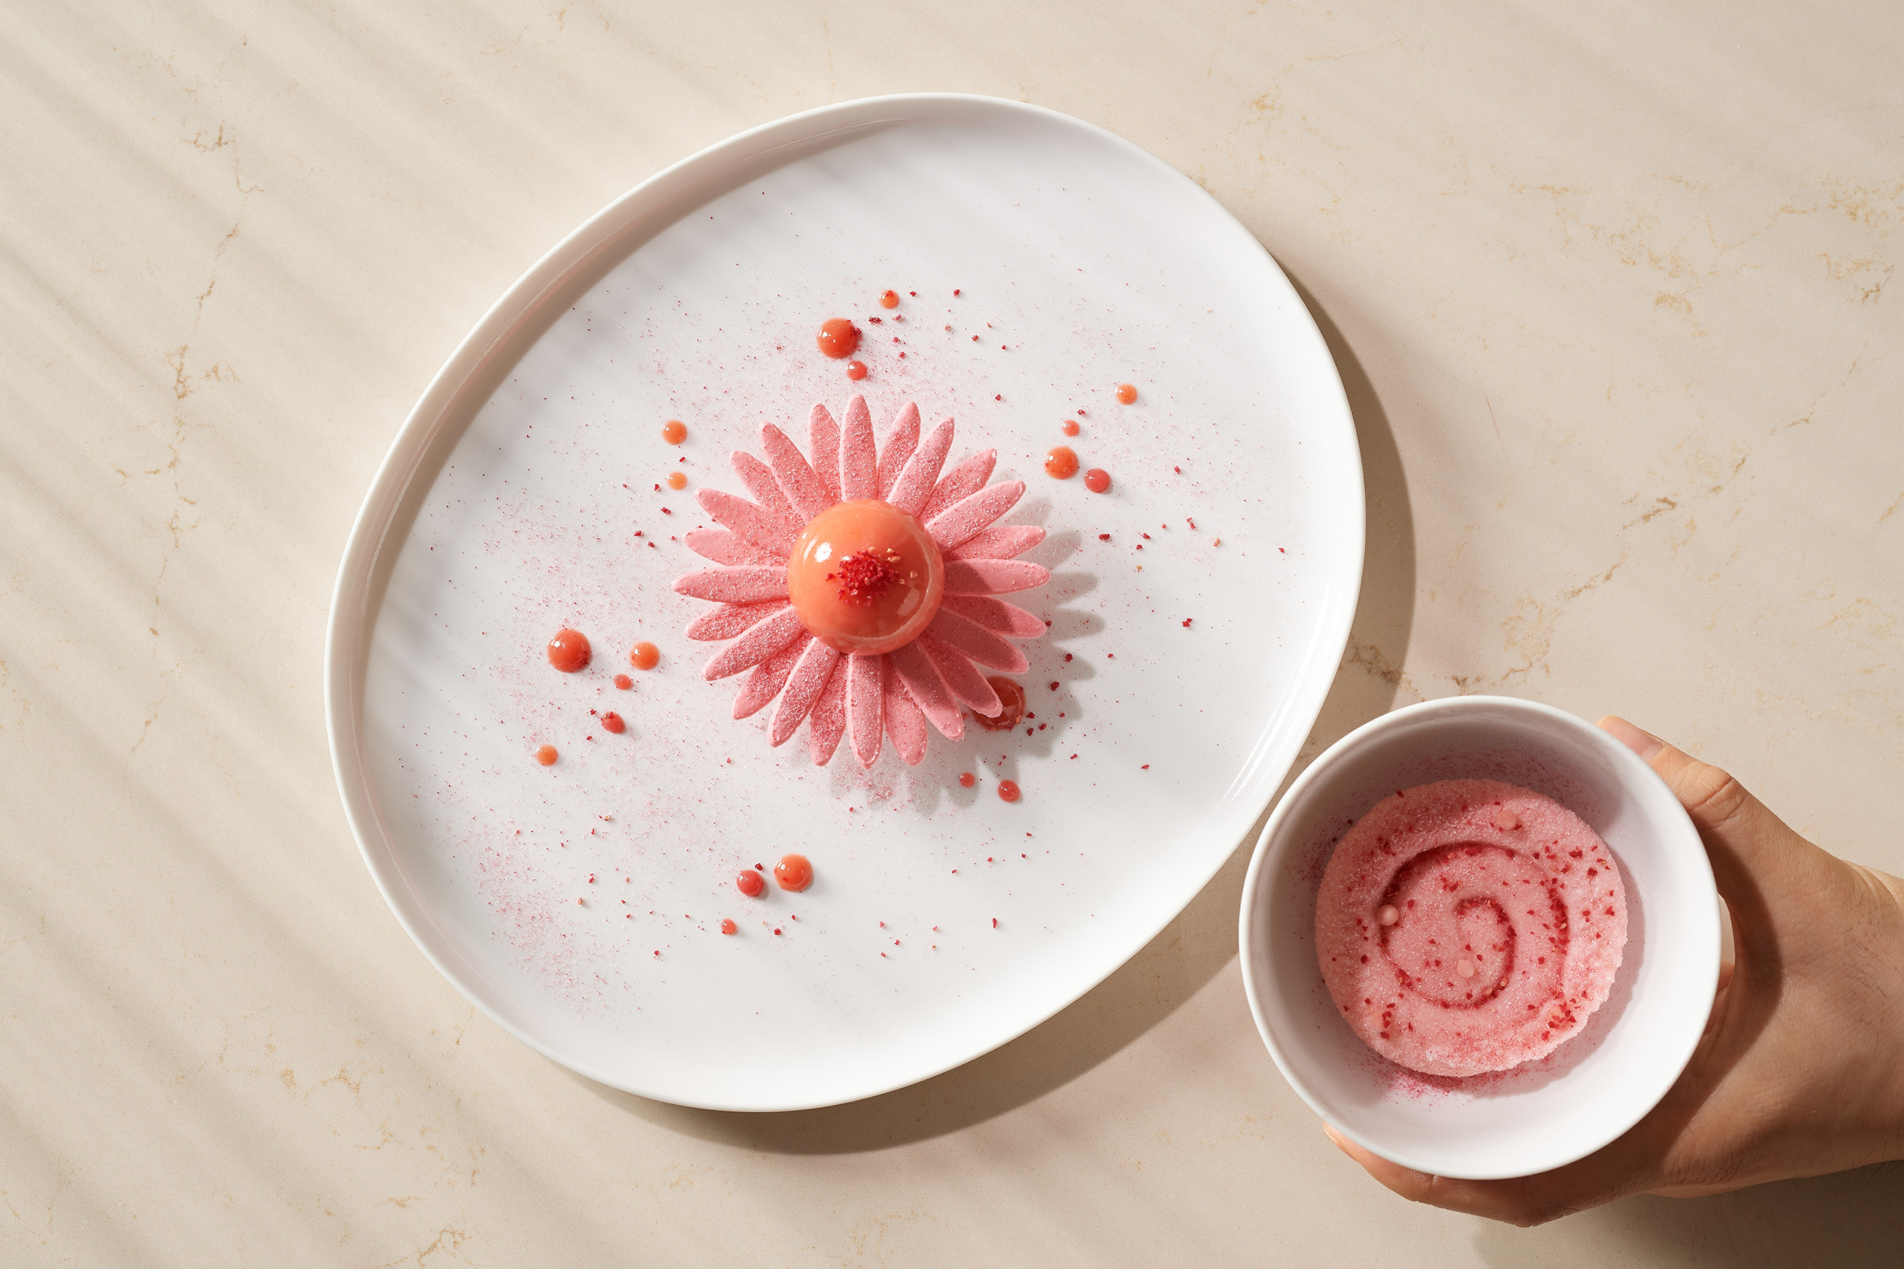 | 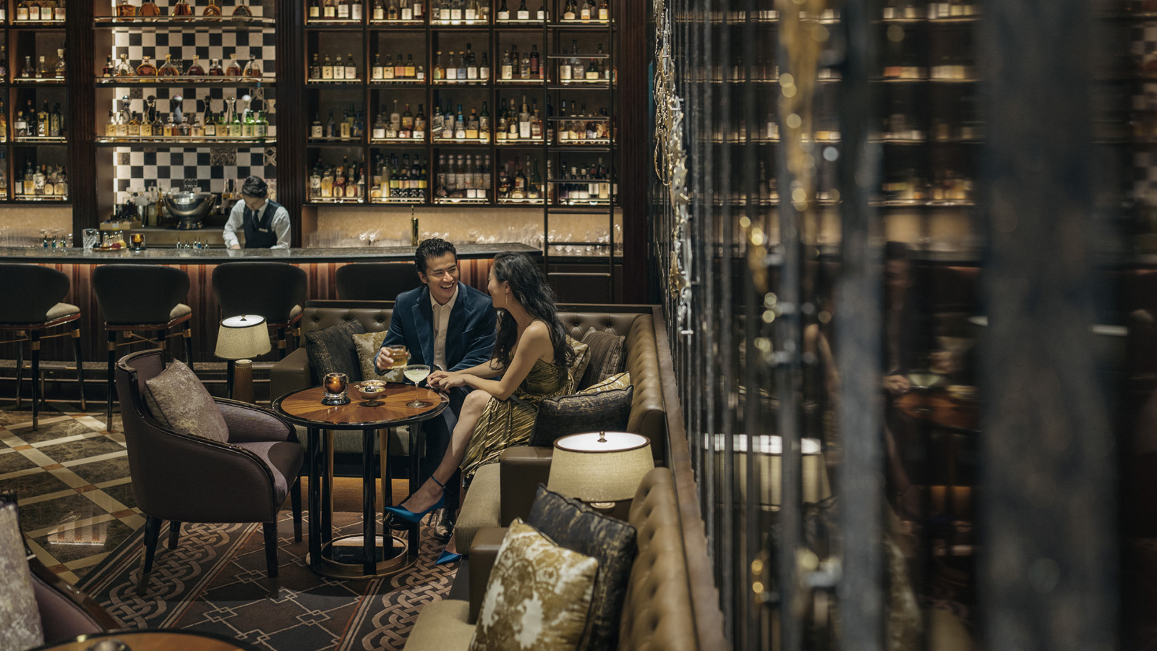 | 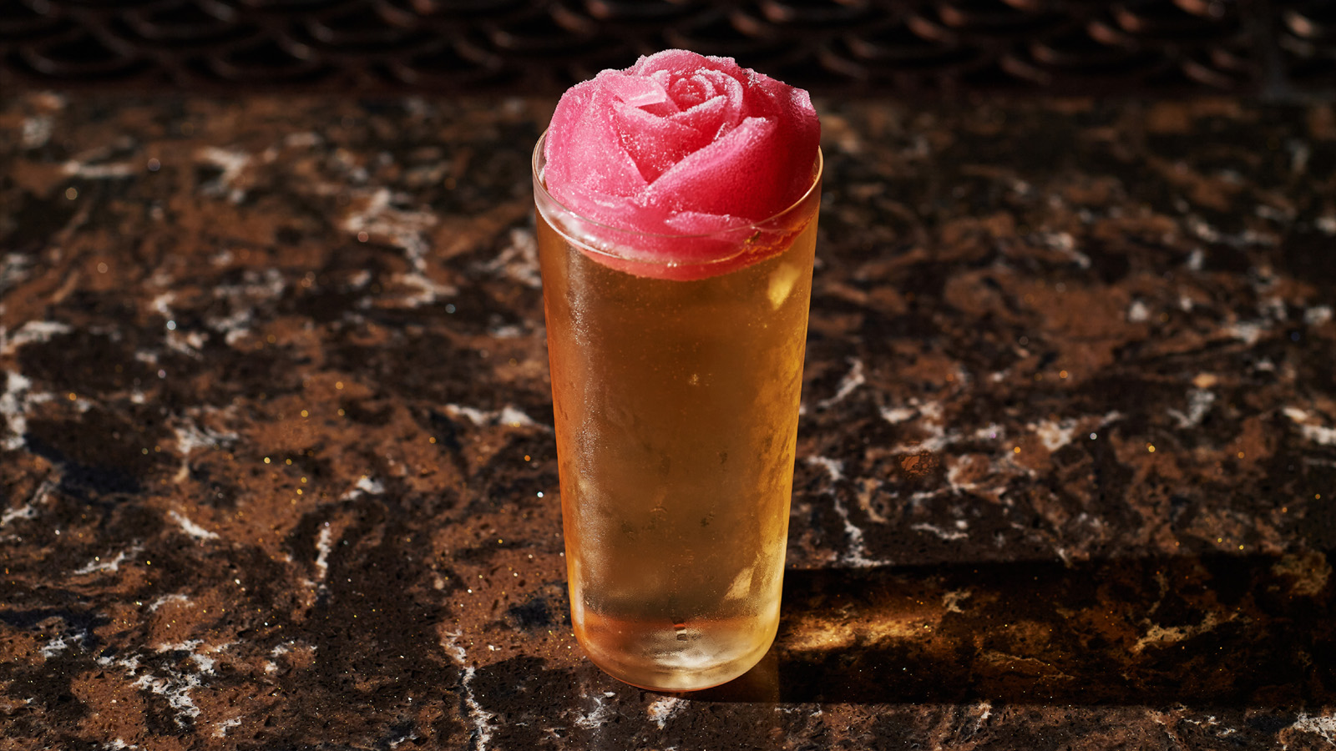
Four Seasons Hotel Tokyo at Otemachi invites couples to reignite romance, with a calendar of magical experiences to set the mood for Valentine’s Day – and beyond.
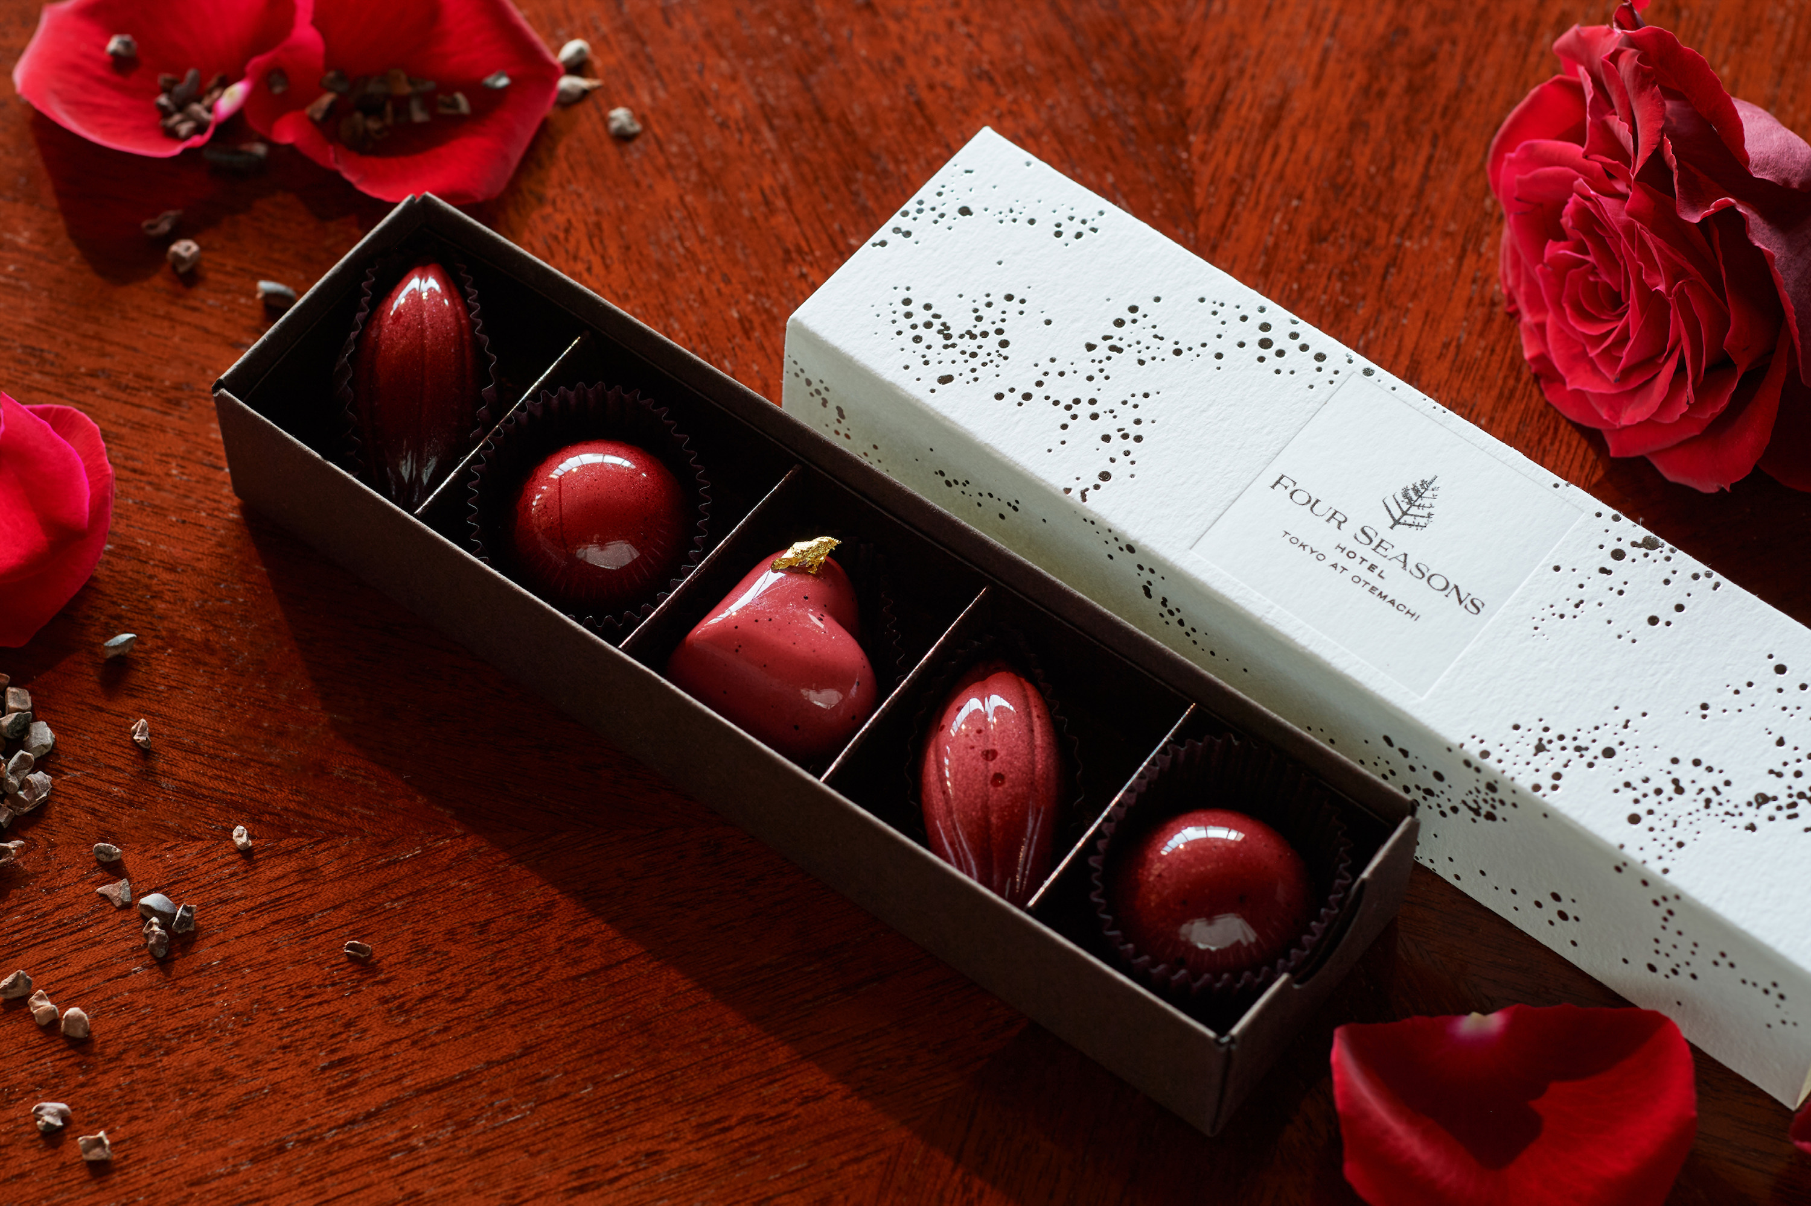 | 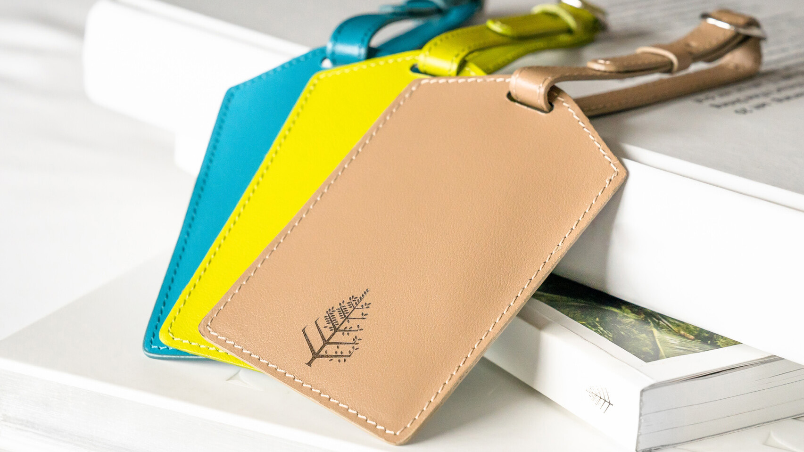 | 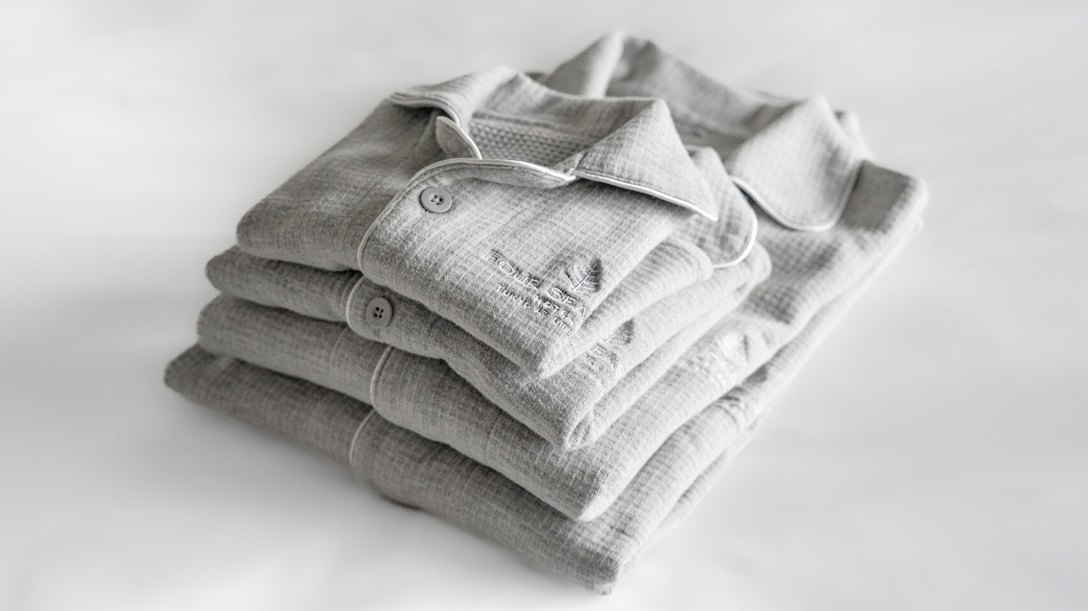
Through February and March 2023, lovebirds can share exclusive dining and drinking experiences at the glamorous sky-high retreat, framed by astonishing views of Tokyo in all its wintry splendour. Also on offer is a sweet variety of gifts, thoughtfully curated to sweep guests off their feet.
Love in Bloom at est
Aphrodite casts her spell on date night in the intimate, seductive embrace of est. At this two Michelin starred venue, couples can savour the most alluring flavours of the season, crafted to perfection by Chef Guillaume Bracaval. Equally elegant in taste and appearance, the nine-course Valentine’s prix fixe menu is served against dramatic views of the city skyline.
The star of the show is the Kishu duck from Wakayama, a rare delicacy comparable to the finest French duck owing to its extraordinary balance of fat and lean meat. The feast concludes with a limited-edition Gerbera dessert, blushing with the sweetness of the most luscious strawberries in season.
The sublime interiors of est are brushed in soft beige and cream, sparkling with sunshine in the day – and illuminated by Tokyo’s after-dark glitter by night. Share an enchanting celebration of love at this 39th-floor dreamscape, enveloped in the gracious warmth and care of Four Seasons.
- est
- Valentine's Day for 2 people - ten Courses with a half bottle of Ruinart Rosé Champagne
- February 10 to 14, 2023
- JPY 36,000 per person
Sweet Chocolate Afternoon Tea at THE LOUNGE
Starting this February, love comes in bold chocolate bites. Turn up the heat with rich, dark, chocolatey treats by award-winning Executive Pastry Chef Yusuke Aoki. A traditional favourite for lovers, chocolate finds fresh expression at this unforgettable Afternoon Tea, a special collaboration with famed French chocolaterie Valrhona.
The seasonally inspired savouries come in a palette of glorious greens, signalling the transition from winter to spring. A dreamy, delectable sojourn awaits couples at THE LOUNGE, surrounded by gorgeous views of the Imperial Palace Gardens and oh-so-blue skies.
- THE LOUNGE
- February 1 to March 31, 2023
- Seatings: 11:00 am to 1:00 pm, 1:30 to 3.30 pm, 4:00 to 6:00 pm
- JPY 8,800 weekdays, JPY 9,800 weekends and holidays, includes premium tea
Passion Potions at VIRTÙ
VIRTÙ puts the spotlight on love-infused cocktails, crafted with a splash of ardour and a swirl of tenderness. Raise a toast to romance with the elegant Thé Hoji &Eacute;picé, inspired by the French fairy tale La Belle et la Bête (The Beauty and the Beast). Woven around roasted hoji tea, this beautiful drink comes topped with a blushing ice-rose, diffusing refreshing raspberry notes as it slowly melts.
Ardent chocolate lovers can sip the Chocolamour, a heavenly union of jasmine vodka and various avatars of chocolate – liqueur, bitters, ice cream. Meet for a romantic rendezvous at this atmospheric drinkerie, overlooking the bright lights of Tokyo.
Valentine’s Gifts
Around the World Bon Bons. Celebrating the return of travel, this indulgent gift is ideal for couples who love to discover new places. Executive Pastry Chef Yusuke Aoki presents a signature selection of bon bons, pairing rich chocolate with iconic tastes from destinations around the globe. These little bites of heaven come in five flavours: Hawaii & Kona Coffee, Bali & Praline Coco, Spain & Sangria, Canada & Ice Wine, and Italy & Limoncello.
- Each box contains 5 bon bons (1 of each flavour)
- JPY 3,800 per box
- Reservations till February 10, 2023, pickup from February 7-14, 2023
- Reservations must be made at least 3 days before desired date of delivery
To reserve this gift, call 3-6810-0655 or click here.
Four Seasons Treats. Head to THE SPA boutique by Four Seasons to browse elegant gifts by Four Seasons, beloved worldwide for impeccable quality and thoughtful craftsmanship. The subtle Four Seasons logo instantly lends an air of refinement.
Luggage tag. Perfect for globetrotters to personalize their luggage. Choose from three chic colours – refreshing light green, striking ocean blue or stylish brown.
- JPY 5,500
Pyjamas. Staying home feels extra special when wrapped in Four Seasons luxury. Crafted with sumptuous cotton, these signature pyjamas are blissfully comfortable – an all-time favourite purchase for guests staying at Four Seasons Hotel Tokyo at Otemachi.
- JPY 15,950, available in size S/M/L/XL
Polo shirts and Hats. Available in pristine white and other stylish hues, these polo shirts and hats are designed to elevate every experience, from a casual brunch with friends to a golf game with business partners.
- Polo shirts: JPY 7,150, available in white/pink/navy blue/blue
- Hats: JPY 4,950, available in white/navy blue
Four Seasons gift items are available at THE SPA boutique, 7:00 am to 9:30 pm

All prices listed above are include taxes and service charge.

RELATED

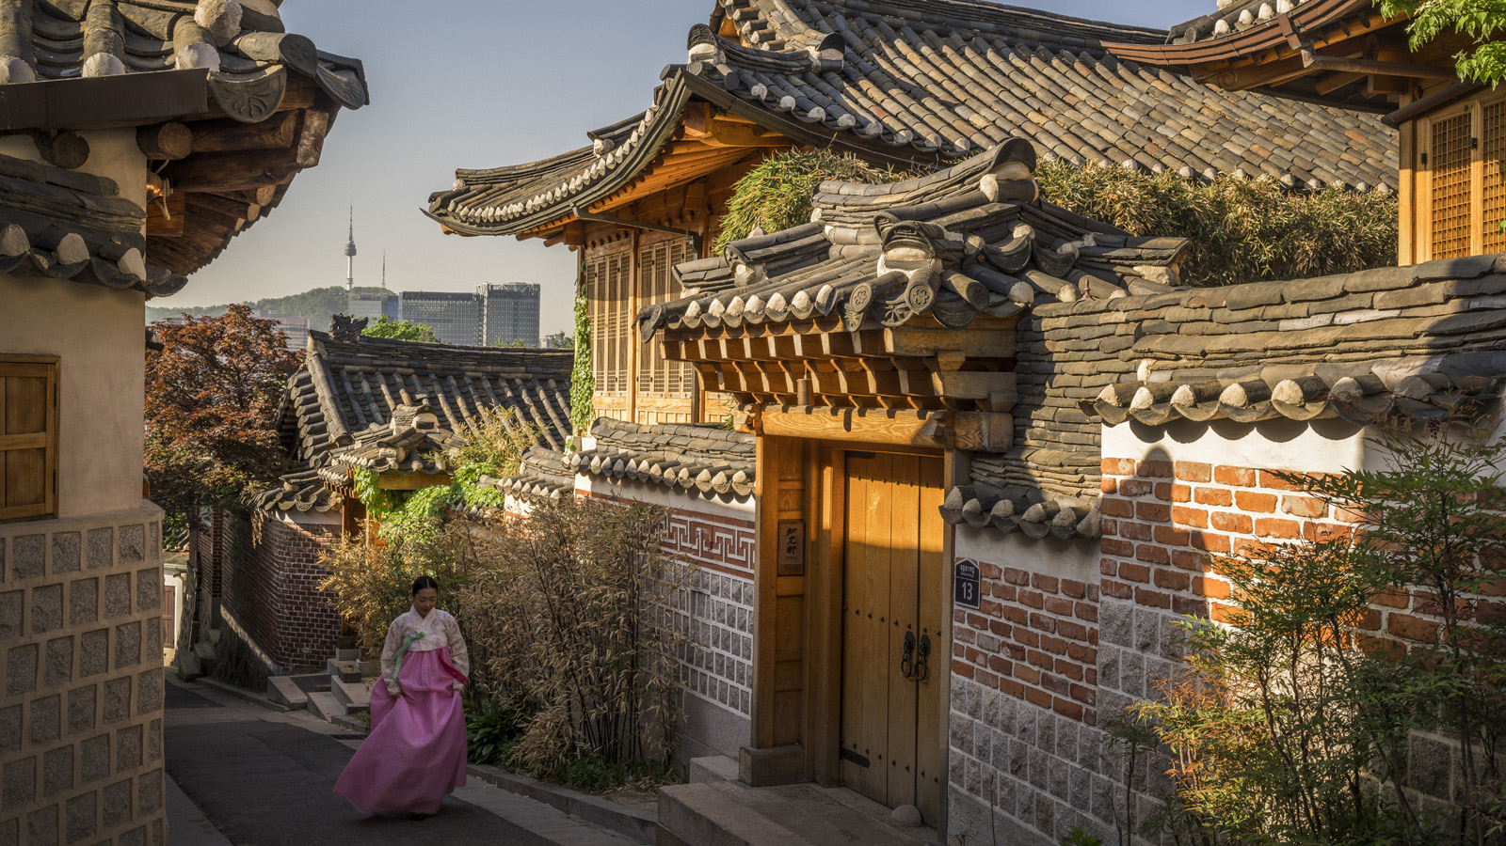 | January 31, 2023, Seoul, Korea  Rediscover the Seasonal Vibrancy of Korea and Japan with Four Seasons This Winter  https://publish.url/news-releases/2023/rediscover-korea-and-japan-in-winter.html
January 31, 2023, Kyoto, Japan
Embark on Journeys of Wellness at Four Seasons Hotel Kyoto
https://publish.url/kyoto/hotel-news/2023/wellness-experiences.html

PRESS CONTACTS

Shingo Kido
Director of Public Relations and Communications
1-2-1 Otemachi
Chiyoda-ku, Tokyo
Japan
shingo.kido@fourseasons.com

