Four Seasons Hotel Chicago Celebrates its City’s Vibrant Music Scene with Live in the Lounge Residency

Robust music program toasts to Chicago’s diverse musical perspectives and personalities
October 19, 2021, Chicago, U.S.A.

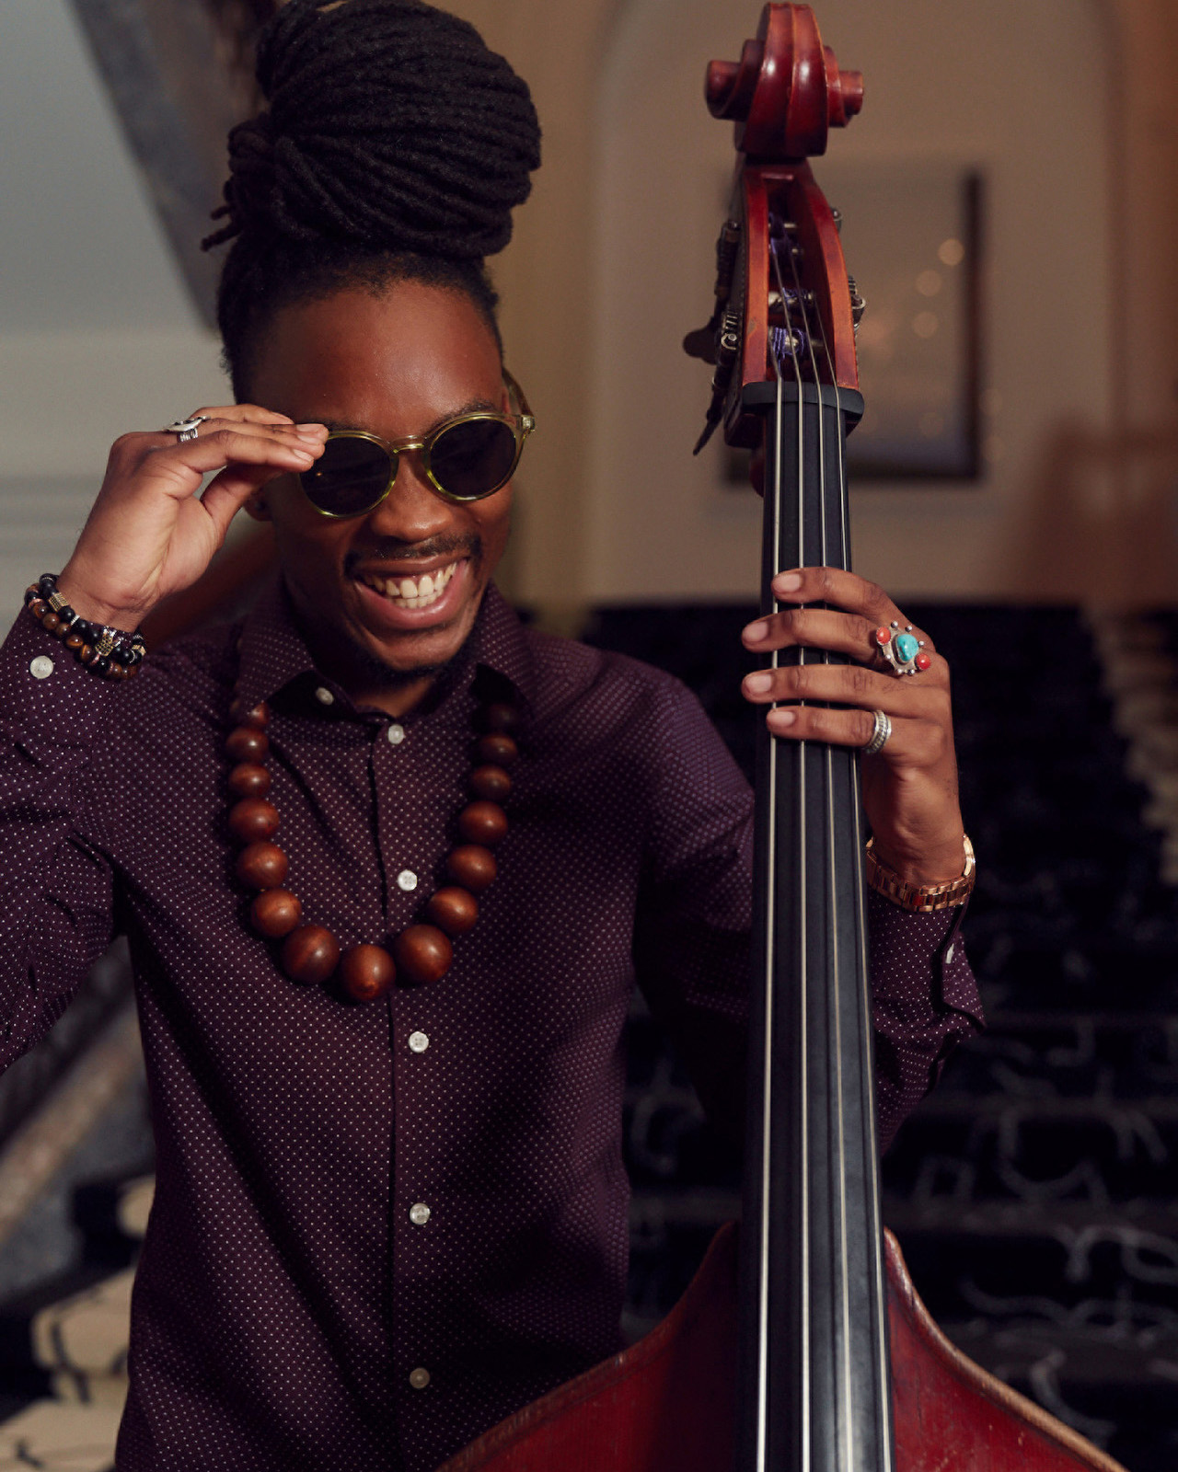
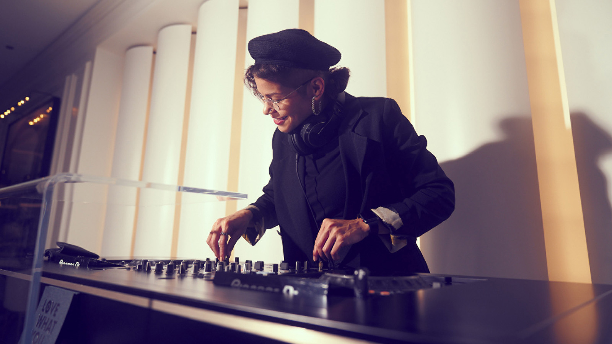 | 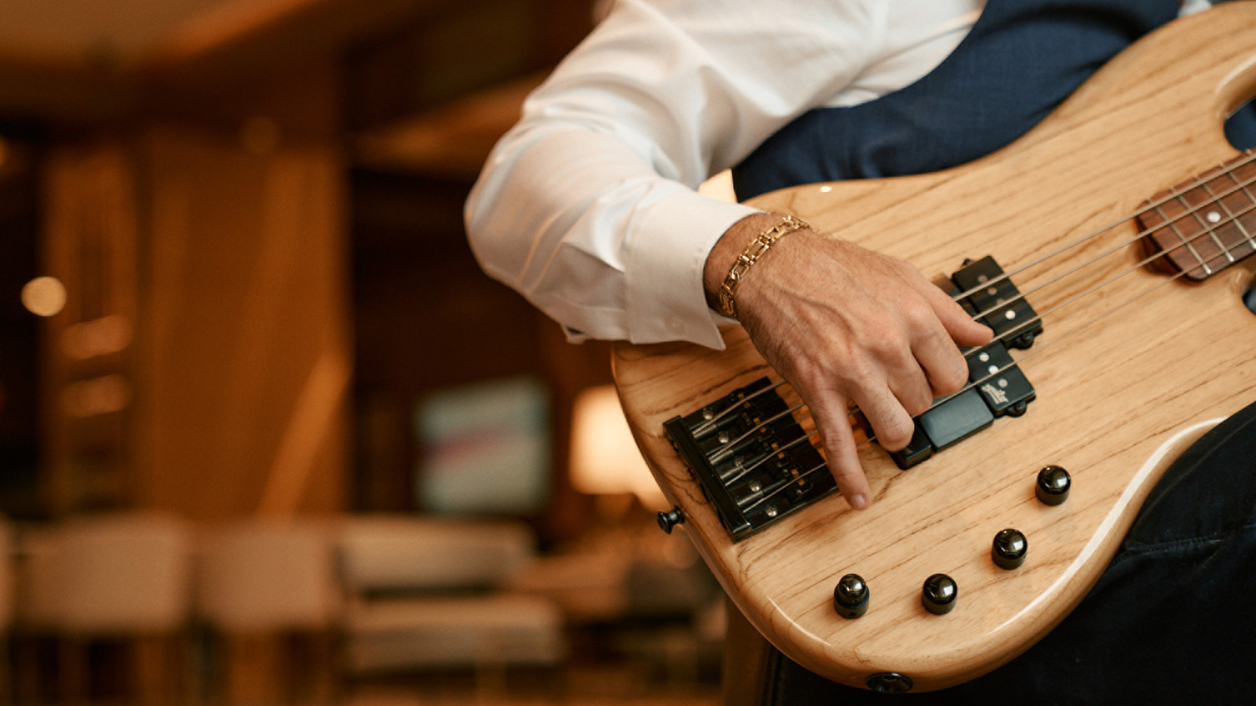 | 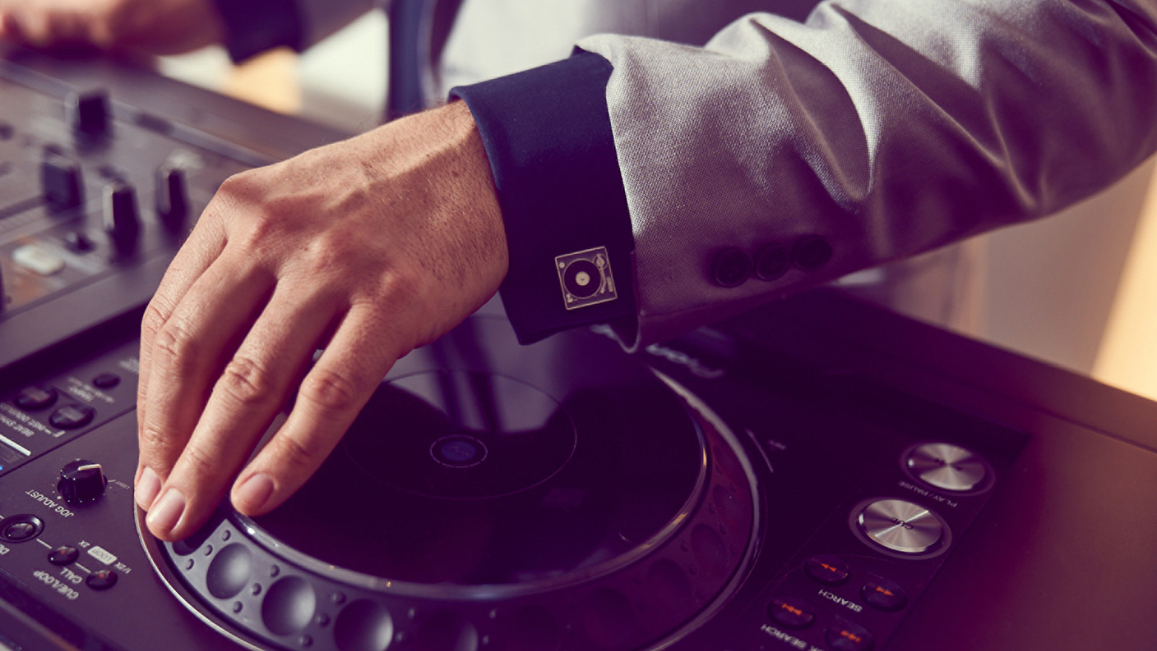
Four Seasons Hotel Chicago and Adorn Bar & Restaurant, with their partner BELLOSOUND, announce a hand-curated musical line-up that accentuates the newly reimagined Hotel and guest experience.
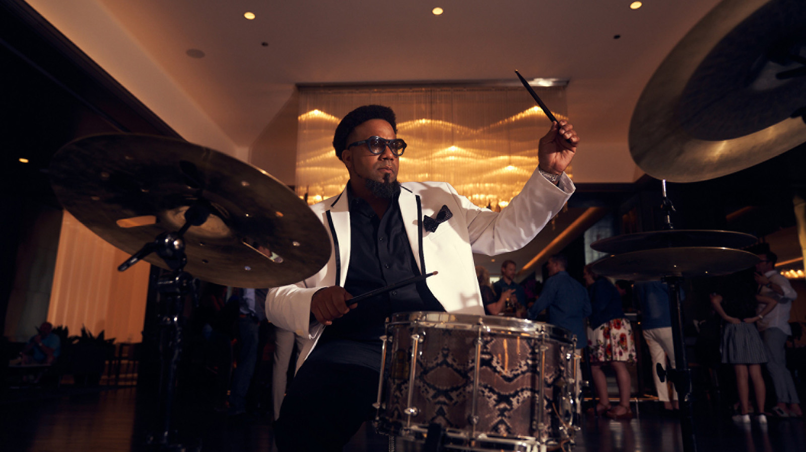
Renovated in October 2020, the fully redesigned Four Seasons Hotel Chicago invites global and local explorers to revel in cultural immersion with locally-inspired food, drinks, art and music that deliver the quintessential Chicago experience. Emanating personality and modern appeal through lively and innovative social spaces, as well as stylish accommodations with unrivalled lake and skyline views, the iconic and enviable location welcomes guests at the heart of the Magnificent Mile and North Michigan Avenue’s best shopping and attractions.
“Our sophisticated new public spaces set the scene for a luxury urban experience unlike any in the city,” says Stephen Wancha, General Manager at Four Seasons Hotel Chicago. “As we usher in a new era of Four Seasons experiences in Chicago, we are thrilled to showcase local musical talent, new and established, and welcome guests to reconnect, gather and celebrate in our boldly reimagined Hotel.”
Building on their existing partnership after the success of the property’s reopening, Four Seasons Hotel Chicago and Toronto-based sound agency BELLOSOUND have launched the Live in the Lounge series, an expanded entertainment program. The residency features Chicago DJs and musicians for performances inspired by the style of the Hotel’s redefined luxury experience, sophistication, and global vision, including its new bar and restaurant concept, Adorn. Guests will enjoy a roster of varied musical styles from South American guitarists and veterans of the Chicago jazz scene to DJs who spin house, funk, and disco in the city’s most acclaimed clubs. Taken together, these artists produce a soundtrack that celebrates both the Hotel and Chicago’s diversity, energy and musical history.
"I’m incredibly inspired and proud of the team of talents we put together for the Live in the Lounge series. It’s like we have a big family of diverse performers with their own unique strengths and complementary style. We’ve got flamenco guitar virtuosos from Argentina, seasoned DJs spinning vintage soul records, leaders of the Chicago jazz scene, and a brilliant group of female DJs who are making waves in the Chicago club scene, all under one roof,” says Daniel Buckman, Founder and CEO of BELLOSOUND.
Music can be enjoyed weekly on Thursdays, Fridays, and Saturdays from 7:30 to 11:30 pm and Sundays from 10:00 am to 2:00 pm. Amplifying the series, Live in the Lounge artists have curated Spotify playlists for guests to tune in from anywhere.
Learn more about Four Seasons Hotel Chicago residency Live in the Lounge and its talented musicians here, and follow #LiveInTheLounge on Instagram for information on upcoming performances and latest jams.
To make reservations at Adorn Bar and Restaurant book online, call 312 280 8800, and follow Adorn on Facebook and Instagram.
Talent roster and music styles
- DJ Alissa | Uplifting lounge, EDM and house
- Charles | Jazz standards, Neo soul and R&B groove
- DJ Eliana | Eclectic mix of retro, rock, Latin and party favourites
- DJ Jamian | Upbeat mix of current hits and remixes
- DJ Jeilah | Queen of Soul, disco, Afro, funk, and house
- Jon | Classic and standard jazz
- DJ Kevin | Rare edits, electronic, lounge, dance & house
- Mario | New Orleans style jazz horn improv, playing originals and covers
- Micah | Nu-Jazz improv and covers
- DJ Stevenson | Rare 45s and vintage soul, retro and R&B groove
- DJ Tess | mixing old school into contemporary music and all-around dance party magic
- Vagando Muzica | Acoustic flamenco guitar classics and rock n roll covers

RELATED

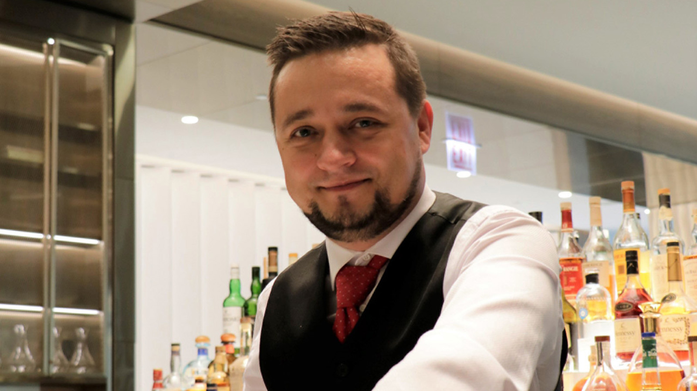 | October 13, 2021, Chicago, U.S.A.  Adorn Bar & Restaurant at Four Seasons Hotel Chicago Expands Best-In-Class Team, Announces Award-Winning New Mixologist Slava Borisov  https://publish.url/chicago/hotel-news/2021/adorn-lead-mixologist-slava-borisov.html
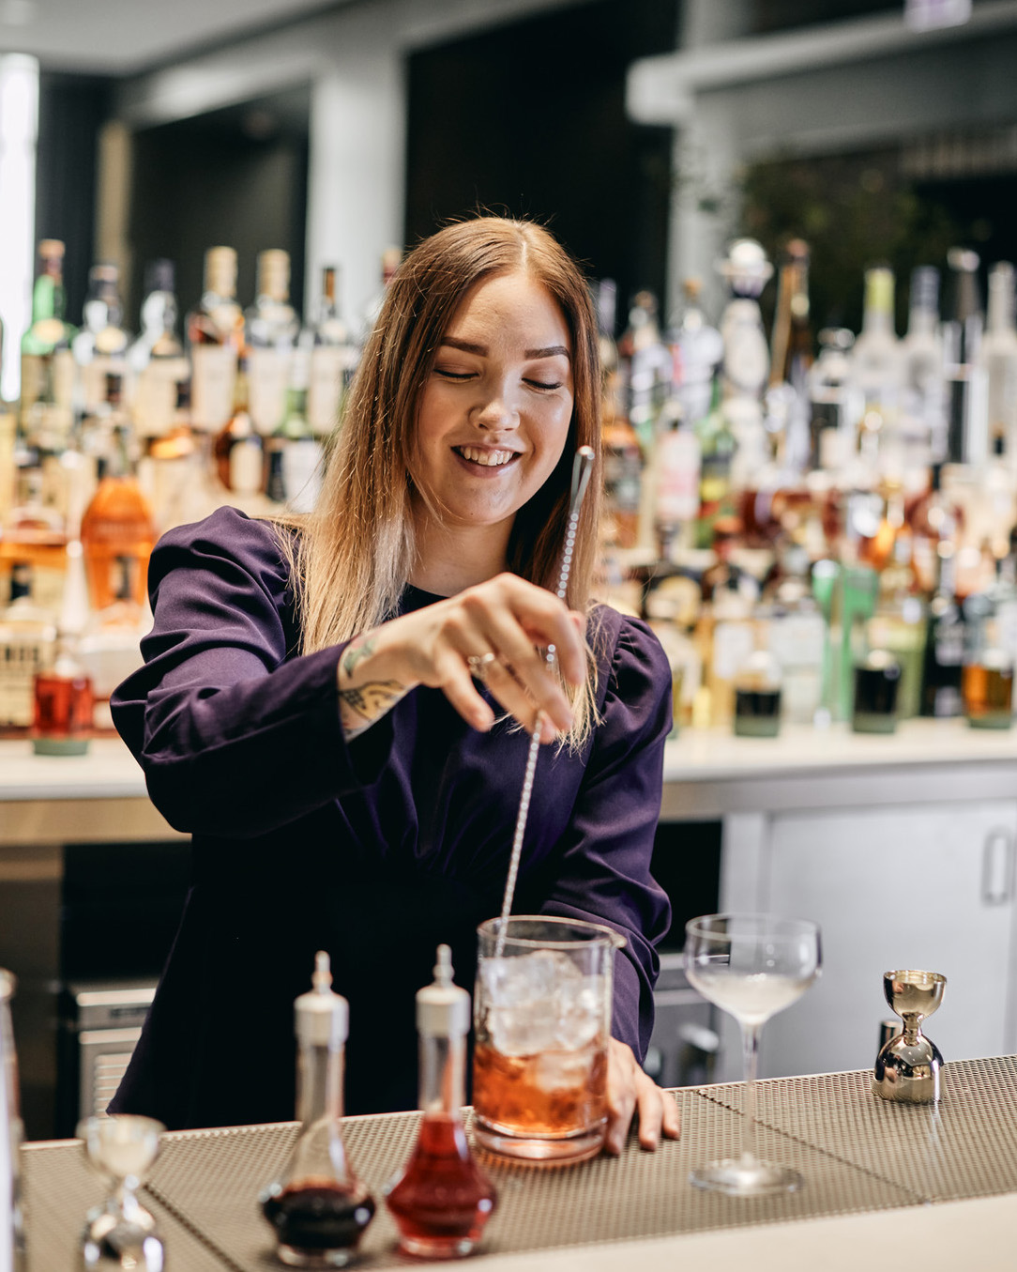 | June 2, 2021, Chicago, U.S.A.  Adorn Bar & Restaurant at Four Seasons Hotel Chicago Expands Offerings with the Appointment of New Food and Beverage Craftspeople  https://publish.url/chicago/hotel-news/2021/new-team-members-at-adorn-restaurant-and-bar.html

PRESS CONTACTS

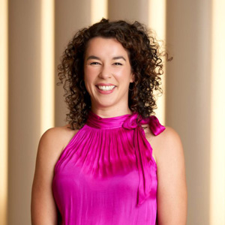 | Ciara Merouan  Director of Public Relations  120 East Delaware Place  Chicago  USA  ciara.merouan@fourseasons.com  +1 312 649 2373

