Embrace the Spirit of Ramadan at Four Seasons Hotel Istanbul at the Bosphorus in a Magical City Where East Meets West

April 6, 2021, Istanbul at the Bosphorus, Turkey

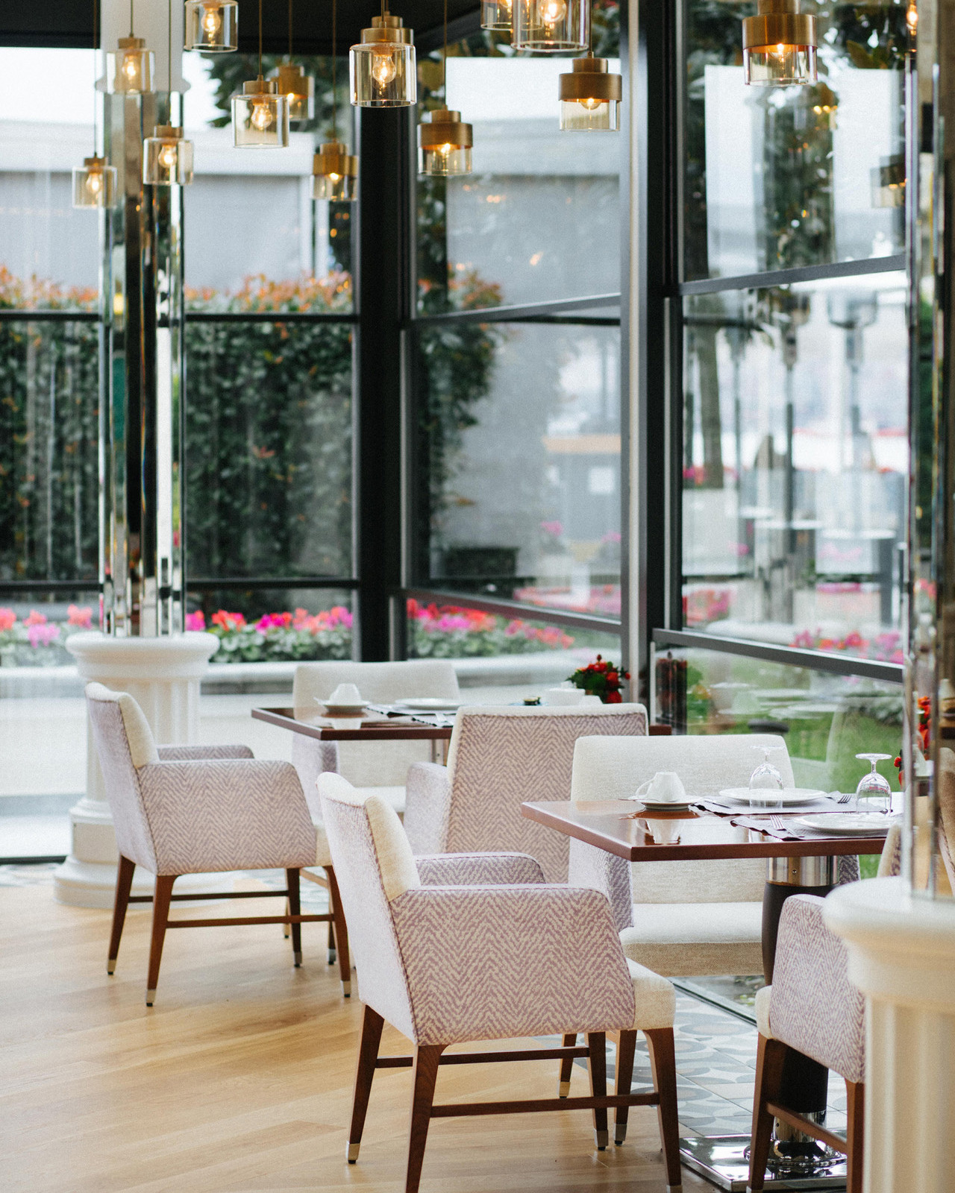
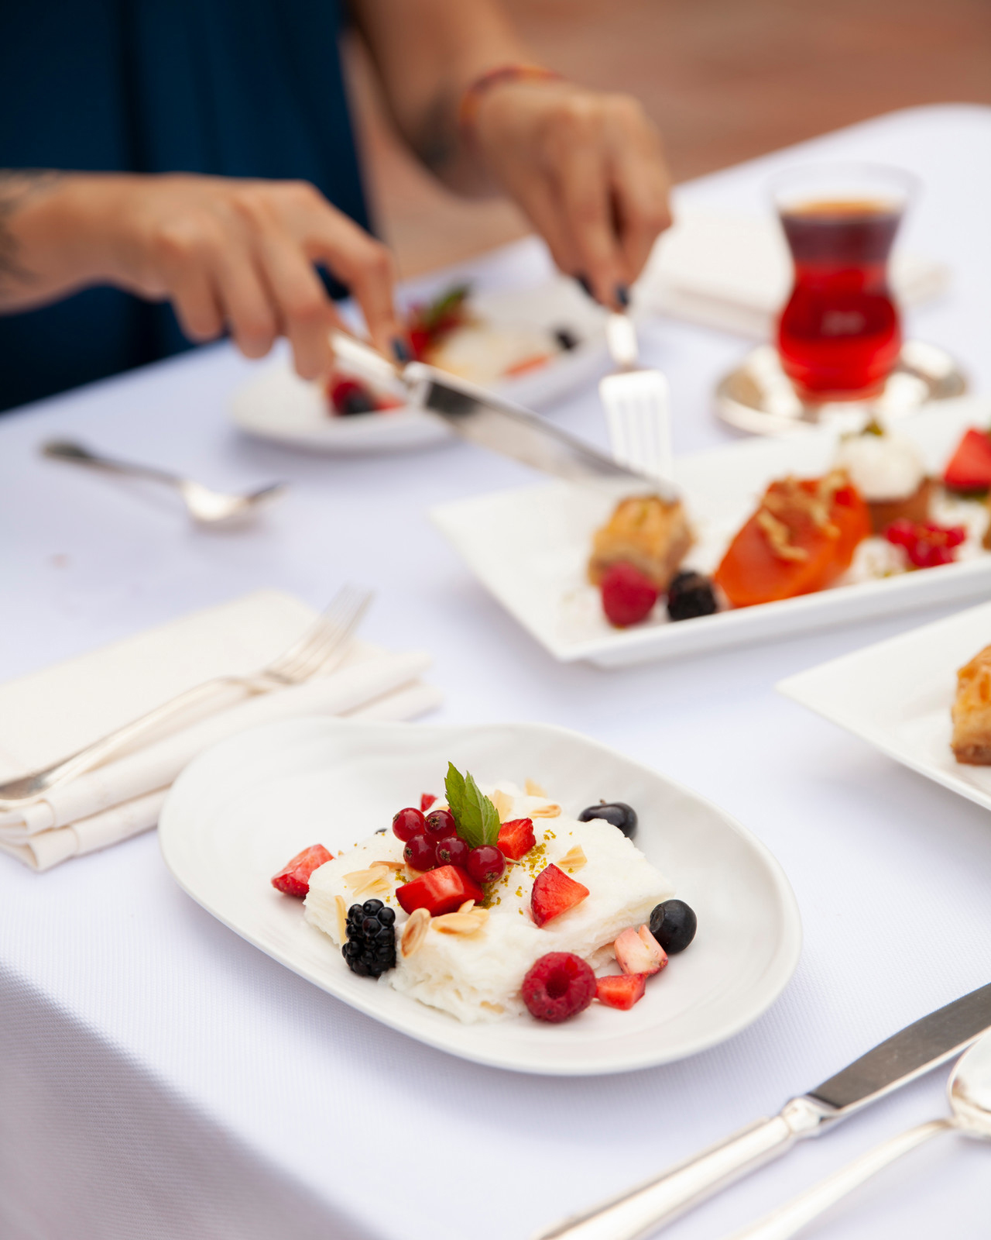 | 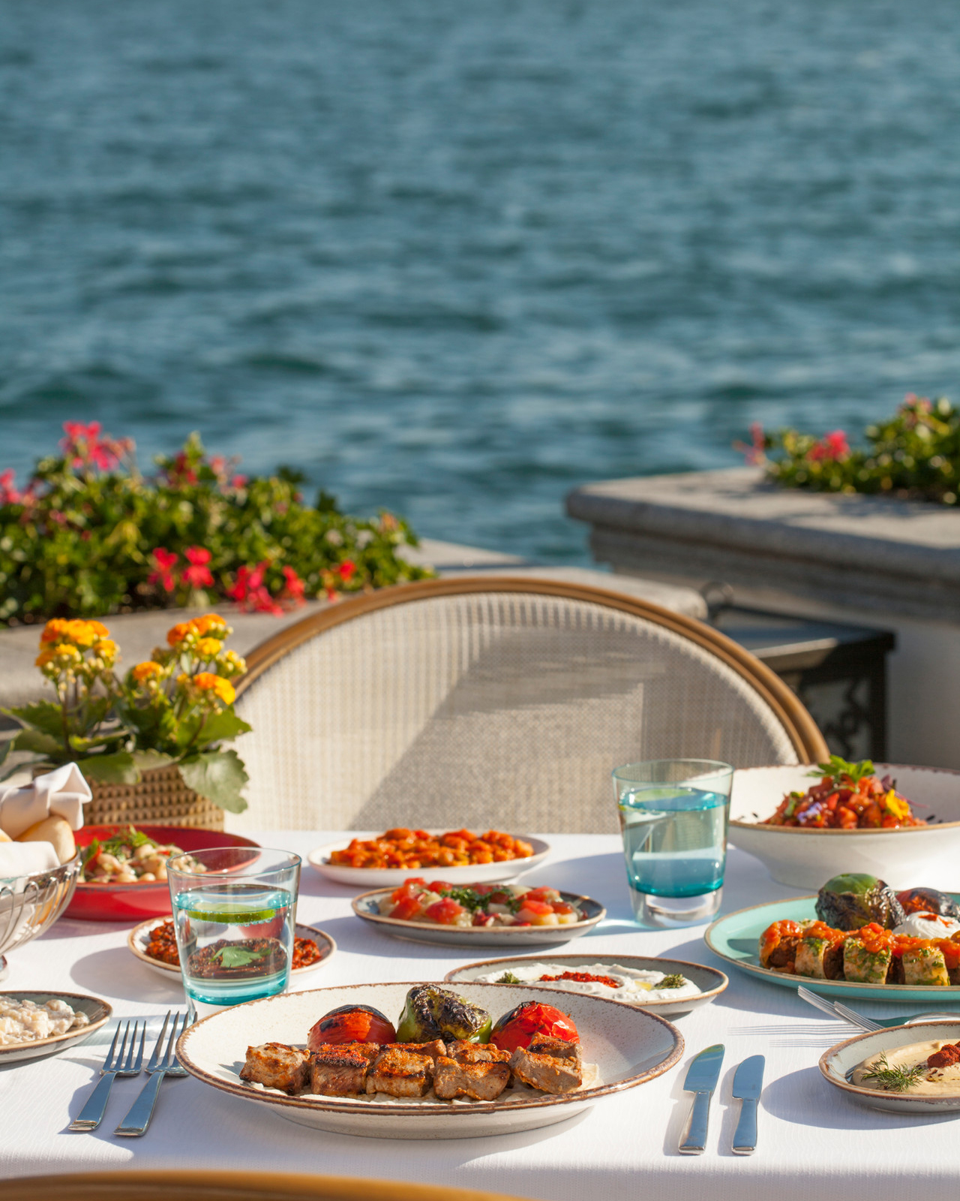 | 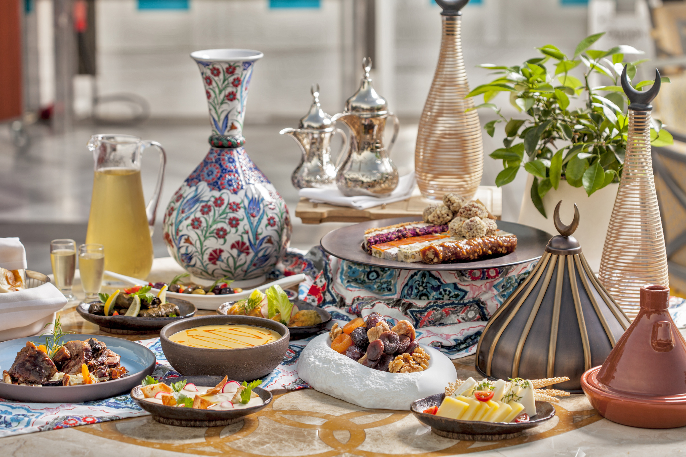
Four Seasons Hotel Istanbul at the Bosphorus welcomes Ramadan with a range of outdoor and indoor dining offerings this year. During the Holy Month, the Hotel will serve special iftar and sohour menus that reflect the bounty of Ramadan with the promise of a unique experience by the beautiful Bosphorus.
Celebrate Ramadan Outdoors Under the Glittering Stars
Located on the spacious terrace of the Hotel along the Bosphorus, Aqua will host its guests with a set iftar menu this year. Accompanied by a classical music ensemble, the iftar menu features an array of flavours, including the must-have Ramadan appetisers, the popular doner, and traditional desserts of the month.
For those looking for an al fresco experience during sohour, guests may choose to enjoy their meals in this unique atmosphere by the Bosphorus or in the comfort of their rooms or suites.
A Taste of Turkey by the Bosphorus
Ocakbaşı, the Hotel’s popular restaurant is another great option for guests who wish to enjoy an a-la-carte iftar menu with authentic Anatolian dishes, mezes and kebabs.
For an exclusive Ramadan experience, a private dome at the Ocakbaşı will provide a special ambience for families of up to six people.
Children below 6 years dine with the Hotel's compliments; children 6 to 12 years are entitled to 50 percent savings.
Four Seasons Hotel Istanbul at the Bosphorus continues to implement maximum hygiene and physical distancing measures with its global Lead With Care program and aims to offer its guests a unique Ramadan experience with diversified offerings prepared by Hotel’s talented culinary experts.
For reservations call +90 212 381 40 00.

RELATED

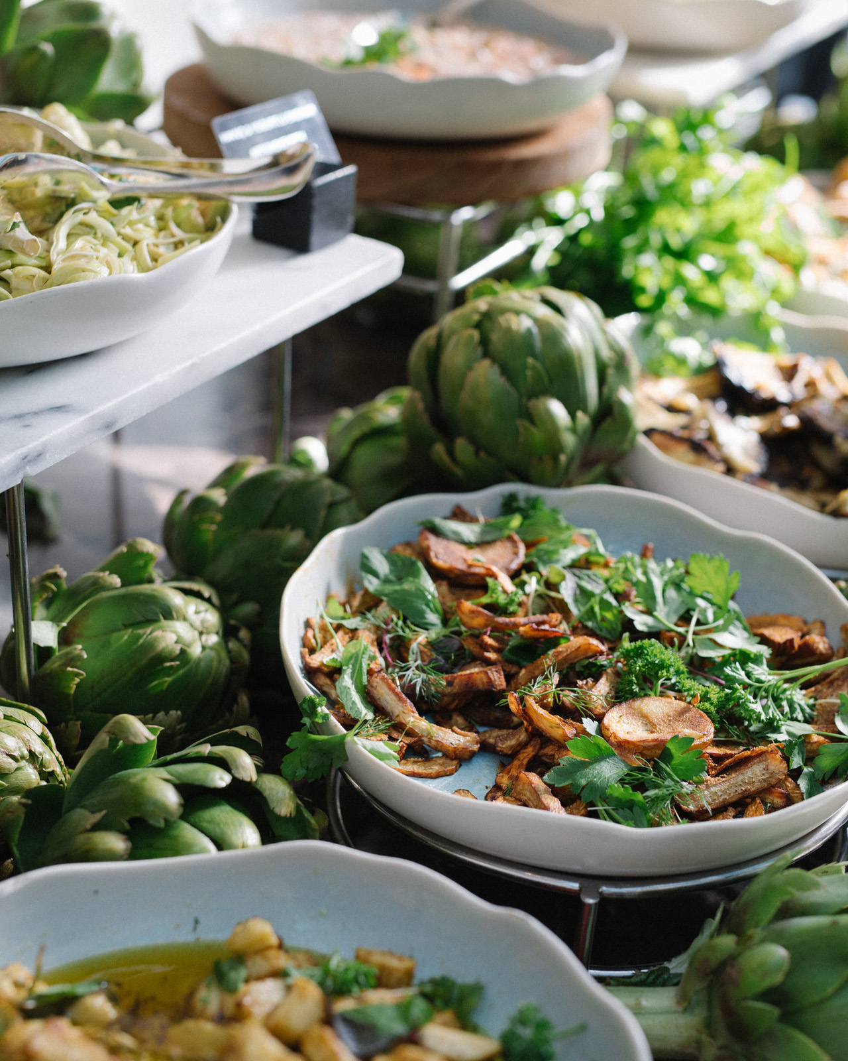 | March 17, 2021, Istanbul at the Bosphorus, Turkey  Boğaz Kıyısındaki Brunch Keyfini Her Cumartesi Four Seasons Hotel Istanbul at the Bosphorus’ta Yaşayın  https://publish.url/tr/bosphorus/hotel-news/2021/aqua-brunch.html
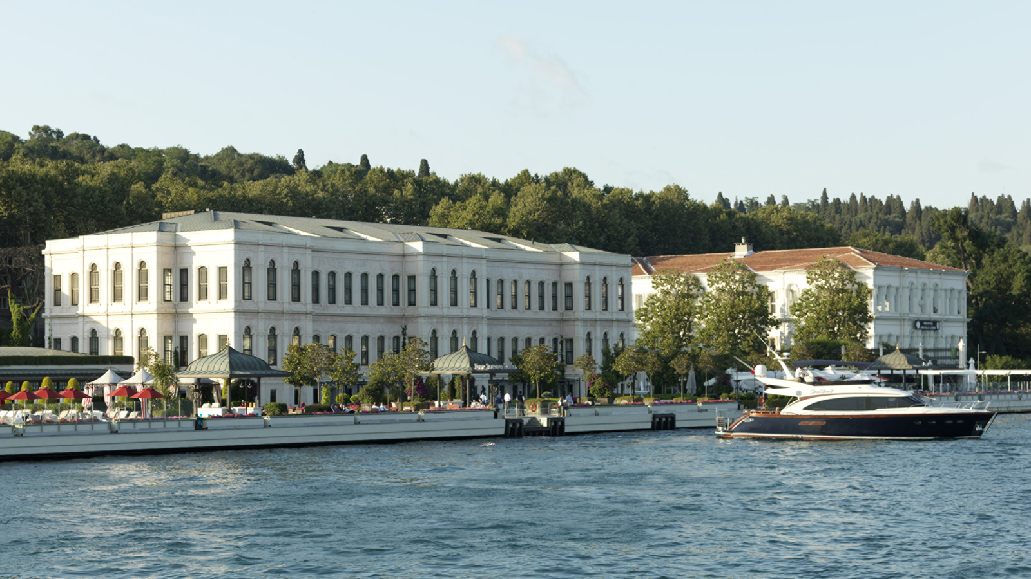 | February 23, 2021, Istanbul, Turkey  Forbes Travel Guide Four Seasons İstanbul Otellerini Bir Kez Daha Beş Yıldızla Ödüllendirdi  https://publish.url/tr/bosphorus/hotel-news/2021/forbes-five-star-hotels.html

PRESS CONTACTS

Sibel Benli
Senior Director of Public Relations and Communications
Çırağan Cad. No. 28
Istanbul
Turkey
sibel.benli@fourseasons.com

90 (212) 381 41 35

