Easter by Four Seasons Hotel Bengaluru

Curated experiences for a relaxed time with family
April 11, 2022, Bengaluru, India

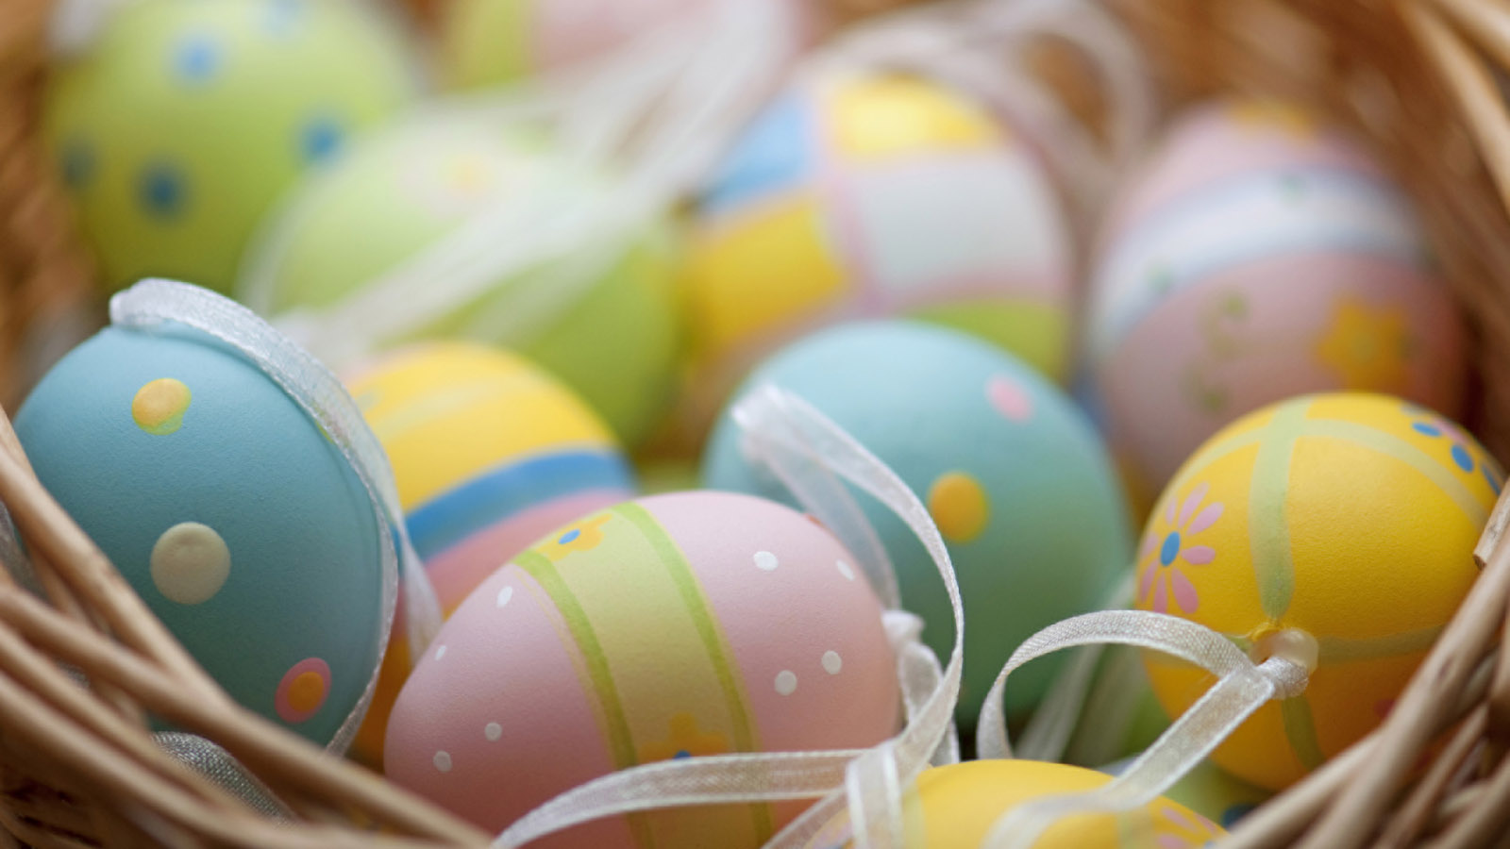
Easter, commemorating spring break and the beautiful outdoors, is a time for families to come together to decompress. Long family meals, fun egg hunts and chocolate are some elements of a truly happy Easter holiday.
Chefs at Four Seasons Hotel Bengaluru are planning a spectacular Easter Sunday Brunch; there are Easter goodies up on sale; and a delightful Afternoon Tea to savour.
Easter Brunch
Guests can enjoy a long and lingering Sunday Brunch for Easter with a live band setting the tone and an expansive array of mouth-watering dishes. Look forward to a range of antipasti, cheeses of the world, fresh salads, international and Indian mains finished with a slew of delectable desserts with Easter-themed sweet treats such as hot cross buns, babka, Easter nest torte, chocolate hazelnut Easter egg, and the cutest Hippity Hop Bunny Cake.
- Date: Sunday, April 17, 2021
- Time: 12:30 pm onwards
- Venue: CUR8
- Prices: INR 3363 all inclusive (non-alcoholic package), INR 5463 all inclusive (alcoholic package)
For reservations, call +91 76191 46004.
Easter-themed Afternoon Tea
Guests can enjoy a choice of delightful Easter-themed goodies as they savour that perfect brew at The Lobby Lounge.
- Dates: April 11-17, 2022
- Time: 3:00-5:30 pm
- Price: INR 1,250 + taxes per person (inclusive of a selection of tea and coffee)
Afternoon Tea available only on prior reservation.
Easter Goodies on Retail
It isn’t quite Easter without Easter eggs and other sweet treats. The pastry team have the most delicious cakes, macarons and eggs on sale including a fully loaded Easter Goodie Box that will have a traditional hot cross buns, Easter carrot cake, apple pie and pralines.
- Prices start at INR 450 + taxes
Orders are to be made 24 hours in advance. For more details, call +91 76191 46004

RELATED

March 28, 2022, Bengaluru, India
Copitas at Four Seasons Hotel Bengaluru Named Among 30 Best Bars in India
https://publish.url/bengaluru/hotel-news/2022/best-bars-in-india-awards.html

March 3, 2022, Bengaluru, India
Women’s Day at Four Seasons Hotel Bengaluru
https://publish.url/bengaluru/hotel-news/2022/womens-day.html

PRESS CONTACTS

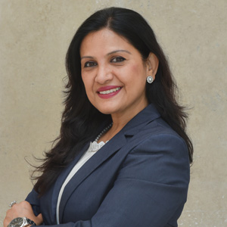 | Gargi Guha  Director of Public Relations  8, Bellary Road, Ganganagar  Bengaluru  India  gargi.guha@fourseasons.com  +91 80 4522 2222

