MÚZSA, Budapest’s Most Inspired Bar Turns One with a Weekend Full of Celebrations with World’s 50 Best Bars Guest Bartenders at Four Seasons Hotel Gresham Palace Budapest

Four Seasons invites guests for an unforgettable weekend of celebrations on the first birthday of the Hotel’s stunning Art Nouveau craft cocktail bar MÚZSA
September 24, 2021, Budapest, Hungary

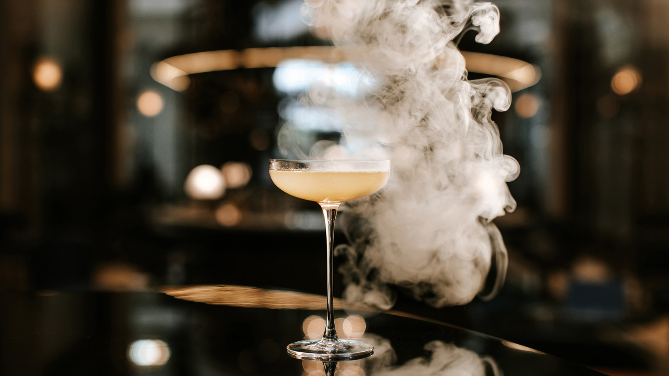
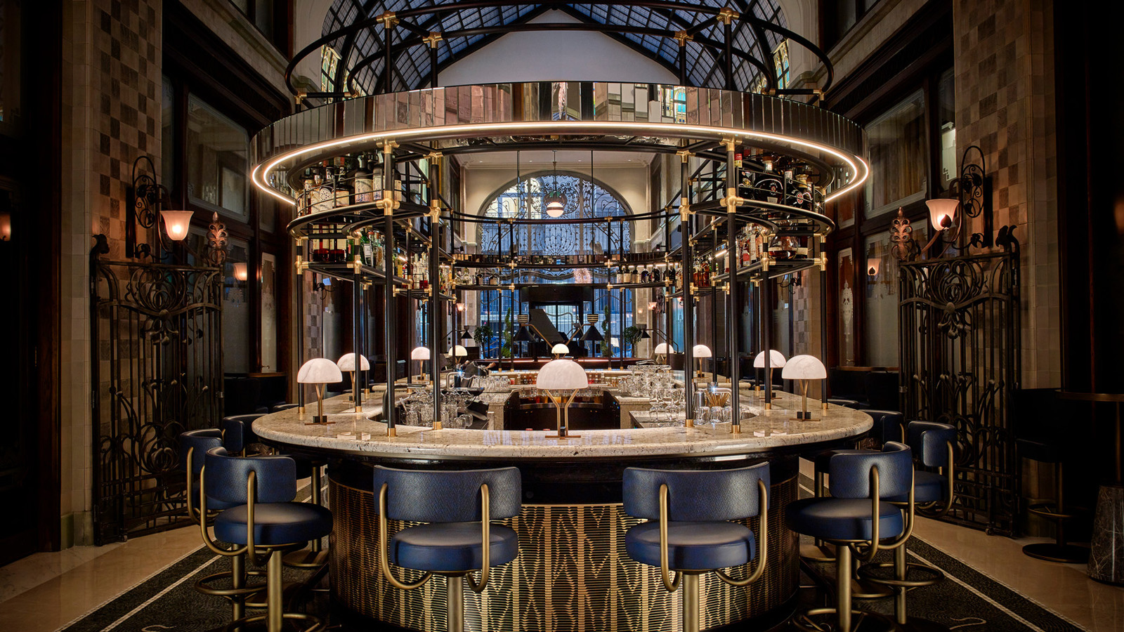 | 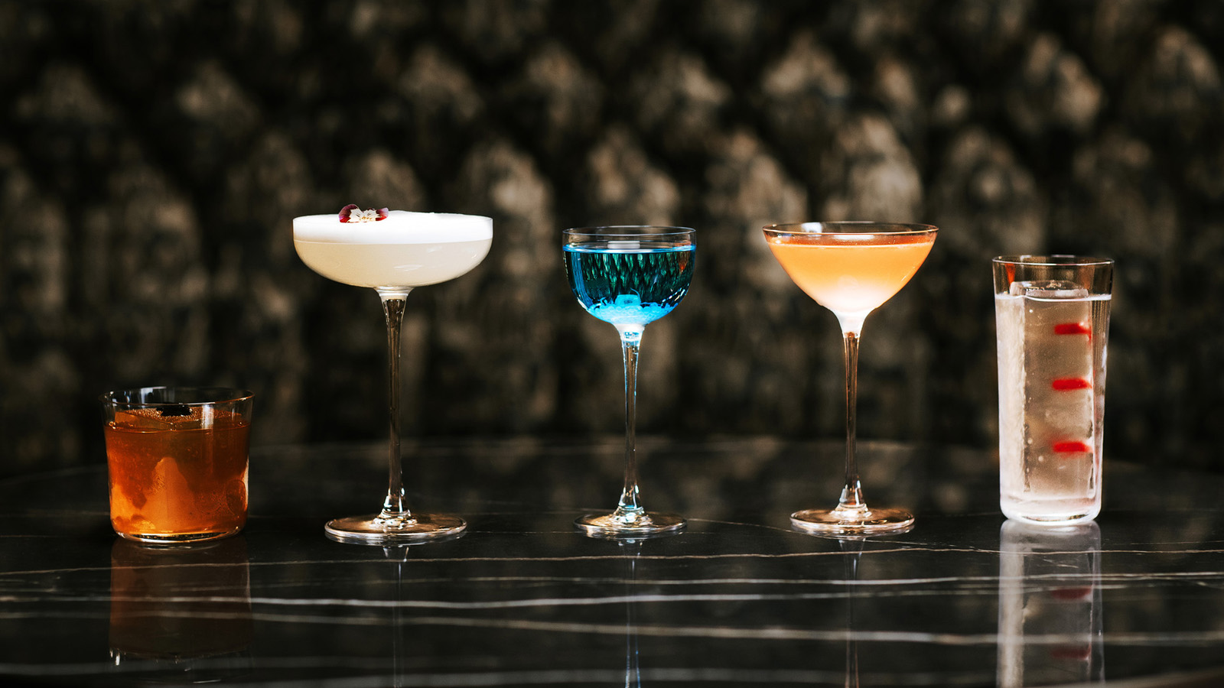 | 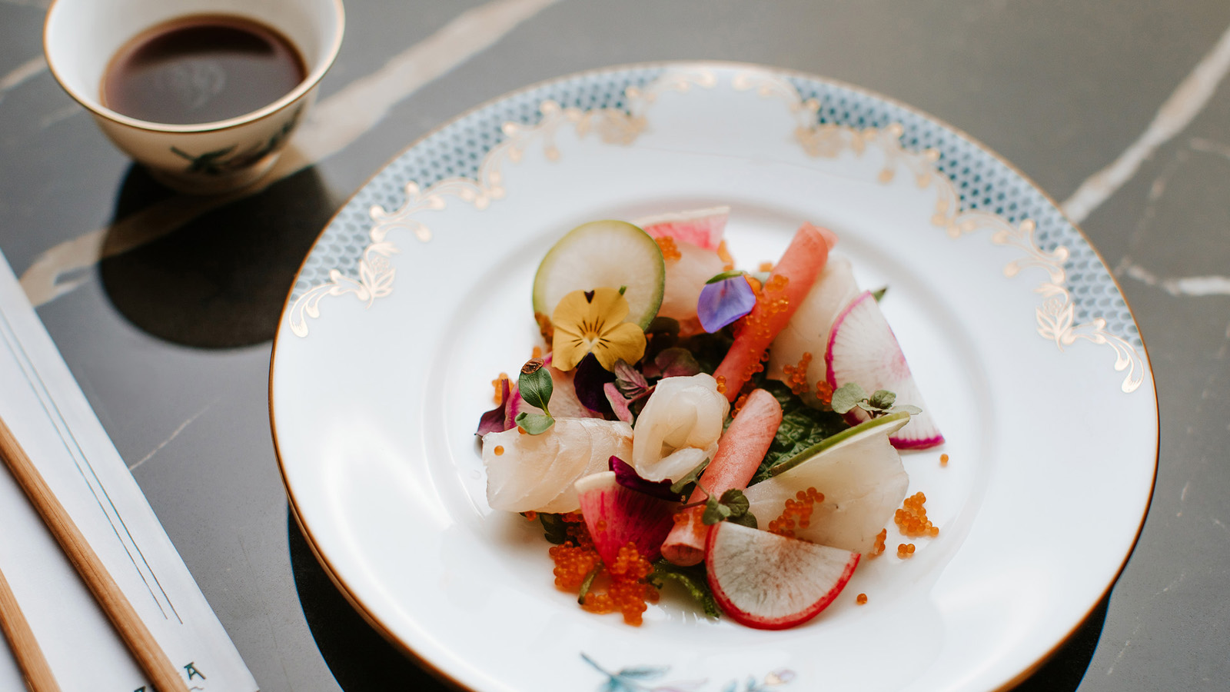
On October’s first weekend, MÚZSA is celebrating her first dance around the sun. Elegant and refined, yet modern and playful, MÚZSA, the stunning new cocktail bar and lobby at Four Seasons Hotel Gresham Palace Budapest became a popular destination for visitors and locals alike since its unveiling in 2020. With its inspired atmosphere to enjoy artful cocktail creations, an exciting blend of Asian and Hungarian cuisines, and a diverse mix of local authentic live entertainment, MÚZSA portrays the best of Hungary’s rich cultural and culinary heritage.
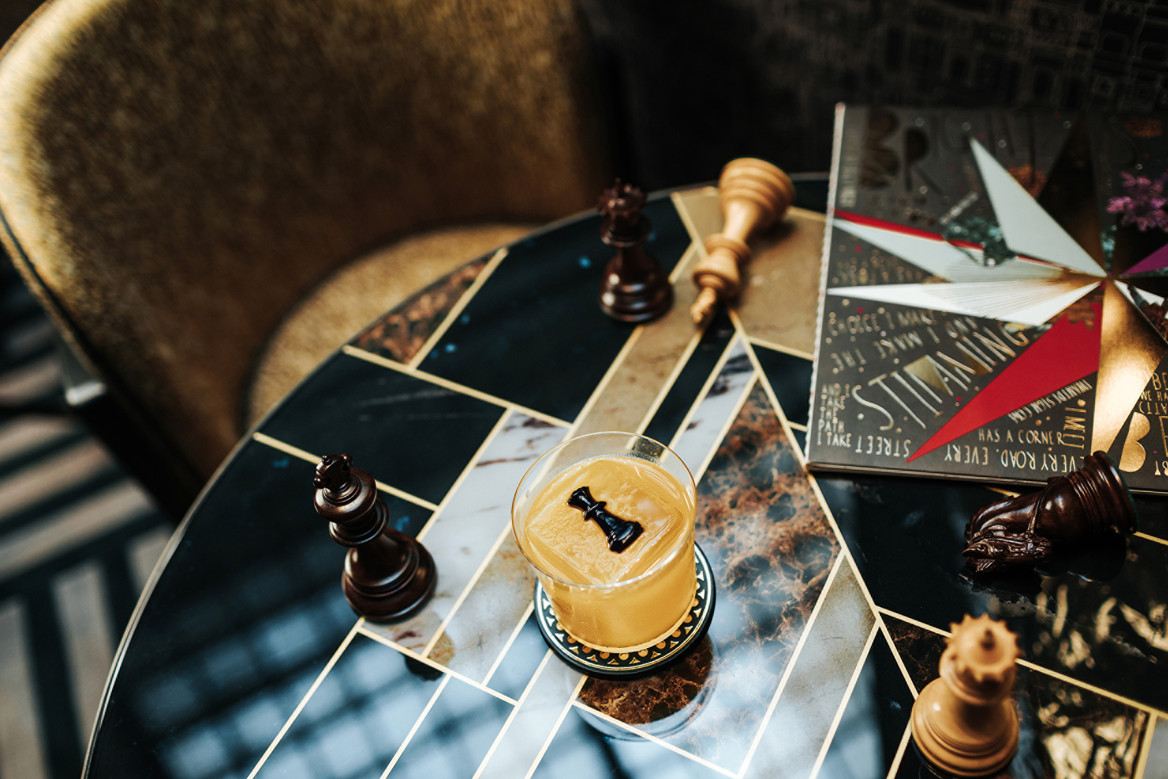 | 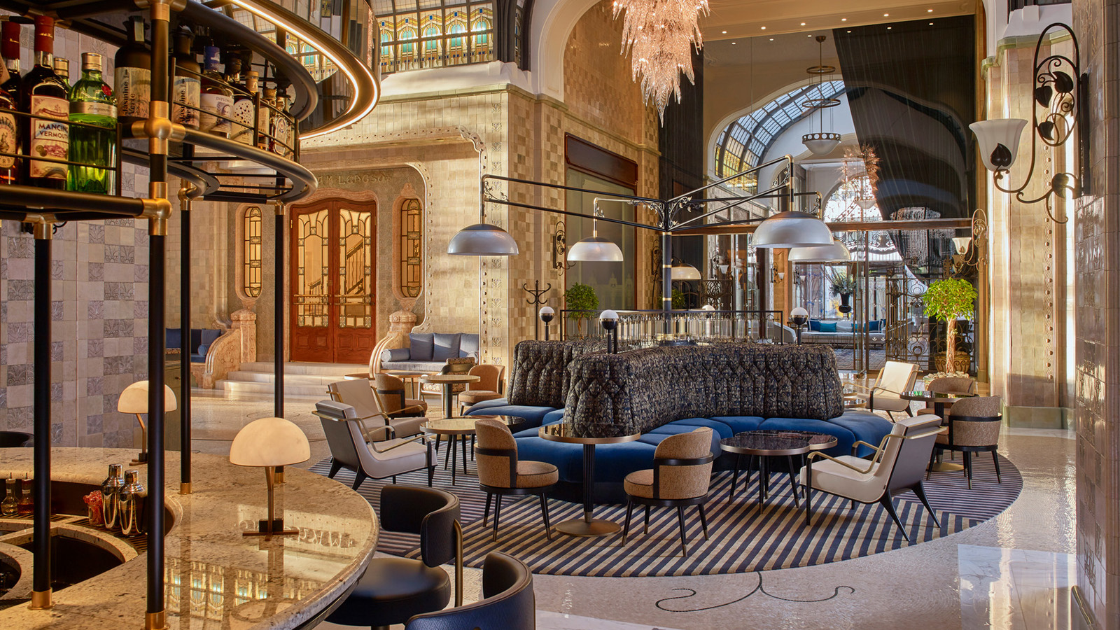
MÚZSA is the Hungarian word for “muse” and as the name suggests, the concept of the bar is inspiration and creativity indicative of the Art Nouveau era that once thrived in Budapest. The modern take on MÚZSA’s interior motifs reflects and honours the rich heritage of the Gresham Palace, known as one of the most beautiful Art Nouveau buildings in the world. MÚZSA represents a modern interpretation of Budapest’s golden age that is as innovative as it is iconic.
Celebrating the spirit of MÚZSA, the two-day birthday soirée promises to enchant senses with exceptional cocktails delivered by World’s 50 Best Bars guest bartenders, from The Clumsies #3 and Paradiso #19. The world-renowned bartenders make their highly anticipated Budapest debut for a treat not to be missed. MÚZSA invites guests for two visionary nights, where magic becomes reality.
Program
Live music will accompany each show stopping night.
Friday, October 1, 2021
- Introducing Nikos Bakoulis, The Clumsies, #3 World's 50 Best Bars
- Presented by London Essence Hungary
- 7:00-9:00 pm - Foxy Cleopatra and the Big Lovers
- 9:00 pm – 12:00 midnight - Piros Cipellők
Saturday, October 2, 2021
- Introducing Giacomo Giannotti, Paradiso, #19 World's 50 Best Bars
- Presented by Mancino Vermouth and Sei Bellissimi BelliNo
- 7:00-9:00 pm - Rewod & Artemisz
- 9:00 pm – 12:30 am - On Time Band
The team at MÚZSA is looking forward welcoming two top-tier World’s 50 Best Bar pioneers behind its bar, while celebrating the first anniversary of its unveiling. Reservations are required at info@muzsa.com or by calling +36 1 268 5120.
About The Clumsies, Athens
From modern Greek plates to top-notch mixology The Clumsies is a brilliant creation of two world class bartenders, Vassilis Kyritsis and Nikos Bakoulis, who are eager to create something truly special in Athens. The bar isn’t just about ordering a drink; it’s about experimenting with all the senses, by building a fundamental link between bar customer and server. Nikos Bakoulis, one of Europe’s most beloved bartenders will take over the MÚZSA bar for a night to be remembered.
About Paradiso, Barcelona
Giacomo Giannotti, the owner of Paradiso Bar, is known for his eye-catching drinks. A hidden “neo-speakeasy” gem behind a pastrami restaurant in Barcelona, Paradiso’s imaginative mixology knows no borders. Delivering the magic into cocktails, they play with the laws of physics. Giacomo Gianotti promises to bring all his expertise and creativity behind the MÚZSA bar, for a show-stopping night not to be missed.
About MÚZSA
“Through the ages, I’ve had many names and appeared in many places. In my beloved Budapest, they call me Múzsa.”
A jewel in the heart of Budapest, MÚZSA was unveiled in fall 2020. Budapest’s first Art Nouveau luxury craft cocktail bar opened its doors within Four Seasons Hotel Gresham Palace. Imbuing the glamour and elegance of Budapest’s golden age, MÚZSA introduces a new lobby lounge concept, fusing the building’s rich past with the needs of today’s sophisticated clientele. Elegant and refined, yet modern and playful, MÚZSA sets a new standard in craft cocktail excellence for the region. MÚZSA offers an inspired atmosphere to enjoy artful cocktail creations, an exciting blend of Asian and Hungarian cuisines, and a diverse mix of local authentic live entertainment.
Accompanied by live music, guests can enjoy an eclectic cocktail menu inspired by local ingredients fusing the best of East and West, carefully crafted by Head Bartender Ádám Rédli, who brings World's Best Bars expertise to MÚZSA. To provide the perfect pairing to the cocktails, Executive Chef &Aacute;rpád Győrffy artfully blends innovative Japanese dishes with locally-sourced ingredients, providing an exciting selection of sophisticated bar food offering. The artisan dessert selection created by Pastry Chef Attila Menyhárt features an exotic selection of dazzling desserts. MÚZSA’s signature Herend Afternoon Tea experience attracts visitors and locals alike, accompanied by live music, available weekly.
For more information on the weekly entertainment and events program, visit muzsa.com or stay up-to-date on MÚZSA’s official Instagram and Facebook channels.

RELATED

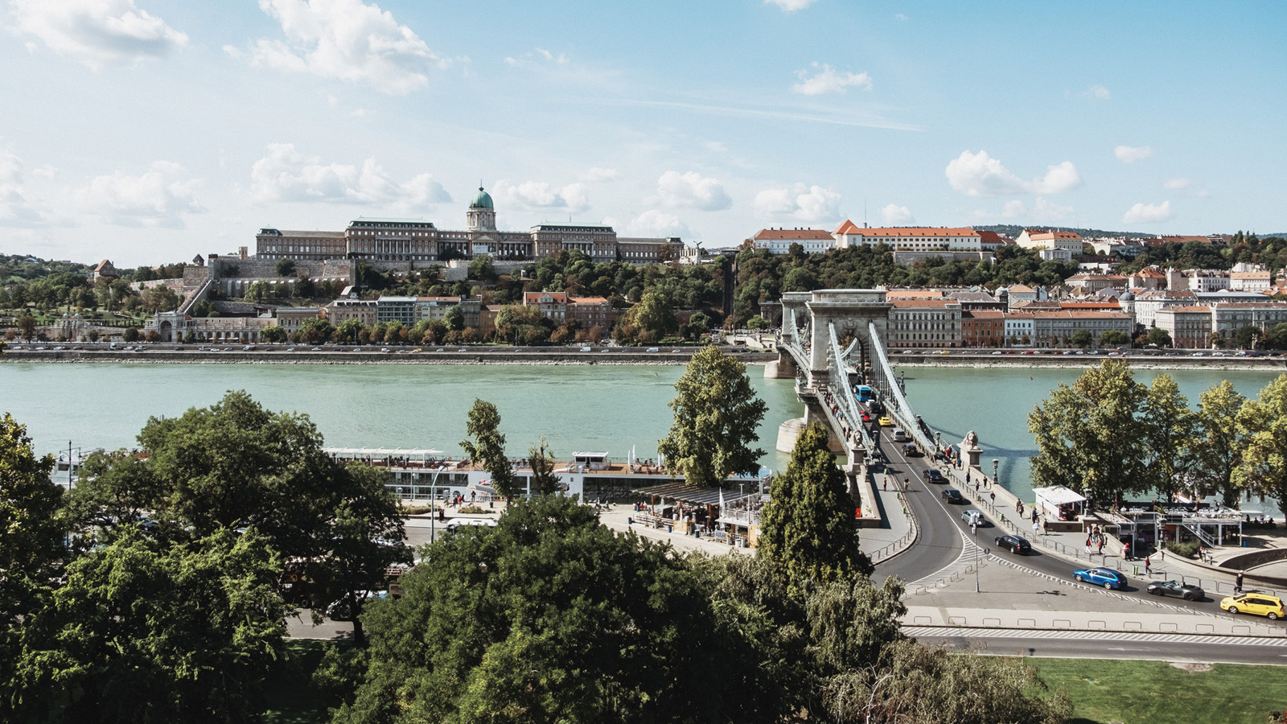 | June 3, 2021, Budapest, Hungary  An Inspiration Can Change Our Lives – On Global Wellness Day, Four Seasons Hotel Gresham Palace Budapest Presents a Series of Events Focussed on Well-Being  https://publish.url/budapest/hotel-news/2021/global-wellness-day.html
June 3, 2021, Budapest, Hungary
Egy Inspiráci&oacute; Megváltoztathatja az Életünket – A Wellness Világnapja Alkalmáb&oacute;l, a Four Seasons Hotel Gresham Palace Bemutatja Motiváló Program és Előadás Sorezatát
https://publish.url/hu/budapest/hotel-news/2021/global-wellness-day-2.html

PRESS CONTACTS

Krisztina Ilosfai
Director of Public Relations
Széchenyi István tér 5-6.
Budapest
Hungary
krisztina.ilosfai@fourseasons.com

+36 1 268 5452

Fruzsina Otto
Public Relations and Marketing Communications Coordinator
Széchenyi István tér 5-6.
Budapest
Hungary
fruzsina.otto@fourseasons.com

+36 1 268 5419

