Four Seasons Resort Sharm El Sheikh Brings Guests Five Romantic Reasons to Celebrate Valentine’s Day This Year

The romantic Red Sea resort offers guests an indulgent itinerary of champagne and chocolate, brown sugar body scrubs and herb-infused massages, to share with a loved one or enjoy all to oneself
February 10, 2020, Sharm El Sheikh, Egypt

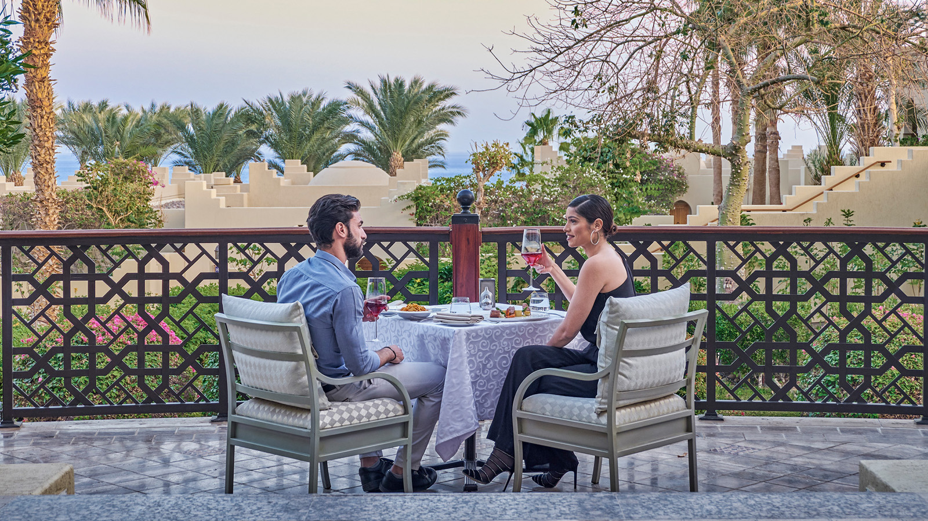
 | 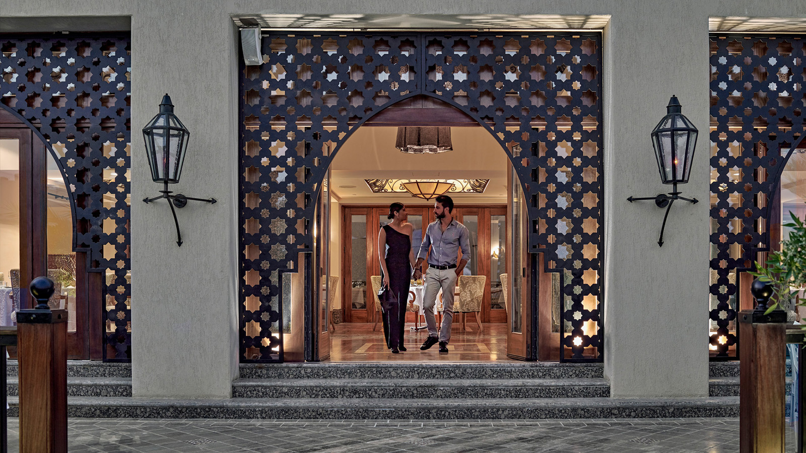 | 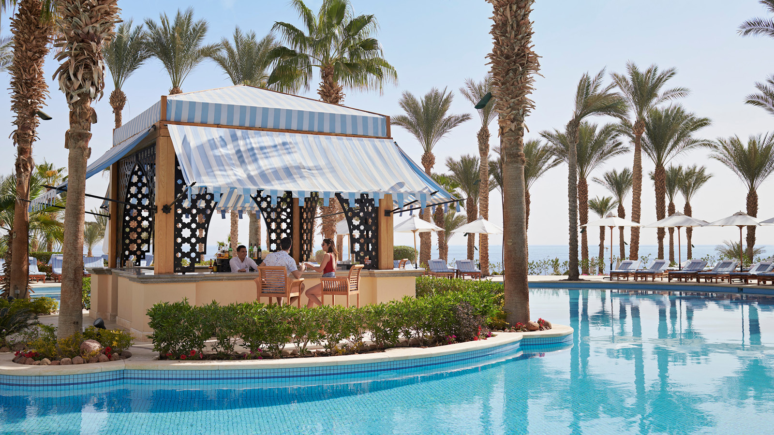
Four Seasons Resort Sharm el Sheikh invites guests to celebrate the most romantic day of the year with their 2020 Valentine’s Day itinerary. From spoiling spa packages for couples or singles, to a four-course set menu under the stars, the Red Sea resort has five key reasons to spend a Valentine’s holiday with Four Seasons in this rare desert-and-sea oasis.
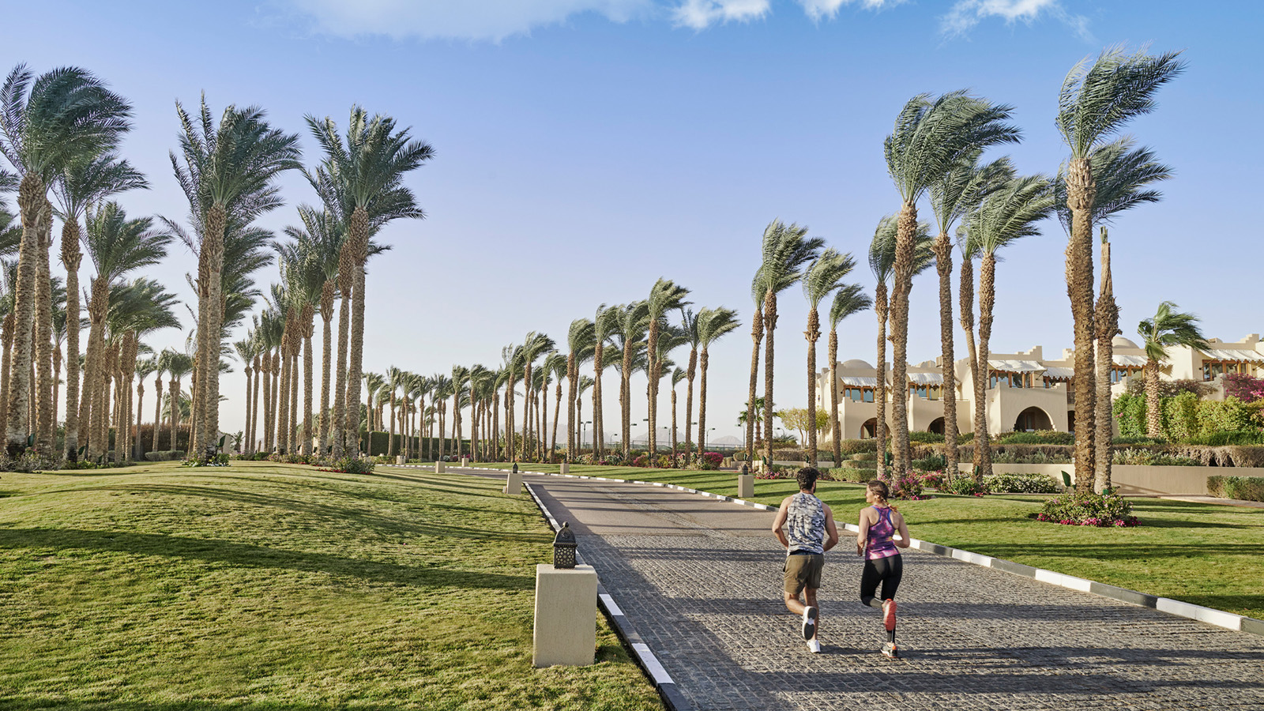 | 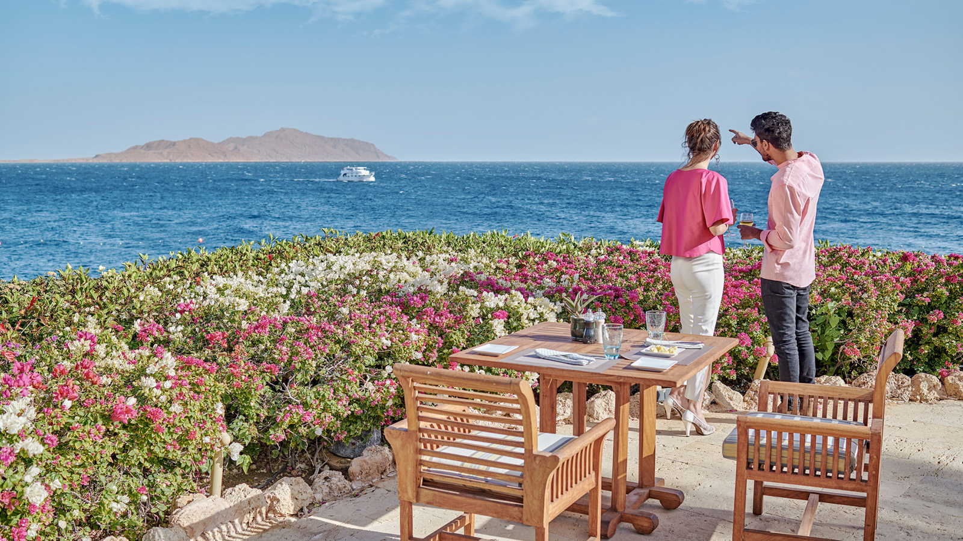 | 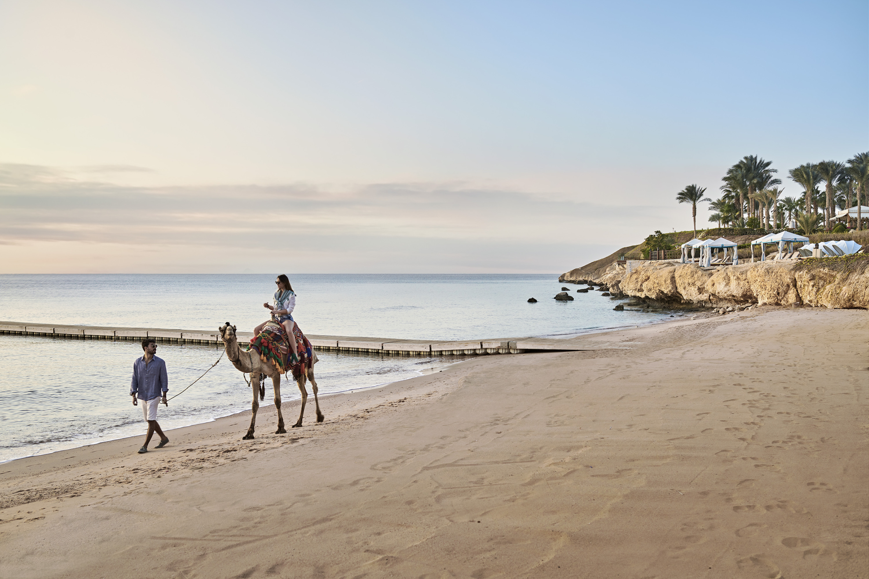
Wake to the sound of lapping waves. From now until February 14, 2020, guests can upgrade to a sea-view room and indulge in romantic in-room touches designed by the Resort’s masters of craft, all of which will be revealed on arrival.
Bedouin bliss. Whether guests are celebrating the holiday with a loved one, or simply enjoying some much-needed “me time’” the Spa at Four Seasons Resort Sharm el Sheikh has a variety of packages on offer. Couples can choose to opt for a Day of Romance where they will be treated to an invigorating aroma massage using herb-berry infusions and grilled spice fruits, followed by a lifting face massage; or the Be My Valentin’ package to enjoy the Spa’s private suite and indulge in a rose petal hot tub accompanied by a fruit plate and refreshing smoothie, and finally, a volcanic hot stone or Pharaonic massage.
Singles can choose between the Cupidon package, where they will be transported into a state of total relaxation with an aroma rose oil massage and rejuvenating facial; or the Aphrodite package for a sweet-sour body scrub with sea salt and brown sugar, followed by a Balinese massage to support emotional balance.
Fountain of love. On arrival at Il Frantoio, the Resort’s Italian dining concept, guests will be met by a chocolate fountain and offered a glass of champagne or signature Valentine’s Day cocktail. From there, guests will have the choice of a four-course set menu to be enjoyed under the stars while enjoying idyllic views of the Red Sea, or a la carte menu options such as hand cut ravioli, fresh grouper or veal au Jus. Twenty four hours prior to the big day, guests will receive a flyer delivered to their room, revealing details of a love-inspired pool and beach celebration, and pre-dinner cocktail reception.
Night swimming. For a truly bonding experience, why not try a night dive with a loved one and explore the Resort’s stunning house reef by the light of the moon? As the only resort in the region with an on-site diving centre, Four Seasons Sharm el Sheikh offers exclusive access to the hidden secrets of the Red Sea.
Fiery entertainment to ignite the sparks of passion. Before retreating to the room for the night, couples can sink their toes into the sandy shores of the Resort, lit-up by live entertainment from dazzling flame throwers to an Arabic takht playing traditional violin music from sunset and into the night.
Chef Concierge Ahmed Nazmy looks forward to creating truly memorable moments for his guests, commenting: “This most romantic time of year is perfect for our Resort, in terms of the experiences we are able to offer our guests. From the Hotel’s charming Moorish-inspired architecture to vibrant entertainment and dining offerings, everything about this desert-and-sea hideaway is ideal for couples seeking an intimate escape.”
For bookings, contact Concierge.SharmElSheikh@fourseasons.com or +20 69 360 3555, or book online.

RELATED

December 11, 2019, Sharm El Sheikh, Egypt
Four Seasons Resort Sharm El Sheikh Invites Guests to Enjoy an Exotic Festive Break at This Rare Desert-and-Sea Hideaway
https://publish.url/sharmelsheikh/hotel-news/2019/festive-season.html

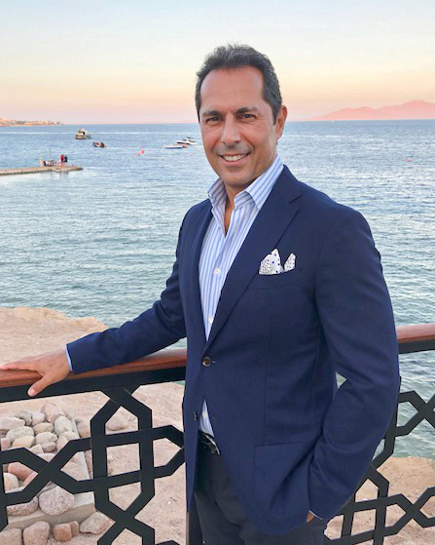 | September 18, 2019, Sharm El Sheikh, Egypt  Sam Ioannidis Appointed General Manager of Four Seasons Resort Sharm El Sheikh  https://publish.url/sharmelsheikh/hotel-news/2019/new-gm-sam-ioannidis.html

PRESS CONTACTS

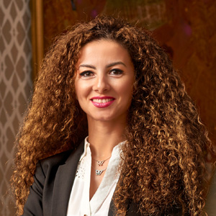 | Sherry Adel  Senior Director of Public Relations and Marketing Communications - Egypt  1089 Corniche El Nil, P.O. Box 63 Maglis El Shaab  Garden City 11519, Cairo  Egypt  sherry.adel@fourseasons.com  +20 (2) 2791 7000
Sally Hamdy
Public Relations Manager
1089 Corniche El Nil, P.O. Box 63 Maglis El Shaab, Garden City
Cairo
Egypt
sally.hamdy@fourseasons.com

+20 (2) 2791 7788

